Exercise 1: Airquality Dataset

a)

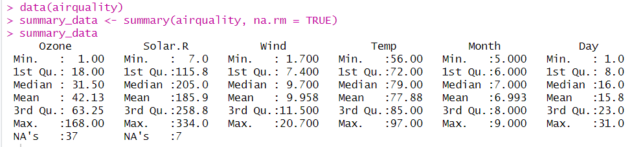

b)

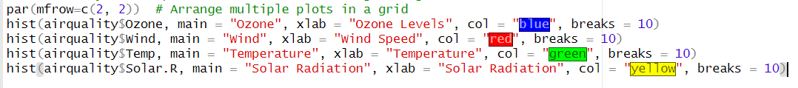

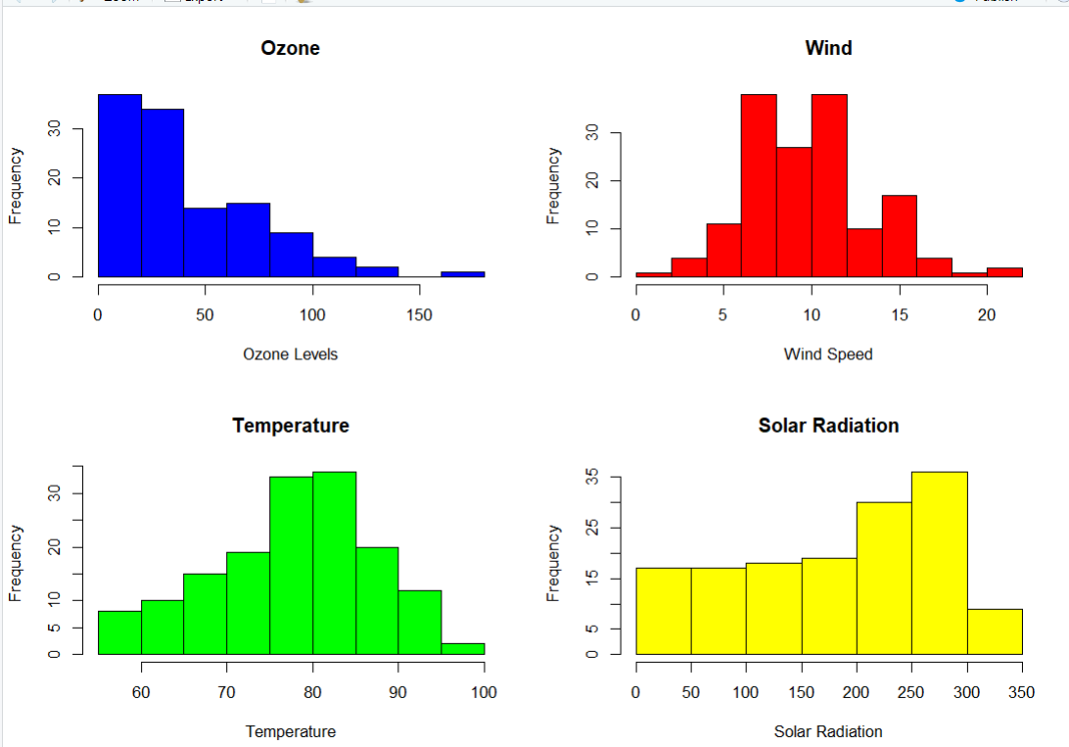

The histograms of Ozone, Wind, Temp, and Solar.R indicate that the distributions vary. Temperature appears approximately normally distributed, while others may be skewed.

c)



Temperature

Exercise 2: Iris Dataset

a)

Exercise 3: Cat Dataset

a)

The scatter plot shows a positive relationship between body weight and heart weight, indicating that as body weight increases, heart weight also tends to increase.

b)



Heart Weight=4.034+4.341×Body Weight.

c)

The R-squared value is approximately 0.6466209, indicating that 65% of the variation in heart weight is explained by body weight.

d)

The ANOVA test shows a significant p-value, indicating that the relationship between body weight and heart weight is statistically significant.

e)

The predicted heart weight for a cat with a body weight of 2.52 kg is approximately 9.809176g.