Lab Exercise

a)

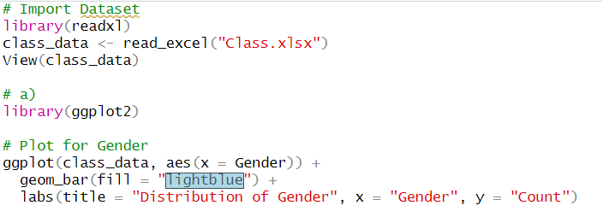

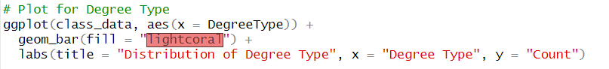

b)

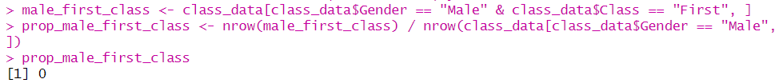

c)



d)



