Install ggplot2 package

Load the dataset



Inspect Dataset



Convert necessary columns to factors

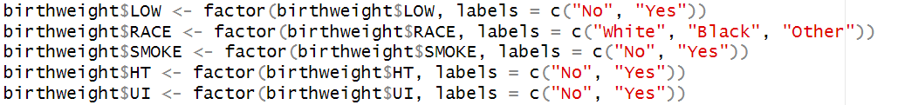

1. Univariate analysis
2. Bar plot for LOW (Low Birth Weight)



Most births are not classified as low birth weight.

1. Histogram for AGE (Age of the Mother)



Most mothers are in their 20s and 30s, with a few older mothers in the dataset.

1. Histogram for LWT (Weight at Last Menstrual Period)



The weights range from about 80 to 180 pounds, with most mothers around 130 pounds.

1. Bivariate analysis
2. Box plot of Birth Weight (BWT) by Race



There is some variation, but no race appears to have significantly different birth weights on average.

1. Scatter plot of Birth Weight (BWT) against Mother's Weight (LWT)

Heavier mothers tend to have babies with higher birth weights.

1. Scatter plot of Birth Weight against Age, colored by Smoking Status

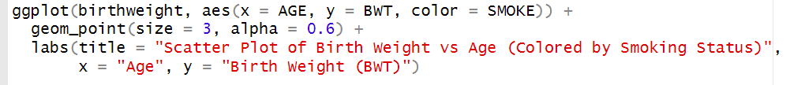

There is a positive relationship between the mother's age and birth weight, though it's less clear.

1. Box plot of Birth Weight by History of Hypertension

The box plot shows that mothers with a history of hypertension tend to have lower birth weight babies compared to those without a history of hypertension.