Q1)

Load the rock dataset

1. Descriptive analysis
2. 
3. A screenshot of a computer screen

   Description automatically generated
4. 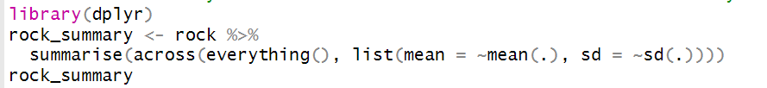
5. 

c)

1. A black and white text

   Description automatically generated+
2. A black text with black letters

   Description automatically generated with medium confidence
3. d)
4. 
5. A white background with black text

   Description automatically generated

Q2)



a)



b)



