- Turning Cybersecurity Expertise Into Brand Assets:
file:///C:/Users/monic/Downloads/AI%20Security%20Report%202026.pdf
Create proprietary, research-led reports that turn our cybersecurity expertise into authoritative, high-value brand assets.
Use each report to build sustained SEO/AEO visibility, thought leadership, PR, backlinks, and downstream content.
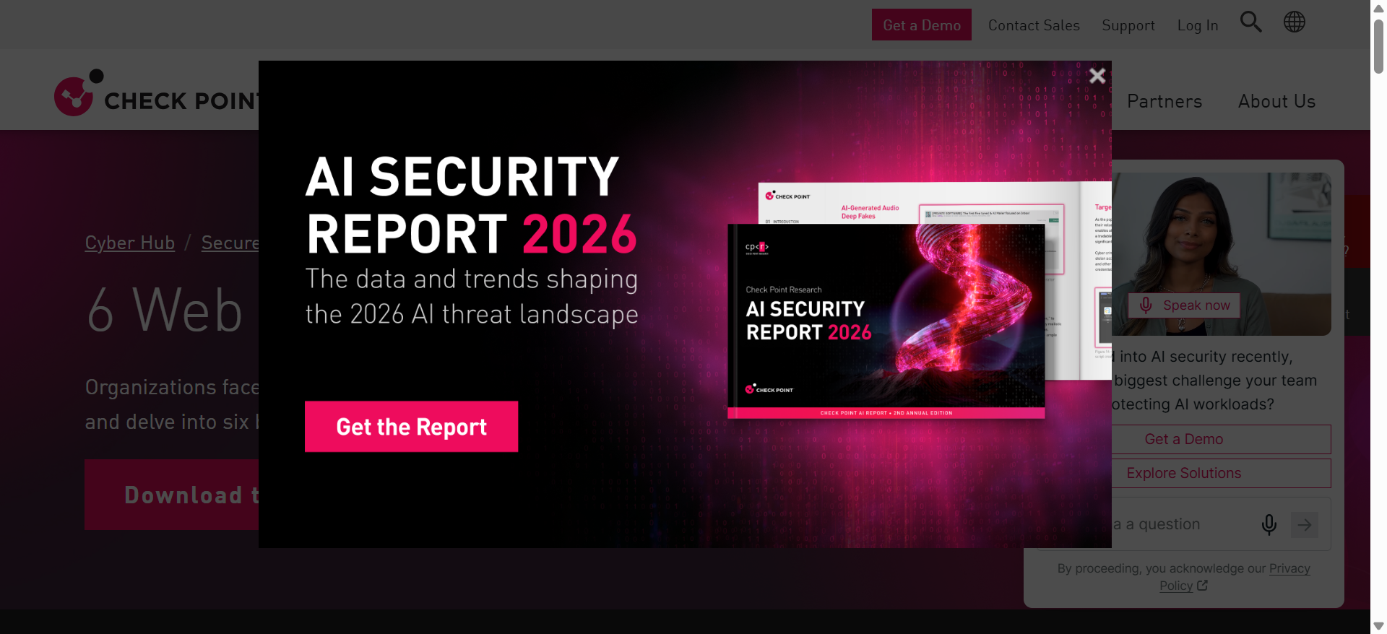

- Competitive Shift: From Security Blogs to Threat Intelligence Hubs: https://www.wiz.io/cloud-threat-landscape
Competitors are moving beyond blogs to build data-led threat intelligence hubs designed to capture broad, high-intent search demand across threats, actors, techniques, vulnerabilities, and incidents.
These evergreen hubs strengthen topical authority, improve AI/search visibility, and create scalable entry points into their broader security platforms and research.
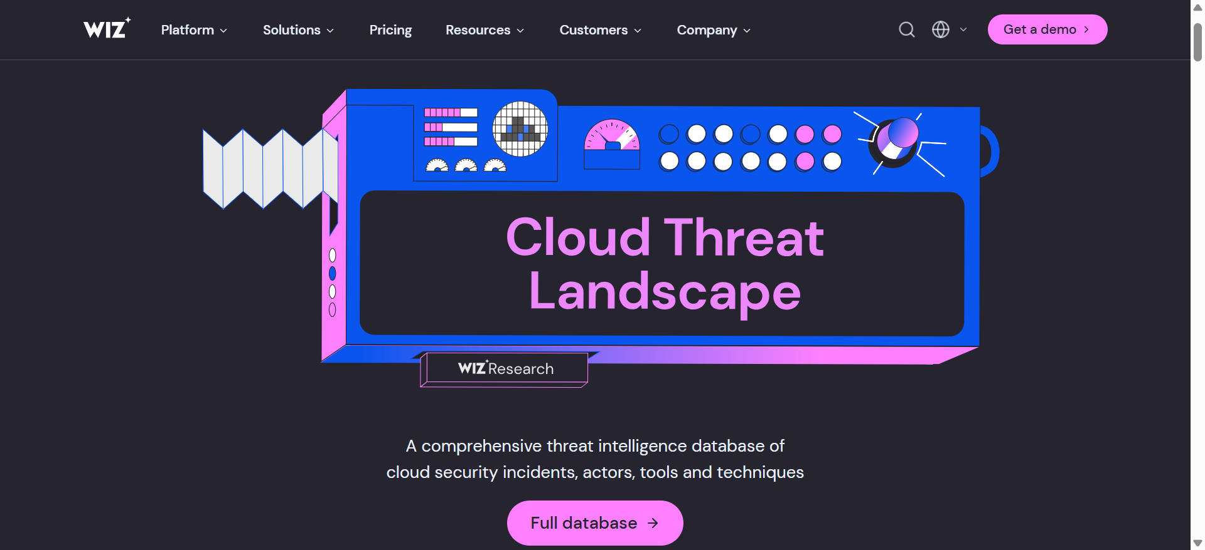

- PQC tester: https://www.wiz.io/pqc-tester
Build a Fortinet PQC Readiness Tester to turn quantum-security awareness into action.
Fortinet could create a differentiated version that uses its existing PQC expertise to generate an actionable readiness assessment and naturally connect prospects to Fortinet’s quantum-safe solutions.
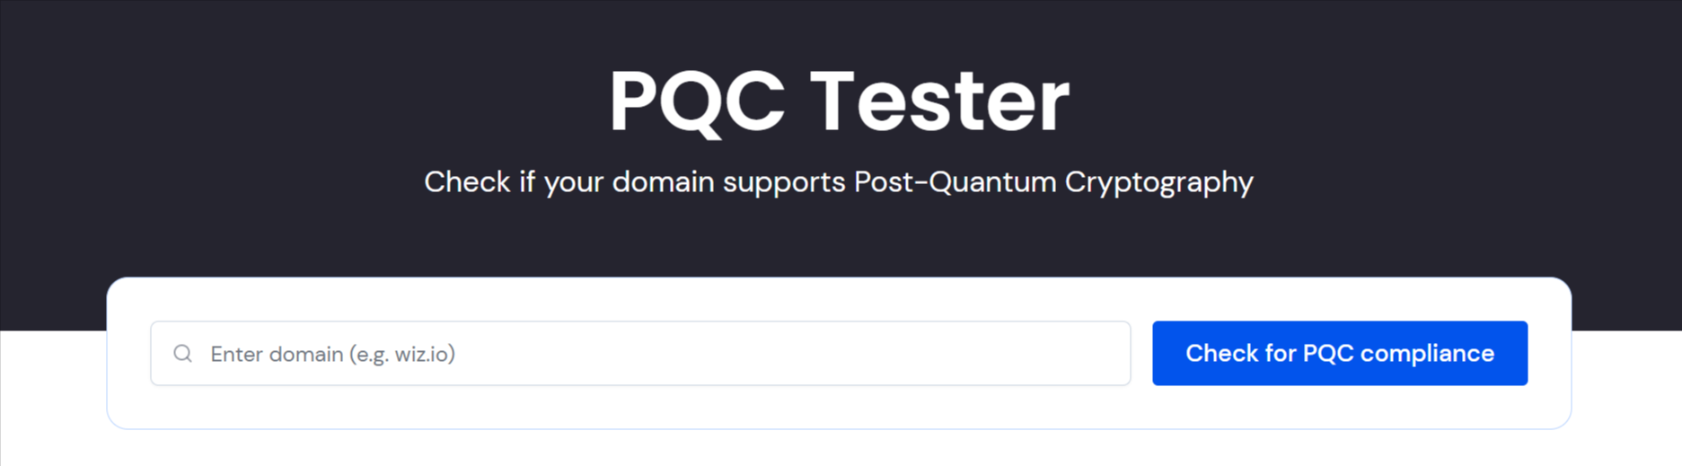
- Turn key takeaways into an AI-search-ready summary:
Create concise, answer-ready summaries that help users quickly grasp the topic while giving search engines and AI platforms clear, authoritative information to surface.
