
Invoice Process Automation

1. Introduction
This document describes the complete, end-to-end process flow of the LeadWalnut Invoice Process Automation system. It explains how a vendor invoice travels from the moment it lands in the shared email inbox, through automated reading and data extraction, into human review, and finally into Zoho Books as a bill.
It is written for all audiences finance and accounts staff, reviewers, leadership, and new team members and avoids deep technical detail. A separate Technical Architecture Document covers the implementation.

2. What the System Does
The system replaces manual invoice data entry with a supervised, semi-automated pipeline:
- Vendor invoices arriving by email as PDF attachments are picked up automatically, without anyone forwarding or downloading them.
- Each PDF is archived to Google Drive for audit purposes, then read by an AI extraction service that pulls out invoice number, dates, GSTINs, amounts, tax breakdown, and line items.
- The extracted invoice is stored and queued for human review it is never posted to accounts automatically.
- A reviewer verifies the data against the original PDF, assigns the correct expense ledger and tax treatment, then accepts, edits, or rejects it.
- On acceptance, a bill is created in Zoho Books against the correct vendor, and the result is verified back.
- Dashboards track volumes received, processed, and successfully pushed to accounts.
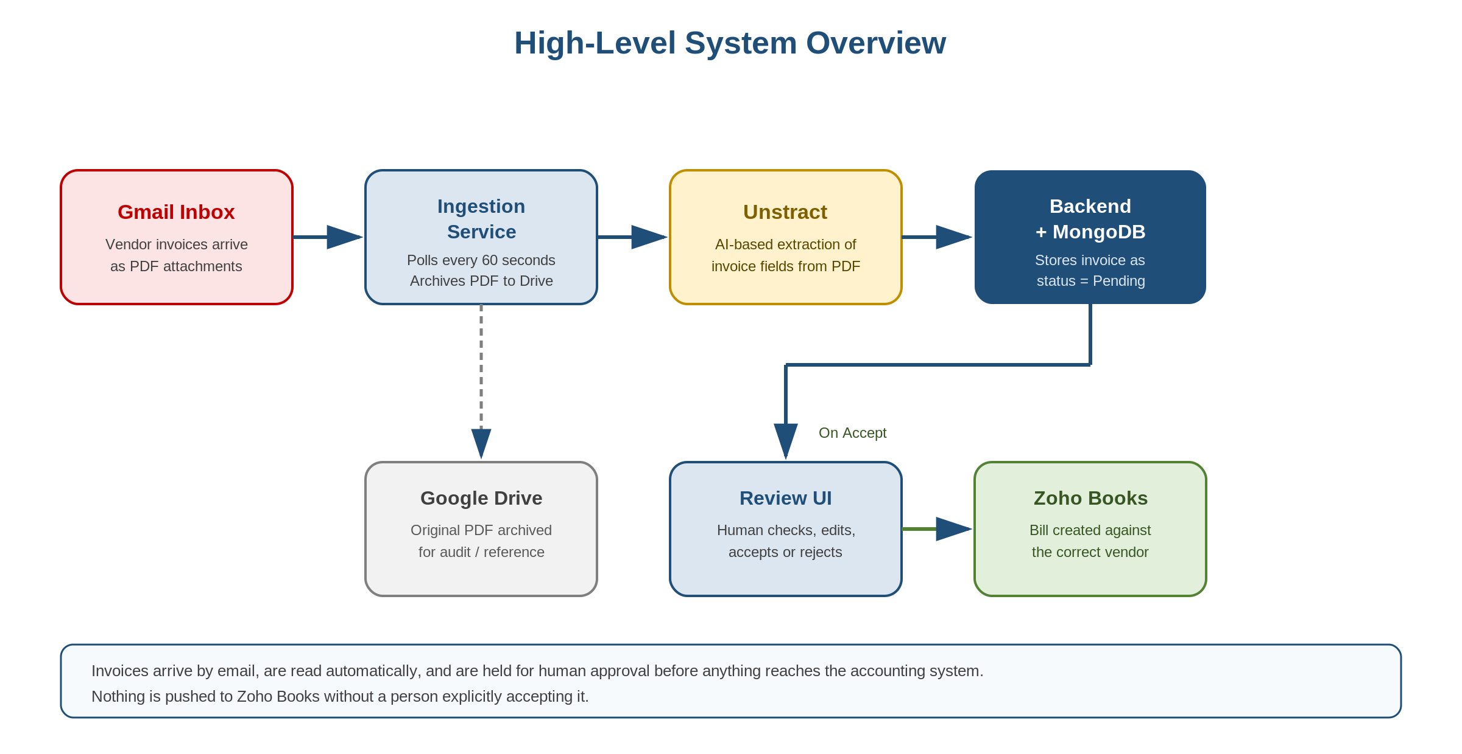
Figure 1: High-Level System Overview

3. Why Human Review Exists
AI extraction from PDF invoices is accurate but not infallible. Vendor invoice layouts vary widely, scanned documents can be poor quality, and some judgement calls simply cannot be automated:
- Which expense ledger an item belongs to is an accounting decision, not a data-extraction one.
- Whether GST is CGST/SGST or IGST depends on the place of supply, and whether TDS applies depends on the nature of the service.
- Duplicate invoices, pro-forma invoices, statements, and non-invoice attachments all reach the inbox and must be filtered out by a person.
For these reasons, the design principle is deliberate: nothing reaches Zoho Books without a person explicitly accepting it.

4. Roles and Responsibilities
Role | Who | Responsibilities
Vendor | External supplier | Emails the invoice as a PDF attachment to the designated inbox. No system access.
Reviewer | Accounts / finance team | Works the pending queue, verifies extracted data against the PDF, assigns ledgers and tax treatment, and accepts, edits, or rejects each invoice.
Finance lead | Accounts owner | Monitors metrics, maintains the vendor-to-ledger mapping, and resolves invoices that cannot be processed.
System (automated) | Ingestion service + backend | Polls the inbox, archives PDFs, calls AI extraction, normalizes data, stores invoices, creates Zoho bills on acceptance, and tracks metrics.

5. Invoice Statuses
Every invoice in the system is always in exactly one of the following states:
Status | Meaning | Who acts next
Pending | Newly extracted and stored. Waiting for a reviewer to look at it. | Reviewer
Edited | A reviewer has corrected or completed the data and saved it, but has not yet accepted it. It remains in the working queue. | Reviewer
Accepted | Verified and pushed to Zoho Books as a bill. Terminal. | None — closed
Rejected | Declined with a written remark (duplicate, not an invoice, wrong entity, etc.). No bill is created. Terminal. | None — closed
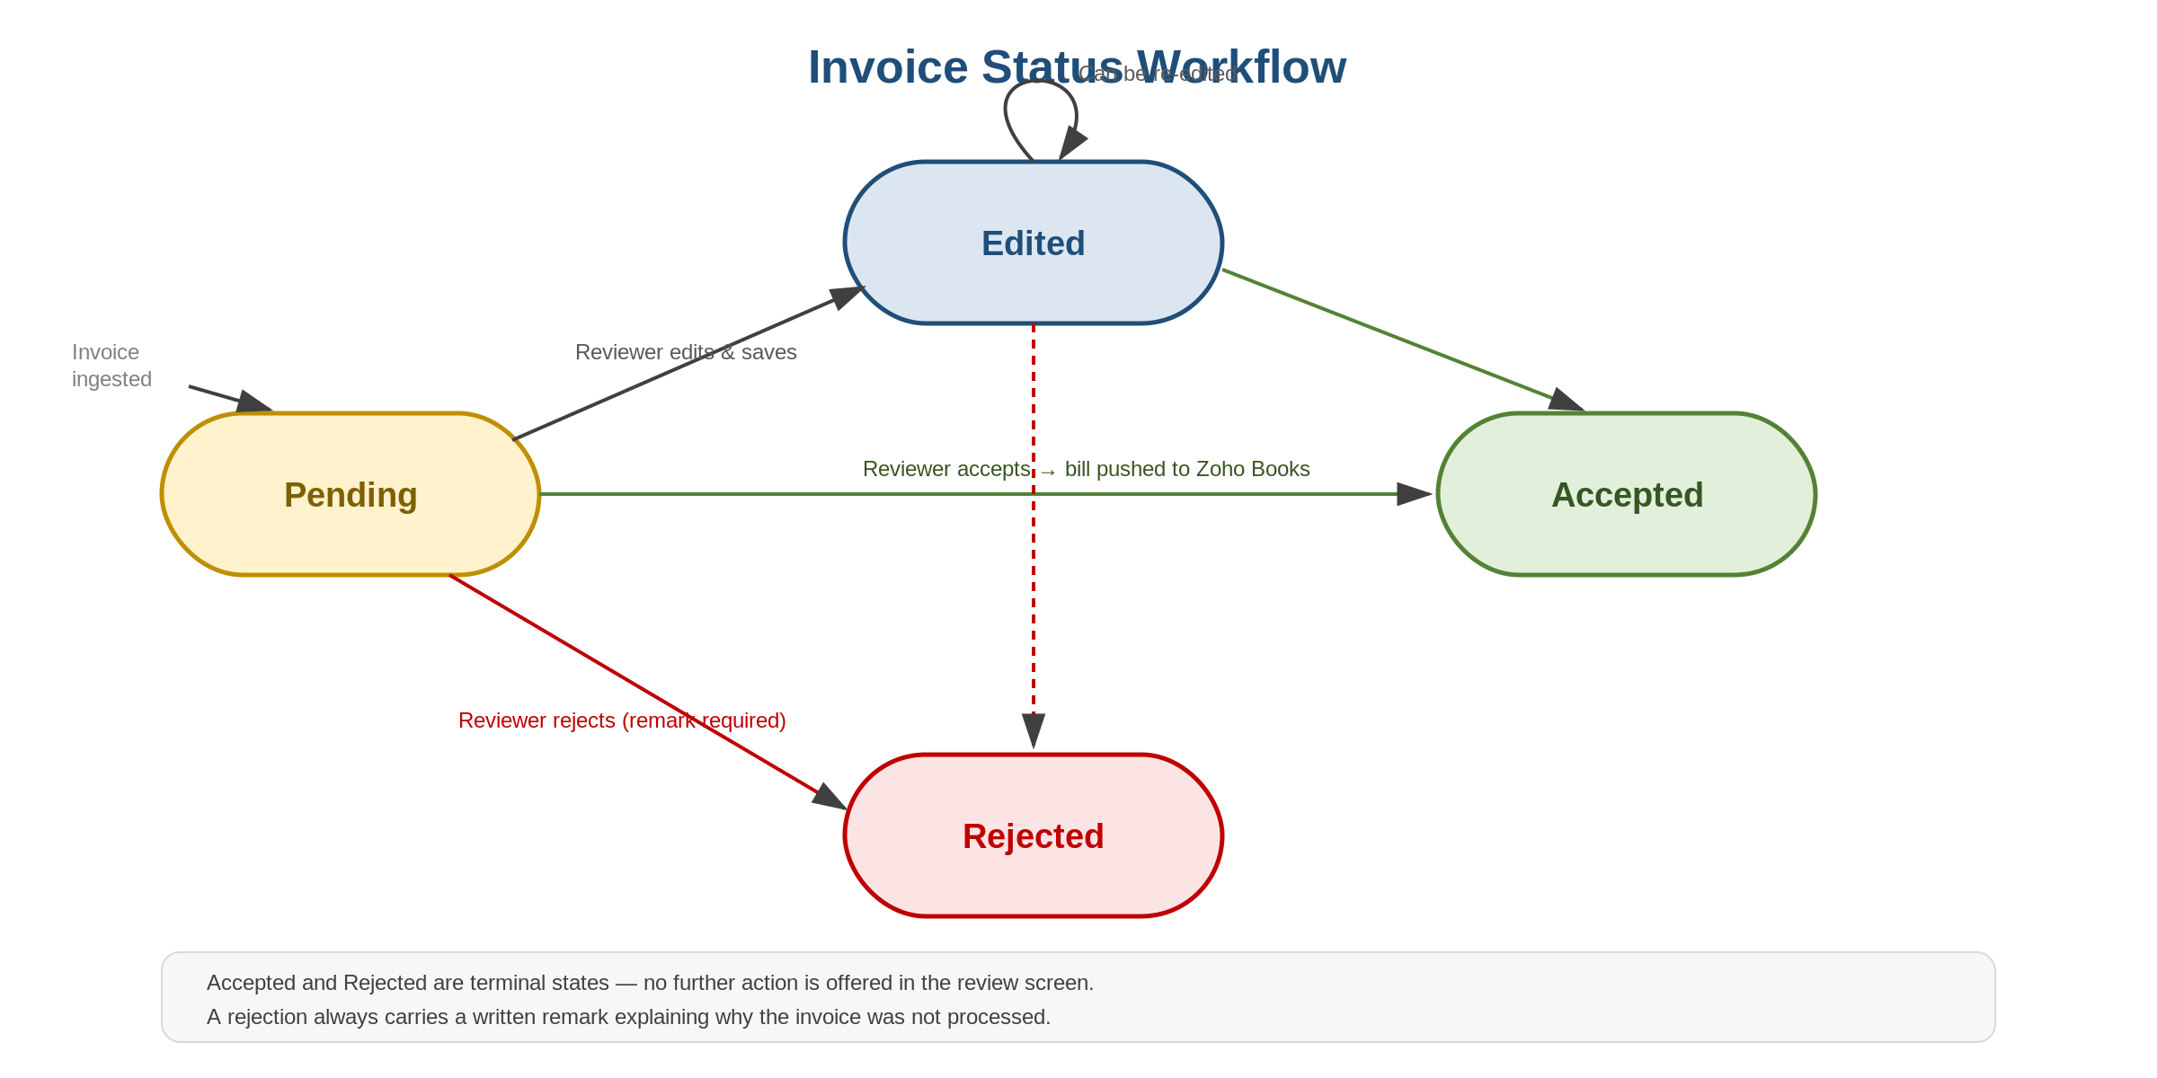
Figure 2: Invoice Status Workflow

6. End-to-End Process Flow
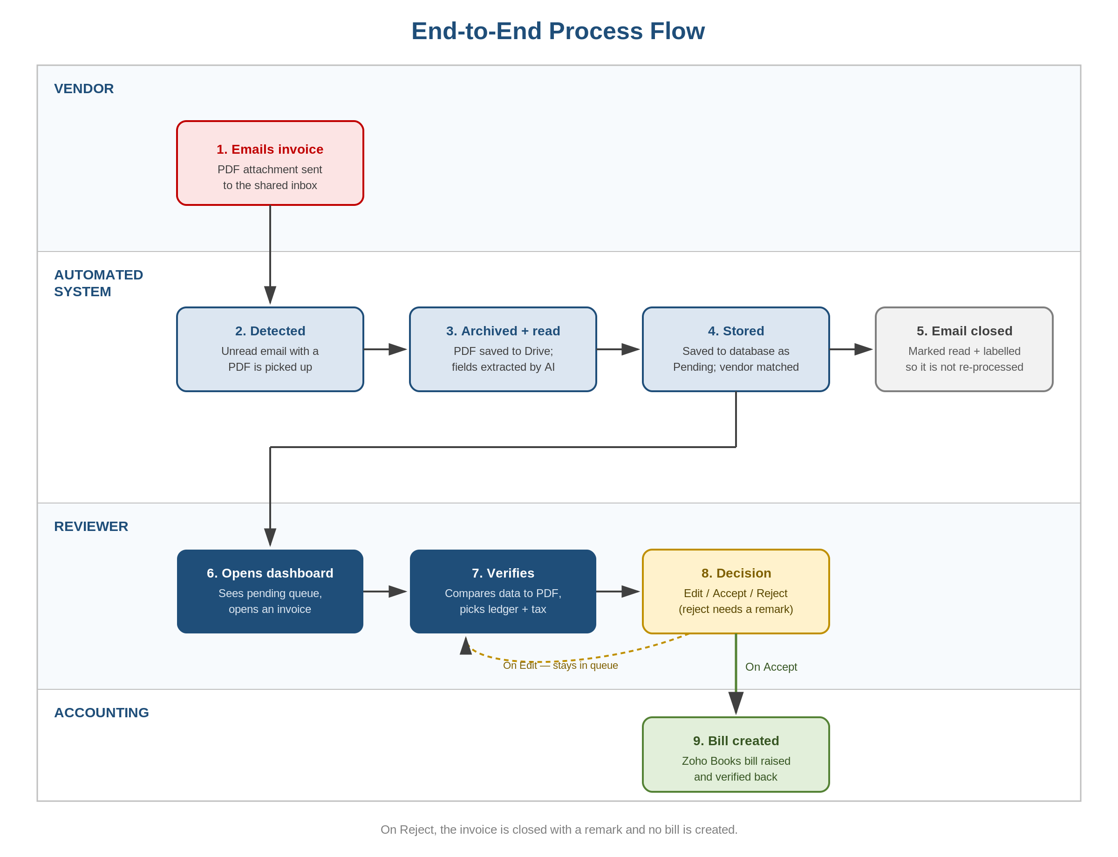
Figure 3: End-to-End Process Flow Diagram

6.1 Invoice Arrives (Vendor)
- The vendor emails the invoice as a PDF attachment to the shared invoice inbox. No special subject line or format is required.
- Only PDF attachments are processed. Invoices embedded in the email body, or sent as images or Office documents, are not picked up.

6.2 Automatic Detection
- The ingestion service checks the inbox on a short repeating cycle (approximately once a minute).
- It looks specifically for unread messages that carry a PDF attachment. Read messages are ignored, which is what prevents the same invoice being processed twice.
- A counter is recorded for every PDF attachment detected this feeds the 'Received by Mail' figure on the metrics screen.

6.3 Archival and Data Extraction
- The original PDF is uploaded to a designated Google Drive folder, giving an untouched copy for audit and reference independent of the system.
- The PDF is then sent to Unstract, an AI-based document extraction service, which returns the invoice as structured data.
Fields captured include:
Group | Fields extracted
Invoice header | Invoice number, invoice date, currency
Parties | Vendor name, vendor GSTIN, buyer name, buyer GSTIN
Amounts | Subtotal, CGST, SGST, IGST, total tax, total amount
Line items | Item description, HSN/SAC code, quantity, unit, unit price, line amount

6.4 Storage and Vendor Matching
- The extracted data is cleaned and standardised for example, 'GSTIN:' prefixes are stripped, amounts are converted to numbers, and a missing quantity defaults to 1 so the line still computes.
- The system attempts to match the invoice to a known vendor using the vendor master list, which maps each vendor to their Zoho contact record and their default expense ledger.
- If no match is found, the invoice is still stored and flagged in the dashboard as an 'Unregistered Vendor' so the reviewer knows the ledger will need to be chosen manually.
- The invoice is saved with status Pending, and the PDF is retained so the reviewer can open it side by side with the extracted data.

6.5 Email Closed Out
- Once processed, the source email is marked as read and given a label. This closes the loop and guarantees the invoice is not picked up again on the next cycle.

6.6 Human Review
The reviewer opens the dashboard, which lists every invoice with its status. Pending items sort to the top, then newest first. Filters are available by status and by date range.
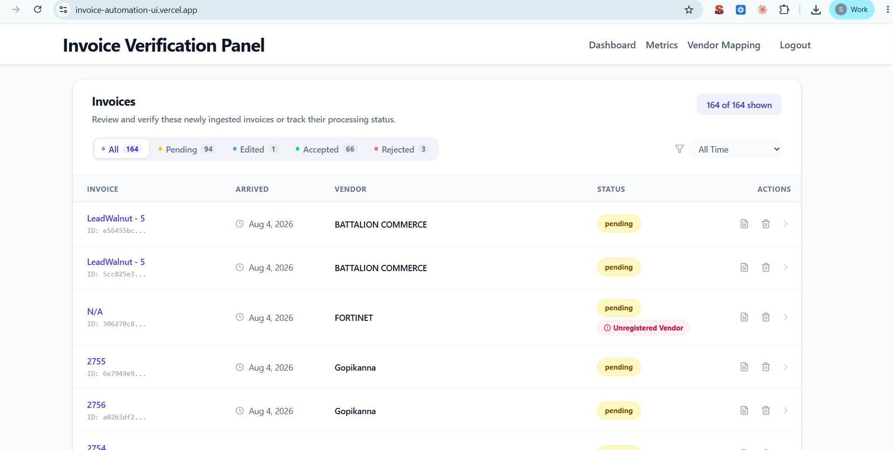
Figure 4: Review Dashboard
Opening an invoice shows the extracted data in an editable form alongside a link to the original PDF. The reviewer checks and completes:
Check | What the reviewer is confirming
Figures match the PDF | Invoice number, date, amounts, and totals were read correctly
Vendor is recognised | The invoice is matched to the right vendor record; unregistered vendors are flagged
Ledger assignment | Each line item is booked to the correct expense account. A bulk 'apply to all rows' option exists for single-category invoices
Tax treatment | The correct GST or IGST rate is selected; the system pre-selects a rate based on which tax fields the invoice carries
TDS | Whether tax deducted at source applies, and at which section/rate
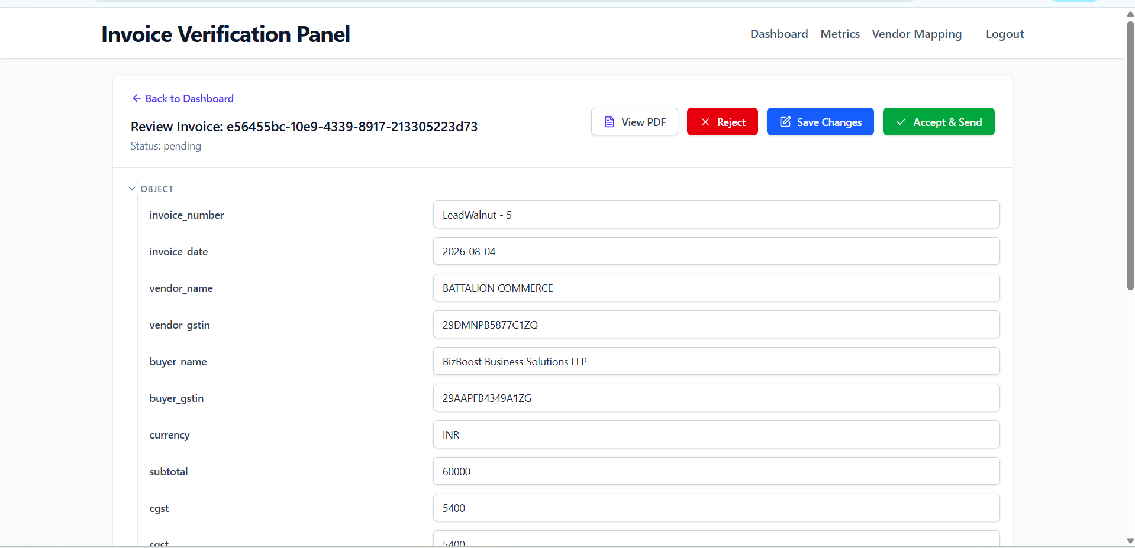
Figure 5: Invoice Review Screen

6.7 The Decision
Action | What happens
Save changes (Edit) | Corrections are stored and the status becomes Edited. The invoice stays in the working queue and can be revised again before a final decision.
Accept | A bill is created in Zoho Books against the matched vendor. The system reads the bill back to confirm it was created correctly, and optionally attaches a link to the archived PDF as a comment on the bill.
Reject | The invoice is closed without creating a bill. A written remark is mandatory and is displayed against the invoice in the dashboard.
Accepted and Rejected are terminal the review screen offers no further action once an invoice reaches either state.

6.8 Bill Creation in Zoho Books
- The bill is raised against the vendor's Zoho contact record, carrying the invoice number, invoice date, and every line item with its ledger, tax, and HSN/SAC code.
- Zoho Books recalculates the tax and totals itself from the line items and the selected tax codes, rather than accepting the totals from the PDF. This is intentional it means the booked figures always follow Zoho's own tax logic.
- Immediately after creation the system re-reads the bill and compares the invoice number. A mismatch is reported so it can be investigated.

7. Metrics and Monitoring
The metrics screen gives finance a view of throughput over any date range:
Metric | What it counts
Received by Mail | PDF attachments detected in the inbox. Counted before extraction, so it includes attachments that turned out not to be usable invoices.
Total Processed | Invoices successfully extracted and stored in the system.
Pushed to Zoho | Invoices accepted and successfully created as bills in Zoho Books.
Status distribution | Breakdown of all invoices across Pending, Edited, Accepted, Rejected.
Top vendors | Which vendors account for the most invoice volume.
Timeline | Daily invoice volume, useful for spotting backlogs or unusual spikes.
A gap between 'Received by Mail' and 'Total Processed' is normal and expected it represents attachments that were not usable invoices, or where extraction did not succeed.
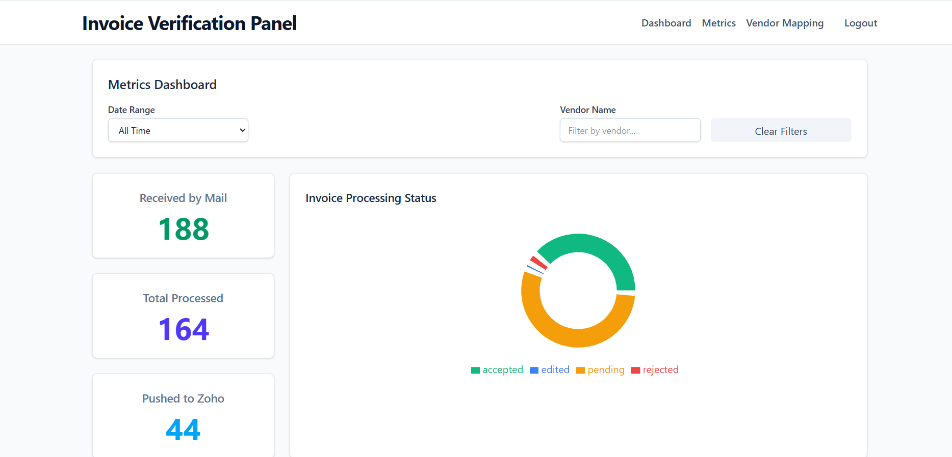
Figure 6: Metrics Dashboard

8. Vendor and Ledger Mapping
- A vendor master list links each vendor name and GSTIN to their Zoho contact record and their default expense ledger.
- When a vendor is in the list, the correct ledger is pre-filled on the invoice, which is what makes review fast for regular suppliers.
- When a vendor is not in the list, the invoice is flagged and the reviewer selects the ledger manually.
- The mapping is maintained centrally from a spreadsheet and loaded into the system it is not edited through the review screens. Adding new regular vendors to this list is the single highest-leverage way to reduce review effort.

9. Exceptions and Edge Cases
Situation | What happens / what to do
Invoice sent as an image or Word file | Not picked up only PDF attachments are processed. Ask the vendor to resend as PDF, or handle manually.
Same invoice emailed twice | Both copies are ingested as separate records. The reviewer rejects the duplicate with a remark; there is no automatic duplicate detection.
Extraction gets figures wrong | The reviewer corrects them in the review screen before accepting. The corrected values, not the extracted ones, are what reach Zoho Books.
Vendor not recognised | Invoice is flagged 'Unregistered Vendor'. The reviewer selects the ledger manually; the vendor should then be added to the master list.
Attachment is a statement, not an invoice | Ingested and stored, then rejected by the reviewer with a remark. It still counts toward 'Received by Mail'.
Bill creation in Zoho fails | The invoice is not marked accepted and remains in the queue; the error is surfaced so it can be retried after the cause is fixed.
Invoice number mismatch after creation | Reported as a mismatch on acceptance. The bill exists in Zoho and should be checked manually.

10. Quick Reference

For Reviewers
- Always open the PDF alongside the extracted data the figures are usually right, but the layout tells you when something was misread.
- Use 'apply ledger to all rows' for single-category invoices; set line-by-line only when an invoice genuinely spans multiple expense heads.
- Reject rather than delete. The remark becomes the audit record of why an invoice was not booked.
- Once accepted, an invoice cannot be revised in this system corrections have to be made in Zoho Books directly.

For Finance Leads
- Watch the gap between 'Received by Mail' and 'Total Processed' a widening gap suggests extraction failures worth investigating.
- Keep the vendor-to-ledger mapping current; it directly determines how much manual work each invoice requires.
- A growing Pending count means the review queue is not being worked, not that the automation has failed.

