
Invoice Process Automation

1. Introduction and Scope
This document describes the technical architecture of the Invoice Process Automation system: a Gmail-polling ingestion service, a FastAPI backend acting as a Zoho Books gateway and human-review workflow engine, a React review UI, and a MongoDB Atlas datastore.It covers the repository layout, deployment topology, ingestion pipeline, data model, API surface, Zoho Books integration, configuration, security posture, and known limitations.
Audience: developers, DevOps, and technical reviewers. For a non-technical walkthrough of the business process, see the companion End-to-End Process Flow Document.

2. Repositories and Deployment Topology
Repository | Role | Runtime | Deployed to
invoice-automation-ingestion | Gmail polling, Drive archival, Unstract extraction, normalization | FastAPI + APScheduler, Python 3.11, port 8002 | LeadWalnut server (Docker)
invoice-automation | Backend API review workflow + Zoho Books gateway | FastAPI + Motor (async MongoDB), port 8001 | LeadWalnut server (Docker)
invoice-automation-ui | Review UI (package name: review-ui) | React 19 + Vite 8 + Tailwind 4 | Vercel
MongoDB Atlas | Datastore | Managed MongoDB, database invoice_db | Atlas (cloud)
The three repositories deploy independently and share no code. Integration is entirely over HTTP.
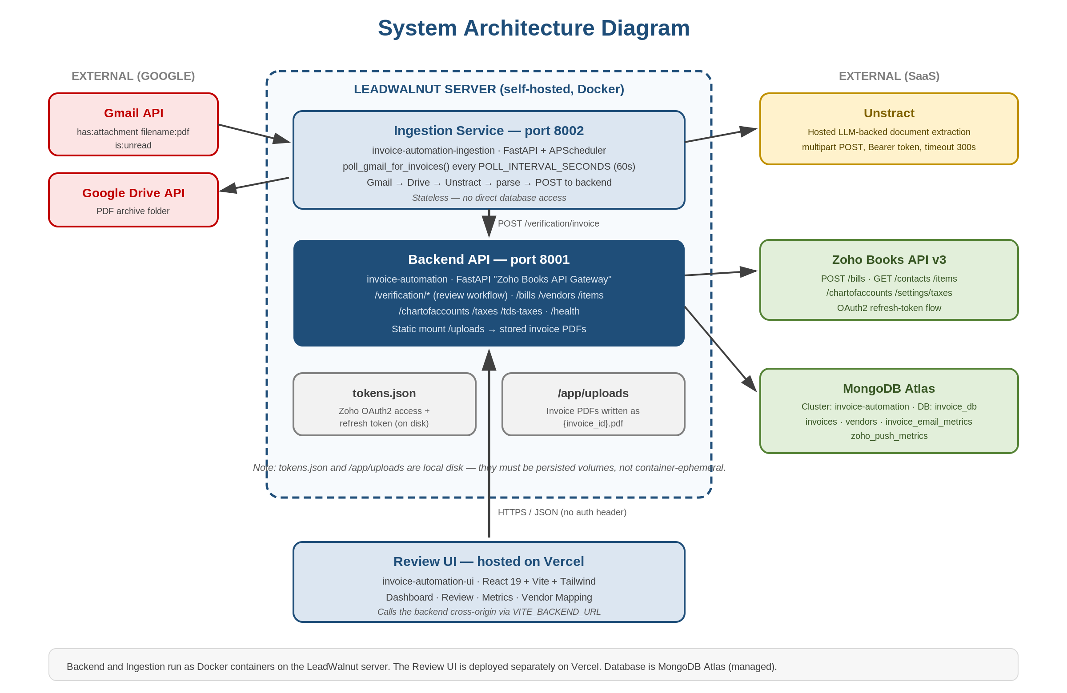
Figure 1: System Architecture Diagram

3. Technology Stack
Layer | Technology | Notes
Ingestion | FastAPI, APScheduler BackgroundScheduler, google-api-python-client, google-auth-oauthlib, requests | Long-running service; interval job, not cron. Single HTTP route (GET /health).
Extraction | Unstract (hosted, LLM-backed document extraction) | No local OCR or LLM no pdfplumber/PyPDF/Tesseract in the dependency set. All extraction is a remote multipart POST.
Backend | FastAPI, Uvicorn, Motor (AsyncIOMotorClient), Pydantic v2, pydantic-settings | Titled 'Zoho Books API Gateway', version 1.0.0. Serves both the review workflow and thin Zoho passthrough endpoints.
Database | MongoDB Atlas cluster invoice-automation, database invoice_db | Four collections. No schema validation, no foreign keys, no transactions.
Accounting | Zoho Books API v3, OAuth2 refresh-token flow | Token persisted to tokens.json on local disk.
Frontend | React 19.2, Vite 8, react-router-dom 7, axios, recharts, Tailwind CSS 4, lucide-react | Plain JavaScript (.jsx), no TypeScript. Dev server on 5173.
Google APIs | Gmail API (gmail.modify), Google Drive API (drive.file) | Installed-app OAuth; credentials.json → token.json.
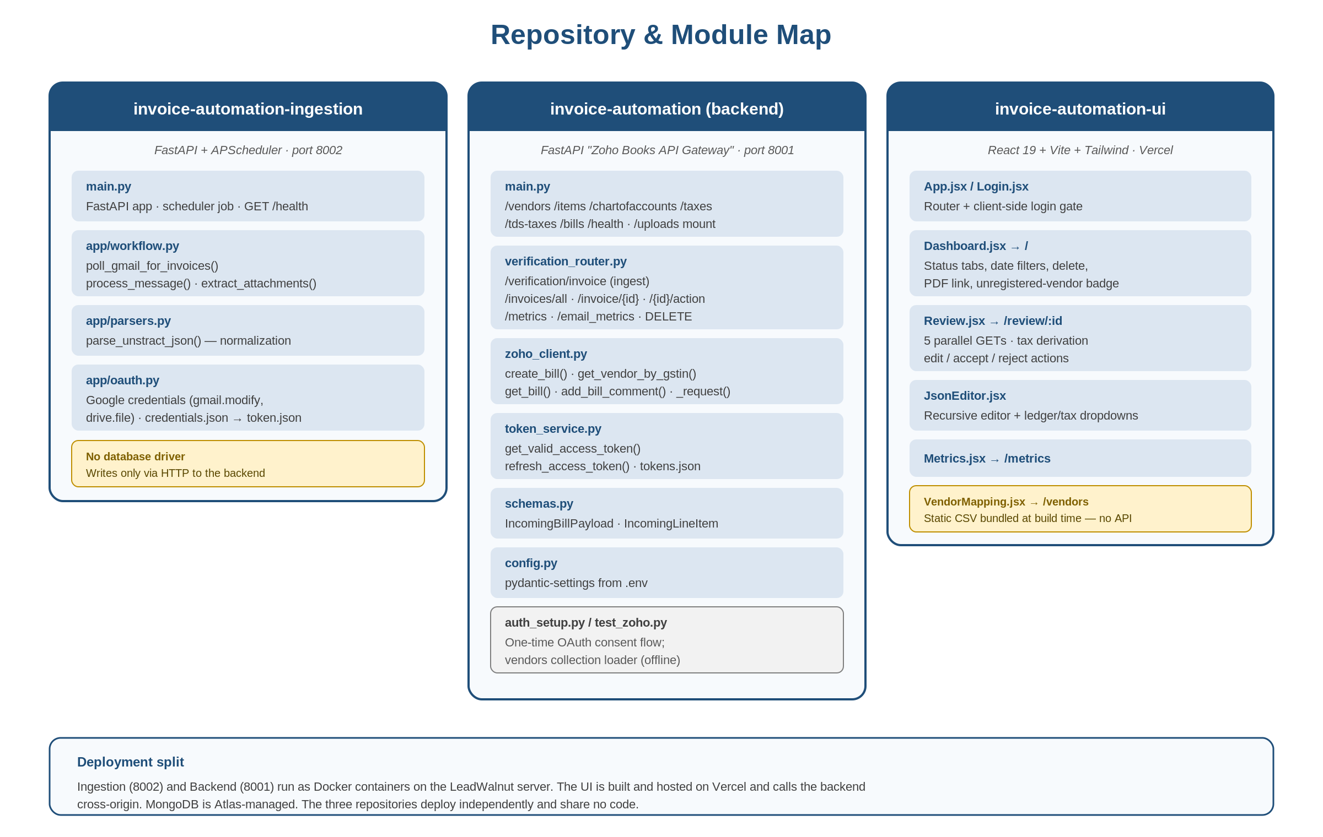
Figure 2: Repository & Module Map

4. Ingestion Service

4.1 Execution model
- main.py creates the FastAPI app ('Ingestion Service'). The startup hook registers an APScheduler interval job (id poll_invoices) running poll_gmail_for_invoices every POLL_INTERVAL_SECONDS (default 60), with next_run_time set to now so it fires immediately on boot.
- It is a BackgroundScheduler (thread-based, synchronous job) inside an async FastAPI app the polling job occupies a scheduler thread rather than the event loop.
- Only one HTTP route exists: GET /health returning {"status": "ok"}. The service is otherwise headless.

4.2 Pipeline
app/workflow.py poll_gmail_for_invoices() → process_message() per message:
- Gmail query is hardcoded: has:attachment filename:pdf is:unread via messages().list(userId='me', q=query).
- A nested recursive extract_attachments() walks message['payload']['parts'], keeps parts whose filename ends in .pdf, fetches each via messages().attachments().get(), and base64-urlsafe-decodes the data into raw bytes.
- Posts the email metric first: POST {BACKEND_URL}/verification/email_metrics with {metrics_type: 'invoice_email_metrics', total_invoices_received: <PDF count in that message>}.
- Per PDF: uploads to GOOGLE_DRIVE_FOLDER_ID via MediaIoBaseUpload(BytesIO(pdf_data), mimetype='application/pdf', resumable=True).
- Per PDF: POST to UNSTRACT_URL as multipart/form-data, header Authorization: Bearer {UNSTRACT_API_KEY}, file field 'files', form fields timeout=300, include_metadata=False, include_metrics=False.
- On HTTP 200: parse_unstract_json(raw_json), then attaches base64_pdf (b64 of the raw bytes) and pdf_filename, and POSTs the result to {BACKEND_URL}/verification/invoice.
- Finally messages().modify() with {addLabelIds: [GMAIL_LABEL_ID], removeLabelIds: ['UNREAD']}.
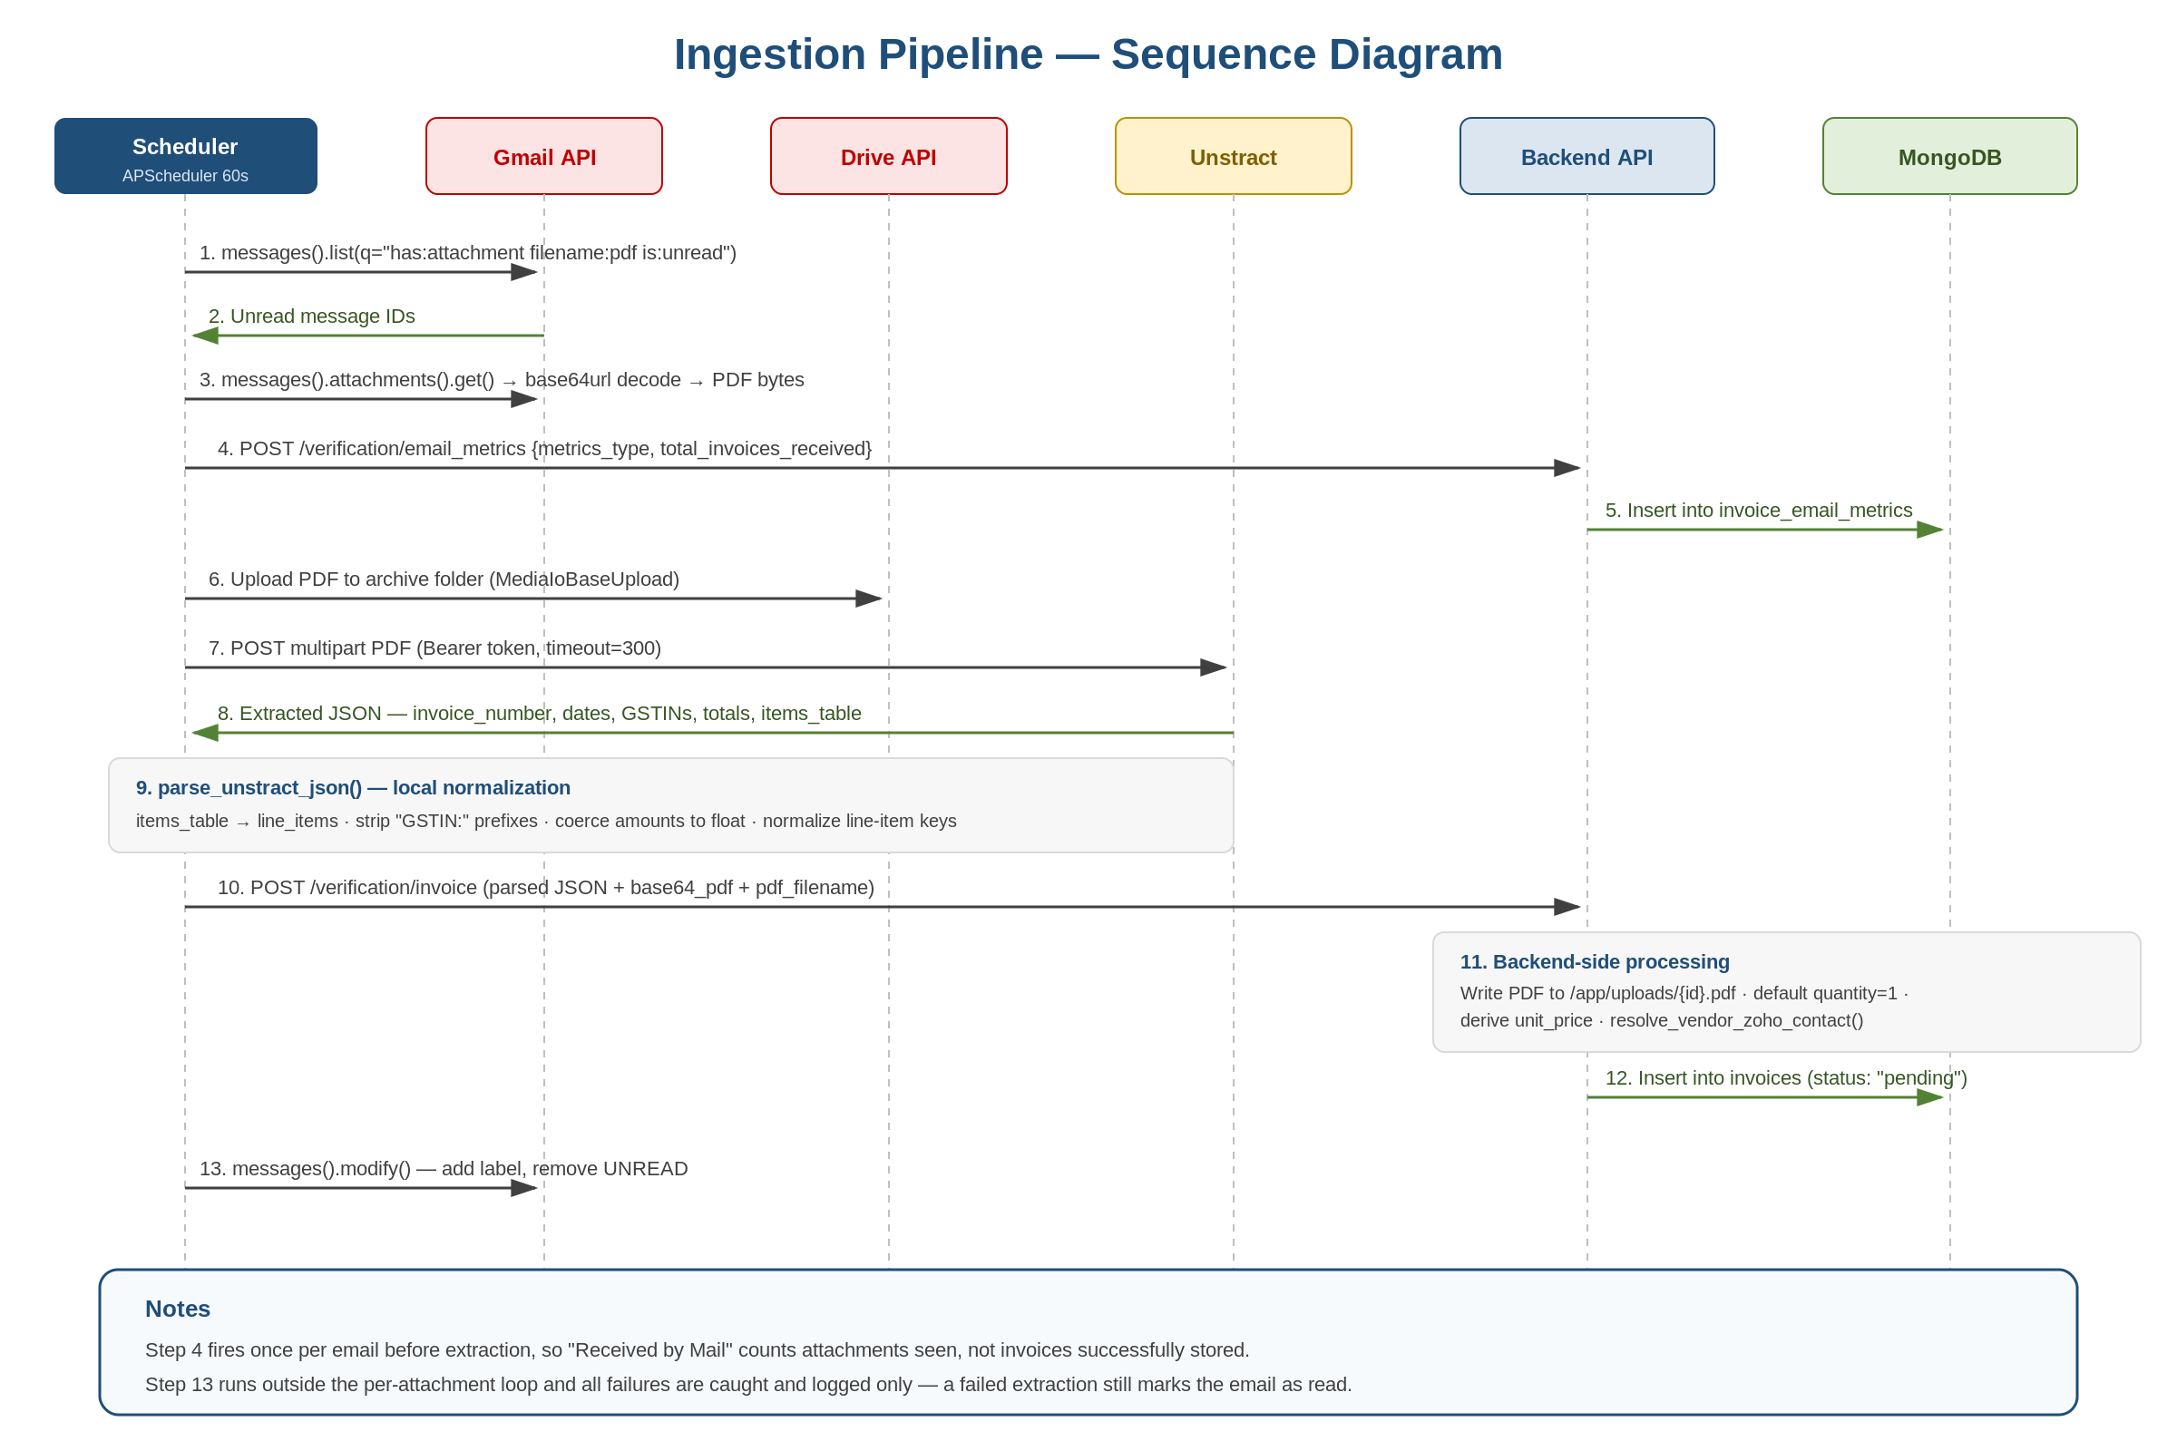
Figure 3: Ingestion Pipeline - Sequence Diagram

4.3 Normalization (app/parsers.py)
parse_unstract_json(data) performs:
- Unwraps the Unstract envelope data['message']['result'][0]['result']['output']; also tolerates a bare top-level list.
- Flattens items_table → line_items (handles both the dict form {'line_items': [...]} and a bare list), then deletes items_table.
- Strips literal 'GSTIN:' / 'GSTIN' prefixes from buyer_gstin and vendor_gstin.
- Coerces subtotal, cgst, sgst, igst, tax_total, total_amount to float (0.0 on failure).
- Normalizes each line item to exactly: item_number, description, hsn_sac (stringified), quantity, unit, unit_price, amount.
A second normalization pass runs backend-side in POST /verification/invoice: it maps items_table → line_items again as a fallback, forces quantity = 1 when null/empty/0/unparseable, and derives unit_price = amount / quantity when unit_price is missing or zero. The same logic is repeated inside the accept branch.

4.4 Failure behaviour
- All per-attachment failures are caught and logged only, never re-raised.
- The messages().modify() call sits outside the per-attachment loop, so an email is marked read and labelled even if extraction failed for its attachments that invoice will not be retried on the next poll.
- There is no dedupe or idempotency mechanism beyond the is:unread flag.

5. Backend API

5.1 Review workflow routes (prefix /verification)
Method & Path | Purpose
POST /verification/invoice | Ingest. Body is an untyped Dict no Pydantic validation. Writes the PDF to disk, normalizes, resolves the vendor, inserts with status 'pending'. Returns {id, status, pdf_url}.
POST /verification/email_metrics | Accepts a single object or list of EmailMetricsPayload; sums total_invoices_received where metrics_type == 'invoice_email_metrics' and inserts one aggregated doc.
GET /verification/invoices/all | find({}).sort('created_at', -1), capped at 1000 documents.
GET /verification/invoice/{id} | Fetch one; 404 if missing. Side effect: re-runs resolve_vendor_zoho_contact() on the returned data in memory (not persisted), so the latest vendor/ledger mapping is applied on read.
POST /verification/invoice/{id}/action | Body {action: 'accept'|'edit'|'reject', data?, remark?}. Invalid action → 400.
DELETE /verification/invoice/{id} | Hard delete; 404 if deleted_count == 0.
GET /verification/metrics | Query start_date, end_date (ISO, 'Z' → '+00:00'), vendor_name. Runs five aggregation pipelines; returns {status_distribution, total, vendors, timeline, total_email_invoices, total_zoho_pushed}.

5.2 Zoho passthrough routes (app root)
Method & Path | Purpose
GET /vendors | Zoho GET /contacts?contact_type=vendor (page, per_page=200).
GET /items | Paged loop over Zoho GET /items, per_page=200, breaks on empty page or page > 10.
GET /chartofaccounts | Same paging loop over Zoho GET /chartofaccounts, page > 10 safeguard.
GET /taxes | Zoho GET /settings/taxes with filter_by=Taxes.Active, then drops any tax whose tax_specific_type == 'tds'.
GET /tds-taxes | Zoho GET /settings/taxes with filter_by=Taxes.All, is_tds_request=true, usestate=false, per_page=100.
GET /bills | Zoho GET /bills (page, per_page).
POST /bills | 201. Body: a single IncomingBillPayload or a list. Bypasses review entirely — creates bills directly.
GET /health | {status: 'healthy', tokens_initialized: <bool>}.
/uploads/* | StaticFiles mount serving stored invoice PDFs from settings.upload_dir.
All routes wrap exceptions into HTTP 500 with detail=str(e). CORS is allow_origins=['*'], all methods and headers, credentials allowed.

6. Data Model
MongoDB Atlas, database invoice_db, accessed via AsyncIOMotorClient. Four collections, no schema validation and no foreign-key constraints.
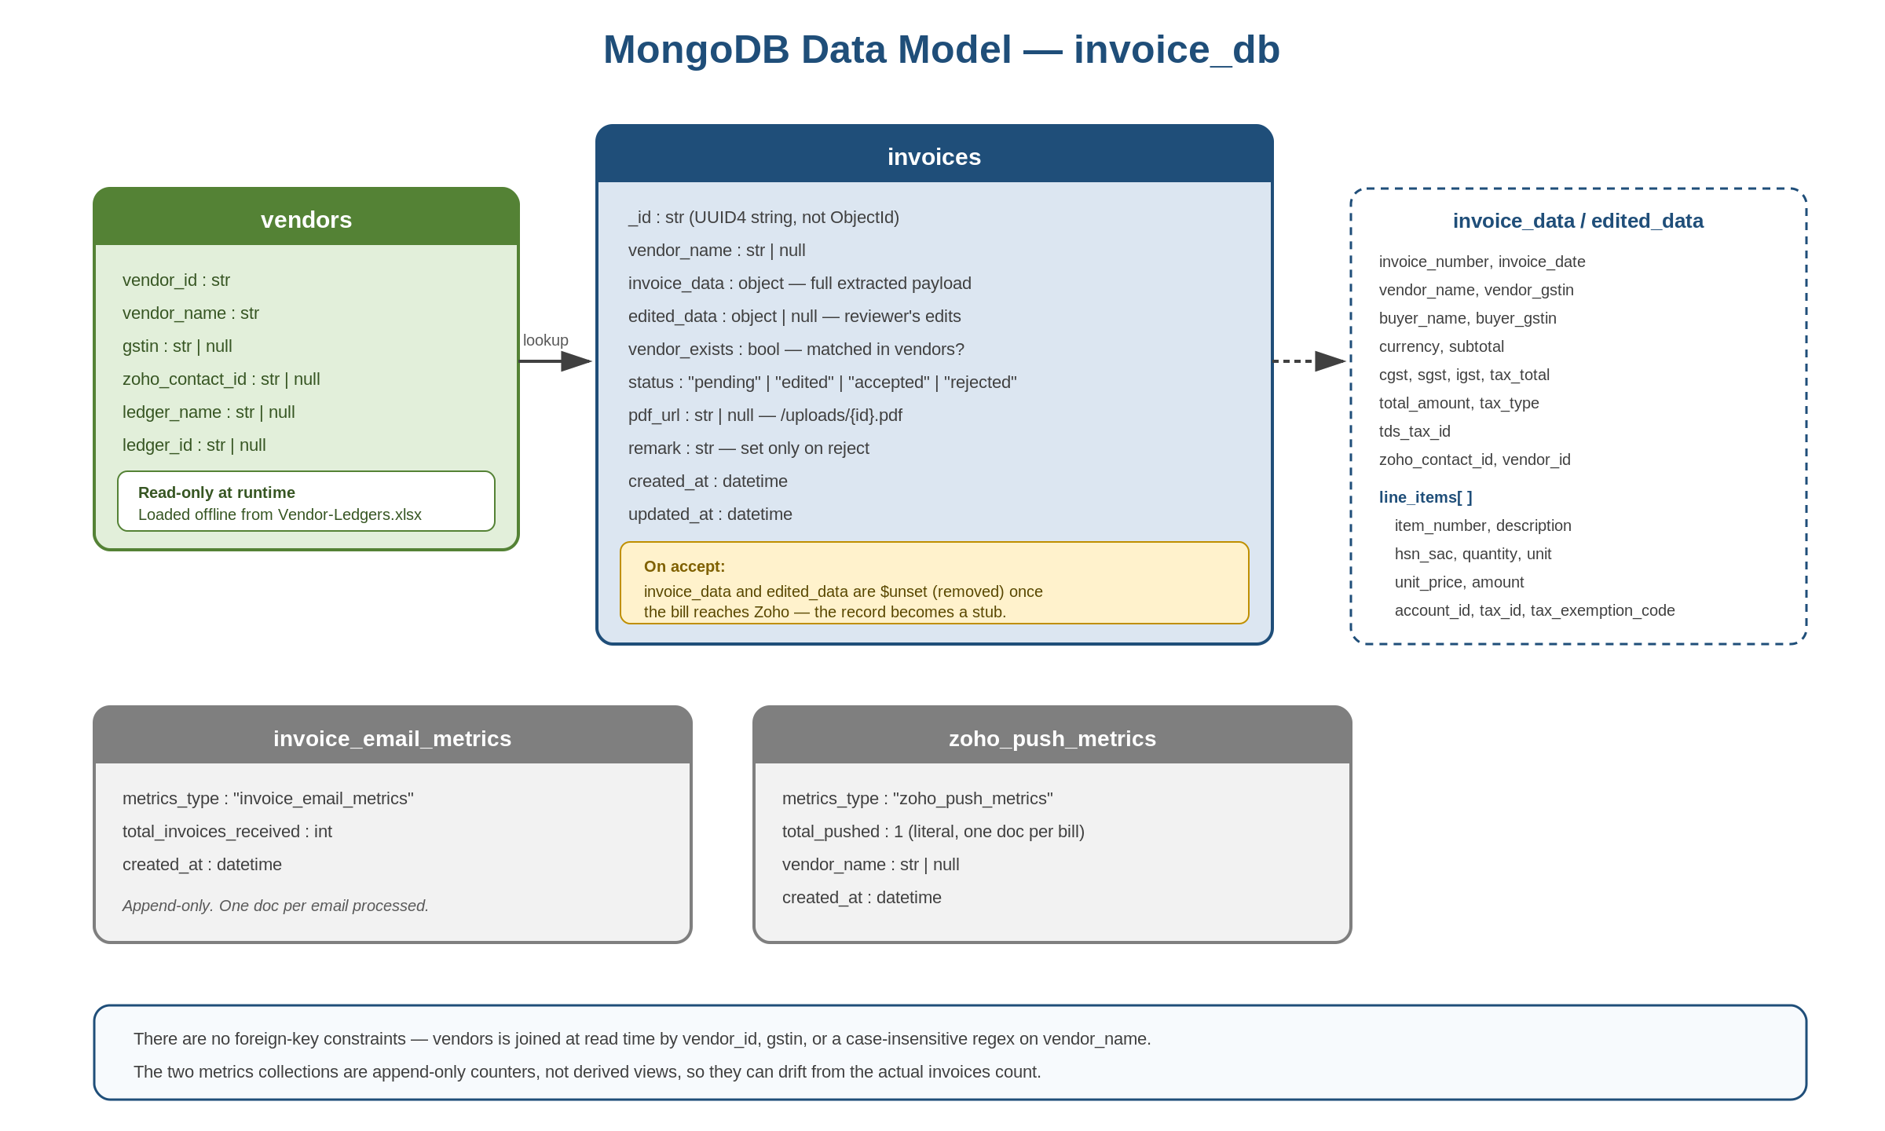
Figure 4: MongoDB Data Model

invoices
Field | Type | Notes
_id | str | UUID4 string, deliberately not an ObjectId
vendor_name | str | null | Copied from the ingested payload
invoice_data | object | The full normalized payload as ingested
edited_data | object | null | Reviewer's corrections; null on insert
vendor_exists | bool | Result of resolve_vendor_zoho_contact()
status | str | pending | edited | accepted | rejected
pdf_url | str | null | /uploads/{invoice_id}.pdf
remark | str | Added only on reject; mandatory and stripped
created_at / updated_at | datetime | UTC
- Important: on accept, both invoice_data and edited_data are $unset removed from the document. An accepted invoice retains only _id, vendor_name, vendor_exists, status, pdf_url, remark and timestamps. The line-item detail exists only in Zoho Books and in the archived PDF from that point on.

vendors
Fields: vendor_id, vendor_name, ledger_name, ledger_id, zoho_contact_id, gstin. Read-only at runtime never written by the running application. It is populated offline by test_zoho.py, which performs delete_many({}) then insert_many(...) from Vendor-Ledgers.xlsx joined against Zoho contacts and chart of accounts.resolve_vendor_zoho_contact() looks up by vendor_id, gstin, or a case-insensitive regex on vendor_name, and injects zoho_contact_id, vendor_id, and a per-line account_id (from ledger_id) into the invoice data.

invoice_email_metrics / zoho_push_metrics
Collection | Shape | Semantics
invoice_email_metrics | {metrics_type: 'invoice_email_metrics', total_invoices_received: int, created_at} | Append-only, one doc per email processed. Written before extraction, so it counts attachments seen, not invoices stored.
zoho_push_metrics | {metrics_type: 'zoho_push_metrics', total_pushed: 1, vendor_name, created_at} | Append-only, one doc per bill successfully created in Zoho. total_pushed is always the literal 1.

7. Status Workflow (backend behaviour)
Action | Effect
edit | status → 'edited'; edited_data set to the posted data; updated_at refreshed. Idempotent — can be repeated.
accept | Builds an IncomingBillPayload from edited_data or invoice_data, calls create_bill(), reads the bill back, optionally comments the Drive link, inserts zoho_push_metrics, sets status → 'accepted', and $unsets invoice_data + edited_data.
reject | status → 'rejected'; remark stored (400 if empty).
- The accept response includes a transient verification_status of 'verified' or 'mismatch' 'mismatch' when the re-fetched bill's bill_number differs from the submitted invoice_number. This value is reported but not persisted.
- Terminality is enforced only in the UI. The backend does not block re-acting on an accepted or rejected invoice though a second accept would fail because invoice_data was unset.

8. Zoho Books Integration

8.1 Request layer
- Base URL: {api_domain}/books/v3. Every call injects organization_id as a query param and Authorization: Zoho-oauthtoken {access_token} as a header.
- Retry policy: max_retries = 1. On HTTP 401 it calls token_service.refresh_access_token() and retries once, else raises. Status >= 400 raises 'HTTP {code}: {message}'.
- A 200 response carrying data['code'] != 0 is also treated as an error ('Zoho API Error: {message} (Code: {code})') — Zoho signals business errors in-band.

8.2 create_bill() logic
- Vendor resolution precedence: zoho_contact_id wins; else vendor_gstin → get_vendor_by_gstin() → contact_id. Raises if neither yields an id.
- get_contact(vendor_id) reads gst_treatment; is_unregistered = gst_treatment in ['business_unregistered', 'business_none'].
- Per line item — rate = unit_price, falling back to amount / quantity when quantity > 0, else 0.0.
- Account vs item: if account_id is present it is used; otherwise item_id, otherwise settings.default_item_id (DEFAULT_ITEM_ID). DEFAULT_ITEM_ID is the last-resort Zoho item when no ledger or explicit item is mapped.
- HSN: hsn_or_sac is digits-only sanitized and truncated to the first 8 characters; omitted entirely if no digits remain.
- Tax priority chain: tax_id → tax_exemption_code → if the vendor is NOT unregistered, force tax_exemption_code = 'NON-GST'. If unregistered and no tax info, nothing is set.
- TDS: a bill-level tds_tax_id is copied down onto every line item.
- The final POST /bills body contains only vendor_id, date, bill_number, line_items. Invoice-level subtotal, cgst, sgst, igst, tax_total, total_amount, currency, and buyer_* are NOT sent Zoho recomputes totals from line items and tax IDs.
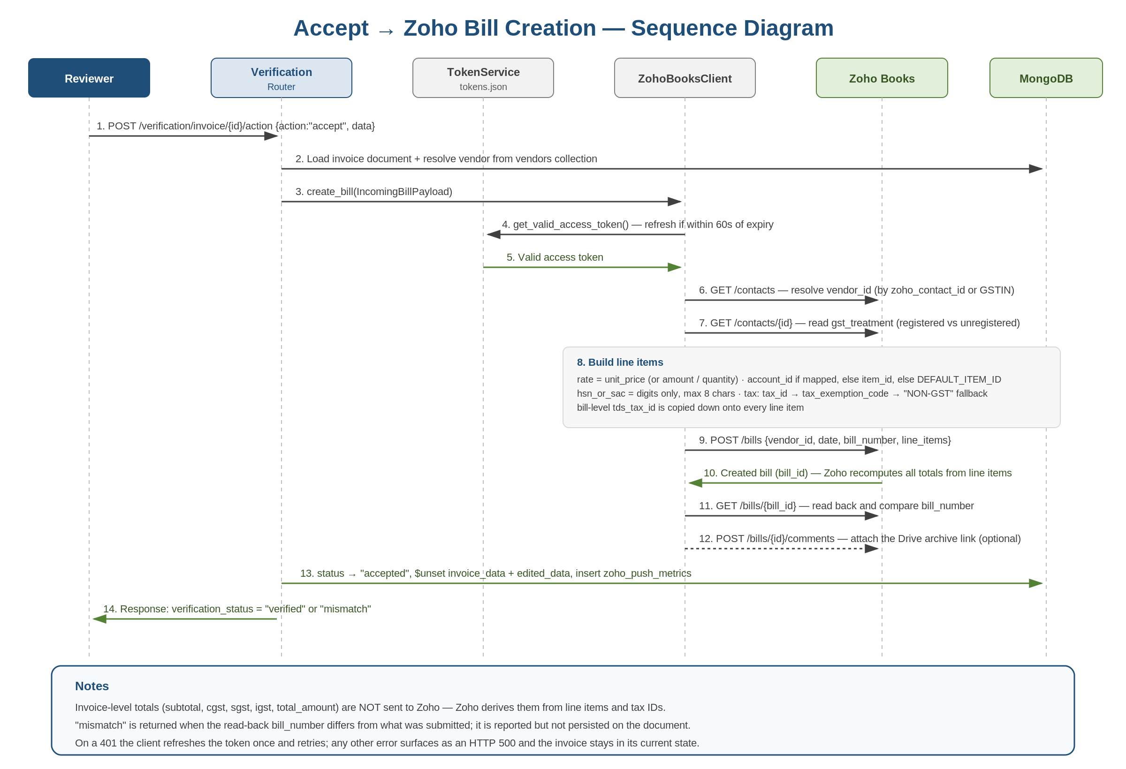
Figure 5: Accept → Zoho Bill Creation Sequence Diagram

8.3 OAuth token lifecycle
- token_service.py persists access_token, refresh_token, expires_at to tokens.json. A module-level singleton is instantiated at import.
- is_token_expired() → time.time() > (expires_at - 60), i.e. a 60-second safety buffer.
- get_valid_access_token() raises if tokens were never initialized ('Please run auth_setup.py first') and refreshes proactively on expiry.
- auth_setup.py performs the one-time authorization-code exchange, requesting scope ZohoBooks.fullaccess.all with access_type=offline and prompt=consent.
- refresh_access_token() replaces the refresh token only if the response contains one, then re-saves the file.

9. Frontend
Route | Component | Behaviour
/ | Dashboard.jsx | GET /verification/invoices/all; status tabs (all/pending/edited/accepted/rejected) with counts; client-side date filters (today / last7days / lastmonth / custom); DELETE with confirm; PDF link; 'Unregistered Vendor' badge when !vendor_name || vendor_exists === false; rejection remark chip. Sort: pending first (STATUS_ORDER), then created_at desc.
/review/:id | Review.jsx | Promise.all of five GETs: /verification/invoice/{id}, /items, /chartofaccounts, /tds-taxes, /taxes. Seeds editedData from edited_data || invoice_data. POSTs /verification/invoice/{id}/action.
/metrics | Metrics.jsx | GET /verification/metrics with date presets; three summary cards, a status donut, a top-10 vendor bar chart, and a timeline line chart (recharts).
/vendors | VendorMapping.jsx | No API call — imports vendor_mapping_list.csv?raw at build time and parses it in the browser. This list is NOT synced with the Mongo vendors collection.

Client-side tax derivation (Review.jsx)
- If igst > 0, searches /taxes for tax_name 'IGST18' or 'IGST 18%' and sets tax_type = 'IGST (18%)'.
- Else if cgst > 0 || sgst > 0, searches for 'GST18' or 'GST 18%' and sets tax_type = 'GST (18%)'.
- Strips item_id from every line item and injects account_id and tax_id defaults. Before submit, back-fills hsn_sac from the matching Zoho item for any line still carrying an item_id.
- Note: this hardcodes 18% as the assumed rate. Invoices at 5%, 12%, or 28% require the reviewer to change the tax selection manually.

JsonEditor.jsx
- Generic recursive editor (ObjectEditor / ArrayEditor / PrimitiveEditor). Key-name-driven widgets: account_id → chart-of-accounts select, tds_tax_id → TDS select, tax_id → standard-tax select.
- Arrays of objects render as an editable table with a bulk 'apply ledger to all rows' account_id setter.
- Hides empty igst/cgst/sgst keys, and suppresses igst when cgst/sgst are present (and vice versa).

10. Configuration

Backend (.env, pydantic-settings, extra='ignore')
Variable | Purpose | Default
CLIENT_ID / CLIENT_SECRET / REDIRECT_URI | Zoho OAuth application credentials | empty
ZOHO_DOMAIN | OAuth host | https://accounts.zoho.com
API_DOMAIN | Zoho Books API host | https://www.zohoapis.in (overridden to .com in .env)
ORGANIZATION_ID | Zoho Books organization | empty
DEFAULT_ITEM_ID | Fallback Zoho item for unmapped lines | empty
MONGO_URI | MongoDB Atlas connection string | mongodb://localhost:27017
GDRIVE_LINK | Drive folder URL appended as a bill comment | empty
UPLOAD_DIR | Where invoice PDFs are written | /app/uploads
TDS_ITEM_ID | Declared but never referenced anywhere in the codebase | empty

Ingestion service
Variable | Purpose | Default
POLL_INTERVAL_SECONDS | Gmail poll cadence | 60
BACKEND_URL | Backend base URL | http://192.168.200.11:8000
UNSTRACT_URL / UNSTRACT_API_KEY | Extraction endpoint and bearer token | required, no default
GOOGLE_DRIVE_FOLDER_ID | PDF archive folder | required, no default
GMAIL_LABEL_ID | Label applied to processed messages | required, no default
credentials.json / token.json | Google OAuth client secrets and persisted user credentials (files, not env vars) | must be mounted at runtime

Frontend (Vite, build-time)
- VITE_BACKEND_URL backend base URL. VITE_USERNAME / VITE_PASSWORD login gate credentials.
- All VITE_-prefixed variables are inlined into the production bundle at build time and are publicly readable.

11. Security Considerations
The system currently has no meaningful access control. This is acceptable only if the backend is not reachable from the public internet; it should be addressed before or alongside any public exposure.
Issue | Detail | Suggested action
No backend authentication | Every /verification/* route and every Zoho passthrough route is unauthenticated. Anyone who can reach the host can read, delete, or accept invoices and POST /bills writes directly to Zoho Books, bypassing review entirely. | Add an auth layer (API key, JWT, or reverse-proxy auth) before any public exposure.
Cosmetic frontend login | Login.jsx compares typed input to VITE_USERNAME / VITE_PASSWORD, which Vite inlines into the public bundle. Success only sets localStorage.authenticated = 'true', so setting that key in devtools bypasses login. Current values are admin / admin. | Replace with real server-side authentication; never rely on VITE_ vars for secrets.
CORS fully open | allow_origins=['*'] with all methods and headers, credentials allowed. | Restrict to the Vercel origin once auth exists.
Secrets committed to disk | The backend .env holds the Zoho client secret, the Unstract API key, and a MongoDB Atlas URI with inline credentials, despite .env being listed in .gitignore. | Rotate the exposed credentials; move to a secrets manager or injected environment variables.
Live token in tracked file | The Unstract bearer token is hardcoded in the n8n workflow JSON, which IS tracked in git in the ingestion repository. | Rotate the token and remove it from the tracked file and from git history.
Local-disk state | tokens.json (Zoho refresh token) and /app/uploads (invoice PDFs) live on container-local disk. | Ensure both are on persisted volumes; treat tokens.json as a secret at rest.
Hard delete | DELETE /verification/invoice/{id} permanently removes the document with no soft-delete or audit trail. | Consider soft delete if invoice records need to be auditable.

12. Known Limitations and Improvement Areas
- No audit trail. Unlike a status-history model, the system records only the current status and a rejection remark there is no record of who acted, when, or what changed.
- Data loss on accept. Unsetting invoice_data and edited_data means an accepted invoice cannot be inspected or re-pushed from within the system; the only remaining copies are the Zoho bill and the archived PDF.
- No duplicate detection. The same invoice emailed twice creates two independent records; only the reviewer catches it.
- Metrics can drift. Both metrics collections are append-only counters written at different points in the pipeline, not views derived from invoices, so they can diverge from the actual invoice count.
- Email marked read on failure. Because modify() runs outside the attachment loop and errors are swallowed, a failed extraction silently loses the invoice it will never be retried.
- Hardcoded 18% tax assumption in the UI's tax derivation; other GST slabs require manual selection.
- Vendor mapping is split-brain. The UI's /vendors page reads a build-time CSV while the backend resolves against the Mongo vendors collection loaded from a spreadsheet the two can disagree, and neither is editable through the application.
- Ingestion payload is unvalidated. POST /verification/invoice accepts an untyped Dict, so malformed extractions are stored as-is and only surface at accept time.
- No pagination. GET /verification/invoices/all is capped at 1000 documents; the dashboard will silently stop showing older invoices past that point.
- Stale documentation. The backend CLAUDE.md still references a review-ui/ directory (removed) and a GET /verification/invoices/pending endpoint that does not exist.
- No automated tests or CI in any of the three repositories.

13. Operational Runbook
Task | How
Check ingestion is alive | GET :8002/health → {"status": "ok"}. Also confirm invoice volume is still arriving on the metrics screen.
Check Zoho auth is healthy | GET :8001/health → tokens_initialized must be true. If false, re-run auth_setup.py to re-consent.
Zoho token fully expired | Refresh tokens do not expire under normal use, but if revoked, re-run auth_setup.py on the server and restart the backend.
Add a new vendor mapping | Update Vendor-Ledgers.xlsx and re-run test_zoho.py. Note this does delete_many({}) then insert_many(...) it rebuilds the whole collection.
Invoice stuck / not appearing | Confirm the source email is a PDF attachment and was unread. If it was marked read but never appeared, extraction failed silently re-mark unread to retry.
Reprocess a failed invoice | Mark the original Gmail message unread and remove the processed label; the next poll will pick it up again.

