1.Introduction

1.1 project overview

ChatConnect - A Real-Time Chat and Communication App

Project Description:

**ChatConnect** is a demonstration project showcasing the capabilities of **Android Jetpack Compose** for creating modern, real-time messaging applications. It offers a seamless chat experience with features like instant message delivery, typing indicators, read receipts, group chats, and multimedia sharing, all powered by **Firebase Realtime Database.** The app includes push notifications for new messages and a sleek, customizable UI built with Compose, ensuring responsiveness across devices. This project highlights the use of Compose libraries and real-time technologies to craft intuitive, scalable, and user-friendly Android applications.

Architecture:

Android Room DB

Get DAO

Get DA Get entities from DB

Data Access Object(DAO)

Get entities fields value

Entities

LEARNING OUTCOMES:

- Gain proficiency in Android Studio for building mobile applications.

- Learn to implement and manage database integrations effectively.

Project Workflow:

* Users create an account to register within the app.
* After registration, users log in to access the chat application.
* Upon login, users land on the main chat screen.
* Users can browse their contacts, select desired chats, and start messaging.
* Users can participate in one-on-one or group chats, share multimedia, and view typing indicators and message read receipts.
* Admin access allows monitoring and managing active chats and user activities.

Tasks:

1. Preliminary Setup

Install Android Studio and ensure your development environment is configured with the latest tools and SDKs.

2. Project Initialization

Create a new Android project in Android Studio, selecting Jetpack Compose as the UI toolkit.

3. Adding Necessary Libraries

Add dependencies such as **Firebase Authentication**, **Firebase Realtime Database** (or WebSocket libraries), **Glide/Coil** for media, and other required libraries in the build.gradle file.

4. Designing Database Architecture

Define the database schema for user accounts, chat messages, group conversations, and multimedia storage. Implement Firebase Realtime Database or Firestore as the backend.

5. Developing User Interface and Database Integration

Use Jetpack Compose to create a dynamic and user-friendly interface for registration, login, chat screens, and multimedia sharing. Integrate Firebase APIs or WebSocket handlers for real-time messaging.

6. Configuring AndroidManifest.xml

Declare essential app components such as activities and services. Add permissions for internet access, notifications, and media usage.

7. Running and Testing the Application

Test the app on an emulator or physical device to verify features like user registration, real-time chat, multimedia sharing, and push notifications. Debug and optimize as needed.

1.2 Purpose of the Project:

The ChatConnect app aims to facilitate seamless and efficient communication by providing users with a modern, user-friendly platform for real-time messaging. It enables users to connect instantly through one-on-one or group chats, share multimedia, and stay updated with typing indicators, message read receipts, and push notifications.

ChatConnect is designed for individuals, teams, and organizations, making it an ideal solution for personal conversations, professional collaboration, or community engagement. With features like group chat management, customizable themes, and secure communication, ChatConnect enhances interaction while ensuring user convenience. The app’s robust real-time capabilities create a dynamic and reliable communication experience for all users.

2.Problem Definition and Design Thinking:

2.1.Empathy:

* Understand the pain points of current messaging apps through user research and feedback.
* Identify the importance of real-time responsiveness, intuitive UI, and customizable features.

2.2.Ideation:

* Brainstorm solutions like typing indicators, read receipts, multimedia sharing, group management, and push notifications to enhance communication.
* Focus on creating a sleek, responsive interface using **Jetpack Compose** for a modern look and feel.

2.3. Prototype:

* Design wireframes and mockups for user registration, login, chat screens, and multimedia sharing workflows.
* Build an initial version integrated with Firebase or WebSocket backends for real-time communication.

Test:

* Conduct usability testing with diverse user groups to gather feedback on features, responsiveness, and UI/UX.
* Iterate on the design based on user feedback, focusing on improving performance and experience.

3.Result

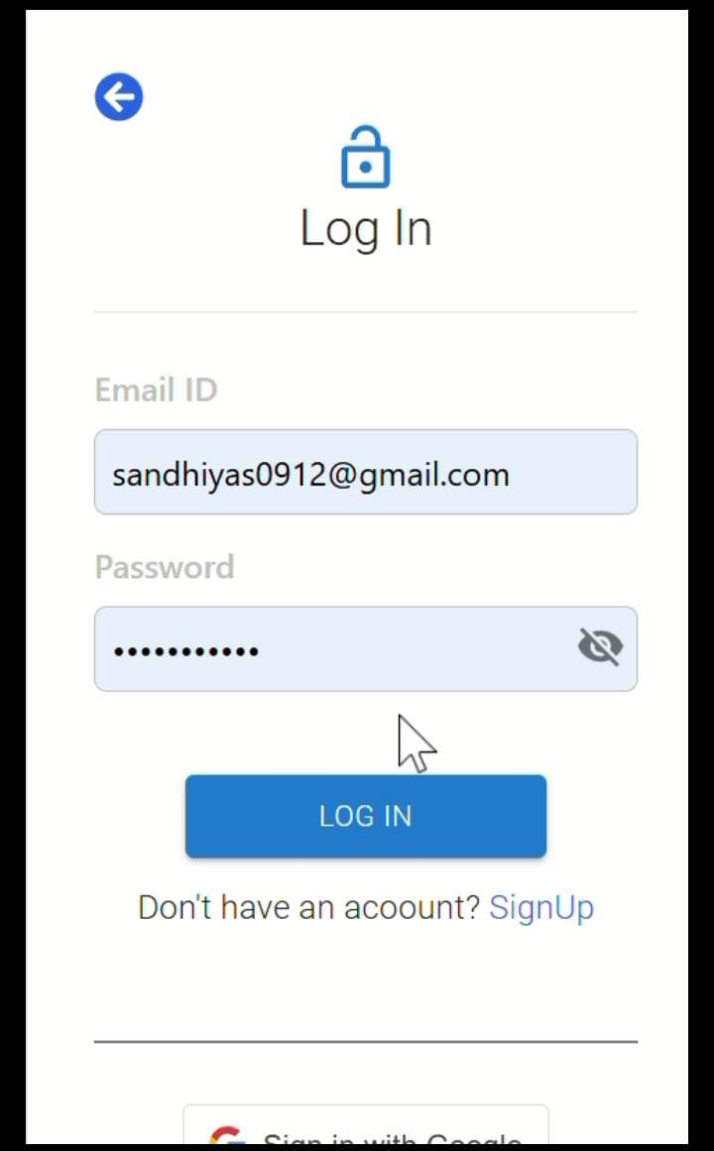

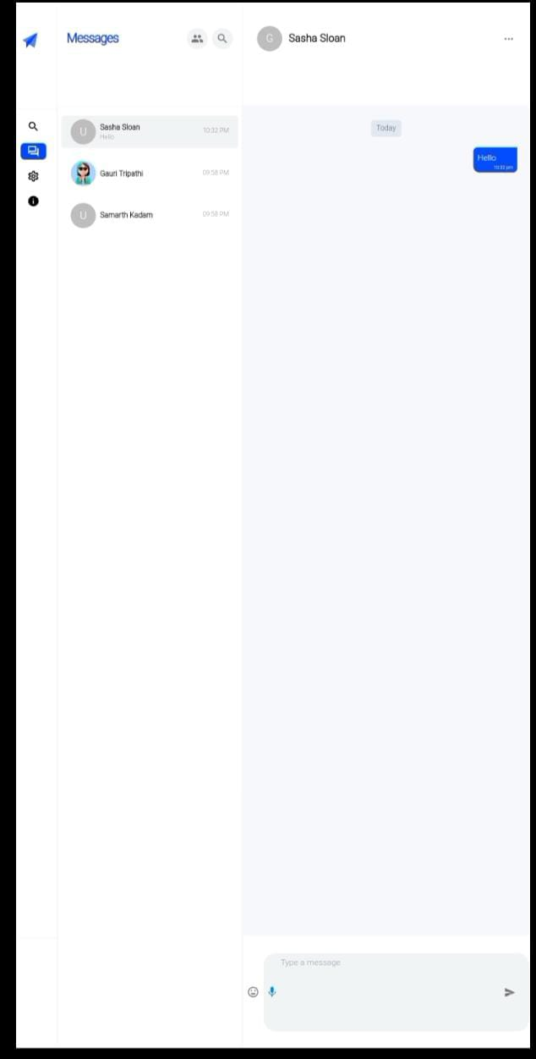

Advantages:

1. Enhanced Communication Experience: ChatConnect provides a seamless, intuitive interface with features like typing indicators, read receipts, and real-time messaging, ensuring users have a smooth and enjoyable interaction.

2. Broader Accessibility: The app caters to a diverse audience, including individuals and groups, enabling both personal and professional communication across various locations and demographics.

3. Increased Engagement and Retention: Features like customizable themes, group chats, and multimedia sharing encourage users to stay active, while push notifications keep them engaged with timely updates.

4. Real-Time Interaction: Instant messaging capabilities with real-time updates and synchronization provide users with a responsive and dynamic communication experience.

5. Operational Scalability: For developers or organizations, the app ensures scalable backend architecture to support a growing user base while maintaining performance and reliability.

6. User Personalization:

Customizable profiles, themes, and settings create a tailored experience, increasing satisfaction and loyalty among users.

7. Secure Communication:

Robust authentication mechanisms and encrypted communication ensure user privacy and data security.

Disadvantages:

1.High Development and Maintenance Costs: Building and maintaining ChatConnect with advanced features like real-time messaging, multimedia sharing, and push notifications can be costly. Regular updates, bug fixes, and backend infrastructure scaling also add to the expenses.

2.Dependence on Technology: Users require modern smartphones and stable internet connectivity to access the app, which may exclude those with limited access to technology or technical expertise.

3. Data Privacy Concerns: ChatConnect handles sensitive information, such as user messages, profile data, and multimedia files. This raises the need for robust encryption and security protocols, which can be complex and costly to implement.

4. Scalability Challenges: As the user base grows, ensuring real-time performance, minimal latency, and smooth operation becomes increasingly challenging, requiring significant backend resources.

5. Potential Overload of Notifications: Excessive notifications for new messages, group activity, or typing indicators may overwhelm users and lead to app fatigue if not managed well.

Applications:

1. **Team Collaboration Platforms:** ChatConnect can be integrated into team collaboration tools for real-time communication, enabling team members to coordinate, share updates, and discuss projects efficiently.

2. Educational Institutions: Schools and universities can use the app to facilitate communication between students, teachers, and staff, enabling discussions, announcements, and sharing of learning materials.

3. Customer Support Systems: Businesses can leverage ChatConnect as a customer service tool, providing instant messaging support where users can ask questions, get assistance, or provide feedback.

4. Event Management: Event organizers can use the app to create group chats for event teams, send real-time updates to attendees, and manage communication for sessions, schedules, and logistics..

5. Social Networking: ChatConnect can be used as a platform for social interaction, allowing users to create group chats, share multimedia content, and stay connected with friends or communities in a secure and engaging environment.

Conclusion:

In conclusion, **ChatConnect** offers a modern, real-time messaging platform designed to enhance communication with features like instant messaging, multimedia sharing, and customizable user experiences. It provides seamless, secure, and scalable communication for both personal and professional use, improving user engagement and team collaboration. By incorporating push notifications, group chat management, and real-time syncing, ChatConnect addresses the need for efficient and reliable communication across various sectors. Ultimately, it offers a dynamic solution that simplifies communication, supports user interaction, and helps businesses improve engagement and productivity.

Future Scope:

The future of **ChatConnect** is bright, driven by ongoing technological advancements and evolving user expectations for more efficient and personalized communication tools. Key areas for growth and innovation include:

1. **AI-Powered Personalization:** Leveraging AI and machine learning can enhance user experiences by offering personalized chat suggestions, smart replies, and content recommendations based on user behavior, preferences, and interactions.
2. **Voice-Activated Communication:** As voice assistants become more common, integrating voice-activated features into ChatConnect can allow users to send messages, make calls, and manage chats hands-free, providing added convenience.
3. **Integration with Other Platforms:** Future versions of ChatConnect could integrate with third-party platforms like CRM tools, social media networks, and productivity apps to enhance functionality and streamline communication for both personal and business purposes.
4. **Enhanced Security Features:** As data privacy concerns grow, the app could implement end-to-end encryption, two-factor authentication, and additional security layers to ensure user data is protected, building trust and credibility.
5. **Cross-Platform Support:** Expanding to support multiple platforms, including desktop, web, and smart devices, would enable users to stay connected seamlessly across different environments, enhancing accessibility and user engagement.
6. **Global Expansion:** ChatConnect could expand into international markets, adding multilingual support and adapting to various cultural communication preferences, making it more relevant to a diverse global audience.

8.Appendix

1.source code MainPage.kt

package com.example.chatconnect

import android.os.Bundle

import androidx.activity.ComponentActivity

import androidx.activity.compose.setContent

import androidx.compose.foundation.layout.*

import androidx.compose.foundation.text.BasicTextField

import androidx.compose.foundation.verticalScroll

import androidx.compose.foundation.lazy.LazyColumn

import androidx.compose.foundation.lazy.items

import androidx.compose.material.*

import androidx.compose.runtime.*

import androidx.compose.ui.Modifier

import androidx.compose.ui.graphics.Color

import androidx.compose.ui.text.font.FontWeight

import androidx.compose.ui.unit.dp

import com.example.chatconnect.ui.theme.ChatConnectTheme

class MainPage : ComponentActivity() {

override fun onCreate(savedInstanceState: Bundle?) {

super.onCreate(savedInstanceState)

setContent {

ChatConnectTheme {

Surface(modifier = Modifier.fillMaxSize(), color = MaterialTheme.colors.background) {

ChatScreen()

}

}

}

}

}

@Composable

fun ChatScreen() {

var messageText by remember { mutableStateOf("") }

val messages = remember { mutableStateListOf("Hello!", "How are you?", "Welcome to ChatConnect!") }

Column(Modifier.fillMaxSize().padding(16.dp)) {

Text("ChatConnect", fontWeight = FontWeight.Bold, style = MaterialTheme.typography.h4)

Spacer(modifier = Modifier.height(16.dp))

LazyColumn(

modifier = Modifier.weight(1f).fillMaxWidth(),

reverseLayout = true

) {

items(messages.reversed()) { message ->

Text(message, style = MaterialTheme.typography.body1, modifier = Modifier.padding(4.dp))

}

}

Row(Modifier.fillMaxWidth(), horizontalArrangement = Arrangement.SpaceBetween) {

BasicTextField(

value = messageText,

onValueChange = { messageText = it },

modifier = Modifier.weight(1f).padding(8.dp).background(Color.LightGray, shape = MaterialTheme.shapes.small).padding(12.dp),

singleLine = true

)

Button(onClick = {

if (messageText.isNotBlank()) {

messages.add(messageText)

messageText = ""

}

}) {

Text("Send")

}

}

}

}

2.source code LoginActivity.kt

package com.example.chatconnect

import android.content.Intent

import android.os.Bundle

import androidx.activity.ComponentActivity

import androidx.activity.compose.setContent

import androidx.compose.foundation.layout.*

import androidx.compose.material.*

import androidx.compose.runtime.*

import androidx.compose.ui.Alignment

import androidx.compose.ui.Modifier

import androidx.compose.ui.graphics.Color

import androidx.compose.ui.text.font.FontWeight

import androidx.compose.ui.unit.dp

import com.example.chatconnect.ui.theme.ChatConnectTheme

class LoginActivity : ComponentActivity() {

override fun onCreate(savedInstanceState: Bundle?) {

super.onCreate(savedInstanceState)

setContent {

ChatConnectTheme {

Surface(modifier = Modifier.fillMaxSize(), color = MaterialTheme.colors.background) {

LoginScreen { startMainPage() }

}

}

}

}

private fun startMainPage() {

val intent = Intent(this, MainPage::class.java)

startActivity(intent)

finish()

}

}

@Composable

fun LoginScreen(onLoginSuccess: () -> Unit) {

var username by remember { mutableStateOf("") }

var password by remember { mutableStateOf("") }

var error by remember { mutableStateOf("") }

Column(

Modifier.fillMaxSize().padding(16.dp),

horizontalAlignment = Alignment.CenterHorizontally,

verticalArrangement = Arrangement.Center

) {

Text("ChatConnect Login", fontWeight = FontWeight.Bold, style = MaterialTheme.typography.h4)

Spacer(modifier = Modifier.height(16.dp))

TextField(value = username, onValueChange = { username = it }, label = { Text("Username") })

Spacer(modifier = Modifier.height(8.dp))

TextField(value = password, onValueChange = { password = it }, label = { Text("Password") }, singleLine = true)

if (error.isNotEmpty()) {

Spacer(modifier = Modifier.height(8.dp))

Text(error, color = MaterialTheme.colors.error)

}

Spacer(modifier = Modifier.height(16.dp))

Button(onClick = {

if (username == "user" && password == "password") {

error = ""

onLoginSuccess()

} else {

error = "Invalid username or password"

}

}) {

Text("Login")

}

}

}

3.source code MainActivity.kt

package com.example.chatconnect

import android.content.Intent

import android.os.Bundle

import androidx.activity.ComponentActivity

import androidx.activity.compose.setContent

import com.example.chatconnect.ui.theme.ChatConnectTheme

class MainActivity : ComponentActivity() {

override fun onCreate(savedInstanceState: Bundle?) {

super.onCreate(savedInstanceState)

val intent = Intent(this, LoginActivity::class.java)

startActivity(intent)

finish()

}

}

4.Themes and Setup:

<resources xmlns:tools="http://schemas.android.com/tools">

<style name="Theme.ChatConnect" parent="Theme.MaterialComponents.DayNight.DarkActionBar">

<item name="colorPrimary">@color/purple_500</item>

<item name="colorPrimaryVariant">@color/purple_700</item>

<item name="colorSecondary">@color/teal_200</item>

<item name="android:statusBarColor" tools:targetApi="l">?attr/colorPrimaryVariant</item>

</style>

</resources>