**PROGRAM:**

import pandas as pd

import matplotlib.pyplot as plt

import seaborn as sns

from statsmodels.tsa.seasonal import seasonal_decompose

from statsmodels.datasets import get_rdataset

dataset = get_rdataset('AirPassengers', package='datasets').data

dataset.rename(columns={'value': 'Passengers'}, inplace=True)

dataset['Month'] = pd.date_range(start='1949-01-01', periods=len(dataset), freq='MS')

dataset.set_index('Month', inplace=True)

dataset = dataset[['Passengers']]

print(dataset.head())

plt.figure(figsize=(10, 5))

plt.plot(dataset, label='Air Passengers', color='purple')

plt.title('Monthly Air Passengers')

plt.xlabel('Date')

plt.ylabel('Number of Passengers')

plt.legend()

plt.grid(True)

plt.show()

dataset['MA_6'] = dataset['Passengers'].rolling(window=6).mean()

dataset['MA_12'] = dataset['Passengers'].rolling(window=12).mean()

plt.figure(figsize=(10, 5))

plt.plot(dataset['Passengers'], label='Original', alpha=0.5)

plt.plot(dataset['MA_6'], label='6-month MA', color='green')

plt.plot(dataset['MA_12'], label='12-month MA', color='red')

plt.title('Moving Averages')

plt.xlabel('Date')

plt.ylabel('Passengers')

plt.legend()

plt.grid(True)

plt.show()

decompose_result = seasonal_decompose(dataset['Passengers'], model='multiplicative')

decompose_result.plot()

plt.tight_layout()

plt.show()

dataset['Year'] = dataset.index.year

dataset['Month_Num'] = dataset.index.month

heatmap_data = dataset.pivot_table(values='Passengers', index='Month_Num', columns='Year')

plt.figure(figsize=(10, 6))

sns.heatmap(heatmap_data, annot=True, fmt='.0f', cmap='coolwarm')

plt.title('Monthly Passenger Heatmap')

plt.xlabel('Year')

plt.ylabel('Month')

plt.show()

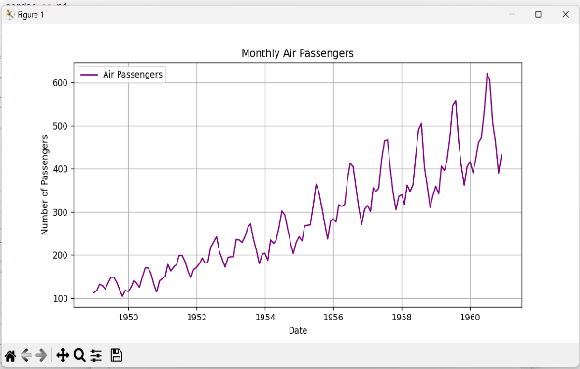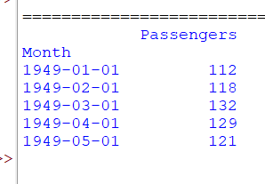**OUTPUT:**

