**PROGRAM:**

import pandas as pd

import seaborn as sns

import matplotlib.pyplot as plt

df = sns.load_dataset('titanic')

print("Dataset shape:", df.shape)

print("Column info:\n", df.info())

print("\nFirst 5 rows:\n", df.head())

print("\nMissing values:\n", df.isnull().sum())

print("\nSummary statistics:\n", df.describe(include='all'))

df = df.drop(columns=['deck', 'embark_town', 'alive'])

df['age'].fillna(df['age'].median(), inplace=True)

df['embarked'].fillna(df['embarked'].mode()[0], inplace=True)

plt.figure(figsize=(6, 4))

sns.countplot(x='survived', data=df, palette='Set2')

plt.title("Survival Count (0 = Died, 1 = Survived)")

plt.show()

plt.figure(figsize=(6, 4))

sns.countplot(x='sex', hue='survived', data=df, palette='Set1')

plt.title("Survival by Gender")

plt.show()

plt.figure(figsize=(6, 4))

sns.countplot(x='pclass', hue='survived', data=df, palette='Set3')

plt.title("Survival by Passenger Class")

plt.show()

plt.figure(figsize=(8, 5))

sns.histplot(data=df, x='age', kde=True, hue='survived', palette='coolwarm')

plt.title("Age Distribution by Survival")

plt.show()

plt.figure(figsize=(10, 6))

sns.heatmap(df.corr(numeric_only=True), annot=True, cmap='Blues')

plt.title("Correlation Matrix")

plt.show()

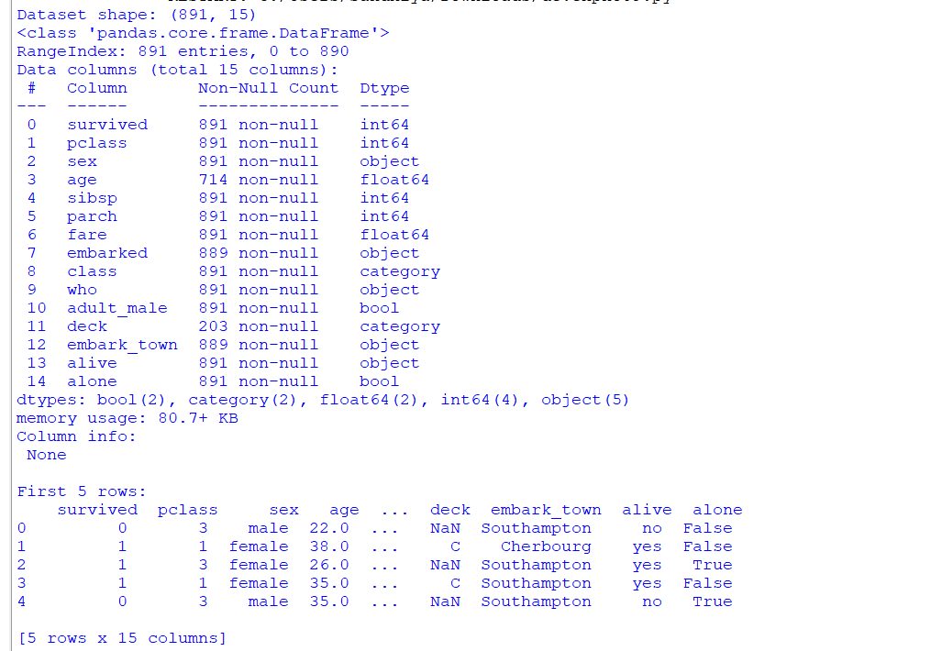**OUTPUT:**



