Internship Project Report

# Project Title: Coca-Cola Stock – Live & Updated

**Name: Sandhiya  
Domain: Data Analyst  
Tools: Python, Pandas, Matplotlib, Seaborn, Scikit-learn, yfinance**

## 1. Abstract

This project analyzes Coca-Cola's historical stock data and builds a machine learning model to predict future stock prices. It includes data preprocessing, exploratory data analysis (EDA), feature engineering, model training, and live prediction using Yahoo Finance data.

## 2. Objective

• Analyze Coca-Cola’s stock performance over time  
• Create useful features such as moving averages and volatility  
• Predict closing prices using Random Forest  
• Perform live predictions using Yahoo Finance API

## 3. Tools & Technologies Used

• Python (Pandas, yfinance, Scikit-learn)  
• Matplotlib, Seaborn  
• Google Colab  
• Machine Learning (Random Forest)

## 4. Dataset Description

Source: Yahoo Finance API  
Columns: Date, Open, High, Low, Close, Volume, Dividends, Stock Splits  
Time Range: 1962 to Present

## 5. Data Preprocessing

• Converted date column to datetime format  
• Extracted Year, Month, Weekday  
• Filled missing values  
• Created Daily Return and Volatility features

## 6. Exploratory Data Analysis (EDA)

• Line plot of closing price  
• Volume trends  
• Weekday-wise price trends  
• Moving average comparisons (20-day & 50-day)

Below are key visualizations used to explore Coca-Cola's historical stock data

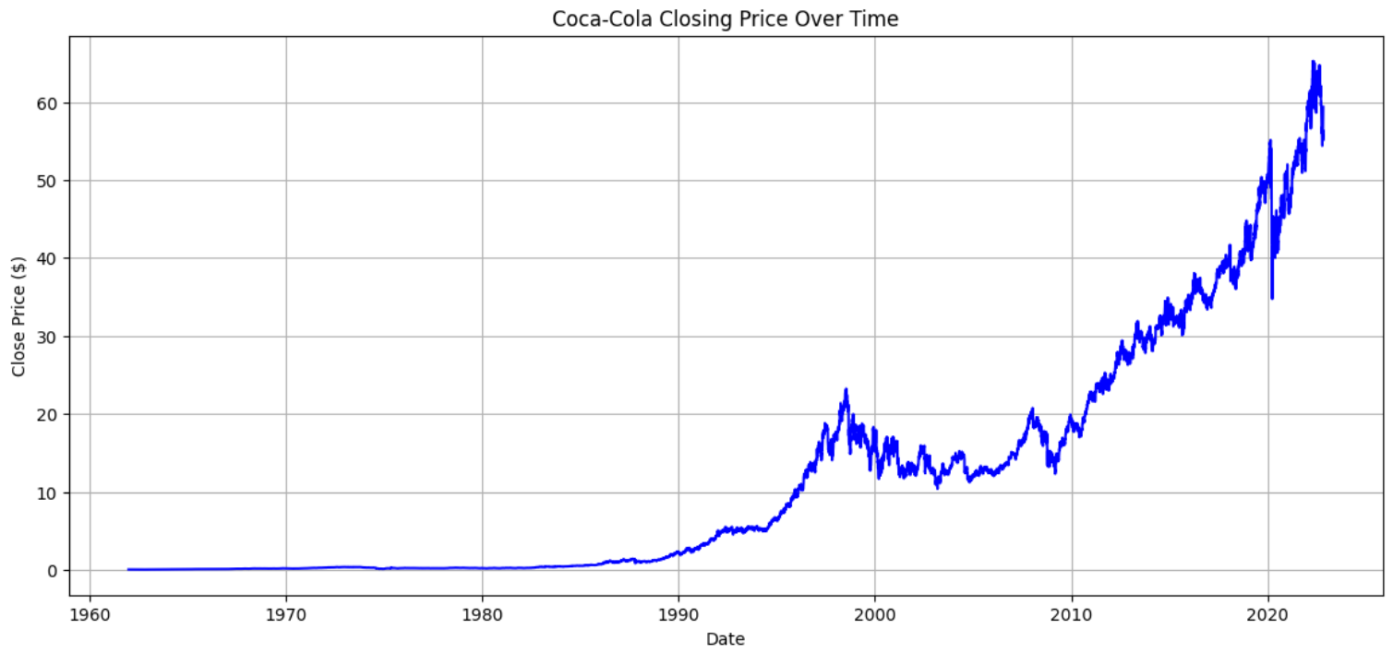

Figure 1: Coca-Cola Closing Price Over Time

how to centre the picture
 Figure 2: Coca-Cola Trading Volume Over Time

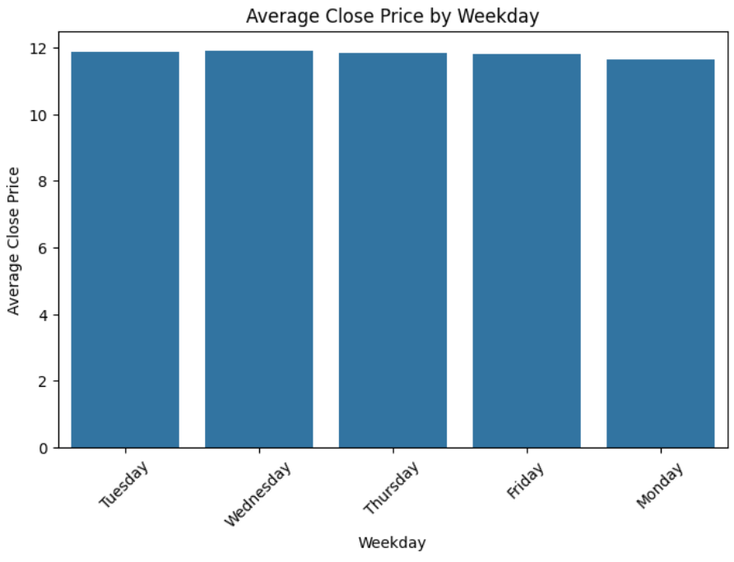

Figure 3: Average Close Price by Weekday

Figure 4: Close Price with Moving Averages (20 & 50 Days)

## 7. ML Model: Random Forest Regressor

• Target: Close  
• Features: Open, High, Low, Volume, MA_20, MA_50, Daily_Return, Volatility  
• MAE: 14.65  
• MSE: 327.38

## 8. Live Prediction

Used Yahoo Finance to fetch 1-minute live stock data and predicted the closing price: $17.89

## 9. Conclusion

The model works as intended. Accuracy can be improved using hyperparameter tuning, advanced models, or sentiment analysis.

## 10. References

• https://finance.yahoo.com/  
• https://github.com/vivekvardhan2810/Coca-Cola-Stock-Analysis