Project Design Phase-II
Data Flow Diagram & User Stories

Date | 29 September 2026
Team ID | SWTID-2026-3192
Project Name | AI WeatherWise
Maximum Marks | 4 Marks

Data Flow Diagrams:
A Level-0 data-flow view of AI WeatherWise shows how requests move from a REST client through Express.js routes and services to MongoDB, OpenWeatherMap, and Google Gemini.
AI WeatherWise Data Flow Diagram (Level 0)
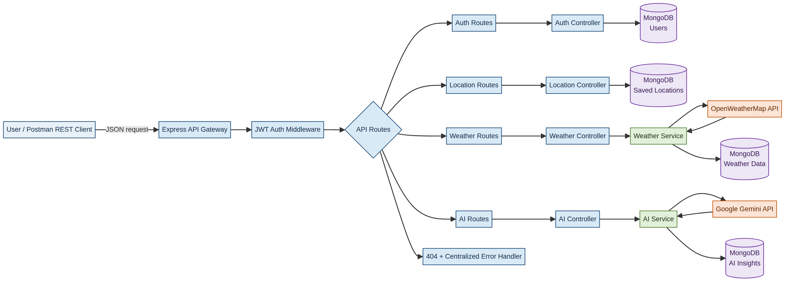
The flow separates authentication, routing, business services, external integrations, and persistent data storage.
User Stories
Use the below template to list all the user stories for the product.
User Type | Functional Requirement (Epic) | User Story Number | User Story / Task | Acceptance criteria | Priority | Release
Customer / API User | Registration | USN-1 | As a user, I can register with my name, email, and password so that I can create an account. | Account is created when required fields are valid. | High | Sprint-1
Customer / API User | Authentication | USN-2 | As a user, I can log in with my email and password and receive a JWT. | A valid JWT is returned and invalid credentials are rejected. | High | Sprint-1
Customer / API User | Weather Lookup | USN-3 | As an authenticated user, I can request the current weather for a city. | The API returns current weather data or a clear error response. | High | Sprint-1
Customer / API User | Saved Locations | USN-4 | As a user, I can save and manage locations for quick weather lookup. | Locations can be created, read, updated, and deleted for the owner. | High | Sprint-1
Customer / API User | Favorite Location | USN-5 | As a user, I can mark a saved location as a favorite. | The favorite status is stored and returned with the location. | Medium | Sprint-2
Customer / API User | AI Weather Insight | USN-6 | As a user, I can request an AI-generated weather summary and recommendation. | Google Gemini returns a practical insight based on the supplied conditions. | High | Sprint-2
API Tester | Error Handling | USN-7 | As an API tester, I receive consistent errors for invalid input and unknown routes. | The response includes a predictable status and error structure. | Medium | Sprint-1
API Tester | Protected Access | USN-8 | As an API tester, I can verify that private routes require a valid Bearer token. | Requests without a valid JWT are denied. | High | Sprint-1

