Project Planning Phase
Project Planning Template (Product Backlog, Sprint Planning, Stories, Story points)

Date | 29 September 2026
Team ID | SWTID-2026-3192
Project Name | AI WeatherWise
Maximum Marks | 5 Marks

Product Backlog, Sprint Schedule, and Estimation (4 Marks)
Use the below template to create product backlog and sprint schedule
Sprint | Functional Requirement (Epic) | User Story Number | User Story / Task | Story Points | Priority | Team Members
Sprint-1 | Project Setup | USN-1 | As a developer, I can set up the Node.js/Express server with a MongoDB (Mongoose) connection so the API can start. | 3 | High | S. Santhiya
Sprint-1 |  | USN-2 | As a developer, I can configure the project structure, environment variables, and a centralized error handler with a 404 handler. | 3 | High | Parameshwari
Sprint-1 | Registration | USN-3 | As a user, I can register with my name, email, and password (stored hashed) and receive a JWT. | 5 | High | Rajalakshmi
Sprint-1 |  | USN-4 | As a user, I get a clear error if I register with an existing email or invalid details. | 2 | Medium | Rajalakshmi
Sprint-1 | Login | USN-5 | As a user, I can log in with my email and password and receive a JWT. | 5 | High | Zeba Fathima
Sprint-1 |  | USN-6 | As a user, my JWT is verified by the auth middleware so only I can access protected routes. | 2 | High | S. Santhiya
Sprint-2 | Weather Lookup | USN-7 | As a developer, I can integrate the OpenWeatherMap API through a weather service. | 5 | High | Parameshwari
Sprint-2 |  | USN-8 | As a user, I can view current weather conditions for any city (GET /api/weather/:city). | 5 | High | S. Santhiya
Sprint-2 |  | USN-9 | As a user, I get a meaningful error when a city is invalid or the weather service fails. | 3 | Medium | Zeba Fathima
Sprint-2 | Saved Locations | USN-10 | As a user, I can save a location with its name and coordinates. | 4 | High | Rajalakshmi
Sprint-2 |  | USN-11 | As a user, I can view, update, and delete my saved locations. | 3 | Medium | Rajalakshmi
Sprint-3 | AI Recommendations | USN-12 | As a developer, I can integrate Google Gemini AI through an AI service. | 5 | High | S. Santhiya
Sprint-3 |  | USN-13 | As a user, I can get an AI-generated weather summary and recommendation (POST /api/ai/weather-recommendation). | 5 | High | Parameshwari
Sprint-3 |  | USN-14 | As a user, my input to the AI route is validated so incomplete requests are rejected. | 2 | Medium | Zeba Fathima
Sprint-3 | Saved Locations | USN-15 | As a user, I can mark a saved location as a favorite for quick lookup. | 3 | Medium | Rajalakshmi
Sprint-3 | Data Storage | USN-16 | As a developer, I can store weather readings and AI insights in MongoDB linked to locations. | 5 | Medium | Parameshwari
Sprint-4 | Testing | USN-17 | As a tester, I can verify every endpoint in Postman with positive and negative cases. | 5 | High | Zeba Fathima
Sprint-4 |  | USN-18 | As a tester, I can run User Acceptance Testing and log any bugs found. | 3 | High | S. Santhiya
Sprint-4 |  | USN-19 | As a developer, I can fix reported bugs and refine error responses. | 4 | Medium | Rajalakshmi
Sprint-4 | Documentation | USN-20 | As a team, we can prepare the technical documentation with architecture and ER diagrams. | 5 | Medium | Parameshwari
Sprint-4 |  | USN-21 | As a team, we can record the project demo and API testing videos. | 3 | Low | Zeba Fathima

Project Tracker, Velocity & Burndown Chart: (4 Marks)
Sprint | Total Story Points | Duration | Sprint Start Date | Sprint End Date (Planned) | Story Points Completed (as on Planned End Date) | Sprint Release Date (Actual)
Sprint-1 | 20 | 6 Days | 24 Aug 2026 | 29 Aug 2026 | 20 | 29 Aug 2026
Sprint-2 | 20 | 6 Days | 31 Aug 2026 | 05 Sep 2026 | 20 | 05 Sep 2026
Sprint-3 | 20 | 6 Days | 07 Sep 2026 | 12 Sep 2026 | 20 | 12 Sep 2026
Sprint-4 | 20 | 6 Days | 14 Sep 2026 | 19 Sep 2026 | 20 | 19 Sep 2026

Velocity:
Our sprint duration is 6 days and the velocity of the team is 20 (points per sprint). Let’s calculate the team’s average velocity (AV) per iteration unit (story points per day)
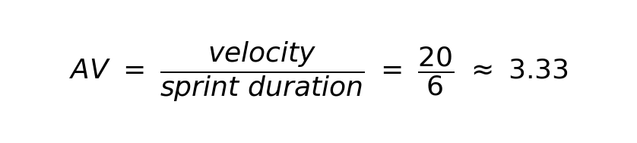

Burndown Chart:
A burn down chart is a graphical representation of work left to do versus time. It is often used in agile software development methodologies such as Scrum. However, burn down charts can be applied to any project containing measurable progress over time.
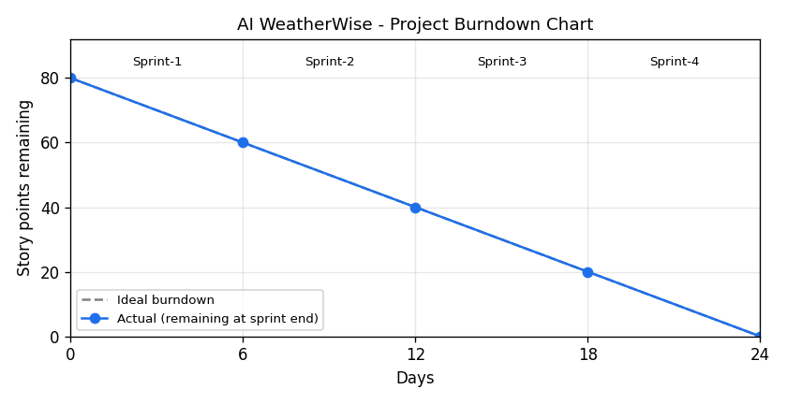
https://www.visual-paradigm.com/scrum/scrum-burndown-chart/
https://www.atlassian.com/agile/tutorials/burndown-charts

Reference:
https://www.atlassian.com/agile/project-management
https://www.atlassian.com/agile/tutorials/how-to-do-scrum-with-jira-software
https://www.atlassian.com/agile/tutorials/epics
https://www.atlassian.com/agile/tutorials/sprints
https://www.atlassian.com/agile/project-management/estimation
https://www.atlassian.com/agile/tutorials/burndown-charts

