Project Design Phase
Solution Architecture

Date | 29 September 2026
Team ID | SWTID-2026-3192
Project Name | AI WeatherWise
Maximum Marks | 4 Marks

Architecture overview
AI WeatherWise is a modular REST API that turns city-level current weather into JSON responses and AI-generated recommendations. The architecture separates request handling, authentication, route orchestration, external services, and data persistence.

Layer | AI WeatherWise implementation
Client / API | A REST client such as Postman, or a consuming client, sends JSON requests and receives JSON responses.
Gateway / security | Node.js and Express handle the API, CORS and JSON parsing; JWT middleware checks tokens on private routes.
Routing / controllers | Auth, location, weather and AI routers dispatch to controllers that validate inputs and coordinate requests.
External services | The Weather Service calls OpenWeatherMap for current conditions; the AI Service calls Google Gemini for summaries and recommendations.
Persistence | Mongoose User and Location models map user accounts and saved locations to MongoDB.

AI WeatherWise architecture diagram and request flow

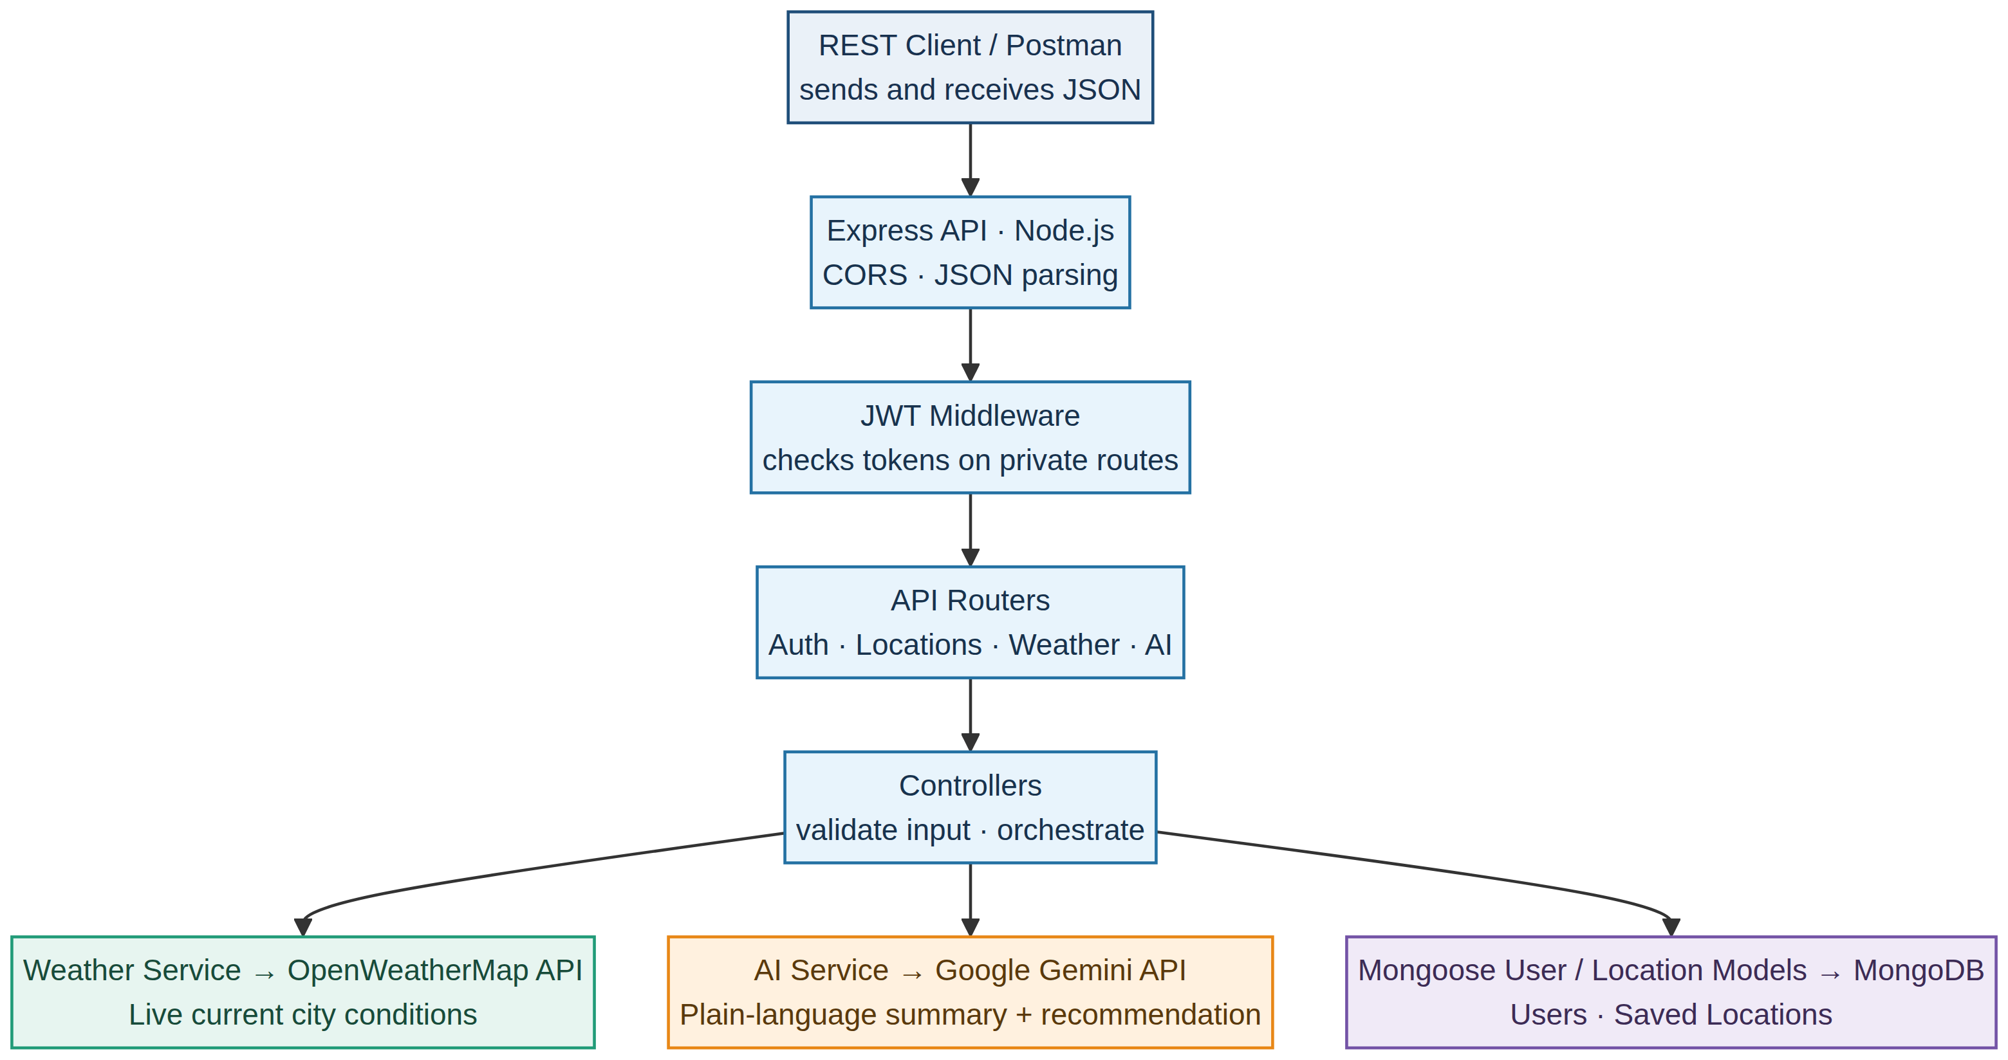
Figure 1. AI WeatherWise logical architecture and request/data flow.
Source: AI WeatherWise Technical Documentation (supplied project reference).
Request flow: The client request passes through Express, JWT middleware, a route and its controller. Depending on the endpoint, the controller calls the weather or AI service and/or MongoDB; the API returns JSON. Registration and login are public, while protected routes require a valid token.

