Project Design Phase-II
Technology Stack (Architecture & Stack)

Date | 29 September 2026
Team ID | SWTID-2026-3192
Project Name | AI WeatherWise
Maximum Marks | 4 Marks

Technical Architecture:
The Deliverable shall include the architectural diagram as below and the information as per the table1 & table 2
The deliverable includes the technical architecture diagram and the information required in Table-1 and Table-2 for the AI WeatherWise REST API.
AI WeatherWise: Intelligent weather forecasts, saved locations, and AI-generated weather insights.
Reference: AI WeatherWise Technical Documentation and project demo: https://drive.google.com/file/d/1gIneGd9Kd12XDrdWPCp2LX3irn2i20_1/view?usp=drive_link
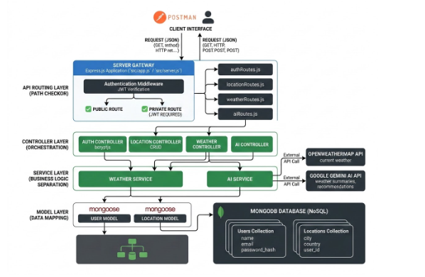

Table-1 : Components & Technologies:
S.No | Component | Description | Technology
1. | User Interface | How the user or tester interacts with the application through REST requests and JSON responses. | Postman or any REST client; JSON over HTTP
2. | Application Logic-1 | User registration, login, JWT issuance, and protected-route authentication. | Node.js v18+; Express.js; JWT middleware
3. | Application Logic-2 | Weather lookup for a requested city and orchestration of live weather data. | Node.js / Express.js; OpenWeatherMap API
4. | Application Logic-3 | Generation of plain-language weather summaries and practical recommendations. | Node.js / Express.js; Google Gemini API
5. | Database | NoSQL collections for users, saved locations, weather data, AI insights, subscriptions, alerts, and usage logs. | MongoDB with Mongoose ODM
6. | Cloud Database | Cloud database service is not specified in the documented local setup; the application uses MongoDB. | MongoDB local deployment; MongoDB Atlas can be used if cloud hosting is configured
7. | File Storage | Source code, configuration, and environment files are stored locally; no end-user file uploads are documented. | Local filesystem; no dedicated file-storage service required
8. | External API-1 | Provides current weather conditions for a requested city. | OpenWeatherMap REST API
9. | External API-2 | Creates AI-powered weather summaries and recommendations from weather conditions. | Google Gemini API
10. | Machine Learning Model | Generative AI model used to interpret weather inputs and produce recommendations. | Google Gemini generative AI model
11. | Infrastructure (Server / Cloud) | Local development and API execution. Local: Node.js server, MongoDB, npm, Postman, and VS Code. Cloud: not specified in the project documentation. | Local server; Node.js v18+; MongoDB; npm; REST client

Table-2: Application Characteristics:
S.No | Characteristics | Description | Technology
1. | Open-Source Frameworks | List of open-source frameworks and libraries used to implement the REST API. | Node.js; Express.js; Mongoose; npm ecosystem
2. | Security Implementations | Authentication and access controls protect private weather and AI routes. | JWT bearer tokens; hashed passwords; CORS; environment variables; centralized error handling; 404 handling
3. | Scalable Architecture | Layered and modular REST design separates routes, controllers, services, and models, allowing modules to evolve independently. | Express routers; controller/service/model layers; MongoDB document model
4. | Availability | The server validates the database connection before serving requests and returns consistent error responses. High-availability deployment is not specified in the documented setup. | Node.js process; MongoDB; centralized error handler; optional cloud deployment
5. | Performance | Lightweight JSON REST endpoints minimize payload size; weather and AI calls are made only for the relevant request. No cache or CDN is documented. | Express.js; JSON; Mongoose; external API integration

References:
OpenWeatherMap API: https://openweathermap.org/api
Google Gemini API: https://ai.google.dev/
Express.js: https://expressjs.com/
MongoDB and Mongoose: https://www.mongodb.com/ and https://mongoosejs.com/
Project Demo: https://drive.google.com/file/d/1gIneGd9Kd12XDrdWPCp2LX3irn2i20_1/view?usp=drive_link

