Divhya Gnanasekar-118A1021

Sandhiya Kanthakumar-118A1031

Usha Konar-118A1035

**EXPERIMENT NO.8**

**AIM:** Develop an Activity Diagram for the project.

**ACTIVITY DIAGRAM:**

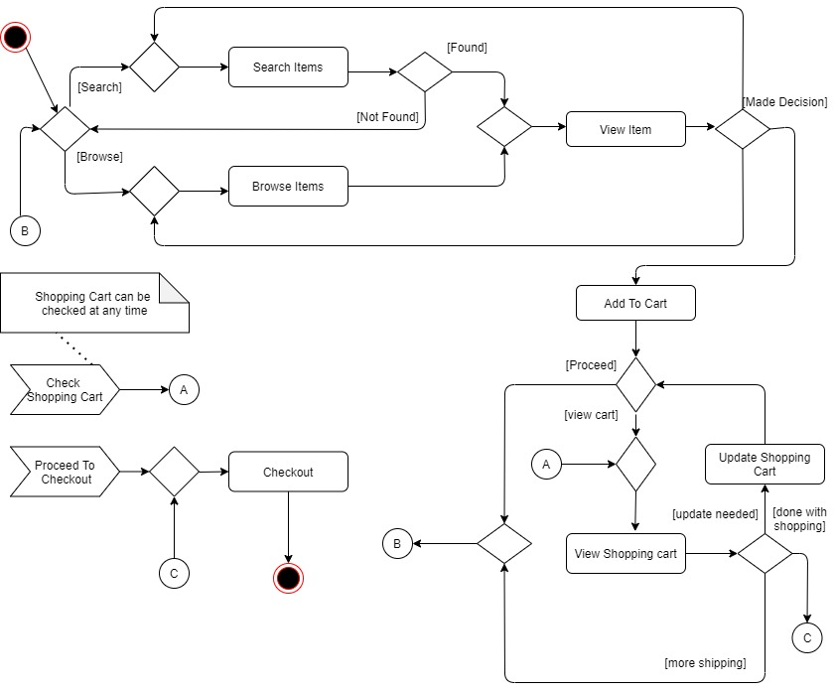

**CONCLUSION:**

Hence, Activity diagram for online jewelry shopping system is successfully created.