 

PROJECT REPORT TEMPLAATE

CRM APPLICATION THAT HELPS TO BOOK A VISA SLOT

1. INTRODUCTION

1.1 OVERVIEW

A Visa slot management project is a system that used to track

and manage the availability of visa slot, which are appoints that are

required for certain visa applications. It might be used by a

government agency or a visa processing centre to schedule and

manage appointment with applications

1.2 PURPOSE

Saving the time of the customers who want to book if by using

CRM application of booking a visa slot. Wandering for booking the

visa slot and tracking can be reduce here. Reduce the paper filling

as much the customers expecting. Ensuring the safety of the

customer and parts of many verification.

2. PROBLEM DEFINITION AND DESIGN THINKING

Reduce the paper costing and fulfill the customer

expectation. Ensuring the safety of the customers and parties of

many verification.

2.1 EMPATHY MAP

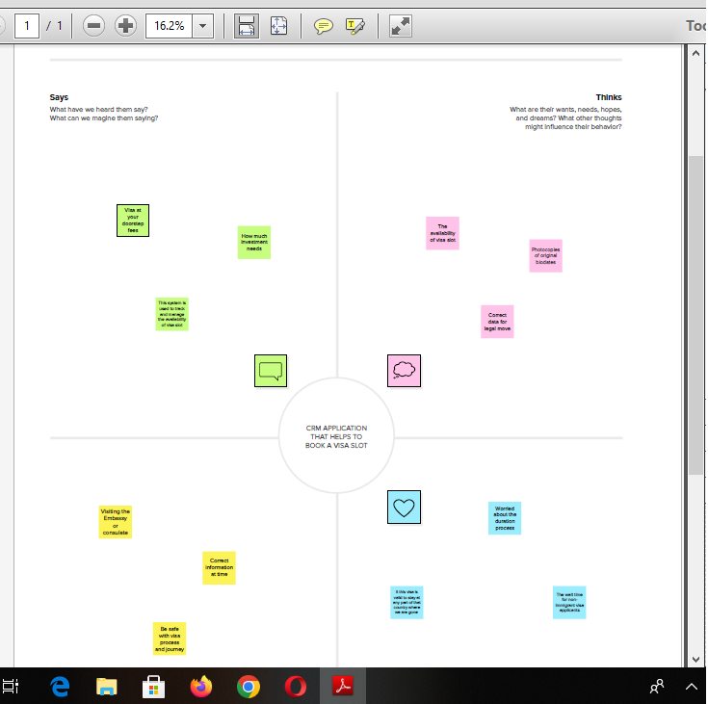

2.2 IDEATION & BRAINSTROMING MAP

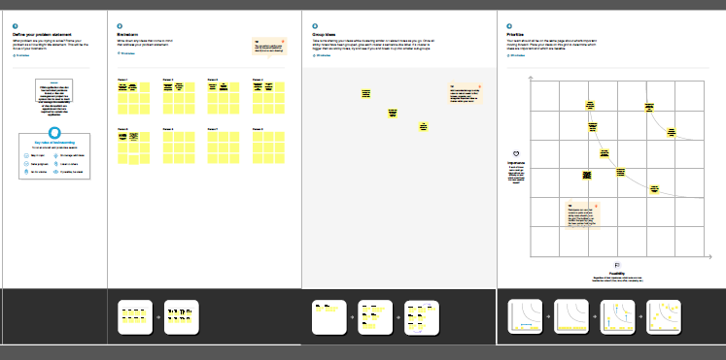

3.RESULT

3.1 Data Model

|  |  |  |  |  |
| --- | --- | --- | --- | --- |
| Objects | Passport | Visa slot | Payment | Reschedule/  Cancel |
| Field and data type | Full name / Number | Location / Text | Payment mode / Text | Passport number(master) / Text |
| Field and data type | Passport number / Number | Time / Number | Card Number / Text | Location / Text |
| Field and data type | Contact Number / Text | Passport number(master) / Text | Transaction ID(Auto Number) / Number | Time / Number |
| Field and data type | Permanent address / Text | Visa slot number / Number | Cancel transaction / Text | Cancel / Text |
| Field and data type |  |  | Visa slot number (master) / Text | Status / Text |

3.2 ACTIVITY AND SCREENSHOTS

1. Creation of sales force platform

Go to developer, salesforce.com and click on sign up.

Enter our details as Name, Email, Company etc. Email is

Send to your mail id.

Go to the inbox of the email that you used while

signing up. Click on the verify account to activate your account**.**

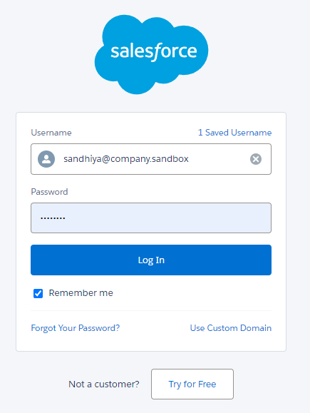

2. Creation of custom object: PASSPORT

Navigate to setup to select the object manager and create the object gives the details like label name has passport and enter the plural name, record name, data type, etc. and save it.

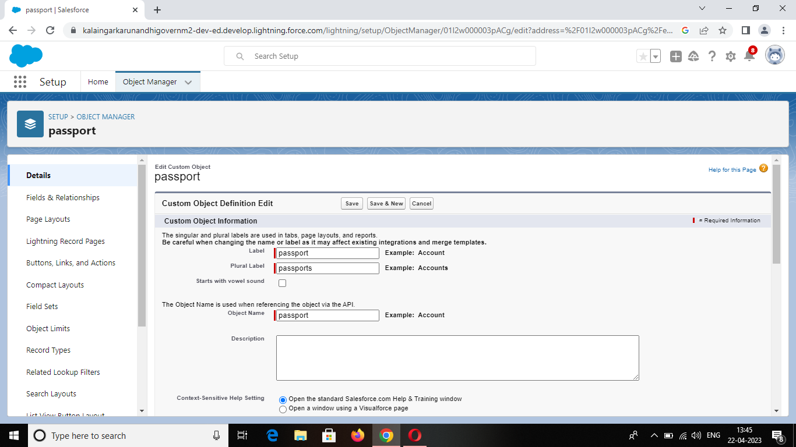

Custom Object: VISA SLOT

Navigate to setup and select object manager. At the top of

the right side there you can find create custom object.

You well navigate to custom object definition edit where

you have to give the object name.

The label name has visa slot and plural label has visa slots.

In enter record name label and format enter name record name and

the data type has text. In deployment status select deployment option.

The click on next you will navigate to the new custom

object tab where you have to select tab style and click on next and save it.

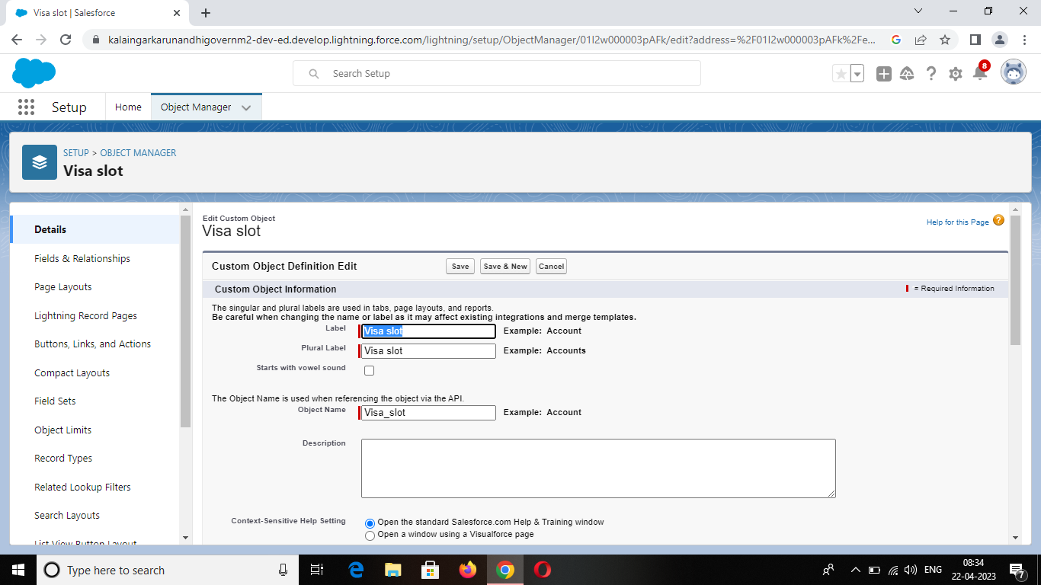

Custom Object: PAYMET

Navigate to setup and select object manager. At the top of

the right side there you can find create custom object.

You well navigate to custom object definition edit where

you have to give the object name.

The label name has payment and plural label has payments.

In enter record name label and format enter name record name and

the data type has text. In deployment status select deployment option.

The click on next you will navigate to the new custom

object tab where you have to select tab style and click on next and save it.

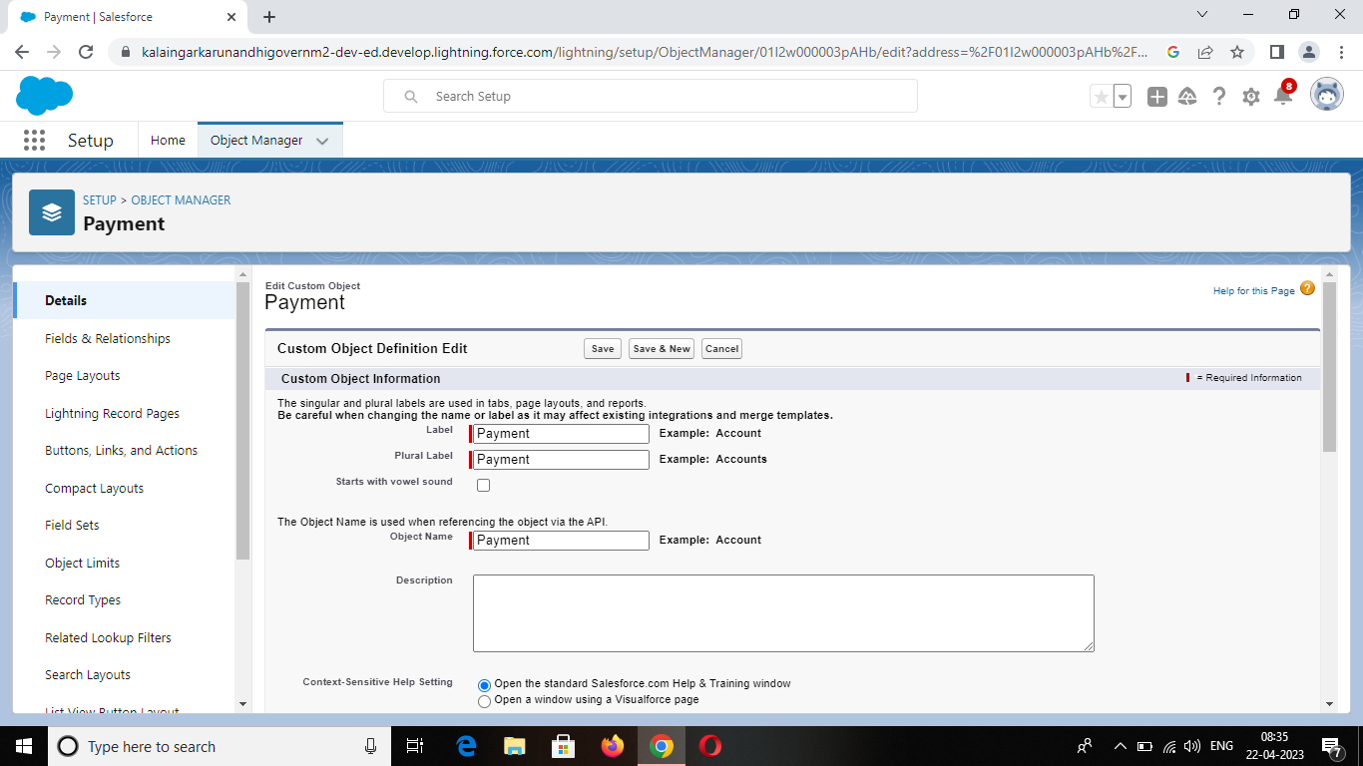

Custom Object: RESCHEDULE

Navigate to setup and select object manager. At the top of

the right side there you can find create custom object.

You well navigate to custom object definition edit where

you have to give the object name.

The label name has reschedule and plural label has reschedules.

In enter record name label and format enter name record

name and the data type has text. In deployment status select

deployment option.

The click on next you will navigate to the new custom

object tab where you have to select tab style and click on next and save it.

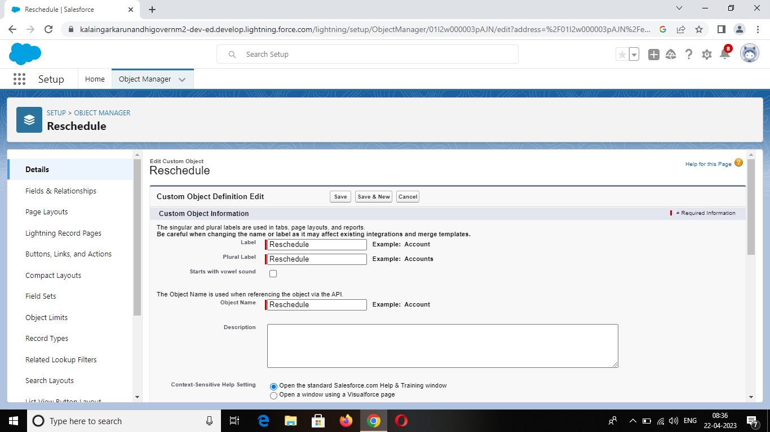

CREATION OF TABS

Once you created the object then click on next you will

navigate to the new custom object tab where you have to select

tab style and click on it.

After the tab selection you will be navigated to add to

Profiles select default on click on next.

You have to create for every object that you are created

in the custom object. We have created the custom tab for the

custom object passport we had given the airplane tab style

for passport.

And for visa slot we have selected the books tab

Style. For payment object we have selected the credit card

tab style. And for reschedule we have selected the box tab style.

The screenshot is attached below.

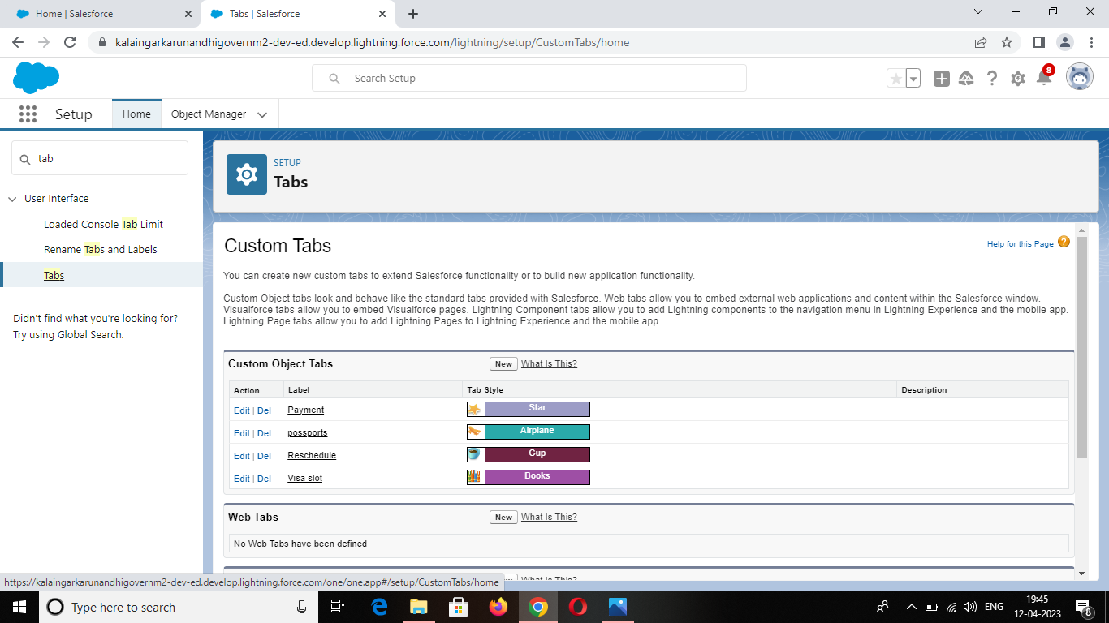

4. Create of field on custom object: PASSPORT

Select your object from the selection has passport. At the top

right side you can find a new select that option. Now you have to

select data type, select has data type.

Select our data type as number go to the next page enter the

filed label has contact number and length should be 10.

In passport object you have to create the following fields; Full

name, passport number, contact number, permanent address and

you can find option like required, unique, external id select required

option so that always required a value in this field in order to save.

Go to next page on visible checkbox so that it visible to all

profile and select option and save it.

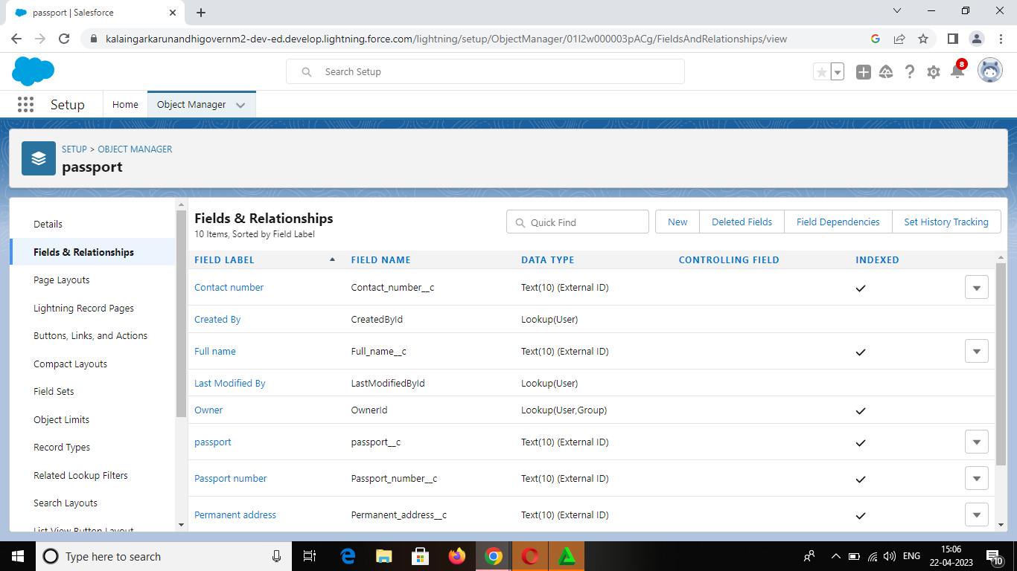

Create of field on custom object: VISA SLOT

Select your object from the selection has visa slot. At the top

right side you can find a new select that option. Now you have to

select data type, select has data type.

Select option fields and relationships. Select our data type as

number go to the next page enter the field label has passport

number (master), Visa slot number

In visa slot object you have to create the following fields;

Location, Time Passport number(master), Visa slot number and

you can find option like required, unique, external id select required

option so that always required a value in this field in order to save.

Go to next page on visible checkbox so that it visible to all

profile and select option and save it.

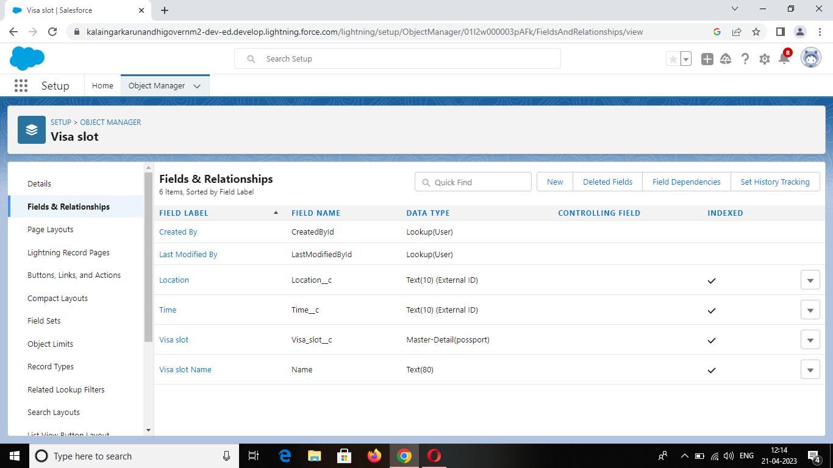

4. Create of field on custom object: PAYMENT

Select your object from the selection has payment. At the top

Right side you can find a new select that option. Now you have

to select data type, select has data type.

Go to the next page enter the field label has contact number

and length should be 10.Select option field and relationships. The field

label as card number, Transaction ID (Auto number).

In payment object you have to create the following fields;

Payment mode, card number, Transaction ID, Cancel transaction, Visa

Slot number and you can find option like required, unique, external id

select required option so that always required a value in this field in

order to save.

Go to next page on visible checkbox so that it visible to all

profile and select option and save it.

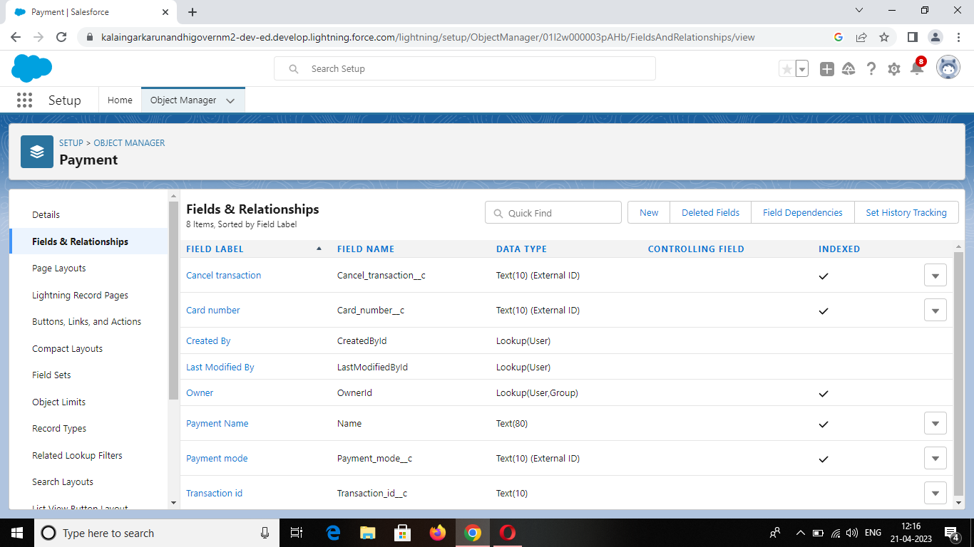

Create of field on custom object: RESHEDULE

Select your object from the selection has reschedule and select

option fields and relationships. Select your data type as number go to

the next page enter the field label has passport number(master).

In reschedule object you have to create the following fields;

Passport number(master), Location, Time, Cancel, Status and you can

find option like required, unique, external id select required option so

that always required a value in this field in order to save.

Go to next page on visible checkbox so that it visible to all

profile and select option and save it.

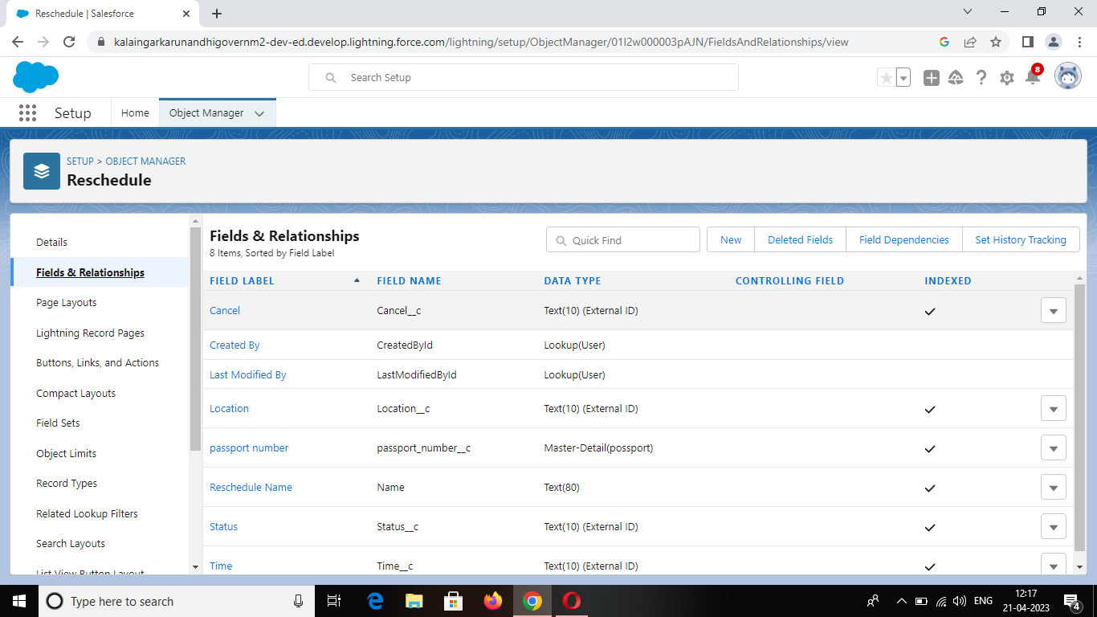

4. Creation of Relationship: Relation between the object

Relationship in sales force is a 2-way association between

2 objects. Using relationship we can link objects with each other

and we can make connections and display data about other

related objects.

There are two type of relationship:

1. Master detail relationship: A master detail

Relationship defines the relationship between the

parent and child. If the master table is deleted then

the child record data is also deleted.

1. Look up relationship: Lookup relationship

in sales force links two objects together but has no effect

on deletion or security.

1. Many to many relationship: Records of a particular

object can connect with various records of different

object and vice versa.

Select the data type has Master detail relationship and

Select related to the object has passport, and click on next.

You will navigate to the label name page where you

give the label name for the field, give it has passport

number and click next. select visible for all problem in field level security and select page layout in next page and save it.



5. Creation of app

Apps in sales force are a group of tabs that help the

application function by working together as a unit. It has a name,

a logo, and a particular set of tabs. The simplest app usually

has just two tabs.

There are two types of sales force Application:

1. Standard App
2. Custom App

To select the new lighting app option and give the app name

has book my visa and upload the picture. Click next.

Choose the app option as navigation style standard

Navigation, support form factors desktop and mobile and select next.

Passport, visa slots, payments, reschedule/cancel to

selected items. And system the admin profile to available items to

selected items and save it.

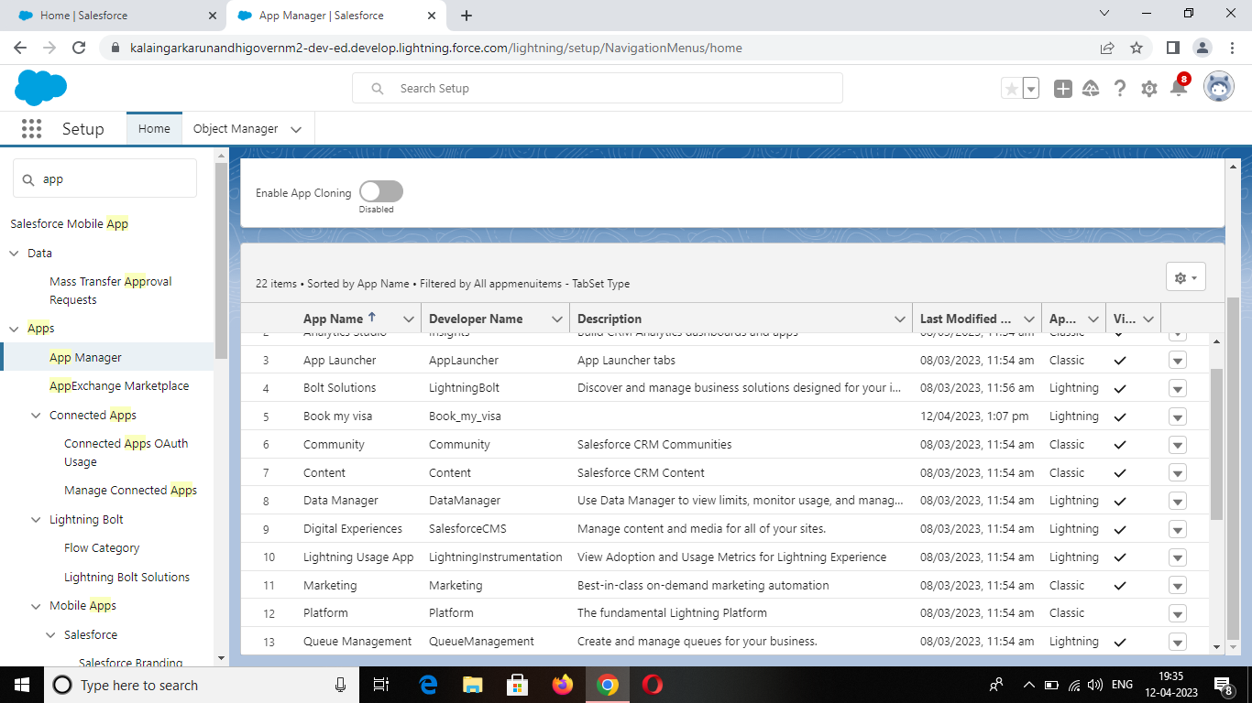

6. Creation of user

A user is anyone who logs in sales force. Users are

employees at your company, such as sales reps, managers,

and IT specialists, who need access to the company records.

Every user in sales force has a user account.

Navigate to setup in quick find search bar, search in

User and select it. Give the first name and last name. Enter your

Email and Enter your username: it must be unique.

Select your user licence of sales force. In the profile

field select standard user. At the bottom of the page check the

box to generate a new password and save the page.

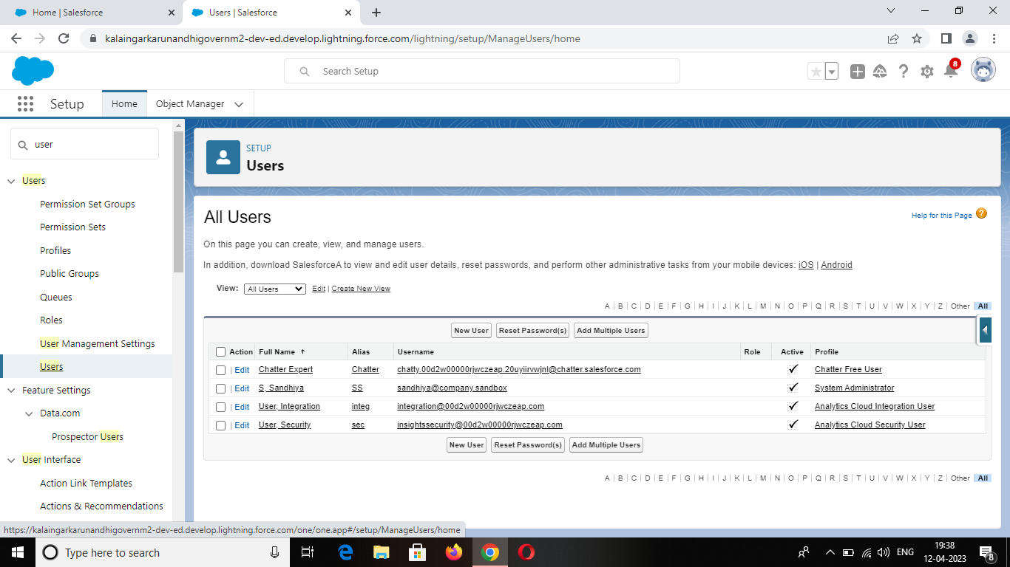

OWD: Organization wide default settings

This can be used to gives permission to the organization

wide and it can be used to restrict the access, we can control

the record level access.

Go to the setup to find out the sharing setting select it.

Edit the organization wide default and select the passport

object and change the default external access to Public/Read/Write.

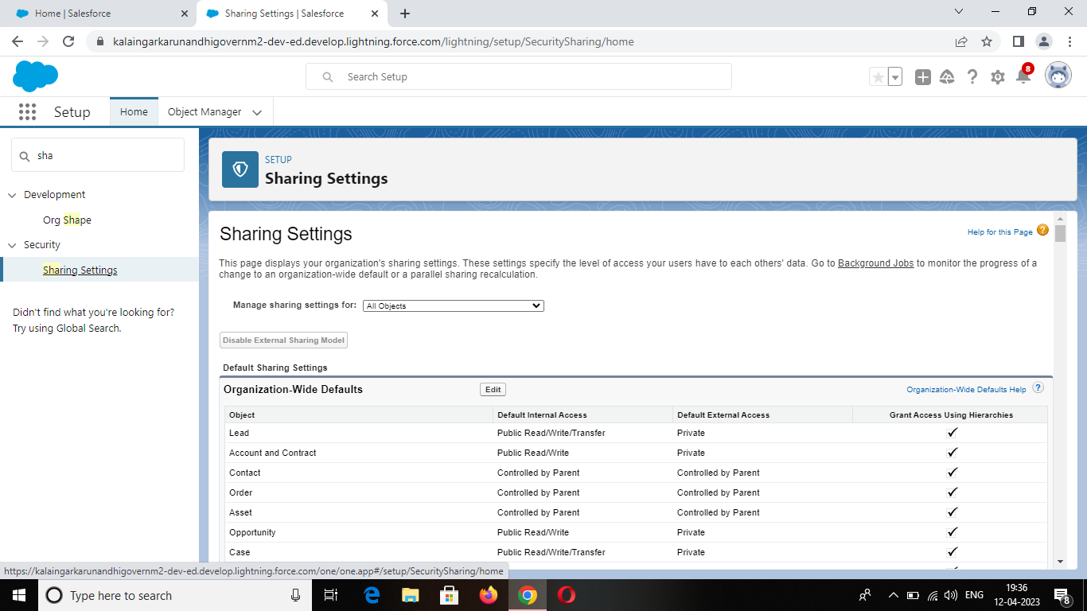

Create a Report

A report is a list of records that meet the criteria you define.

Its displayed in sales force in rows and columns, and can be

filtered, grouped or displayed in a graphical chart. Every repot is

stored in a folder. Folders can be public, hidden or shared and can

be set to read-only or Read/Write.

Click the app launcher and search for book a visa. Select

the report and click new report select the report type and passport

with visa slot with payment and select start report. Left side of the

report you can find the outline pane. In the group row location and

group column select passport: passport number to display and add

the column select has visa slot.

Edit the filters as show me the select all passport and

passport created date select all time finally save and run it. Go

to the edit option export select excel sheet format and click

export. We can see the detail as shown below.

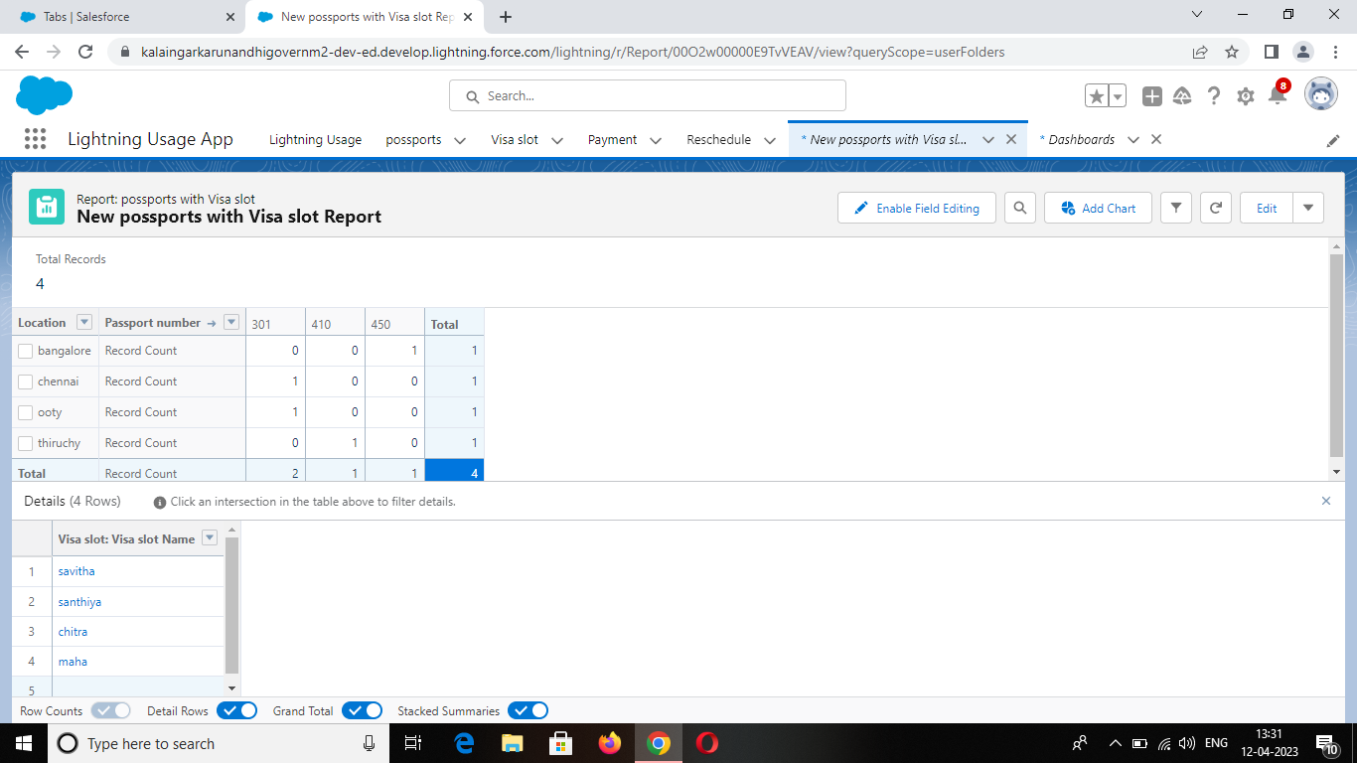

Create a dashboard

Dashboards in sales force are a graphical representation of

reports. Its shows data from source reports as visual components.

Go to the app launcher and search for book a visa. Select

the dashboard and click new dashboard. Click add component and

report passport with location.

Select the donut chart as selection. Ensure the value is

record donut and sliced by locations. Click add and save the

dashboard.

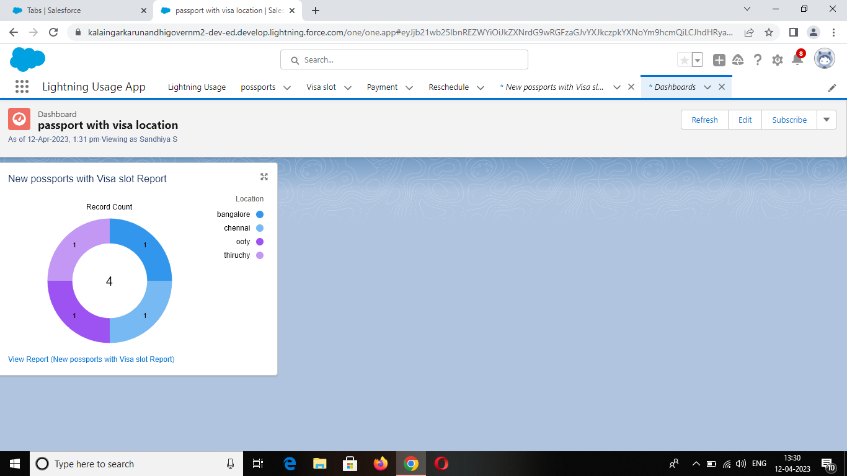

4. TRAILHEAD PROFILE PUBLIC URL:

**TEAM LEADER: S.SANDHIYA**

[**https://trailblazer.me/id/sphyem2**](https://trailblazer.me/id/sphyem2)

**TEAM MEMBER 1: G.PREMA**

[**https://trailblazer.me/id/premg18**](https://trailblazer.me/id/premg18)

**TEAM MEMBER 2: M.SANGEETHA PRIYA**

[**https://trailblazer.me/id/smaruthamuthu3**](https://trailblazer.me/id/smaruthamuthu3)

**TEAM MEMBER 3: S.SHALINI**

[**https://trailblazer.me/id/ssaravanan63**](https://trailblazer.me/id/ssaravanan63)

**TEAM MEMBER 4: M.SHIBANA**

[**https://trailblazer.me/id/shibm2**](https://trailblazer.me/id/shibm2)

5. ADVANTAGES

Processing is fast.

Saving time.

Not much paper work.

Easiest way

DISADVANTAGES

Internet connection problem is there.

Poor connection leads to trouble and anxiety.

Poor communication.

Lack of leadership.

Burdensome data entry.

6. APPLICATIONS

This will help you to track and manage the availability of visa

slot, which are appointments that are required for certain visa

applications.

CRM is a well conceived business strategy with long terms

outcomes that maximize profitability, revenue and customer

satisfaction by organizing around customer segment, fostering

customer satisfying action and implementing customer centric

process.

CRM is a strategy employed to learn and understand

customer need wants ad behavior in order to develop stronger

and sustained relationship with them.

7. CONCLUSION

By using the CRM application, we should track and manage

the availability of visa slots easily. Booking of visa slots will be in an

easier way.

It is a beneficial and useful one for the customers. Save the

time and often visiting trouble is not there.

8. FUTURE SCOPE

This will allow businesses to interact with customer vie

email, phone, social media and other channels.

Companies will be able to pivot to meet the changing

needs and trends driven by customer expectations.