LAB EXPERIMENT – 2

NAME: SANDHIYA P ROLL NO: 230701282

**Design a UI where users recall visual elements (e.g., icons or text chunks) Evaluate the effect of chunking on user memory.**

FRAME 1:

INSTRUCTION PAGE

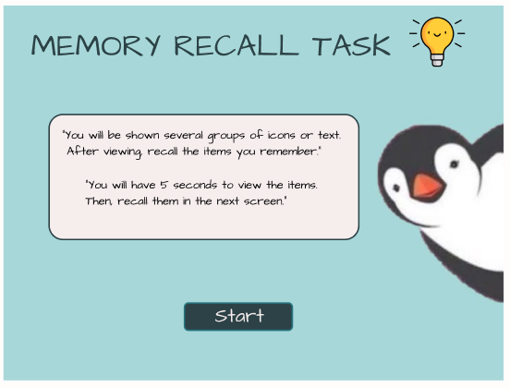

FRAME 2:

CHUNKING PHASE

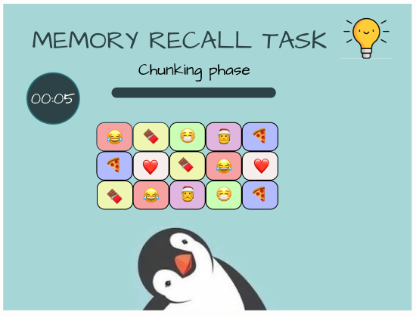

FRAME 3:

RECALL PHASE

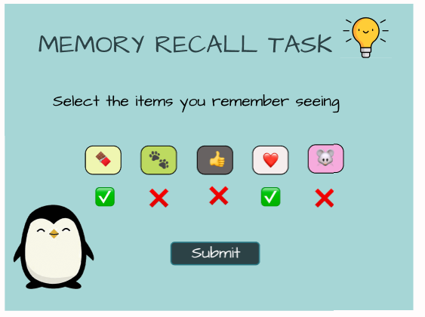

FRAME 4:

RESULT PHASE

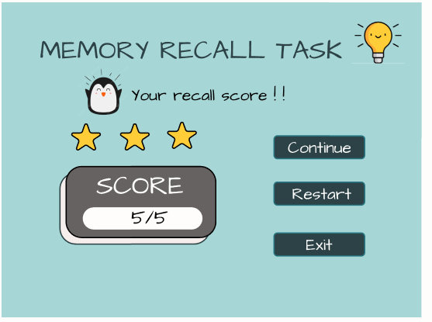

PROTOTYPE LINK:

https://www.figma.com/proto/1PoQw8n5szny12qussSx1d/chunking?page-id=0%3A1&node-id=19-2&starting-point-node-id=3%3A2&scaling=scale-down&content-scaling=fixed&show-proto-sidebar=1&t=zWvDA1NByzVwU2ot-1