LAB EXPERIMENT – 3

NAME: SANDHIYA P ROLL NO: 230701282

1.COMMAND LINE INTERFACE

PYTHON CODE:

import os

import sys

def rename_file(old_name, new_name):

try:

os.rename(old_name, new_name)

print(f"File renamed from {old_name} to {new_name}")

except FileNotFoundError:

print(f"Error: {old_name} not found.")

except Exception as e:

print(f"An error occurred: {e}")

if __name__ == "__main__":

if len(sys.argv) != 3:

print("Usage: python rename_file_cli.py <old_filename> <new_filename>")

else:

rename_file(sys.argv[1], sys.argv[2])

OUTPUT:



2.GRAPHICAL USER INTERFACE

PYTHON CODE:

import tkinter as tk

from tkinter import messagebox

import os

# Function to rename the file

def rename_file():

old_name = old_filename_entry.get().strip()

new_name = new_filename_entry.get().strip()

# Check if input fields are empty

if not old_name or not new_name:

messagebox.showwarning("Warning", "Please enter both filenames!")

return

# Check if the old file exists

if not os.path.exists(old_name):

messagebox.showerror("Error", f"File '{old_name}' not found.")

return

# Check if the new file already exists

if os.path.exists(new_name):

overwrite = messagebox.askyesno("Warning", f"'{new_name}' already exists. Overwrite?")

if not overwrite:

return

try:

os.rename(old_name, new_name)

messagebox.showinfo("Success", f"File renamed from '{old_name}' to '{new_name}'")

except Exception as e:

messagebox.showerror("Error", f"An error occurred: {e}")

# Create main window

root = tk.Tk()

root.title("File Renamer")

root.geometry("400x150")

root.resizable(False, False) # Fixed window size

# Labels

tk.Label(root, text="🗂️ Old Filename:", font=("Arial", 10)).grid(row=0, column=0, padx=10, pady=5, sticky="w")

tk.Label(root, text="📝 New Filename:", font=("Arial", 10)).grid(row=1, column=0, padx=10, pady=5, sticky="w")

# Entry fields

old_filename_entry = tk.Entry(root, width=40)

old_filename_entry.grid(row=0, column=1, padx=10, pady=5)

new_filename_entry = tk.Entry(root, width=40)

new_filename_entry.grid(row=1, column=1, padx=10, pady=5)

# Styled Button

rename_button = tk.Button(root, text="✅ Rename File", bg="green", fg="white", font=("Arial", 10, "bold"), command=rename_file)

rename_button.grid(row=2, column=0, columnspan=2, pady=10)

# Run the GUI event loop

root.mainloop()

OUTPUT:



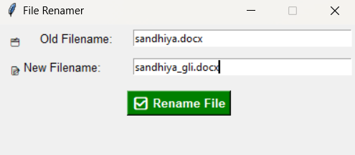

3.VOICE USER INTERFACE

PYTHON CODE:

import speech_recognition as sr

import os

def rename_file_from_voice_command(command):

try:

words = command.lower().split(" ")

if "rename" in words and "to" in words:

rename_index = words.index("rename")

to_index = words.index("to")

# Extract old and new filenames

old_name = words[rename_index + 1]

new_name = words[to_index + 1]

# Check if file exists

if not os.path.exists(old_name):

print(f"Error: File '{old_name}' not found.")

return

# Rename file

os.rename(old_name, new_name)

print(f"✅ File renamed from '{old_name}' to '{new_name}'")

else:

print("Invalid command format. Say: 'Rename oldfile.txt to newfile.txt'")

except Exception as e:

print(f"Error: {e}")

def listen_for_command():

recognizer = sr.Recognizer()

mic = sr.Microphone()

print("🎤 Listening for command to rename a file...")

with mic as source:

recognizer.adjust_for_ambient_noise(source)

audio = recognizer.listen(source)

try:

command = recognizer.recognize_google(audio)

print(f"🎙️ Command received: {command}")

rename_file_from_voice_command(command)

except sr.UnknownValueError:

print("❌ Sorry, I couldn't understand the command.")

except sr.RequestError as e:

print(f"⚠️ Could not request results from Google Speech Recognition service; {e}")

if __name__ == "__main__":

listen_for_command()

OUTPUT:

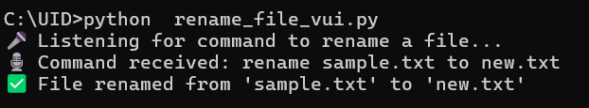

4.USER SATISFACTION COMPARISON

PYTHON CODE:

def survey():

print("Rate your satisfaction with the following interfaces (1-5):")

# Get user input for each interface

try:

cli_satisfaction = int(input("CLI (1-5): "))

gui_satisfaction = int(input("GUI (1-5): "))

vui_satisfaction = int(input("VUI (1-5): "))

# Ensure valid ratings

if not (1 <= cli_satisfaction <= 5 and 1 <= gui_satisfaction <= 5 and 1 <= vui_satisfaction <= 5):

print("Please enter ratings between 1 and 5 only.")

return

# Display the ratings

print("\nYour satisfaction ratings:")

print(f"CLI: {cli_satisfaction}")

print(f"GUI: {gui_satisfaction}")

print(f"VUI: {vui_satisfaction}")

# Calculate the average satisfaction

avg_satisfaction = (cli_satisfaction + gui_satisfaction + vui_satisfaction) / 3

print(f"\nAverage Satisfaction Score: {avg_satisfaction:.2f}")

except ValueError:

print("Invalid input! Please enter numbers between 1 and 5.")

# Run the survey function

if __name__ == "__main__":

survey()

OUTPUT:

