USER INTERFACE AND DESIGN

NAME: SANDHIYA P ROLL NO: 230701282

Create a prototype with familiar and unfamiliar navigation elements. Evaluate ease of use with different user groups

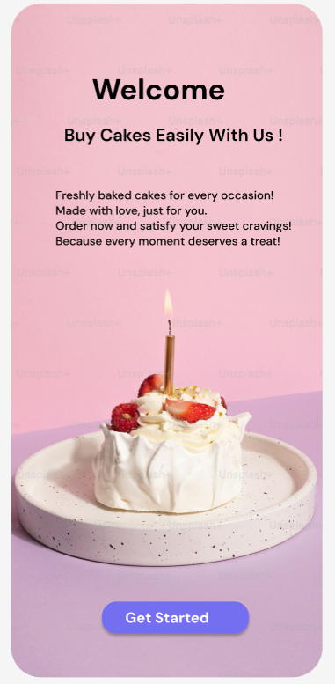

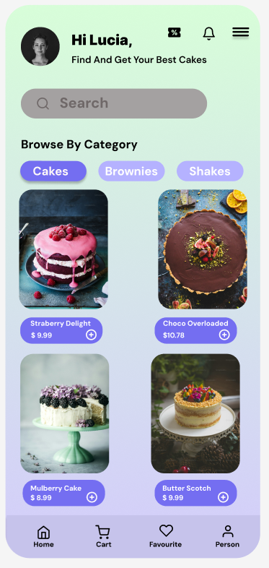

Here familiar icon is the cart located bottom navigation bar, commonly used to navigate to the main or home screen of an app. The cart icon also located to its right where the users can view selected items before making purchase. It is commonly used in e-commerce and food-ordering apps.

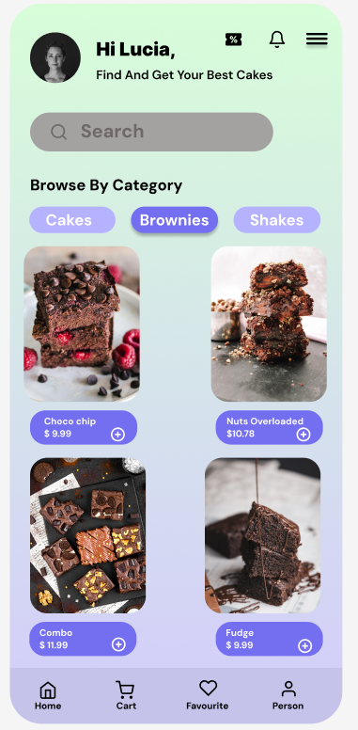

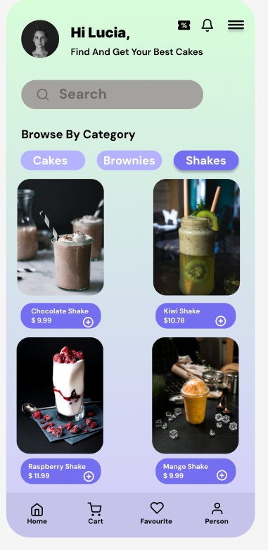

Also clicking the options cakes, brownies and shakes helps the users to view them all these are familiar icons.

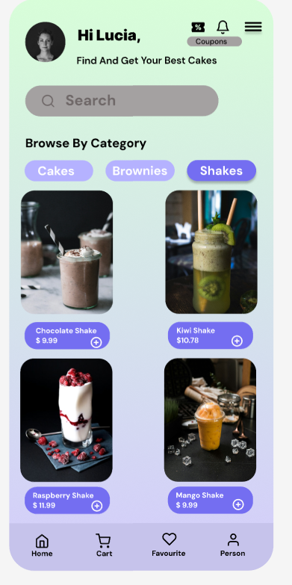

The coupon icon next to the bell icon shows the offers and price discounts. The icon next to the price of the items helps the user to add the items to the cart .

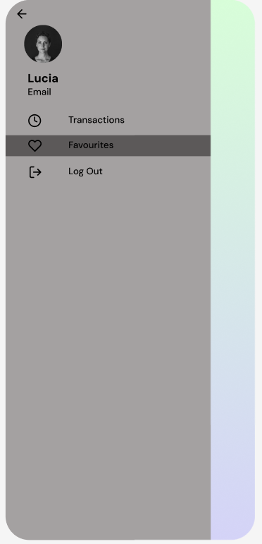

The timer icon which is unfamiliar helps in transactions.