EXPERIMENT - 5

ROLL NO: 230701282 NAME: SANDHIYA.P

Conduct task analysis for an app (eg., Online shopping) and document user flow. Create corresponding using Lucidchart.

AIM: To understand and document the steps a user takes to complete the main tasks within an online shopping app.

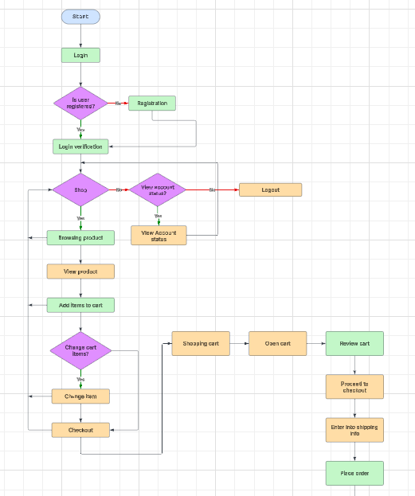

https://lucid.app/lucidchart/b891167f-910a-4a62-bc8b-b18e4ec3a6b0/edit?viewport_loc=-1219%2C-353%2C5293%2C2235%2C0_0&invitationId=inv_dded4c61-44b8-48e3-a8b6-98862edd1fd8

Task Analysis and User Flow for the Documentation Process

**Task Analysis**

The flowchart represents the user journey in an e-commerce system, covering registration, shopping, cart management, and order placement. The key tasks involved are:

1. **User Registration & Login**

-> If a user is not registered, they must complete registration.

-> If registered, they log in to proceed further.

**2. Shopping Process**

-> Users decide whether to shop or check their account status.

-> If shopping, they browse products, view product details, and add items to the cart.

**3. Cart Management**

-> Users can review their cart and make changes if necessary.

-> Proceed to checkout once satisfied with cart contents.

**4. Checkout Process**

-> Open the shopping cart and review items.

-> Proceed to checkout by entering shipping information.

-> Confirm the order by placing it.

**5. Account Management & Logout**

-> If users choose not to shop, they can check their account status.

-> Logout option is available if users do not wish to continue.

User Flow

**1. Entry Point**

-> The user starts at the "Start" node.

-> If not registered → Redirect to Registration.

-> If registered → Login.

**2. Shopping Experience**

-> After login, the user chooses between shopping or checking account details.

-> If shopping, the user browses products, views details, and adds items to the cart.

-> Users can modify cart items before proceeding to checkout.

**3. Cart & Checkout Process**

-> Users review their cart, proceed to checkout, enter shipping details, and place the order.

-> The process concludes at the "Stop" node after order placement.

-> Alternative Flow o If users decide not to shop, they can check account details.

-> Logout option is available at any point.

Task Analysis and User Flow – Detailed Steps

It provides a step-by-step breakdown of the user journey in an e-commerce system, covering user actions from registration to order placement.

**1. Entry Point (Start)**

1. The user begins at the Start node.

2. A decision is made: Is the user registered?

-> If No → Redirect to User Registration.

-> If Yes → Proceed to Login.

**2. User Registration (If Not Registered)**

1. The user is directed to the registration form.

2. The user provides:

-> Name

-> Email

-> Phone Number

-> Password

3. After submission, the system verifies details.

4. If valid → Registration successful, user proceeds to Login.

**3. User Login**

1. The user enters:

-> Email/Username

-> Password

2. If credentials are correct → Access is granted.

3. If incorrect → Show error message & request re-entry.

**4. Shopping Decision**

1. The system asks: Does the user want to shop?

-> If Yes → Go to Browsing Products.

-> If No → Go to View Account Status.

**5. Browsing Products & Adding Items**

1. The user browses products.

2. The user clicks on a product to view details.

3. Options:

-> Add item to cart.

-> Return to browsing.

4. If an item is added, the system updates the Shopping Cart.

**6. Shopping Cart Management**

1. The system asks: Change cart items?

-> If Yes → User can:

Remove items.

Change quantity.

Modify selections.

-> If No → Proceed to Checkout.

**7. Checkout Process**

1. The user navigates to the Shopping Cart.

2. The user opens the cart and reviews selected items.

3. The user proceeds to checkout.

**8. Entering Shipping Information**

1. The system prompts the user for:

Full Name

Address

City & ZIP Code

Phone Number

Payment Method

2. The user **submits shipping info**.

3. If valid → Proceed to **Place Order**.

4. If invalid → Show error message & request corrections.

**9. Placing the Order**

1. The system confirms the **order summary**.

2. The user **places the order**.

3. The system processes payment & generates a **confirmation message**.

**10. Viewing Account Status (If Not Shopping)**

1. The user chooses **View Account Status**.

2. The system displays:

Order history

Account details

Saved addresses & payment methods

3. The user can **log out** or return to **shopping**.

**11. Logout & End**

1. The user **logs out**.

2. The system ends the session.

3. The process **stops**.