# EXPERIMENT-7

ROLL NO: 230701282 NAME: SANDHIYA P

Experiment with different layouts and color schemes for an app.  
Collect user feedback on aesthetics and usability using GIMP (GNU Image Manipulation Program)  
  
AIM: The aim is to trial different app layouts and color schemes and evaluate user feedback on aesthetics and usability using GIMP.

Project Title: Burger House Poster Creation using GIMP  
Tool Used: GIMP (GNU Image Manipulation Program)  
Poster Theme: Fast Food Advertisement — Burger House  
  
Tools and Technologies:  
-> Software: GIMP 2.10+  
-> Resources Used:  
 o Burger image (uploaded)  
 o Flame background (designed using GIMP)  
 o Custom fonts for text elements

Procedure Followed:  
Step 1: Installation  
-> Downloaded and installed GIMP from the official website.  
Step 2: New Project Setup  
-> Opened GIMP and created a new file with dimensions 1080x1350 pixels to suit standard poster dimensions.  
Step 3: Designing the Layout  
-> Background Design:  
 o Applied a red fiery theme using gradients and brushes to simulate flames.  
-> Text Elements:  
 o Added the title "Foodiz park" in a cursive, elegant font at the top.  
 o Added "BURGER" (white) and "HOUSE" (yellow) using bold fonts to attract attention.  
-> Main Image:  
 o Imported the burger image using Open as Layers.  
 o Positioned centrally for visual focus.  
-> Footer Section:  
 o Inserted operational hours in a clean, simple font at the bottom.  
Step 4: Layer Organization  
-> Created and organized separate layers for:  
 o Background  
 o Flame effects  
 o Brand title  
 o Product image (burger)  
 o Footer details  
Step 5: Color Experimentation  
-> Created multiple versions by changing background shades and slight variations in text color.  
-> Saved each version separately using File → Export As in .png format.  
Step 6: User Feedback Collection  
-> Designed a feedback form using Google Forms.  
-> Shared poster variants with peers and collected responses based on:  
 o Attractiveness  
 o Readability  
 o Color appeal  
-> Analyzed the feedback to select the final version.  
Step 7: Final Refinement  
-> Based on feedback, adjusted text size and background contrast.  
-> Finalized and exported the best poster version.

Final Output:  
-> An eye-catching promotional poster featuring:  
 o A vibrant flame background  
 o Bold branding text  
 o High-quality burger image  
 o Clear operation timing details

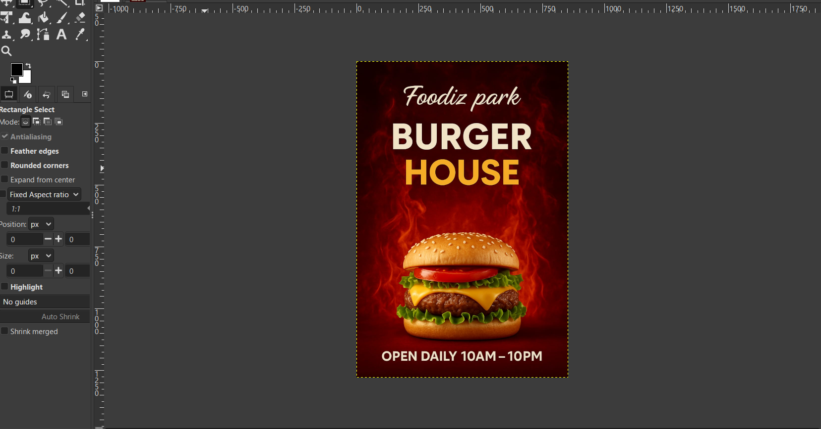

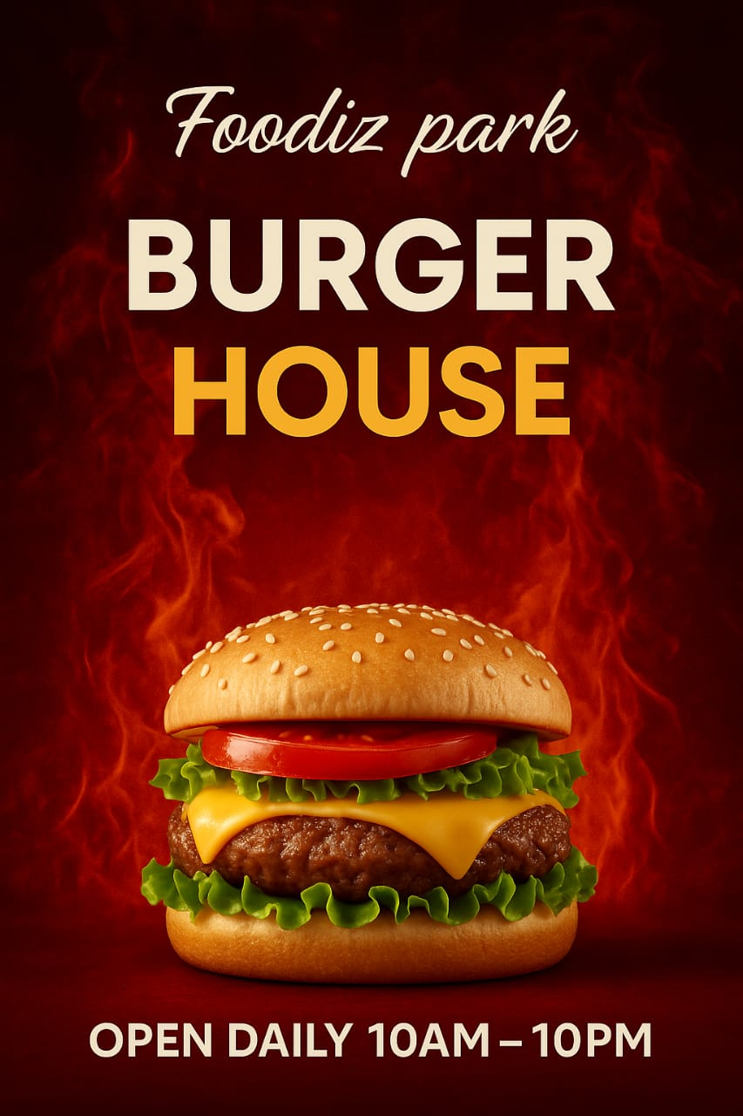

Conclusion:  
GIMP proved to be an excellent tool for poster design. The layer-based editing made it easy to adjust and refine the design. User feedback helped enhance the final output to ensure better visual appeal and brand communication.