**USER INTERFACE AND DESIGN**

**NAME P.SANDHIYA ROLL NO 230701282**

Experiment No. 8: Storyboarding for a Food Delivery Mobile App

**Aim:**

To design and document a storyboard illustrating the user flow of a food delivery mobile application using Balsamiq or similar wireframing tools.

**Tools Used:**

* **Wireframing Tool:** Balsamiq (or any equivalent)

**Procedure:**

1. **Identify Key Screens and Actions:**
   * Welcome Page
   * Home Page
   * Product Page
   * Payment Page
2. **Define the User Journey:**
   * The user opens the app and lands on the Welcome Page.
   * On tapping, they proceed to the Home Page.
   * The user selects a product and is navigated to the Product Page.
   * After clicking "Order Now", the app redirects to the Payment Page.
   * On clicking "Pay Now", the payment is processed, completing the transaction.
3. **Design Storyboards:**
   * Each screen is created as a wireframe.
   * Basic components like buttons, product views, and payment options are included.
   * Screens are arranged to reflect the actual app navigation flow.

**Storyboard Screens Overview:**

1. **Welcome Page:**
   * Introduction screen
   * User taps to proceed
2. **Home Page:**
   * Displays product categories or featured food items
   * Clickable product tiles for selection
3. **Product Page:**
   * Displays product details
   * "Order Now" button for initiating the purchase
4. **Payment Page:**
   * Summary of the order
   * "Pay Now" button for transaction completion

**Output:**

A linear storyboard flow with the following sequence:

1. Welcome Page
2. Home Page
3. Product Page
4. Payment Page

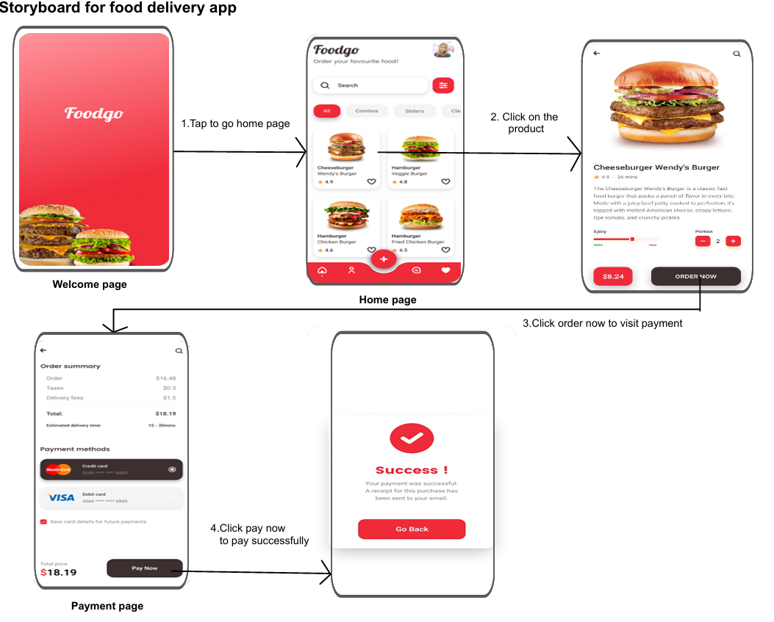

**Conclusion:**

The storyboard effectively maps the core user experience of a food delivery app. It includes the primary actions a user performs, from browsing to ordering and completing a purchase. This structured design enhances understanding of user interaction and aids in app.