CHATGPT
Write a 500-word article on AI in Agriculture.
AI in Agriculture
Artificial Intelligence (AI) is transforming agriculture by helping farmers improve productivity, reduce costs, and make better decisions. Agriculture has always been an essential part of human life, and with the increasing global population, the demand for food continues to rise. Traditional farming methods alone are often not enough to meet this growing demand. AI offers innovative solutions that enable farmers to produce more food while using fewer resources and protecting the environment.
One of the most significant applications of AI in agriculture is precision farming. AI systems analyze data collected from satellites, drones, weather stations, and soil sensors to provide farmers with accurate information about crop health, soil moisture, and weather conditions. This allows farmers to apply water, fertilizers, and pesticides only where they are needed, reducing waste and increasing crop yields. Precision farming also helps conserve natural resources and minimizes environmental pollution.
AI-powered drones and robots are becoming increasingly common in modern agriculture. Drones capture high-resolution images of fields and identify areas affected by pests, diseases, or nutrient deficiencies. Farmers can then take immediate action before the problem spreads. Agricultural robots are capable of planting seeds, removing weeds, harvesting crops, and even sorting fruits and vegetables based on their quality. These technologies reduce the need for manual labor, improve efficiency, and save time.
Another important use of AI is disease and pest detection. Machine learning algorithms can analyze images of plant leaves to identify diseases at an early stage. Early detection helps farmers treat crops quickly, reducing losses and preventing the spread of infections. AI also predicts pest outbreaks by analyzing environmental conditions, enabling farmers to take preventive measures rather than relying heavily on chemical pesticides.
Weather forecasting is another area where AI provides valuable support. By analyzing historical and real-time weather data, AI systems can predict rainfall, temperature changes, and extreme weather events with greater accuracy. Farmers can use these predictions to plan irrigation, planting, and harvesting activities, reducing the risks associated with unpredictable weather conditions.
AI also contributes to livestock management. Smart sensors monitor the health, feeding habits, and movement of animals. If an animal shows signs of illness or unusual behavior, the system alerts the farmer immediately. This improves animal welfare, increases milk and meat production, and reduces veterinary costs.
Despite its many advantages, AI in agriculture also faces certain challenges. High implementation costs, lack of digital infrastructure, limited internet access in rural areas, and the need for technical knowledge can make adoption difficult, especially for small-scale farmers. Governments, educational institutions, and technology companies must work together to make AI tools affordable and accessible through training programs, financial support, and improved rural connectivity.
In conclusion, Artificial Intelligence is revolutionizing agriculture by making farming more efficient, productive, and sustainable. From precision farming and disease detection to weather forecasting and livestock monitoring, AI is helping farmers overcome many traditional challenges. As technology continues to advance and becomes more affordable, AI will play an even greater role in ensuring global food security and promoting environmentally friendly farming practices. By embracing AI responsibly, agriculture can meet future food demands while conserving valuable natural resources for generations to come.
GEMINI
Executive Report: Artificial Intelligence in Agriculture
1. Executive Summary & Market Snapshot
Artificial intelligence (AI) is transforming global agriculture from traditional input-heavy methods into data-driven precision farming. Driven by rising global food demand, severe farm labor shortages, and climate volatility, AI adoption has shifted from experimental pilots into mainstream commercial use.
- Market Valuation: The global AI in agriculture market reached approximately $3.1 billion to $3.5 billion in 2026 and is projected to expand at a compound annual growth rate (CAGR) of 21%–26%, surpassing $24 billion to $46 billion over the next decade.
- Dominant Segments: Software platforms and machine learning account for ~50% of market expenditure, providing foundational analytics for yield forecasting, soil modeling, and crop risk assessment.
- Fastest Growing Drivers: Computer vision (powered by AI drones and robotics) and smart greenhouse management are experiencing the highest growth rates.
2. Core Applications Across the Value Chain
A. Precision Farming & Input Optimization
Using Variable Rate Technology (VRT), AI algorithms analyze satellite imagery, hyper-local weather forecasts, and IoT soil sensors. Instead of applying chemicals uniformly across a field, prescription maps deliver exact dosages of fertilizer, water, and seeds only where needed—reducing seed and chemical outlays by 8–12%.
B. Computer Vision for Disease & Weed Management
AI models trained on computer vision scan crops for micro-changes in leaf coloration and texture.
- Targeted Weeding: Smart sprayers differentiate weeds from cash crops in real time, spraying herbicide strictly on weeds and cutting chemical volume by up to 80%.
- Early Pathology Detection: Algorithms flag fungal infections, insect infestations, and nutrient stress before visible damage spreads across fields.
C. Autonomous Harvesting & Labor Robotics
To offset aging agricultural workforces, autonomous tractors and robotic harvesters use computer vision to navigate fields, gauge crop ripeness, and pick soft fruits without bruising.
D. Livestock Health Monitoring
Wearable IoT sensors and biometric cameras track animal behavior, body temperature, and movement to detect illness days before physical symptoms appear, reducing herd mortality and antibiotic usage.
3. Business & Environmental Impact
Impact Dimension | Key Mechanism | Operational Outcome
Yield Optimization | Predictive analytics for planting & harvest timing | +10% to 20% increase in overall field productivity
Resource Efficiency | Smart drip irrigation driven by soil moisture models | Conserves up to 30% water vs. scheduled watering
Cost Reduction | Targeted chemical & fertilizer application | Direct input cost savings and lower environmental runoff
Supply Chain Resilience | Post-harvest sorting, yield forecasting & demand matching | Reduces post-harvest spoilage and optimizes transport logistics
4. Key Barriers to Adoption
- High Initial Capital Costs: Full-suite hardware—such as autonomous tractors ($30,000+ weeding systems) or dense sensor grids—creates a financial barrier for smallholders (under 5 hectares), who represent ~95% of global farms.
- Connectivity & Data Fragmentation: Rural connectivity bottlenecks impede real-time cloud analytics, while non-standardized farm data formats limit multi-platform integration.
- Model Localization: Agricultural AI requires extensive training on regional micro-climates and soil chemistry; models trained in North America often require re-tuning for Asian or African soil conditions.
5. Strategic Outlook
As AI-as-a-Service (AIaaS) models and sensor subscription contracts (e.g., $18–$25/hectare/season) mature, barriers for small-to-medium farming operations are declining. The future of agricultural AI lies in the convergence of Generative AI co-pilots (offering natural-language agronomic advice directly to farmers on mobile devices) and hybrid edge-computing equipment that processes imagery offline directly on tractors and drones.
PERPLEXITY
Factor | Traditional Farming | AI-based Farming
Farming methods | Manual or experience-based methods, with farmers deciding when to plant, irrigate, spray, and harvest through field observation and local knowledge . | Precision farming methods that combine sensors, automation, drones, machine learning, and data-driven controls for planting, irrigation, monitoring, and harvesting
Monitoring techniques | Farmers inspect fields by walking them, checking crops visually, and relying on periodic manual measurement. | Uses real-time monitoring through IoT sensors, drones, satellite imagery, cameras, and dashboards
Water usage | Water is often applied on fixed schedules or by broad field irrigation, which can cause overuse or waste | Water is applied more precisely using soil moisture data, weather data, and automated irrigation, reducing waste
Fertilizer usage | Fertilizer is usually spread uniformly or based on general judgment, which can lead to over-application | Fertilizer can be targeted to crop and soil needs using variable-rate or data-guided application, improving efficiency
Pest detection | Pest and disease problems are usually noticed after visible damage appears | AI can detect early signs of disease or pest outbreaks from images and field data, allowing faster response
Labor requirements | Requires more manual labour for inspection, watering, spraying, and harvesting | Reduces repetitive manual labour through automation, but needs technical oversight and equipment management
Cost | Lower startup cost because it uses simpler tools and less technology | Higher initial cost for sensors, software, automation, connectivity, and maintenance
Crop yield | Yield can be more variable because inputs are less precise and decisions depend heavily on weather and human judgment | Yields are often higher and more consistent because inputs are optimized; one review notes AI-supported farms can achieve better yield outcomes and efficiency
Accuracy | Lower accuracy in input application, monitoring, and forecasting because decisions are mostly manual | Higher accuracy in monitoring, prediction, and input use because AI analyzes larger datasets
Environmental impact | Can lead to higher water use, fertilizer runoff, and pesticide overuse if management is not precise | Often reduces waste, runoff, and resource use through precision application, though it still depends on how the system is used
Technology used | Basic tools, tractors, irrigation systems, and manual recordkeeping | Sensors, drones, cameras, IoT devices, robotics, machine learning, computer vision, and farm software
Decision making | Mostly based on farmer experience, tradition, and observation | Based on data, forecasts, and AI recommendations, often in near real time
CLAUDE
Summary: Artificial Intelligence in Agriculture: Advancing Crop Productivity and Sustainability
Title: Artificial Intelligence in Agriculture: Advancing Crop Productivity and Sustainability Published in Journal of Agriculture and Food Research (2025), by Nazish Aijaz, He Lan, Tausif Raza, Muhammad Yaqub, Rashid Iqbal, and Muhammad Salman Pathan
Research Objective The paper aims to review how AI can help agriculture cope with two big pressures: a growing world population (expected to reach 10 billion by 2050) and worsening climate change. The authors look at how AI supports precision farming, boosts crop productivity, and improves sustainability, while also examining what's blocking wider adoption of these technologies.
Methodology This is a literature review, not an experimental study. The authors gathered and analyzed existing research, industry reports, and real-world case studies on AI applications in agriculture, organizing their findings into themes: core AI technologies, productivity impacts, adoption barriers, and future outlook.
AI Techniques Used/Discussed
- Precision farming tools – GPS and IoT sensors that track soil moisture, temperature, and crop health in real time
- Machine learning models – for predicting yields, detecting diseases/pests early (via image recognition from drone or camera photos), and optimizing water/fertilizer use
- Agricultural robotics – autonomous machines for planting, weeding, and harvesting
- AI-driven genetic analysis – identifying genes for drought resistance, paired with tools like CRISPR for breeding resilient crops
- Computer vision – for monitoring livestock health and behavior
Results (Key Case Studies)
- John Deere: AI-equipped autonomous tractors and harvesters improved irrigation, fertilization, and pesticide decisions.
- Plantix app: Used AI image recognition to help smallholder farmers in India detect crop diseases early.
- The Climate Corporation (Bayer): AI-based irrigation platform helped conserve water and cut energy costs.
- Monsanto/Bayer: Combined AI with CRISPR to speed up breeding of disease- and drought-resistant crops.
- Cainthus: AI-powered livestock monitoring improved milk production and reduced vet costs.
- California vineyard experiment: AI-managed irrigation and nitrogen use led to a 25% increase in yield and 20% water savings.
Advantages
- Reduces waste of water, fertilizer, and pesticides
- Increases crop yield and quality
- Speeds up breeding of climate-resilient crops
- Cuts labor costs through automation
- Enables early disease/pest detection
- Supports better decision-making through real-time data and weather forecasting
- Helps protect groundwater and reduce environmental damage
Limitations/Barriers
- Technological challenges – High costs, need for reliable internet/infrastructure, especially tough for rural and developing regions
- Sociocultural barriers – Farmer skepticism, generational resistance to new tech, lack of training
- Regulatory/ethical concerns – Data privacy issues, unclear rules around AI-driven genetic modification (GMOs)
- Economic implications – High upfront investment, long payback periods, potential job losses in traditional farming roles
Conclusion The authors conclude that AI has strong potential to transform agriculture by improving productivity and sustainability, but this potential remains largely unrealized due to technological, social, and regulatory hurdles. They call for stronger collaboration between governments, tech companies, academic institutions, and farmers—alongside supportive policies, subsidies, and training programs—to make AI adoption more affordable and accessible. Done right, AI could play a major role in achieving global food security while minimizing agriculture's environmental footprint.
DALL·E

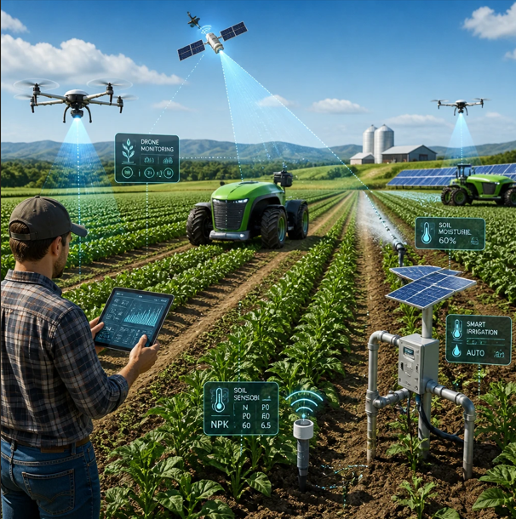
Adobe Firefly
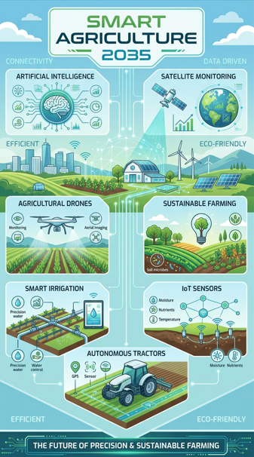
Canva AI
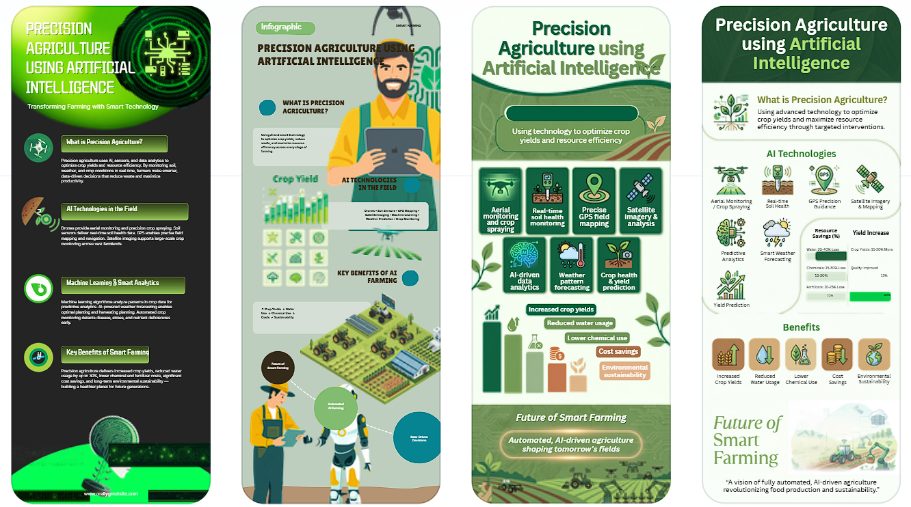
Gamma
GitHub Copilot
# Crop Yield Prediction System using Linear Regression

import pandas as pd
import matplotlib.pyplot as plt
from sklearn.linear_model import LinearRegression

# Create sample dataset
data = {
"Rainfall": [500, 600, 700, 800, 900],
"Temperature": [25, 28, 30, 32, 35],
"Soil_Moisture": [40, 50, 55, 60, 65],
"Fertilizer": [100, 150, 200, 250, 300],
"Crop_Yield": [2.5, 3.0, 3.8, 4.2, 4.8]
}

# Convert to DataFrame
df = pd.DataFrame(data)

# Input features
X = df[["Rainfall", "Temperature", "Soil_Moisture", "Fertilizer"]]

# Output
y = df["Crop_Yield"]

# Train the model
model = LinearRegression()
model.fit(X, y)

# Get user input
rainfall = float(input("Enter Rainfall: "))
temperature = float(input("Enter Temperature: "))
soil = float(input("Enter Soil Moisture: "))
fertilizer = float(input("Enter Fertilizer Usage: "))

# Predict crop yield
prediction = model.predict([[rainfall, temperature, soil, fertilizer]])

print("\nPredicted Crop Yield =", round(prediction[0], 2), "tons/hectare")

# Predict values for dataset
predicted = model.predict(X)

# Plot Actual vs Predicted
plt.scatter(y, predicted)
plt.xlabel("Actual Crop Yield")
plt.ylabel("Predicted Crop Yield")
plt.title("Actual vs Predicted Crop Yield")
plt.plot([min(y), max(y)], [min(y), max(y)])
plt.show()

