Student Enrollment & Course Management System
(SECMS)
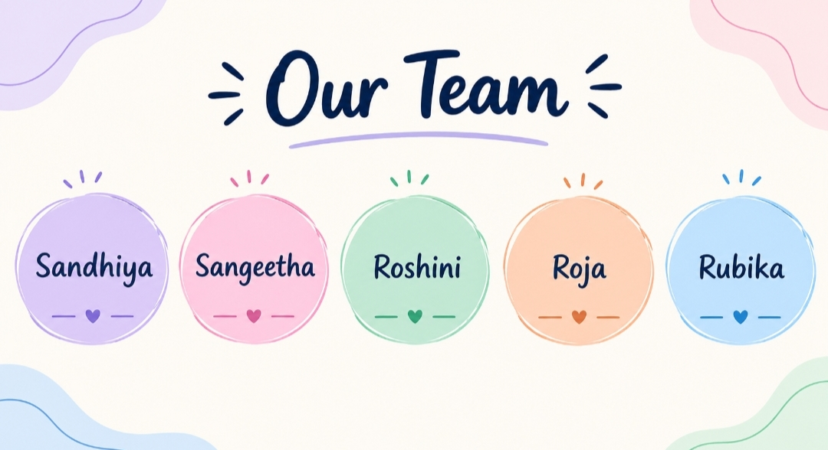

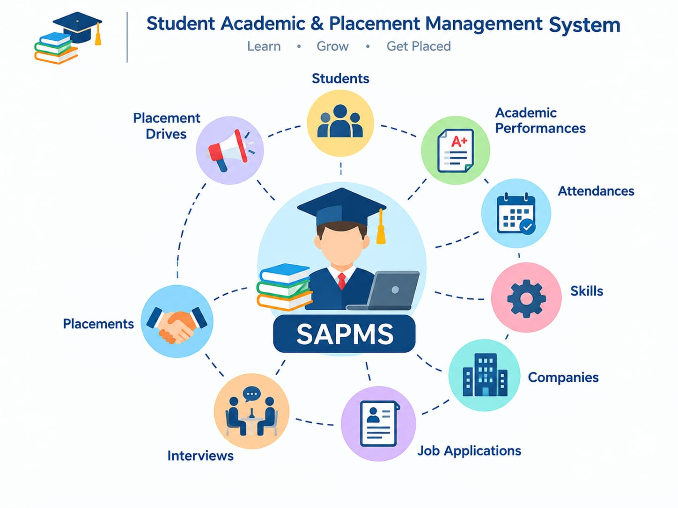

A Salesforce-based solution for admissions, enrollment and academic operations

User Story:

The Student Academic & Placement Management System is a comprehensive Salesforce application designed to streamline and automate the academic progress and placement activities of an educational institution. This system enables administrators, faculty members, placement officers, and students to efficiently manage student profiles, academic performance, attendance, skill development, placement drives, company details, job applications, interview schedules, selection processes, and placement records—all within a unified Salesforce environment.

Project Summary
SECMS is a Salesforce application built to run the day-to-day enrollment work of an educational institute from one place. Administrators, enrollment officers and instructors can maintain student profiles, publish courses, process enrollment requests, allocate instructors, collect fee status, route approvals and view live reports without switching between tools.

1. Introduction

1.1 Overview
Most institutes still keep student, course and enrollment information in separate spreadsheets, emails and paper files. This project brings all of that into a single Salesforce org so that every record is easy to find, every process follows a defined path, and every number in a report can be trusted.
Enrollment Officers use the system to admit students, register them for courses and follow up on requests. Instructors and administrators get a clear view of who teaches what and how each student is progressing. Automation covers instructor allocation, follow-up task creation, data validation and multi-step approvals.
Using Salesforce Flows, Approval Processes, Validation Rules, Reports and Dashboards, the institute can supervise the complete journey from admission to course completion and keep an eye on indicators such as enrollment counts, revenue collected, student status split and requests waiting for approval.

1.2 Purpose
The goal of SECMS is to retire manual, scattered enrollment handling and replace it with a scalable, automated and secure platform that delivers:
- Reliable and consistent student data
- Well-defined enrollment workflows
- Automatic approvals and data checks
- Clear reporting with continuous monitoring

2. Ideation Phase

2.1 Problem Statements
ID | I am (Customer) | I'm trying to | But | Because | Which makes me feel
PS-1 | Enrollment Officer | handle student enrollments efficiently | enrollment data is spread across many places | processes are manual and tools are not connected | Frustrated and prone to mistakes
PS-2 | Administrator | monitor enrollments and revenue | reports arrive late | information is not held in one central place | Unsure when making decisions

2.2 Empathy Map
Persona: Enrollment Officer
Quadrant | Observations
Thinks & Feels | Worries about students being booked twice and about fees going uncollected.
Hears | Students complain about delays; management asks for quicker turnaround.
Sees | A pile of spreadsheets and a crowded inbox.
Says & Does | Verifies the same data repeatedly and chases people by hand.
Pain | Duplicate records and approvals that get stuck.
Gain | Automation, dashboards and faster processing.

2.3 Brainstorming and Prioritization

Step 1 – Ideas considered
- Automating existing spreadsheets
- A separate stand-alone enrollment portal
- Integration with an ERP package
- A Salesforce-based enrollment system

Step 2 – Grouping by level of automation
- Manual: spreadsheet automation
- Semi-automated: stand-alone portal and ERP integration
- Fully automated cloud: Salesforce-based enrollment system

Step 3 – Decision
Plotting the options on an impact-versus-feasibility scale placed the Salesforce-based SECMS in the high-impact, high-feasibility corner, so it was chosen for implementation.

3. Requirement Analysis

3.1 Customer Journey
The journey that SECMS supports is made up of these stages:
- Awareness and registration
- Course selection
- Enrollment request
- Fee payment
- Approval
- Instructor assignment
- Reporting and course completion

3.2 Solution Requirements

Functional requirements
ID | Epic | What the system must do
FR-1 | Student Management | Create, view and update student records
FR-2 | Course Management | Set up courses and keep their details current
FR-3 | Enrollment Processing | Submit enrollment requests and approve or reject them
FR-4 | Instructor Assignment | Allocate an instructor automatically
FR-5 | Reporting | Provide reports and dashboards

Non-functional requirements
Requirement | Description | Examples
NFR-1 Usability | The interface should be simple enough for enrollment officers, administrators, instructors and students to use with very little training. Clearly named tabs, dashboards and forms keep effort and errors low. | Fast student registration form; one-click approval; dashboards per role.
NFR-2 Security | Personal details, enrollment history and academic records must be visible only to people authorized to see them, through proper authentication and access control. | Only admins edit course data; instructors see only their students; students cannot open others' records.
NFR-3 Reliability | Enrollment, approval and reporting logic must run correctly every time so that no duplicate or wrong enrollments are created. | No repeated course registration; correct status after approval; consistent reports.
NFR-4 Performance | Screens and searches should respond quickly, including during the busy admission period. | Quick dashboard refresh; fast student search; smooth bulk uploads.
NFR-5 Scalability | The design should absorb growth in students, courses, departments and users, and allow new modules to be added without rework. | Add departments without redesign; handle yearly intake growth; extend to mobile or portal.
NFR-6 Availability | The platform should stay reachable during institute working hours with minimal downtime. | 24/7 cloud access; dependable during peak season; automatic data backup.

3.3 Data Flow
- A user enters student and enrollment details.
- The system checks the data and stores it in Salesforce objects.
- The approval process routes the request to the right approver.
- An instructor is assigned once the request moves forward.
- Reports and dashboards read the stored, processed data.

3.4 Technology Stack
Layer | Technology
User Interface | Salesforce Lightning
Business Logic | Salesforce Flows
Data Storage | Salesforce Custom Objects
Automation | Validation Rules and Approval Processes
Reporting | Salesforce Reports and Dashboards

4. Project Design

4.1 Problem–Solution Fit
SECMS answers the four pain points of the current setup using features native to Salesforce:
Existing problem | SECMS solution
Fragmented spreadsheets | Unified dashboards
Manual paperwork | Automated approvals
Delayed approvals | Rule-based approval routing
Scattered systems | One centralized database

4.2 Proposed Solution
Parameter | Description
Problem | Enrollment is handled manually and inconsistently
Solution | A Salesforce-based enrollment and course management system
Novelty | Complete end-to-end automation of the enrollment cycle
Social impact | A smoother, faster experience for students
Revenue model | Deployment licensed to institutes
Scalability | Can be extended to many departments

4.3 Solution Architecture
The Salesforce platform hosts four data objects – Student, Course, Enrollment and Instructor. On top of them sit automation flows, approval processes, dashboards and a security layer that together control how the data is created, moved, displayed and protected.

5. Project Planning & Scheduling

5.1 Approach
- Agile delivery in short sprints
- Work broken down as Epics → User Stories → Story Points
- Sprint-by-sprint execution
- Team velocity used to estimate effort

Product backlog and sprint plan
Sprint | Epic | Story No. | User story / task | Points | Priority | Owner
1 | Developer Setup | USN-1 | As a system administrator, I want a Salesforce developer account so that I can build and deploy the enrollment system. | 1 | High | Member 1
1 | Data Modeling | USN-2 | As an admin, I want custom objects for Student, Course, Enrollment and Instructor so that academic data is stored in an organized way. | 3 | High | Member 2
2 | Data Modeling | USN-3 | As a user, I want a tab for each object so that I can move easily between students, courses, enrollments and instructors. | 3 | High | Member 3
2 | Data Modeling | USN-4 | As an admin, I want fields for student details, course information and enrollment status so that records are complete and accurate. | 5 | High | Member 4
2 | Data Modeling | USN-5 | As an enrollment officer, I want one Lightning App so that all academic operations are reachable from a single interface. | 3 | High | Member 4
2 | Data Modeling | USN-6 | As an admin, I want relationships between students, courses and enrollments so that academic activity is linked and traceable. | 5 | Medium | Member 1
2 | Data Modeling | USN-7 | As a user, I want tailored page layouts so that only relevant information is shown and data entry is easier. | 5 | High | Member 2
3 | Automation | USN-8 | As a system, I want to validate mandatory fields and enrollment limits so that incomplete or wrong records are blocked. | 3 | High | Member 4
3 | Automation | USN-9 | As a system, I want flows for enrollment processing and notifications so that manual work drops and processing speeds up. | 3 | High | Member 4
3 | Automation | USN-10 | As an administrator, I want an approval process for enrollment requests so that registrations are verified before confirmation. | 5 | High | Member 1
4 | Security | USN-11 | As an admin, I want role-based security so that users only reach data related to their duties. | 5 | High | Member 2
5 | Reports | USN-12 | As a manager, I want reports on enrollments, course registrations and instructor assignments so that I can monitor academic operations. | 4 | High | Member 3
6 | Dashboards | USN-13 | As a manager, I want dashboards showing enrollment statistics and trends so that I can judge performance at a glance. | 4 | Medium | Member 4

Sprint tracker and velocity
Sprint | Total points | Duration | Start date | Planned end | Points completed | Actual release
Sprint-1 | 20 | 6 days | 24 Oct 2022 | 29 Oct 2022 | 20 | 29 Oct 2022
Sprint-2 | 20 | 6 days | 31 Oct 2022 | 05 Nov 2022
Sprint-3 | 20 | 6 days | 07 Nov 2022 | 12 Nov 2022
Sprint-4 | 20 | 6 days | 14 Nov 2022 | 19 Nov 2022

6. Project Development

Project flow
- Milestone 1: Salesforce developer account
- Milestone 2: Custom objects (Student, Course, Enrollment, Instructor)
- Milestone 3: Fields
- Milestone 4: Relationships
- Milestone 5: Validation rules
- Milestone 6: Approval process
- Milestone 7: Tabs
- Milestone 8: Lightning app
- Milestone 9: Page layouts and record types
- Milestone 10: Flow automation
- Milestone 11: Reports
- Milestone 12: Dashboards
- Milestone 13: Security setup
- Milestone 14: Conclusion and testing

Learning outcomes
- Implementing a real Salesforce project end to end
- Designing custom objects and relationships
- Building page layouts and record types
- Writing validation rules
- Automating with Flows
- Creating approval workflows
- Developing reports and dashboards
- Securing data with profiles, permission sets and sharing
- Testing the whole application

Milestone 1 – Developer Account
Salesforce is a cloud platform that helps organizations manage customers, data, collaboration and analytics in one secure place. Before starting the build, a free Developer Edition org is needed.

Activity 1: Sign up for a developer org
- Open https://developer.salesforce.com/signup.
- Fill in first name, last name and email address.
- Select Role: Developer; enter your college as Company; Country: India; and your postal code.
- Choose a unique username in the form name@organization.com (it does not have to be a working email).
- Click Sign me up.

Activity 2: Activate the account
- Open the verification email (it can take 5–10 minutes) and click Verify Account.
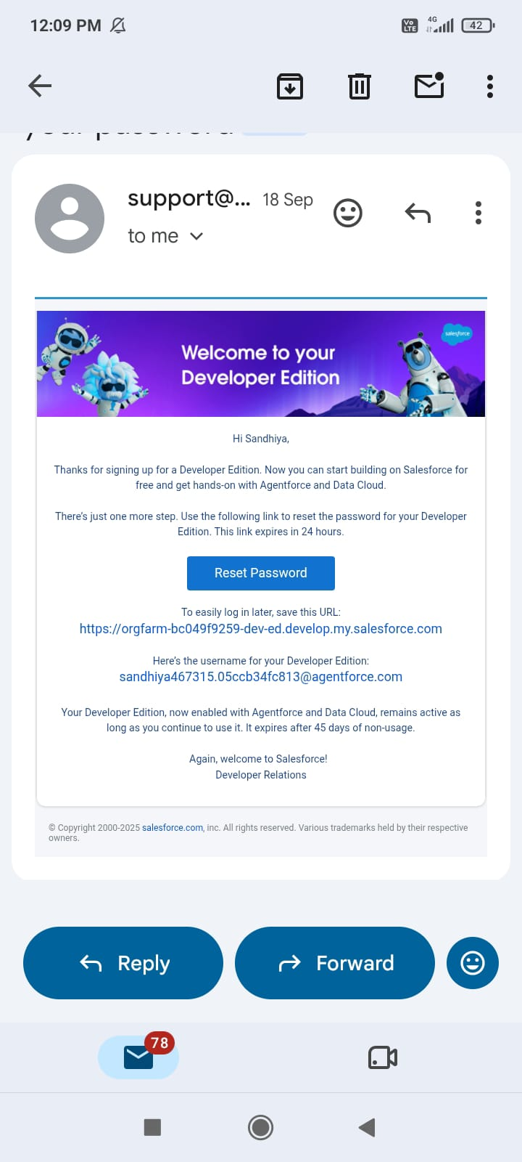
Developer Edition verification email
- Set a password, choose a security question and answer, then click Change Password.
- You will land on the Salesforce Setup home page.
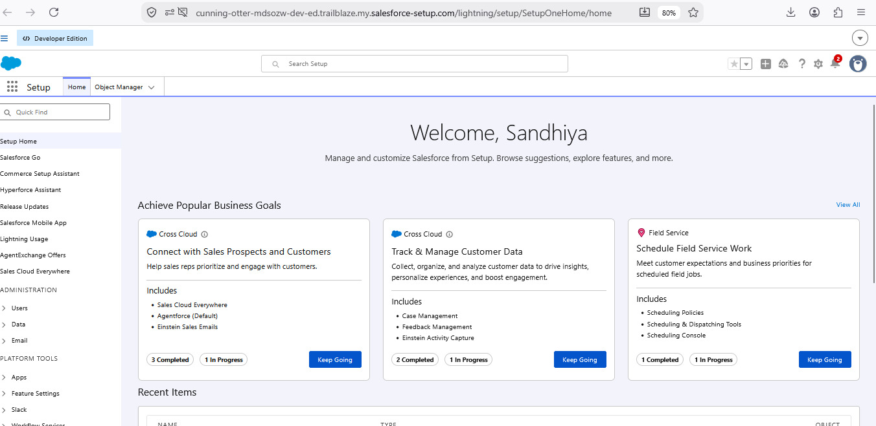
Salesforce Setup home page after activation

Milestone 2 – Custom Objects

Activity 1: Create the Student object
The Student object stores personal details, contact information and status for every learner.
- Go to Setup → Object Manager → Create → Custom Object.
- Label: Student; Plural Label: Students; Object Name: Student.
- Record Name: Student Name; Data Type: Text.
- Tick Allow Reports, Allow Activities and Track Field History; under Search Status tick Allow Search.
- Click Save.
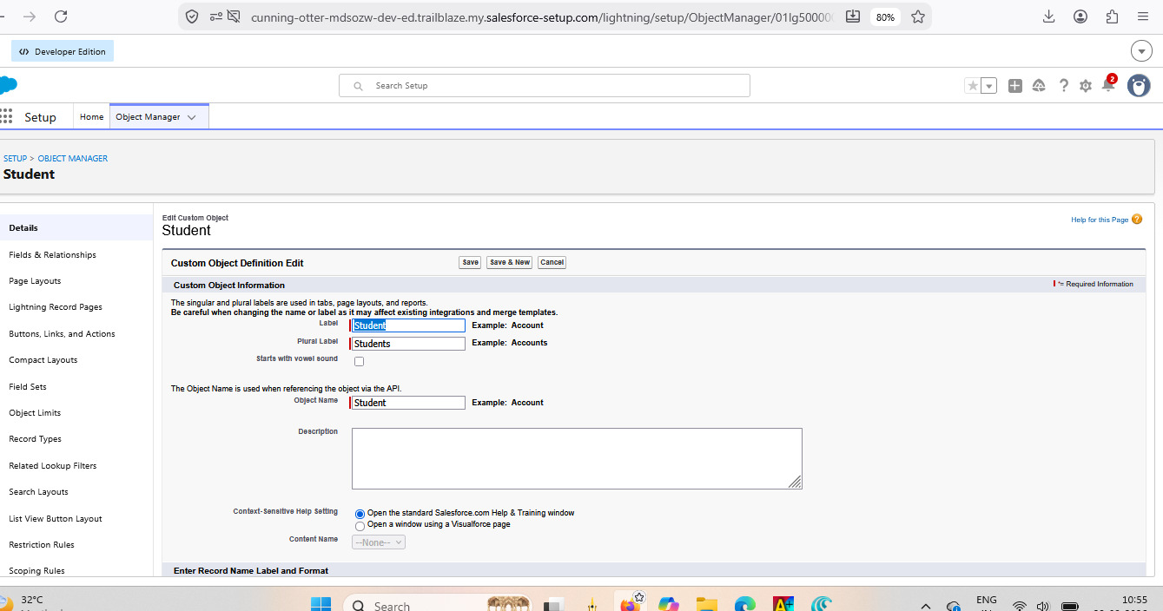
Student custom object definition
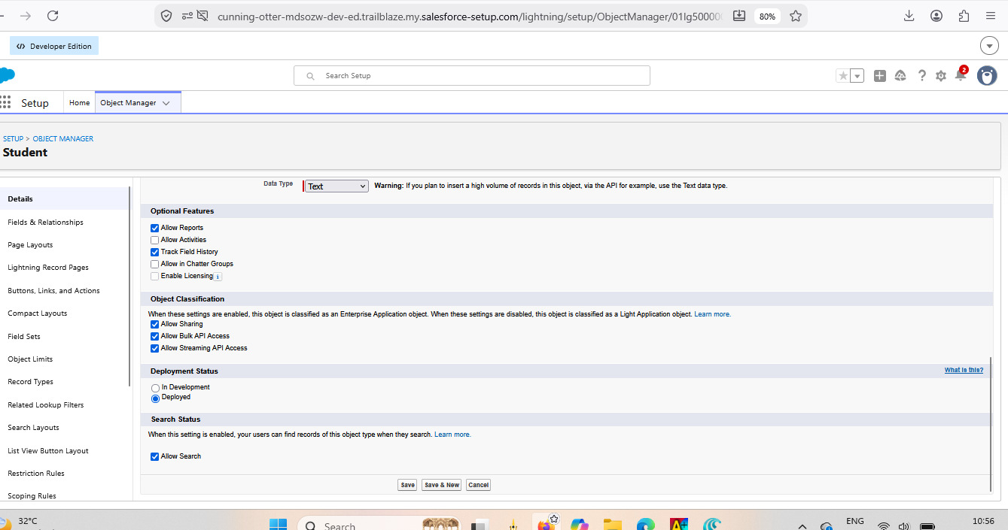
Optional features and deployment status
Repeat the same procedure to create the Course, Instructor and Enrollment objects.

Milestone 3 – Fields

Student object
Field label | Data type
Student Name | Text (standard)
Email | Email
Phone | Phone
Date of Birth | Date
Student Status | Picklist
Address | Text Area

Course object
Field label | Data type
Course Name | Text (standard)
Category | Picklist
Duration | Number / Text
Course Fee | Currency
Description | Text Area

Instructor object
Field label | Data type
Instructor Name | Text (standard)
Instructor Code | Text
Expertise | Picklist
Phone | Phone
Email | Email

Enrollment object
Field label | Data type
Student | Lookup (Student)
Course | Lookup (Course)
Instructor | Lookup (Instructor)
Enrollment Date | Date
Enrollment Status | Picklist
Fees Paid | Checkbox
Total Amount | Currency
Comments | Text Area

Milestone 4 – Relationships
Enrollment acts as the junction between the other objects, so three lookup fields are added on Enrollment__c.
Lookup | Related to | API name | Purpose
Student | Student__c | Student__c | Link each enrollment to a student
Course | Course__c | Course__c | Link each enrollment to a course
Instructor | Instructor__c | Instructor__c | Record who is assigned to the enrollment

Steps for each lookup:
- Setup → Object Manager → Enrollment → Fields & Relationships → New.
- Choose Lookup Relationship and click Next.
- Pick the related object and click Next.
- Enter the field label, set Child Relationship Name to Enrollments and mark the field required.
- Continue through field-level security and layout screens, then Save.
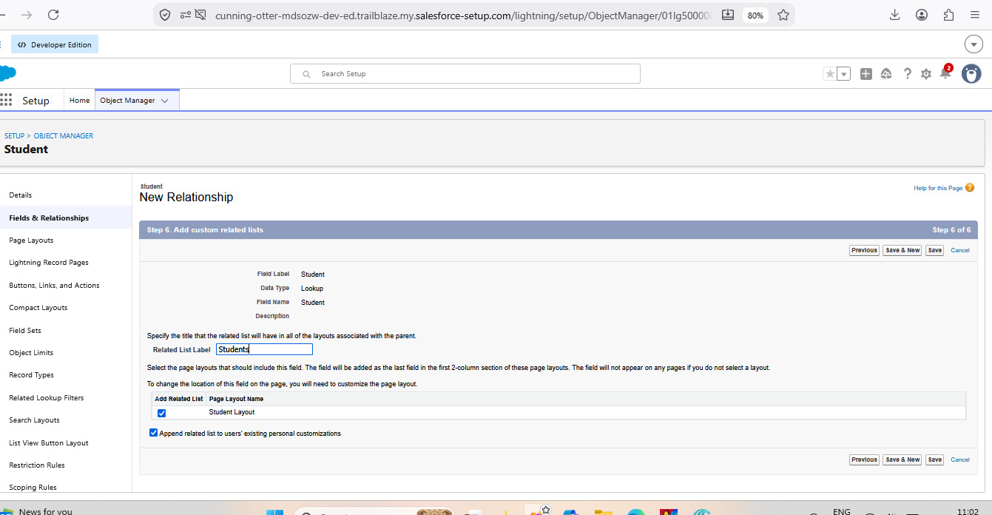
Lookup relationship configuration – Student
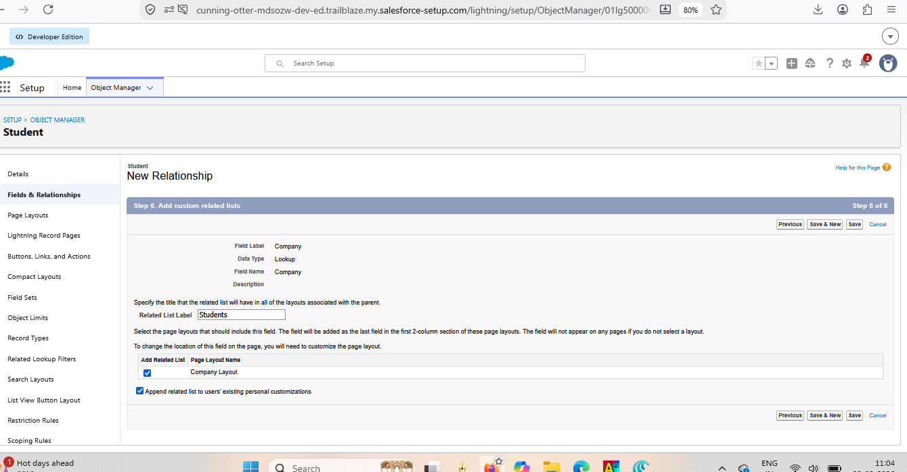
Lookup relationship configuration – Company
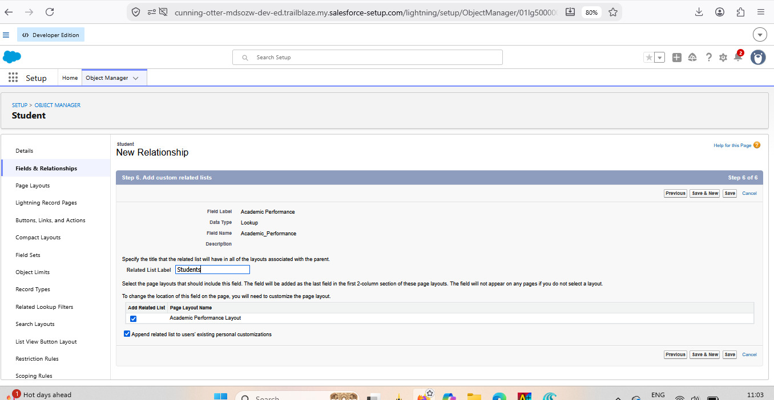
Lookup relationship configuration – Academic Performance

Milestone 5 – Validation Rules

Activity 1: Institutional email check on Student
Purpose: accept only institution-issued student email addresses.
- Setup → Object Manager → Student → Validation Rules → New.
- Rule name: Student_Email_Domain_Validation.
- Error condition formula: NOT(CONTAINS(Email__c, "@student.edu"))
- Error message: Email must be a valid student institutional email.
- Error location: Field → Email; click Save.

Activity 2: Fees must be paid before approval
Purpose: stop an enrollment from being marked Approved while fees are still unpaid.
- Setup → Object Manager → Enrollment → Validation Rules → New.
- Rule name: Fees_Must_Be_Paid_Before_Approval.
- Formula: AND( ISPICKVAL(Enrollment_Status__c, "Approved"), Fees_Paid__c = FALSE )
- Error message: Fees must be paid before approving an enrollment.
- Error location: Top of Page; click Save.

Milestone 6 – Approval Process

Activity 1: Enrollment request approval
Purpose: send each requested enrollment to the Training Manager for a decision.
- Setup → Approval Processes → choose Enrollment → Create New Approval Process → Use Standard Setup.
- Process name: Approval_Enrollment_Request.
- Entry criteria: Enrollment_Status__c equals "Requested".
- Add an approval step named Training Manager, with a specific Training Manager user as approver.
- Final Approval Action: field update setting Enrollment_Status__c to "Approved".
- Final Rejection Actions: field update setting Enrollment_Status__c to "Rejected", plus an email alert that notifies the student.
- Activate the process.

Milestone 7 – Tabs
- Setup → Tabs → Custom Object Tabs → New.
- Select the Student object and choose a tab style.
- Click Next, make it visible to all profiles, and Save.
Repeat these steps to create tabs for Courses, Instructors and Enrollments.
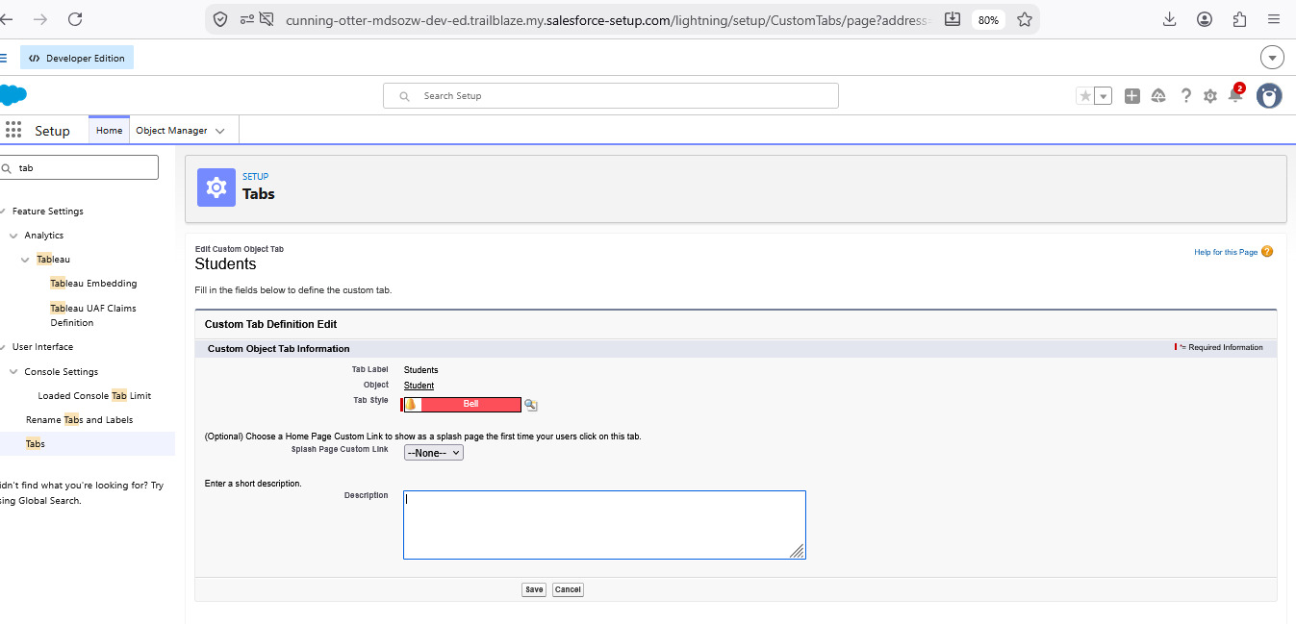
Custom object tab – Students

Milestone 8 – Lightning App
- Setup → App Manager → New Lightning App.
- App name: Student Enrollment & Course Management (developer name fills in automatically); optionally add a description.
- Branding is optional; choose Standard Navigation.
- Assign the app to profiles such as Admin, Enrollment Officer and Instructor.
- Add navigation items: Students, Courses, Instructors, Enrollments, Reports, Dashboards, Home and Tasks.
- Review and click Save & Finish.
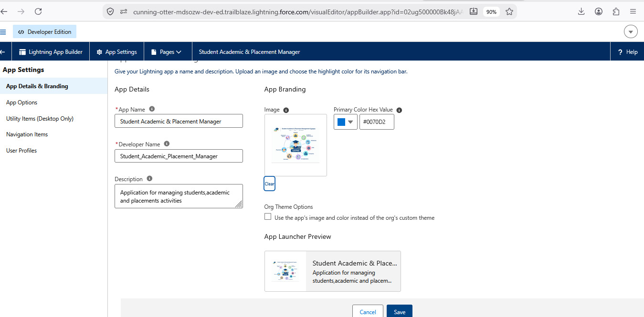
Lightning app details and branding
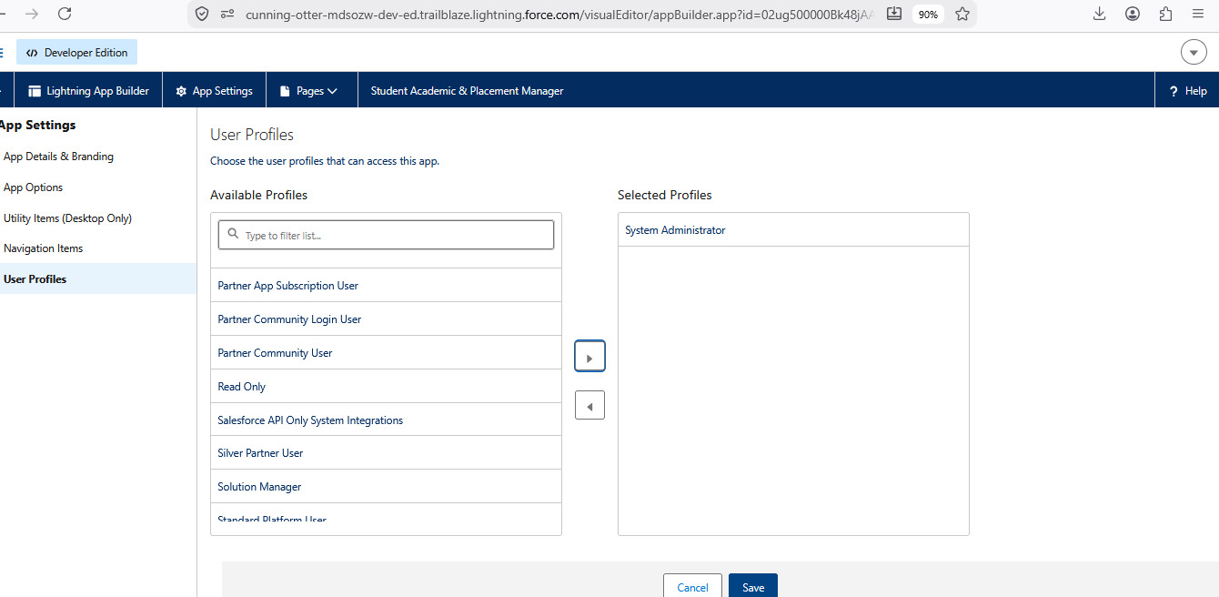
Assigning user profiles to the app
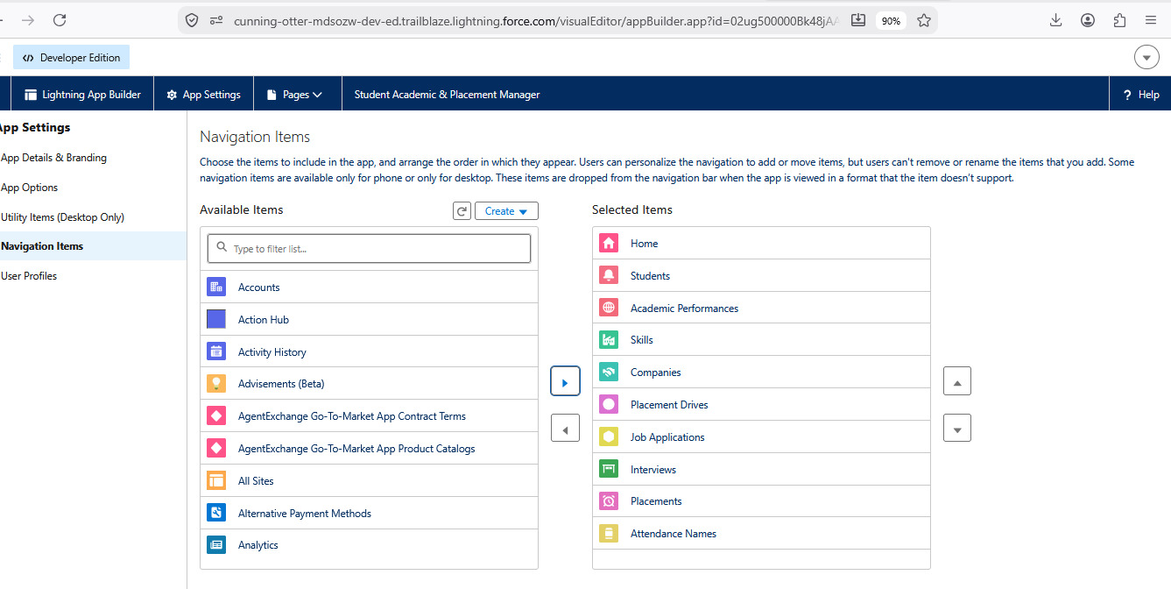
Lightning app navigation items

Milestone 9 – Record Types and Page Layouts

Activity 1: Record types on Enrollment
Purpose: keep first-time enrollments separate from re-enrollments.
- Object Manager → Enrollment → Record Types → New.
- Create New Enrollment (description: first-time enrollments) and Re-Enrollment (description: student enrolling again in a course).
- Enable both for Admin and Enrollment Officer profiles and pick the default layout.

Activity 2: Separate page layouts
- Object Manager → Enrollment → Page Layouts → New; clone the existing layout.
- Name one New Enrollment Layout (student, course, instructor, date, status, fees) and the other Re-Enrollment Layout (previous enrollment reference, re-enrollment reason, status, fees).
- Open Page Layout Assignment → Edit Assignment and map each record type to its layout for every profile; Save.

Activity 3: Related lists on parent objects
Add the Enrollments related list to the Student, Course and Instructor page layouts (Object Manager → object → Page Layouts → drag Enrollments from Related Lists → Save) so that all enrollments are visible from each parent record.
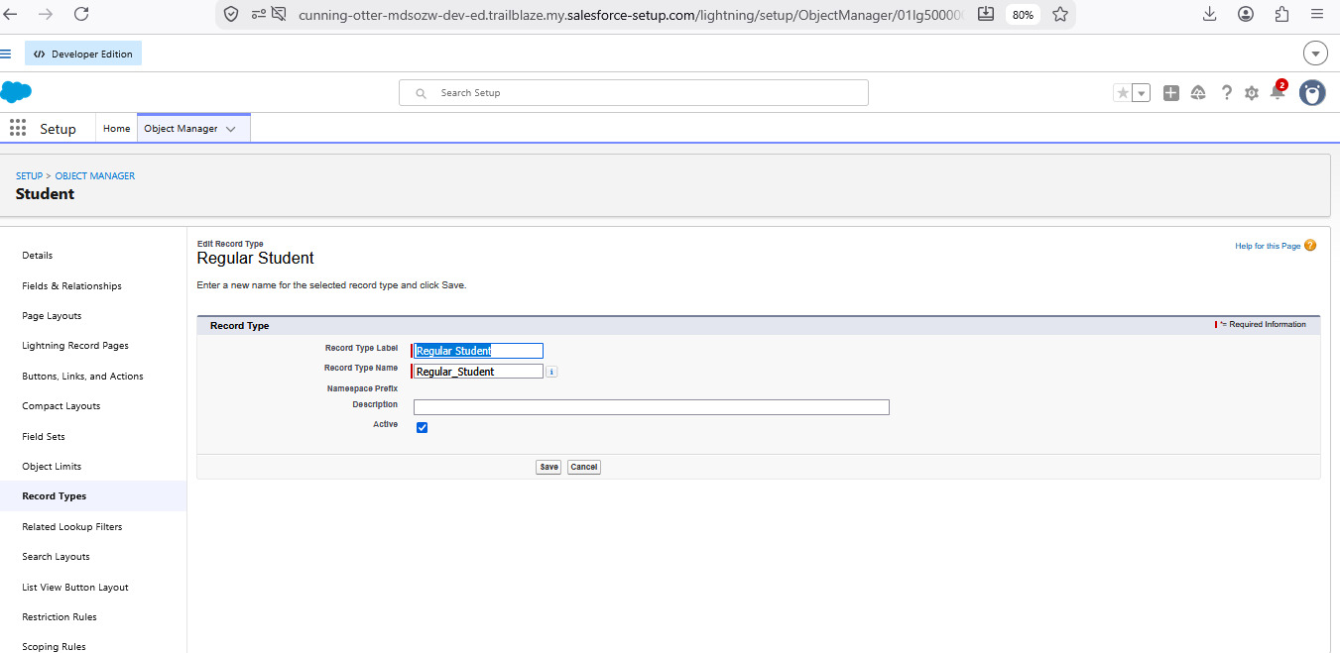
Enrollment record type
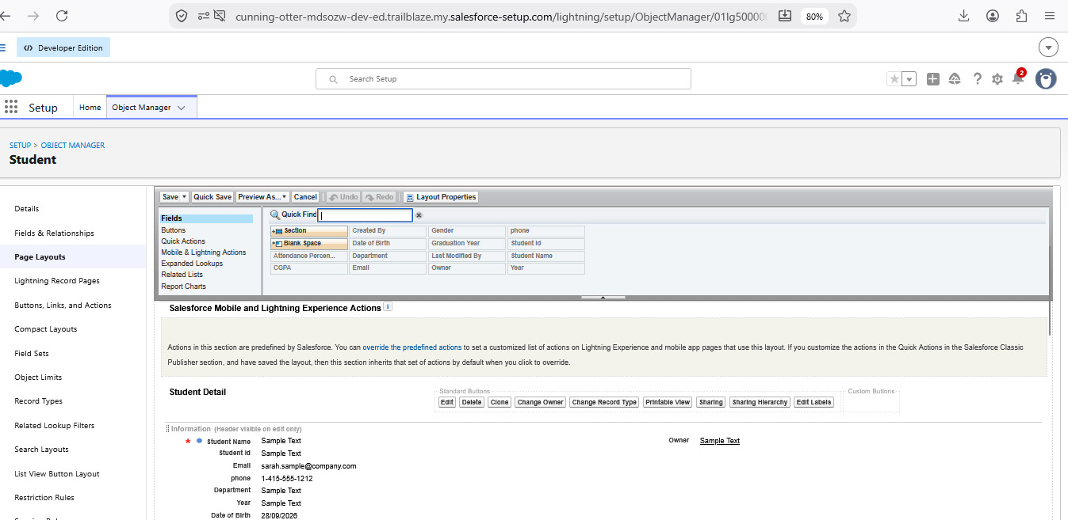
Student page layout

Milestone 10 – Automation with Flow

Activity 1: Set the enrollment date automatically
- Setup → Flows → New Flow → Record-Triggered Flow.
- Object: Enrollment; trigger: a record is created; optimize for Actions and Related Records.
- Add an Update Records element labelled Set Enrollment Date that uses the triggering record and sets Enrollment_Date__c to $Flow.CurrentDate.
- Save as SetEnrollmentDate and activate.

Activity 2: Actions when an enrollment is approved
Purpose: on approval, notify the student, alert the admin and mark the student Active.
- Create an email template and an email alert for the student.
- New Record-Triggered Flow on Enrollment, run on update, with condition Enrollment_Status__c equals Approved.
- Add Get Records for the related Student, then an email-alert action to the student.
- Optionally add an action to notify the admin.
- Add Update Records to set Student Status to Active.
- Save as Enrollment Approved Action and activate.

Activity 3: Assign the instructor by course category
Course category | Instructor assigned
Technical | Instructor A
Language | Instructor B
Non-Technical | Instructor C

- Create Instructor records with codes such as INSTR_A, INSTR_B and INSTR_C.
- Build a Record-Triggered Flow on Enrollment (created or updated).
- Add Get Records to fetch the related Course.
- Add a Decision on the course category with Technical, Language and Non-Technical outcomes.
- For each outcome, get the matching instructor and use Update Records to set Instructor__c to that instructor's Id.
- Save as AutoAssign_Instructor and activate.

Activity 4: Follow-up task for requested enrollments
Purpose: when an enrollment reaches Requested status, create a follow-up task for the admin.
- Record-Triggered Flow on Enrollment, run on create or update, with entry condition Enrollment_Status__c equals Requested.
- Add Get Records to find the admin user by username or profile.
- Create a date formula for the due date: TODAY() + 2.
- Add Create Records for a Task: subject "Follow up on enrollment request", owner = admin user, related to the enrollment, due date = formula, status Not Started, priority Normal.
- Save as Create_Followup_Task and activate.
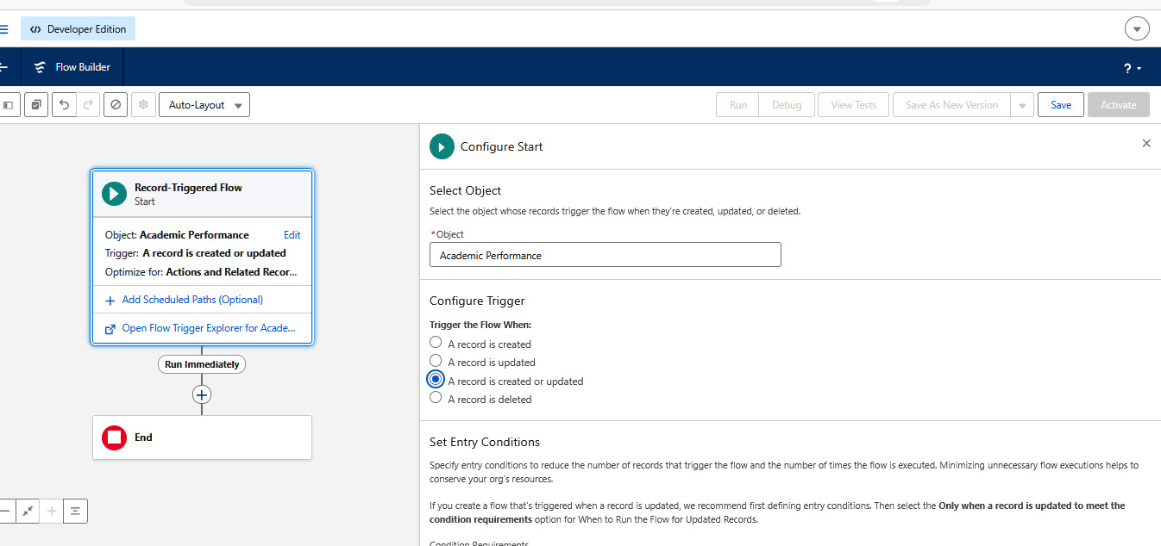
Record-triggered flow canvas

Milestone 11 – Reports
Report | Report type | Configuration
Students by Status | Students | Group rows by Status; show name, email and phone
Enrollments by Course | Enrollments | Group rows by course name; show record count
Pending Enrollment Approvals | Enrollments | Filter Enrollment Status = Requested; columns: student, course, owner, created date
Revenue Report – Fees Paid | Enrollments | Filter Fees Paid = TRUE; group by course; summarize the fee field

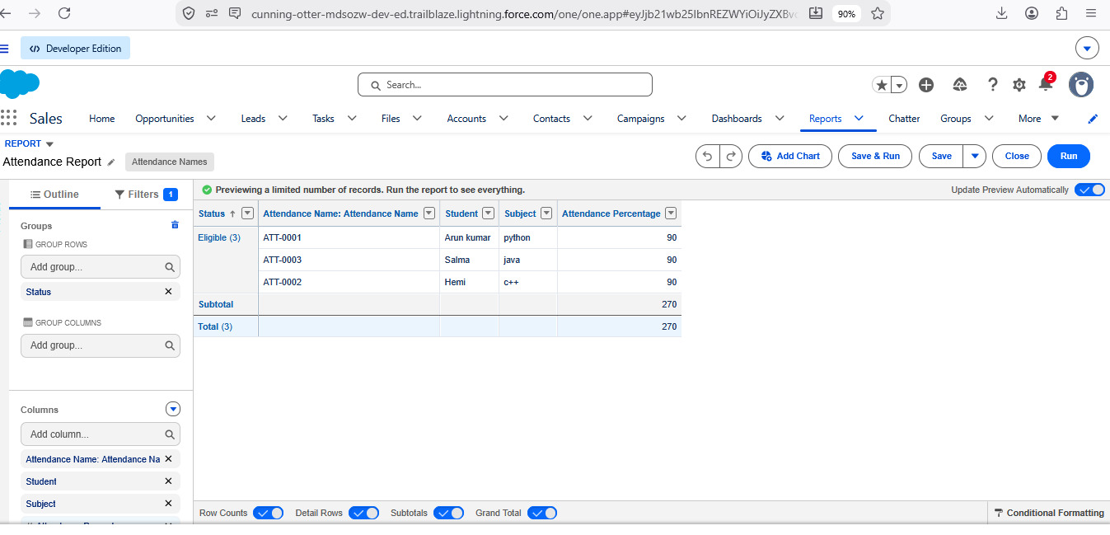
Attendance report
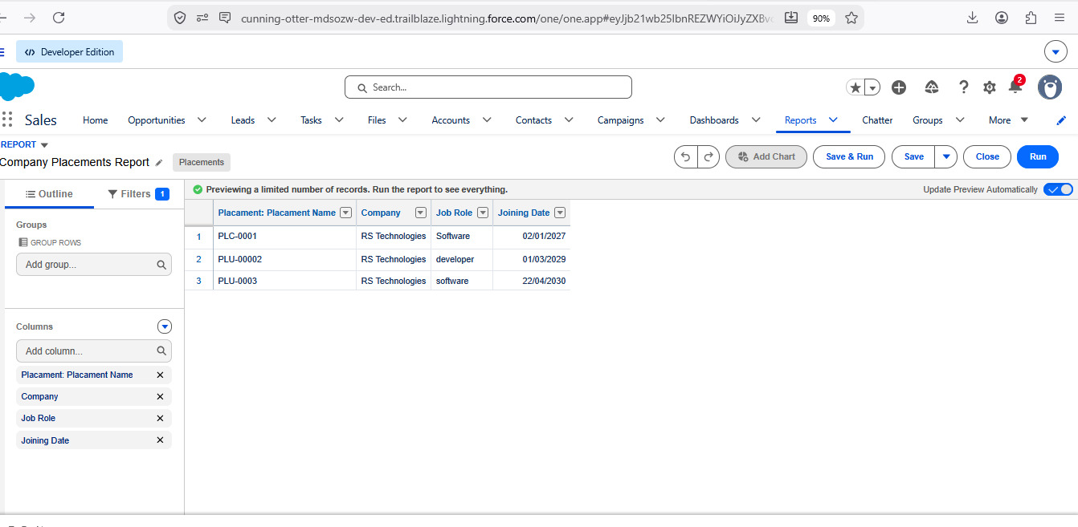
Company placements report

Milestone 12 – Dashboards
- Open Dashboards → New Dashboard and name it Student Management Dashboard.
- Choose or create a folder and click Create.
- Add these components: a donut chart from Students by Status, a bar chart from Enrollments by Course, a gauge from Revenue Report – Fees Paid (sum of revenue), and a table from Pending Enrollment Approvals.
- Arrange the components on the canvas, then Save and Done.
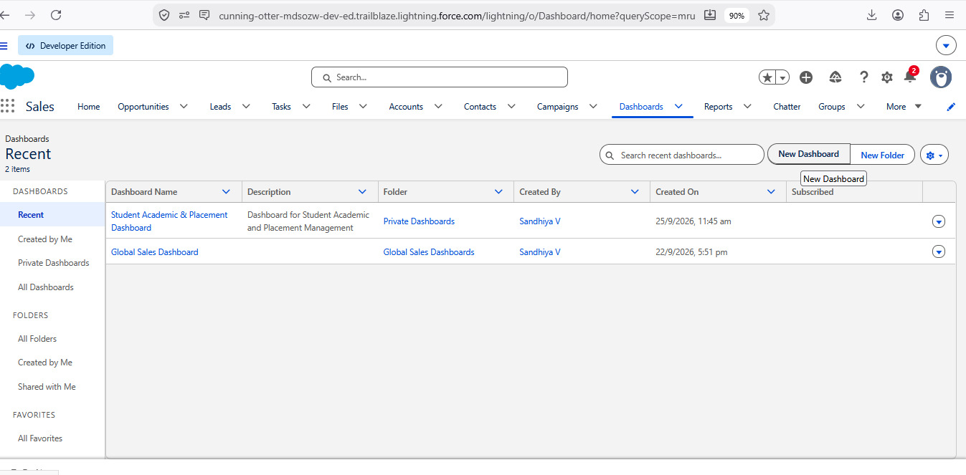
Dashboards list
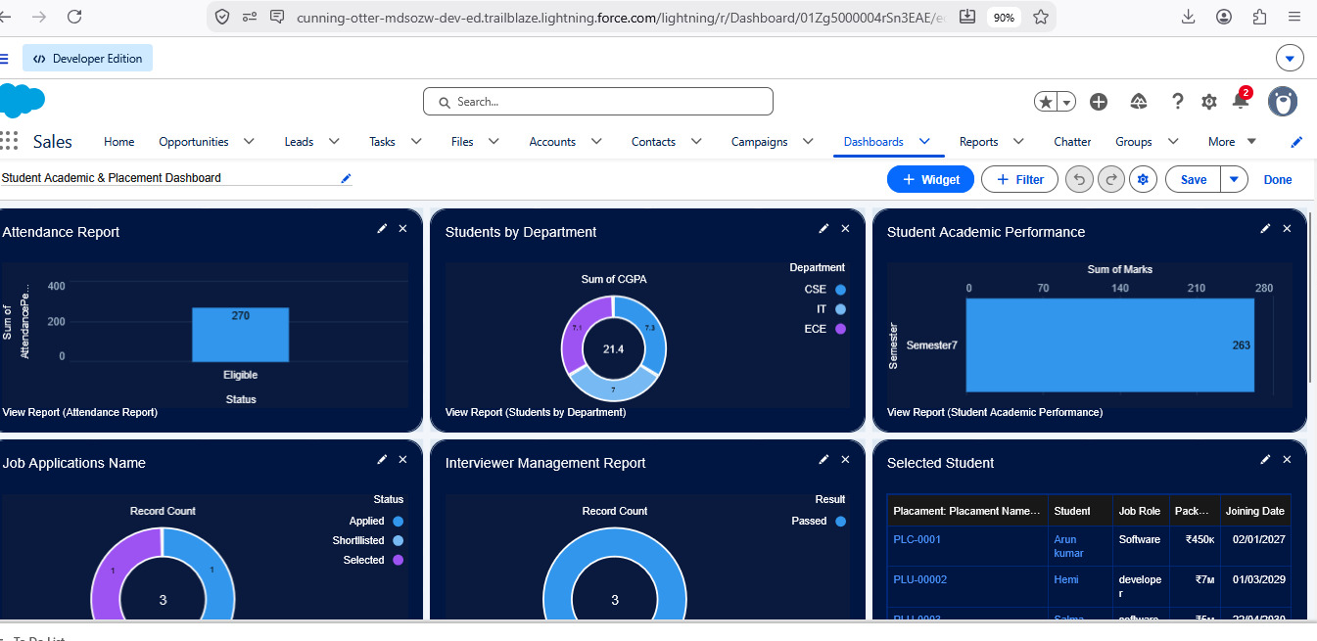
Student Management Dashboard

Milestone 13 – Security Setup

Activity 1: Profiles
Profile | Access
Admin | Full access
Enrollment Officer | Read, create and edit Enrollments; read (and edit if needed) Students and Courses
Instructor | Read-only access to assigned Enrollments

Create each profile by cloning an existing one (Setup → Profiles → New) and set the object permissions accordingly.

Activity 2: Permission sets
- Custom Object Access – extra access to the project objects when needed.
- Dashboard Editor – permission to create and customize reports and dashboards.
- Assign each permission set to the relevant users.

Activity 3: Sharing and organization-wide defaults
Object | Default access
Student | Public Read/Write
Course | Public Read/Write
Enrollment | Private

To let an instructor see only their own enrollments, add an Instructor User lookup on Enrollment and use a simple record-triggered flow to set the record owner to that user.

7. Functional & Performance Testing
Testing was carried out directly in the Salesforce interface and screenshots were captured as evidence. The checks covered:
- Creating student, course, instructor and enrollment records
- Validation rules for mandatory fields, eligibility and enrollment limits
- Record-type behavior for different enrollment types
- Flow execution for approvals, instructor assignment and task creation
- Reports and dashboards showing correct enrollment, revenue and status data
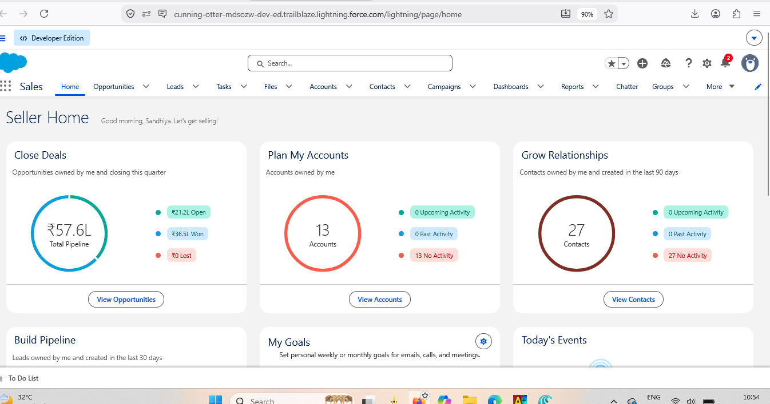
Application home screen confirming successful setup

8. Advantages & Disadvantages
Advantages | Disadvantages
All data held centrally | Depends on the Salesforce platform
Workflows run automatically | Needs effort to configure at the start
Reporting is available in real time

9. Conclusion
SECMS covers the whole academic lifecycle of a student – registration, course setup, enrollment, instructor allocation, approval, revenue tracking and reporting – inside Salesforce. Validation rules, flows, approval processes and dashboards raise data accuracy and cut manual effort, giving decision-makers dependable information. The project shows that a manual, paper-and-spreadsheet process can be turned into a scalable, reliable and easy-to-use digital solution.

10. Future Scope
- Online payment gateway integration
- A self-service portal for students
- Analytics that generate insights
- Mobile access

11. Appendix
- Source code: Salesforce declarative configuration
- Dataset: Salesforce custom objects
- Demo / repository: Salesforce Developer Org
Thank You

