Experiment 7

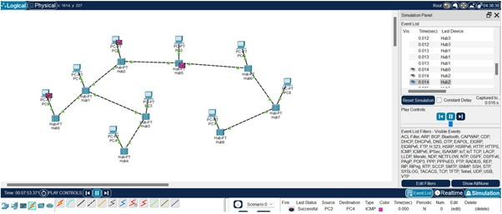

**(a)**

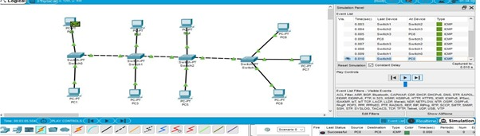

**(b)**