**import** pandas **as** pd

**import** numpy **as** np

**import** matplotlib.pyplot **as** plt

**import** seaborn **as** sns

In [35]: df**=**pd**.**read_csv('Churn_Modelling.csv')

df**.**head()

Out[35]:

|  | **RowNumber** | **CustomerId** | **Surname** | **CreditScore** | **Geography** | **Gender** | **Age** | **Tenure** | **Balance** | **NumOfProducts** | **HasCrCard** | **IsActiveMember** | **EstimatedSalary** | **Exited** |
| --- | --- | --- | --- | --- | --- | --- | --- | --- | --- | --- | --- | --- | --- | --- |
| **0** | 1 | 15634602 | Hargrave | 619 | France | Female | 42 | 2 | 0.00 | 1 | 1 | 1 | 101348.88 | 1 |
| **1** | 2 | 15647311 | Hill | 608 | Spain | Female | 41 | 1 | 83807.86 | 1 | 0 | 1 | 112542.58 | 0 |
| **2** | 3 | 15619304 | Onio | 502 | France | Female | 42 | 8 | 159660.80 | 3 | 1 | 0 | 113931.57 | 1 |
| **3** | 4 | 15701354 | Boni | 699 | France | Female | 39 | 1 | 0.00 | 2 | 0 | 0 | 93826.63 | 0 |
| **4** | 5 | 15737888 | Mitchell | 850 | Spain | Female | 43 | 2 | 125510.82 | 1 | 1 | 1 | 79084.10 | 0 |

**UNIVARIATE SCATTER PLOT**

In [3]: df**.**shape

Out[3]:(10000, 14)

In [4]: df**.**dtypes

Out[4]: RowNumber int64

CustomerId int64

Surname object

CreditScore int64

Geography object

Gender object

Age int64

Tenure int64

Balance float64

NumOfProducts int64

HasCrCard int64

IsActiveMember int64

EstimatedSalary float64

Exited int64

dtype: object

In [5]: df**.**dtypes[df**.**dtypes **==** 'float64']

Out[5]: Balance float64

EstimatedSalary float64

dtype: object

df**.**select_dtypes(include**=**['int64','float64','Int64'])**.**dtypes

Out[6]: RowNumber int64

CustomerId int64

CreditScore int64

Age int64

Tenure int64

Balance float64

NumOfProducts int64

HasCrCard int64

IsActiveMember int64

EstimatedSalary float64

Exited int64

dtype: object

In [7]: df**.**isnull()**.**any()

Out[7]:RowNumber False

CustomerId False

Surname False

CreditScore False

Geography False

Gender False

Age False

Tenure False

Balance False

NumOfProducts False

HasCrCard False

IsActiveMember False

EstimatedSalary False

Exited False

dtype: bool

In [8]:sns**.**displot(df**.**Age)

Out[8]: <seaborn.axisgrid.FacetGrid at 0x1be6afec280>

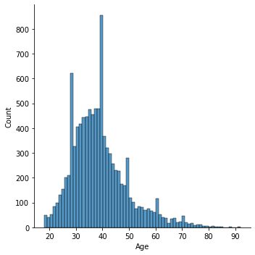

In[9]: sns**.**lineplot(df**.**Age,df**.**Gender)

Out[9]: C:\Users\sunda\anaconda3\lib\site-packages\seaborn\_decorators.py:36: FutureWarning: Pass the following variables as keyword args: x, y. From version 0.12, the only valid positional argument will be `data`, and passing other arguments without an explicit keyword will result in an error or misinterpretation.

warnings.warn(

<AxesSubplot:xlabel='Age', ylabel='Gender'>

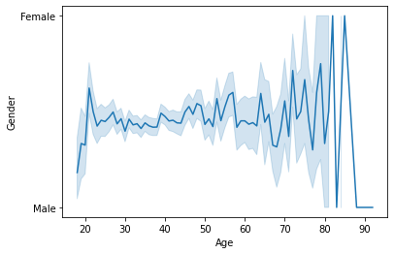

In[10]: sns**.**barplot(df**.**Geography**.**value_counts()**.**index,df**.**Geography**.**value_counts())

Out[10]:

C:\Users\sunda\anaconda3\lib\site-packages\seaborn\_decorators.py:36: FutureWarning: Pass the following variables as keyword args: x, y. From version 0.12, the only valid positional argument will be `data`, and passing other arguments without an explicit keyword will result in an error or misinterpretation.

warnings.warn(

<AxesSubplot:ylabel='Geography'>

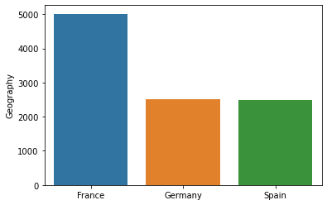

In[11]: sns**.**scatterplot(df**.**IsActiveMember,df**.**HasCrCard)

C:\Users\sunda\anaconda3\lib\site-packages\seaborn\_decorators.py:36: FutureWarning: Pass the following variables as keyword args: x, y. From version 0.12, the only valid positional argument will be `data`, and passing other arguments without an explicit keyword will result in an error or misinterpretation.

warnings.warn(

Out[11]: <AxesSubplot:xlabel='IsActiveMember', ylabel='HasCrCard'>

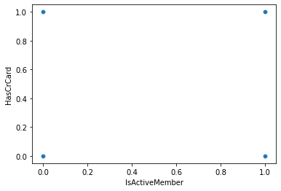

In[20]: sns**.**pairplot(df) *#multivariate analysis*

Out[20]:<seaborn.axisgrid.PairGrid at 0x1be70507670>

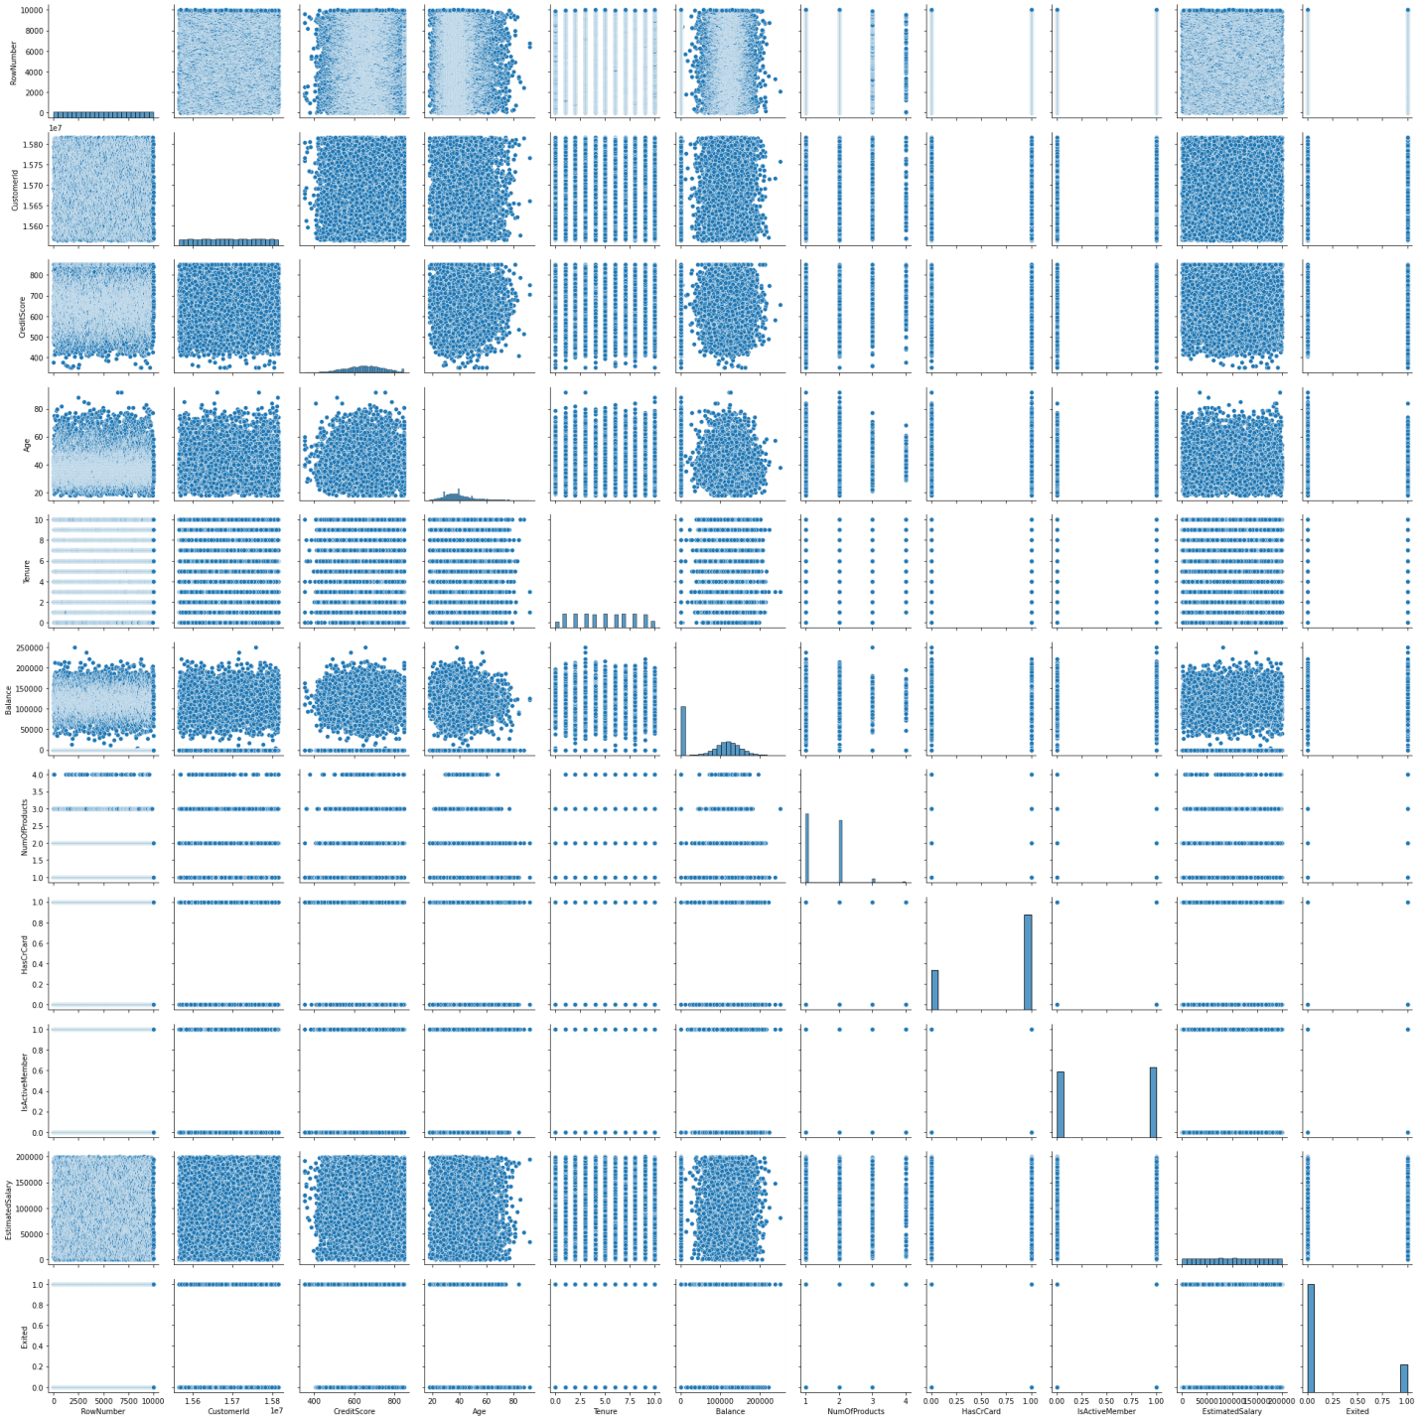

In[23]:

plt**.**pie(df**.**Geography**.**value_counts(),[0.2,0,0.1],shadow**=True**,labels**=**['France','Spain','Germany'],autopct**=**'%1.1f%%')

plt**.**title('GEOGRAPHY')

plt**.**show()

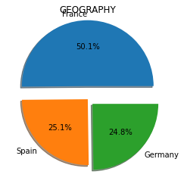

In[24]: sns**.**distplot(df**.**Exited)

C:\Users\sunda\anaconda3\lib\site packages\seaborn\distributions.py:2619: FutureWarning: `distplot` is a deprecated function and will be removed in a future version. Please adapt your code to use either `displot` (a figure-level function with similar flexibility) or `histplot` (an axes-level function for histograms).

warnings.warn(msg, FutureWarning)

Out[24]: <AxesSubplot:xlabel='Exited', ylabel='Density'>

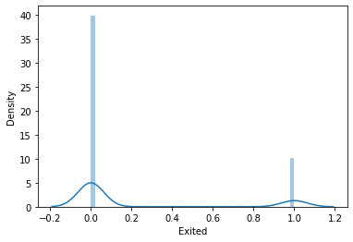

In[25]: sns**.**heatmap(df**.**corr(),annot**=True**)

Out[25]: <AxesSubplot:>

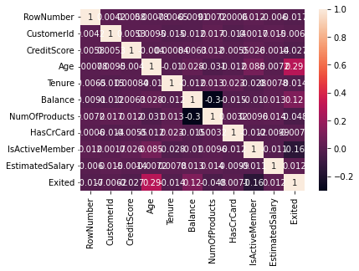

In[26]: df**.**corr()

Out[26]:

|  | **RowNumber** | **CustomerId** | **CreditScore** | **Age** | **Tenure** | **Balance** | **NumOfProducts** | **HasCrCard** | **IsActiveMember** | **EstimatedSalary** | **Exited** |
| --- | --- | --- | --- | --- | --- | --- | --- | --- | --- | --- | --- |
| **RowNumber** | 1.000000 | 0.004202 | 0.005840 | 0.000783 | -0.006495 | -0.009067 | 0.007246 | 0.000599 | 0.012044 | -0.005988 | -0.016571 |
| **CustomerId** | 0.004202 | 1.000000 | 0.005308 | 0.009497 | -0.014883 | -0.012419 | 0.016972 | -0.014025 | 0.001665 | 0.015271 | -0.006248 |
| **CreditScore** | 0.005840 | 0.005308 | 1.000000 | -0.003965 | 0.000842 | 0.006268 | 0.012238 | -0.005458 | 0.025651 | -0.001384 | -0.027094 |
| **Age** | 0.000783 | 0.009497 | -0.003965 | 1.000000 | -0.009997 | 0.028308 | -0.030680 | -0.011721 | 0.085472 | -0.007201 | 0.285323 |
| **Tenure** | -0.006495 | -0.014883 | 0.000842 | -0.009997 | 1.000000 | -0.012254 | 0.013444 | 0.022583 | -0.028362 | 0.007784 | -0.014001 |
| **Balance** | -0.009067 | -0.012419 | 0.006268 | 0.028308 | -0.012254 | 1.000000 | -0.304180 | -0.014858 | -0.010084 | 0.012797 | 0.118533 |
| **NumOfProducts** | 0.007246 | 0.016972 | 0.012238 | -0.030680 | 0.013444 | -0.304180 | 1.000000 | 0.003183 | 0.009612 | 0.014204 | -0.047820 |
| **HasCrCard** | 0.000599 | -0.014025 | -0.005458 | -0.011721 | 0.022583 | -0.014858 | 0.003183 | 1.000000 | -0.011866 | -0.009933 | -0.007138 |
| **IsActiveMember** | 0.012044 | 0.001665 | 0.025651 | 0.085472 | -0.028362 | -0.010084 | 0.009612 | -0.011866 | 1.000000 | -0.011421 | -0.156128 |
| **EstimatedSalary** | -0.005988 | 0.015271 | -0.001384 | -0.007201 | 0.007784 | 0.012797 | 0.014204 | -0.009933 | -0.011421 | 1.000000 | 0.012097 |
| **Exited** | -0.016571 | -0.006248 | -0.027094 | 0.285323 | -0.014001 | 0.118533 | -0.047820 | -0.007138 | -0.156128 | 0.012097 | 1.000000 |

In [37]:

sns**.**boxplot(df**.**Exited)

C:\Users\sunda\anaconda3\lib\site-packages\seaborn\_decorators.py:36: FutureWarning: Pass the following variable as a keyword arg: x. From version 0.12, the only valid positional argument will be `data`, and passing other arguments without an explicit keyword will result in an error or misinterpretation.

warnings.warn(

Out[37]: <AxesSubplot:xlabel='Exited'>

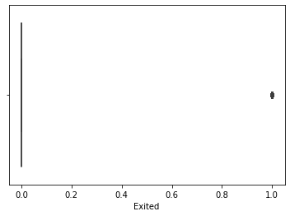

In[38]: df**.**describe()

Out[38]:

|  | **RowNumber** | **CustomerId** | **CreditScore** | **Age** | **Tenure** | **Balance** | **NumOfProducts** | **HasCrCard** | **IsActiveMember** | **EstimatedSalary** | **Exited** |
| --- | --- | --- | --- | --- | --- | --- | --- | --- | --- | --- | --- |
| **count** | 10000.00000 | 1.000000e+04 | 10000.000000 | 10000.000000 | 10000.000000 | 10000.000000 | 10000.000000 | 10000.00000 | 10000.000000 | 10000.000000 | 10000.000000 |
| **mean** | 5000.50000 | 1.569094e+07 | 650.528800 | 38.921800 | 5.012800 | 76485.889288 | 1.530200 | 0.70550 | 0.515100 | 100090.239881 | 0.203700 |
| **std** | 2886.89568 | 7.193619e+04 | 96.653299 | 10.487806 | 2.892174 | 62397.405202 | 0.581654 | 0.45584 | 0.499797 | 57510.492818 | 0.402769 |
| **min** | 1.00000 | 1.556570e+07 | 350.000000 | 18.000000 | 0.000000 | 0.000000 | 1.000000 | 0.00000 | 0.000000 | 11.580000 | 0.000000 |
| **25%** | 2500.75000 | 1.562853e+07 | 584.000000 | 32.000000 | 3.000000 | 0.000000 | 1.000000 | 0.00000 | 0.000000 | 51002.110000 | 0.000000 |
| **50%** | 5000.50000 | 1.569074e+07 | 652.000000 | 37.000000 | 5.000000 | 97198.540000 | 1.000000 | 1.00000 | 1.000000 | 100193.915000 | 0.000000 |
| **75%** | 7500.25000 | 1.575323e+07 | 718.000000 | 44.000000 | 7.000000 | 127644.240000 | 2.000000 | 1.00000 | 1.000000 | 149388.247500 | 0.000000 |
| **max** | 10000.00000 | 1.581569e+07 | 850.000000 | 92.000000 | 10.000000 | 250898.090000 | 4.000000 | 1.00000 | 1.000000 | 199992.480000 | 1.000000 |

In [39]: df**.**median()

C:\Users\sunda\AppData\Local\Temp\ipykernel_9816\530051474.py:1: FutureWarning: Dropping of nuisance columns in DataFrame reductions (with 'numeric_only=None') is deprecated; in a future version this will raise TypeError. Select only valid columns before calling the reduction.

df.median()

Out[39]: RowNumber 5.000500e+03

CustomerId 1.569074e+07

CreditScore 6.520000e+02

Age 3.700000e+01

Tenure 5.000000e+00

Balance 9.719854e+04

NumOfProducts 1.000000e+00

HasCrCard 1.000000e+00

IsActiveMember 1.000000e+00

EstimatedSalary 1.001939e+05

Exited 0.000000e+00

dtype: float64

In [44]: **from** sklearn.preprocessing **import** LabelEncoder

In [45]: le**=**LabelEncoder()

In [46]: df**.**Age**=**le**.**fit_transform(df**.**Age)df**.**HasCrCard**=**le**.**fit_transform(df**.**HasCrCard)

In [47]: df**.**head()

Out[47]:

| **RowNumber** | **CustomerId** | **Surname** | **CreditScore** | **Geography** | **Gender** | **Age** | **Tenure** | **Balance** | **NumOfProducts** | **HasCrCard** | **IsActiveMember** | **EstimatedSalary** | **Exited** |
| --- | --- | --- | --- | --- | --- | --- | --- | --- | --- | --- | --- | --- | --- |
| **0** | 1 | 15634602 | Hargrave | 619 | France | Female | 24 | 2 | 0.00 | 1 | 1 | 1 | 101348.88 | 1 |
| **1** | 2 | 15647311 | Hill | 608 | Spain | Female | 23 | 1 | 83807.86 | 1 | 0 | 1 | 112542.58 | 0 |
| **2** | 3 | 15619304 | Onio | 502 | France | Female | 24 | 8 | 159660.80 | 3 | 1 | 0 | 113931.57 | 1 |
| **3** | 4 | 15701354 | Boni | 699 | France | Female | 21 | 1 | 0.00 | 2 | 0 | 0 | 93826.63 | 0 |
| **4** | 5 | 15737888 | Mitchell | 850 | Spain | Female | 25 | 2 | 125510.82 | 1 | 1 | 1 | 79084.10 | 0 |

In [48]: df_main**=**pd**.**get_dummies(df,columns**=**['Gender'])

df_main**.**head()

Out[48]:

|  | **RowNumber** | **CustomerId** | **Surname** | **CreditScore** | **Geography** | **Age** | **Tenure** | **Balance** | **NumOfProducts** | **HasCrCard** | **IsActiveMember** | **EstimatedSalary** | **Exited** | **Gender_Female** | **Gender_Male** |
| --- | --- | --- | --- | --- | --- | --- | --- | --- | --- | --- | --- | --- | --- | --- | --- |
| **0** | 1 | 15634602 | Hargrave | 619 | France | 24 | 2 | 0.00 | 1 | 1 | 1 | 101348.88 | 1 | 1 | 0 |
| **1** | 2 | 15647311 | Hill | 608 | Spain | 23 | 1 | 83807.86 | 1 | 0 | 1 | 112542.58 | 0 | 1 | 0 |
| **2** | 3 | 15619304 | Onio | 502 | France | 24 | 8 | 159660.80 | 3 | 1 | 0 | 113931.57 | 1 | 1 | 0 |
| **3** | 4 | 15701354 | Boni | 699 | France | 21 | 1 | 0.00 | 2 | 0 | 0 | 93826.63 | 0 | 1 | 0 |
| **4** | 5 | 15737888 | Mitchell | 850 | Spain | 25 | 2 | 125510.82 | 1 | 1 | 1 | 79084.10 | 0 | 1 | 0 |

In [49]: df_main**.**corr()

Out[49]:

| **RowNumber** | **CustomerId** | **CreditScore** | **Age** | **Tenure** | **Balance** | **NumOfProducts** | **HasCrCard** | **IsActiveMember** | **EstimatedSalary** | **Exited** | **Gender_Female** | **Gender_Male** |
| --- | --- | --- | --- | --- | --- | --- | --- | --- | --- | --- | --- | --- |
| **RowNumber** | 1.000000 | 0.004202 | 0.005840 | 0.000747 | -0.006495 | -0.009067 | 0.007246 | 0.000599 | 0.012044 | -0.005988 | -0.016571 | -0.018196 | 0.018196 |
| **CustomerId** | 0.004202 | 1.000000 | 0.005308 | 0.009440 | -0.014883 | -0.012419 | 0.016972 | -0.014025 | 0.001665 | 0.015271 | -0.006248 | 0.002641 | -0.002641 |
| **CreditScore** | 0.005840 | 0.005308 | 1.000000 | -0.004017 | 0.000842 | 0.006268 | 0.012238 | -0.005458 | 0.025651 | -0.001384 | -0.027094 | 0.002857 | -0.002857 |
| **Age** | 0.000747 | 0.009440 | -0.004017 | 1.000000 | -0.009936 | 0.028275 | -0.030707 | -0.011697 | 0.085408 | -0.007214 | 0.285537 | 0.027664 | -0.027664 |
| **Tenure** | -0.006495 | -0.014883 | 0.000842 | -0.009936 | 1.000000 | -0.012254 | 0.013444 | 0.022583 | -0.028362 | 0.007784 | -0.014001 | -0.014733 | 0.014733 |
| **Balance** | -0.009067 | -0.012419 | 0.006268 | 0.028275 | -0.012254 | 1.000000 | -0.304180 | -0.014858 | -0.010084 | 0.012797 | 0.118533 | -0.012087 | 0.012087 |
| **NumOfProducts** | 0.007246 | 0.016972 | 0.012238 | -0.030707 | 0.013444 | -0.304180 | 1.000000 | 0.003183 | 0.009612 | 0.014204 | -0.047820 | 0.021859 | -0.021859 |
| **HasCrCard** | 0.000599 | -0.014025 | -0.005458 | -0.011697 | 0.022583 | -0.014858 | 0.003183 | 1.000000 | -0.011866 | -0.009933 | -0.007138 | -0.005766 | 0.005766 |
| **IsActiveMember** | 0.012044 | 0.001665 | 0.025651 | 0.085408 | -0.028362 | -0.010084 | 0.009612 | -0.011866 | 1.000000 | -0.011421 | -0.156128 | -0.022544 | 0.022544 |
| **EstimatedSalary** | -0.005988 | 0.015271 | -0.001384 | -0.007214 | 0.007784 | 0.012797 | 0.014204 | -0.009933 | -0.011421 | 1.000000 | 0.012097 | 0.008112 | -0.008112 |
| **Exited** | -0.016571 | -0.006248 | -0.027094 | 0.285537 | -0.014001 | 0.118533 | -0.047820 | -0.007138 | -0.156128 | 0.012097 | 1.000000 | 0.106512 | -0.106512 |
| **Gender_Female** | -0.018196 | 0.002641 | 0.002857 | 0.027664 | -0.014733 | -0.012087 | 0.021859 | -0.005766 | -0.022544 | 0.008112 | 0.106512 | 1.000000 | -1.000000 |
| **Gender_Male** | 0.018196 | -0.002641 | -0.002857 | -0.027664 | 0.014733 | 0.012087 | -0.021859 | 0.005766 | 0.022544 | -0.008112 | -0.106512 | -1.000000 | 1.000000 |

In [51]: plt**.**figure(figsize**=**(12,10))

sns**.**heatmap(df_main**.**corr(),annot**=True**)

Out[51]: <AxesSubplot:>

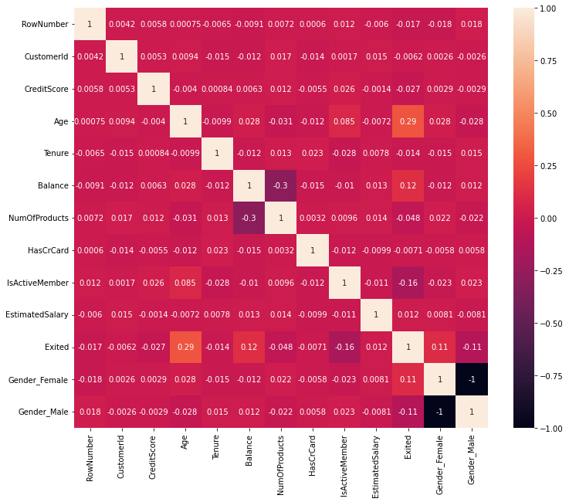

In[53]: y**=**df_main['Tenure']

y

Out[53]:

0 2

1 1

2 8

3 1

4 2

..

9995 5

9996 10

9997 7

9998 3

9999 4

Name: Tenure, Length: 10000, dtype: int64

In [59]: X**=**df_main**.**drop(columns**=**['Tenure'],axis**=**1)

X**.**head()

Out[59]:

|  | **RowNumber** | **CustomerId** | **Surname** | **CreditScore** | **Geography** | **Age** | **Balance** | **NumOfProducts** | **HasCrCard** | **IsActiveMember** | **EstimatedSalary** | **Exited** | **Gender_Female** | **Gender_Male** |
| --- | --- | --- | --- | --- | --- | --- | --- | --- | --- | --- | --- | --- | --- | --- |
| **0** | 1 | 15634602 | Hargrave | 619 | France | 24 | 0.00 | 1 | 1 | 1 | 101348.88 | 1 | 1 | 0 |
| **1** | 2 | 15647311 | Hill | 608 | Spain | 23 | 83807.86 | 1 | 0 | 1 | 112542.58 | 0 | 1 | 0 |
| **2** | 3 | 15619304 | Onio | 502 | France | 24 | 159660.80 | 3 | 1 | 0 | 113931.57 | 1 | 1 | 0 |
| **3** | 4 | 15701354 | Boni | 699 | France | 21 | 0.00 | 2 | 0 | 0 | 93826.63 | 0 | 1 | 0 |
| **4** | 5 | 15737888 | Mitchell | 850 | Spain | 25 | 125510.82 | 1 | 1 | 1 | 79084.10 | 0 | 1 | 0 |

In [66]: **from** sklearn.preprocessing **import** scale

In[69]: X**=** df**.**drop(columns**=**['Age'])

X**.**head()

Out[69]:

|  | **RowNumber** | **CustomerId** | **Surname** | **CreditScore** | **Geography** | **Gender** | **Tenure** | **Balance** | **NumOfProducts** | **HasCrCard** | **IsActiveMember** | **EstimatedSalary** | **Exited** |
| --- | --- | --- | --- | --- | --- | --- | --- | --- | --- | --- | --- | --- | --- |
| **0** | 1 | 15634602 | Hargrave | 619 | France | Female | 2 | 0.00 | 1 | 1 | 1 | 101348.88 | 1 |
| **1** | 2 | 15647311 | Hill | 608 | Spain | Female | 1 | 83807.86 | 1 | 0 | 1 | 112542.58 | 0 |
| **2** | 3 | 15619304 | Onio | 502 | France | Female | 8 | 159660.80 | 3 | 1 | 0 | 113931.57 | 1 |
| **3** | 4 | 15701354 | Boni | 699 | France | Female | 1 | 0.00 | 2 | 0 | 0 | 93826.63 | 0 |
| **4** | 5 | 15737888 | Mitchell | 850 | Spain | Female | 2 | 125510.82 | 1 | 1 | 1 | 79084.10 | 0 |

In [71]: y**=**df**.**Age

y**.**head()

Out[71]:

0 24

1 23

2 24

3 21

4 25

Name: Age, dtype: int64

In [72]:

**from** sklearn.model_selection **import** train_test_split

x_train,x_test,y_train,y_test**=**train_test_split(X,y,test_size**=**0.2,random_state**=**0)

In[73]: x_train**.**shape

Out[73]: (8000, 13)

In [74]: x_test**.**shape

Out[74]: (2000, 13)

In [75]: y_test

Out[75]:

9394 17

898 22

2398 24

5906 14

2343 20

..

1037 6

2899 17

9549 18

2740 16

6690 12

Name: Age, Length: 2000, dtype: int64

In [76]: **from** sklearn.linear_model **import** LinearRegression

In [77]: MLR**=** LinearRegression()