RE-2022-668940

*by* Research Paper

Submission date: 25-Oct-2025 10:15PM (UTC+0700)

Submission ID: 2792108430

File name: RE-2022-668940.docx (182.02K)

Word count: 3363

Character count: 19573

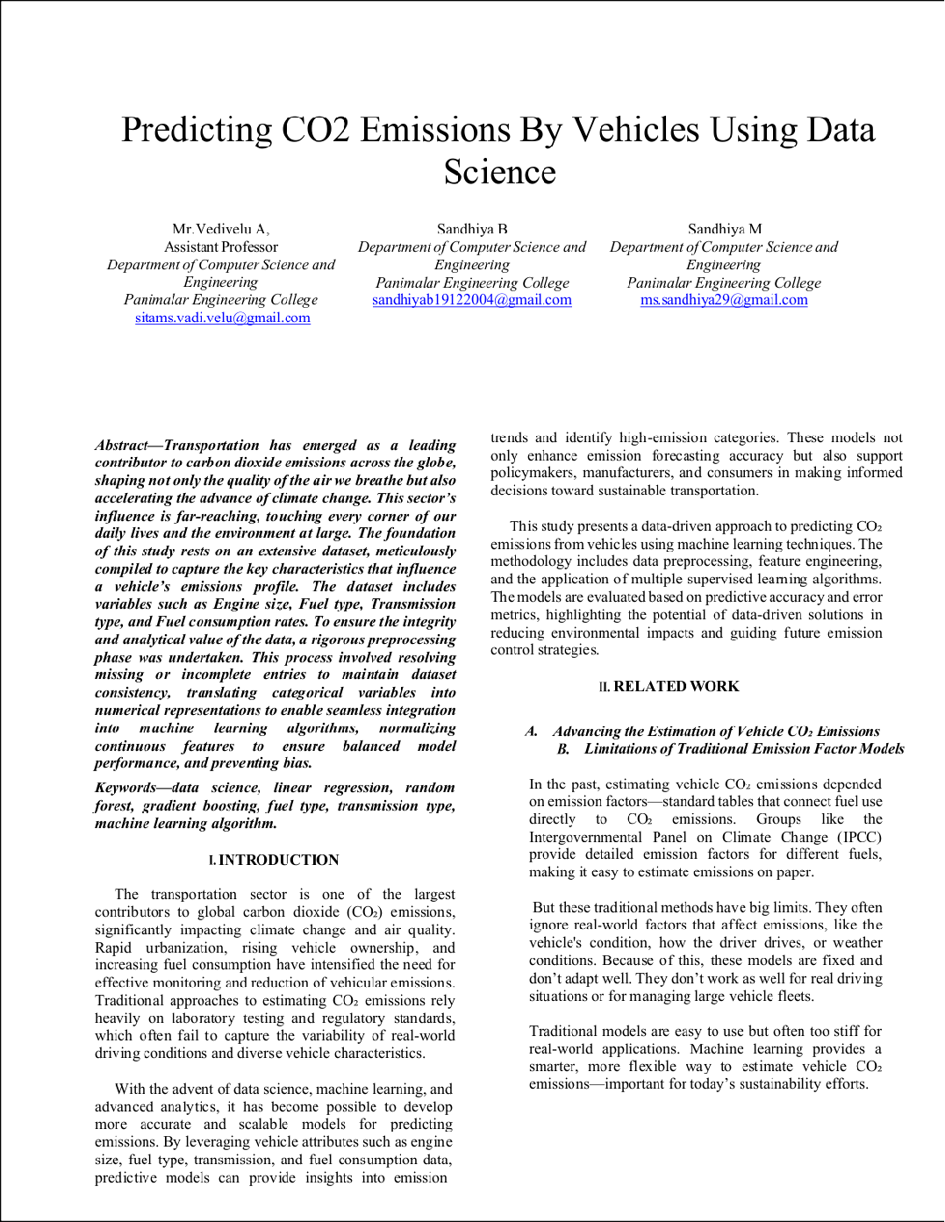

1

2

4

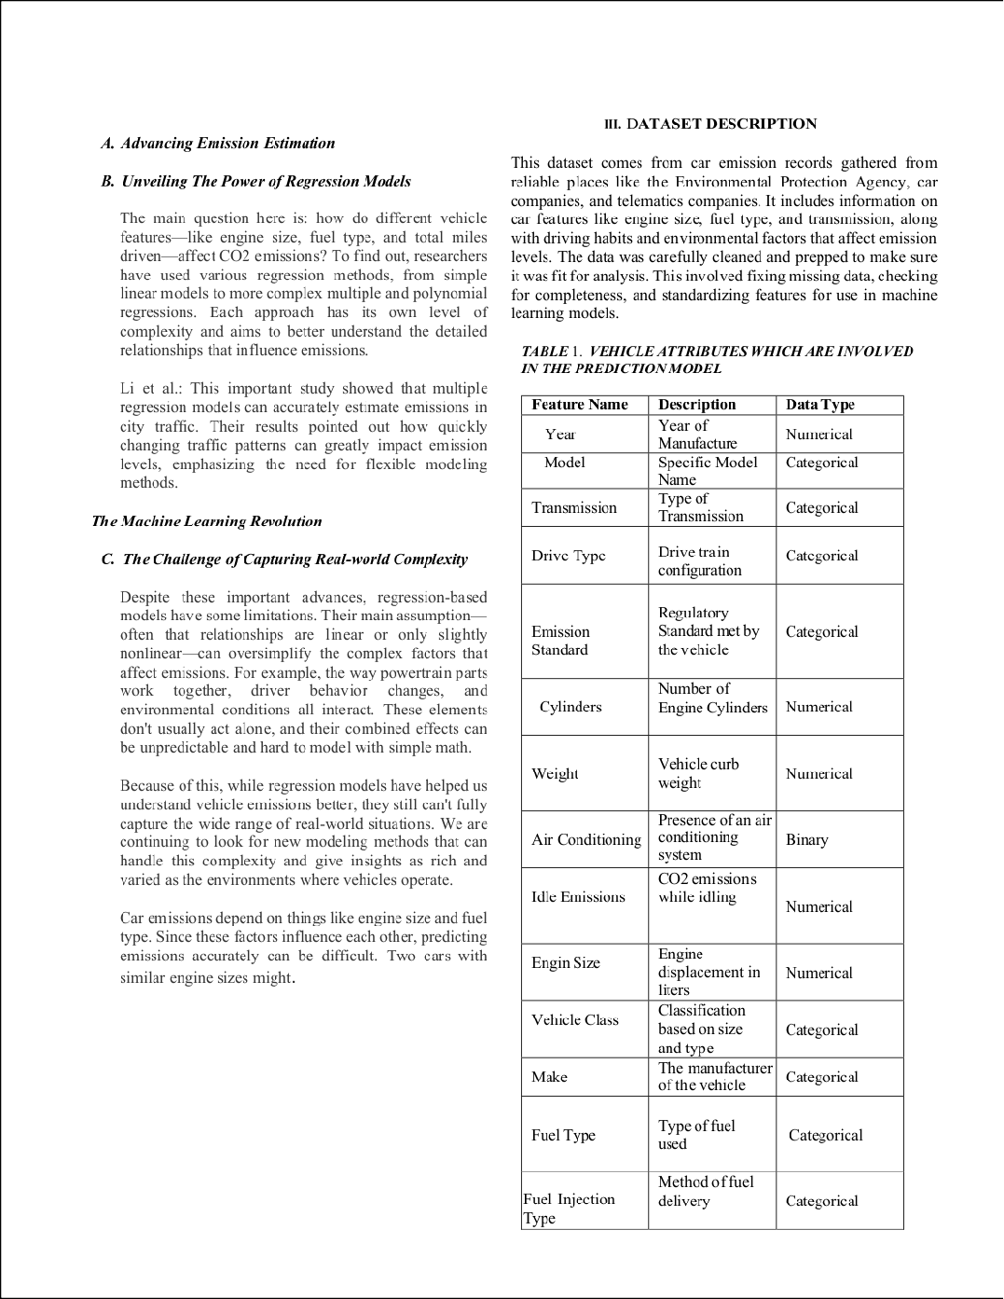

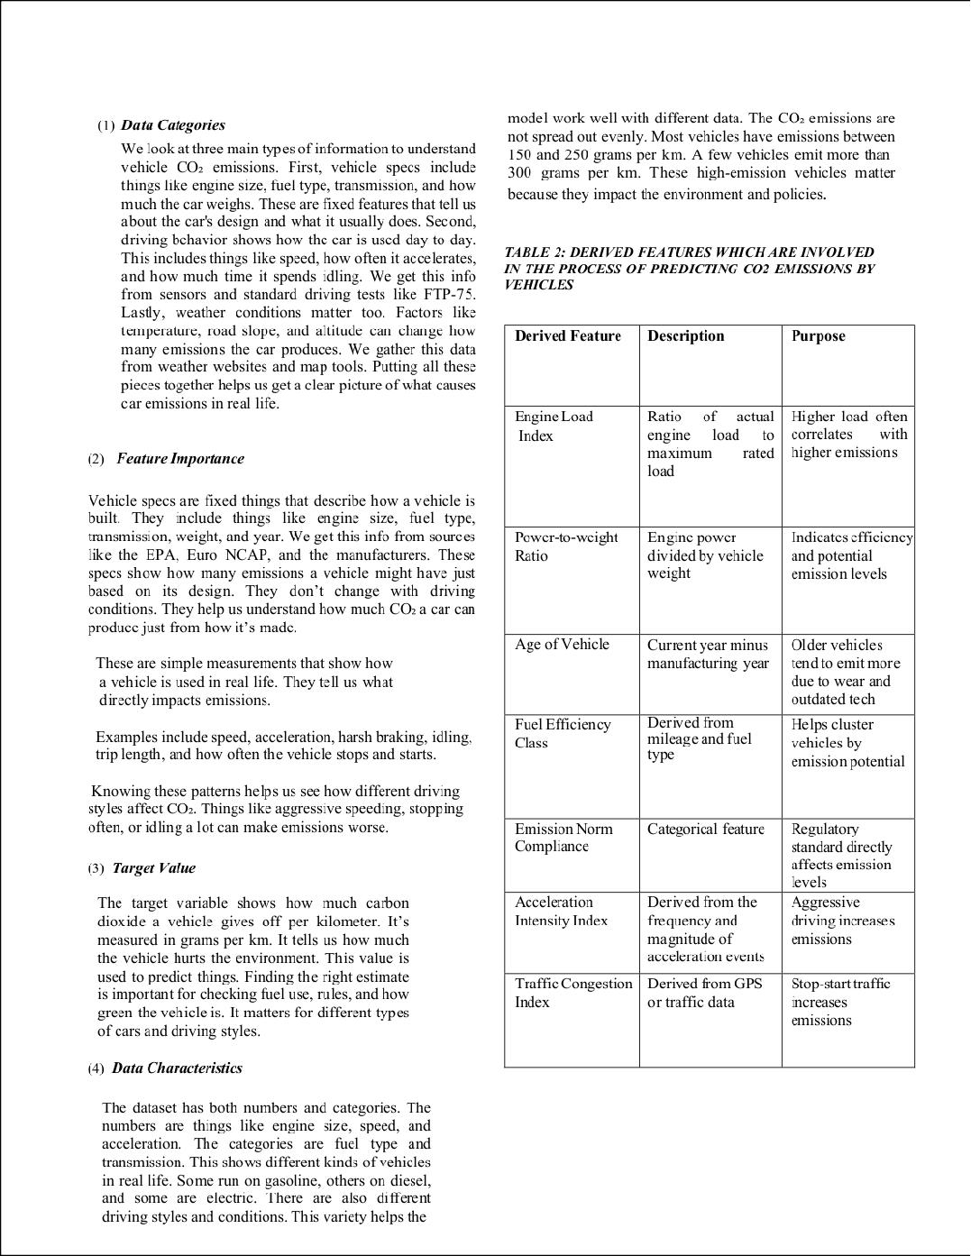

3

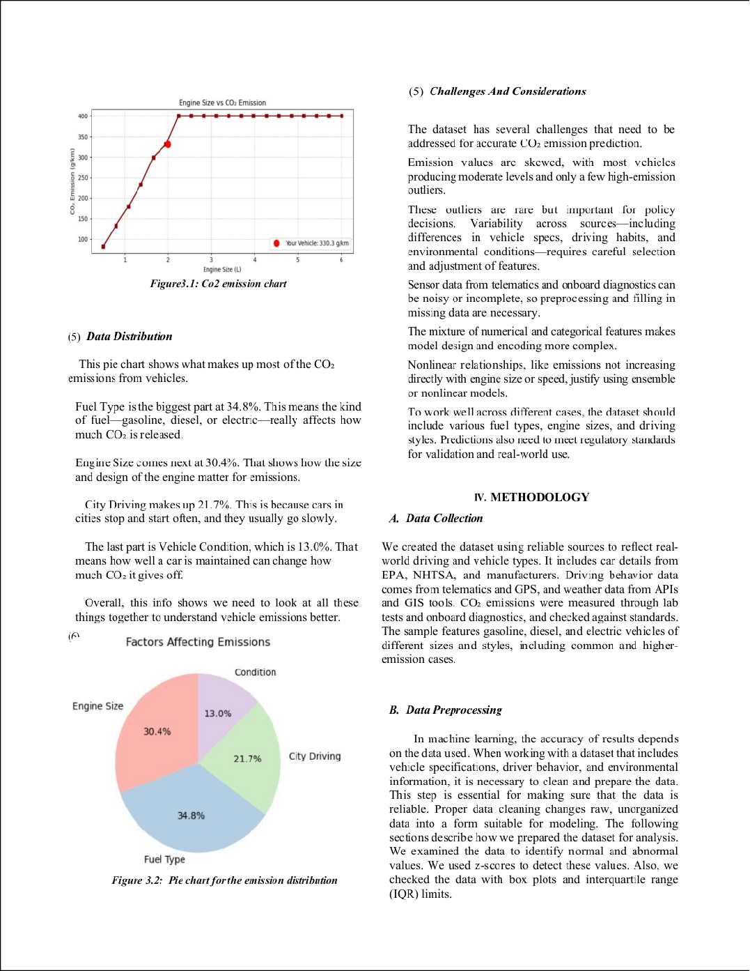

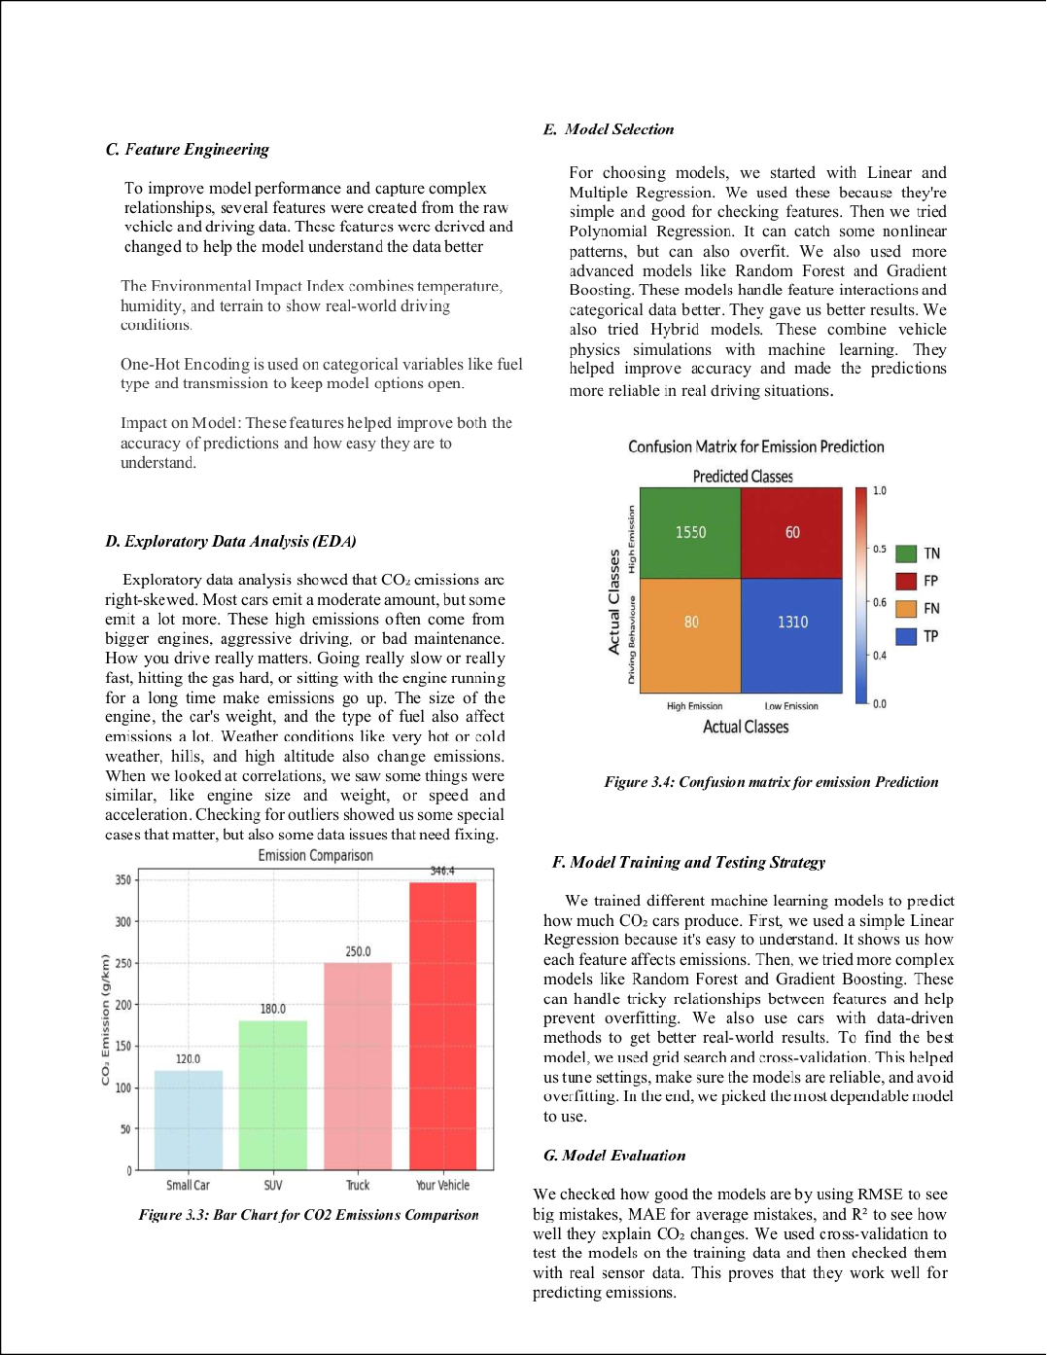

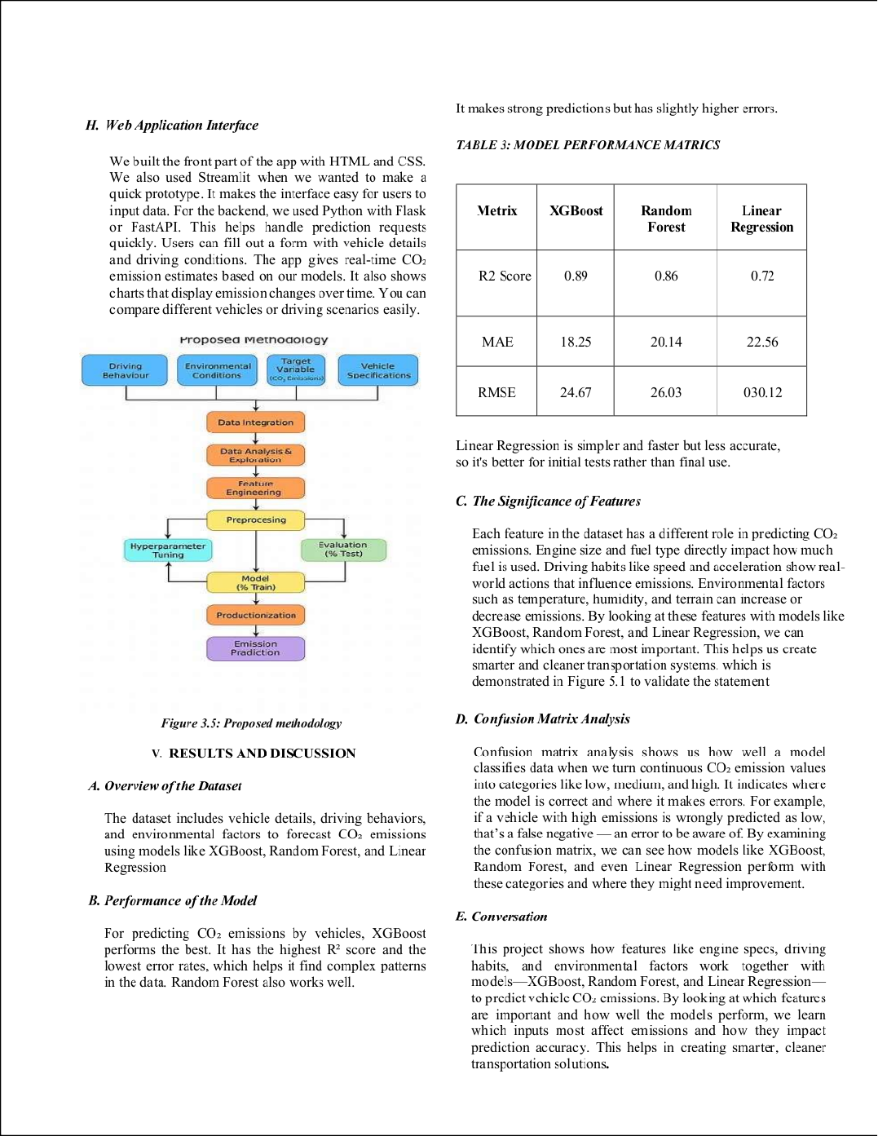

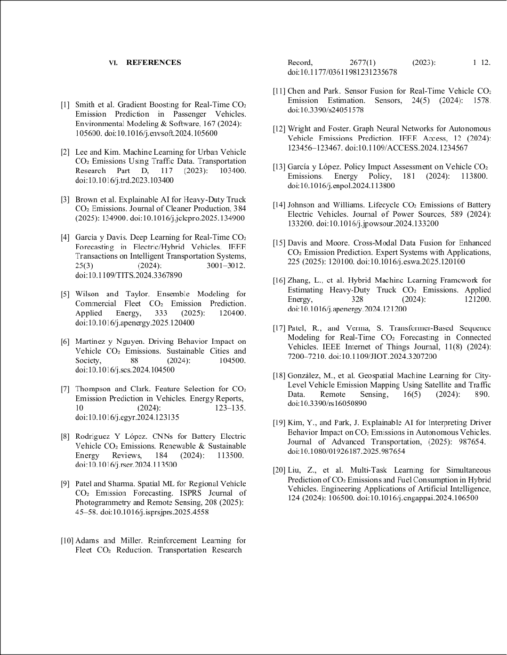

RE-2022-668940

2

ORIGINALITY REPORT

%

## SIMILARITY INDEX

1%

## INTERNET SOURCES

2%

## PUBLICATIONS

1%

## STUDENT PAPERS

PRIMARY SOURCES

# ijsred.com

1

Internet Source

# Submitted to Dublin Business School

2

Student Paper

# [www.carsales.com.au](http://www.carsales.com.au/)

3

Internet Source

# pnrsolution.org

4

Internet Source

1%

<1%

<1%

<1%

Exclude quotes On Exclude bibliography On

Exclude matches Off