Name | Sandhiya R
Reg No | 192511132
Course | Cryptography and network security
Course Code | CSA5107
Slot | D

DESIGN AND EVALUATION OF AN ENTERPRISE-WIDE
SECURE COMMUNICATION AND NETWORK DEFENSE ARCHITECTURE

1. Problem Statement and Problem Formulation

1.1 Problem Statement
A multinational organization uses different digital services such as web applications, email servers, enterprise servers, branch offices and remote access facilities. These systems communicate through both private and public networks. Since confidential business information is transferred between different locations, the organization faces several security risks.
The major threats identified are packet sniffing, man-in-the-middle attacks, IP spoofing, phishing, unauthorized access, malware propagation, data modification and denial-of-service attacks. The organization currently uses separate security mechanisms, but there is no common security architecture connecting all these controls.
Therefore, a secure enterprise-wide network architecture is required. The proposed architecture should protect information during transmission, verify users and systems, prevent unauthorized access, detect attacks and provide protection against malware.

1.2 Problem Formulation
The problem can be formulated as designing a layered security architecture that provides:
• Confidentiality of sensitive information.
• Integrity of transmitted and stored data.
• Authentication of users and systems.
• Non-repudiation for important transactions.
• Secure communication between branches and remote users.
• Protection of web and email services.
• Detection and prevention of network attacks.
• Protection against malware.
• Controlled access to enterprise resources.
• Scalability for future expansion.
The architecture should combine cryptographic techniques and network security mechanisms instead of depending on only one security control.

2. Objectives and Expected Outcomes

2.1 Objectives
1. To design a secure enterprise network architecture using multiple layers of protection.
2. To use cryptographic hash functions for checking data integrity.
3. To use digital signatures for authentication, integrity and non-repudiation.
4. To implement Kerberos for secure internal user authentication.
5. To use X.509 certificates for trusted system and server authentication.
6. To protect web communication using SSL/TLS.
7. To secure communication between branch offices using IPsec VPN.
8. To protect email communication using PGP and S/MIME.
9. To control network traffic using firewalls.
10. To detect and prevent suspicious network activity using IDS/IPS.
11. To reduce malware propagation using endpoint and network-based malware protection.
12. To evaluate the architecture against common network attacks.

2.2 Expected Outcomes
The expected outcome is a unified security architecture in which different security mechanisms work together. The proposed system should prevent unauthorized users from accessing protected resources, protect confidential information from packet sniffing, reduce the possibility of man-in-the-middle attacks, detect suspicious network traffic, protect email communication, verify the identity of servers and users, detect data modification, reduce malware spreading, provide secure branch communication and improve overall network reliability.

3. Requirements, Constraints and Assumptions

3.1 Hardware Requirements
Server – Minimum 8 GB RAM
Client System – Minimum 4 GB RAM
Router – VPN and firewall capable
Network Switch – Managed switch preferred
Storage – Minimum 50 GB for testing
Network Adapter – Ethernet/Wi-Fi
Security Gateway – Firewall/VPN device

3.2 Software Requirements
Linux/Windows – System environment
OpenSSL – TLS, certificates and cryptographic testing
Wireshark – Packet analysis
VirtualBox/VMware – Virtual network environment
pfSense/Firewall – Network traffic filtering
Snort/Suricata – IDS/IPS testing
OpenSSH – Secure remote administration
Python – Cryptographic demonstration
GnuPG – PGP testing

3.3 Functional Requirements
The system should provide user authentication, server authentication, secure web communication, secure email communication, secure VPN communication, network traffic filtering, intrusion detection, malware protection, data integrity verification, digital signing and security logging.

3.4 Non-Functional Requirements
The system should be secure, scalable, reliable, available, manageable, performant and fault tolerant.

3.5 Constraints
Security solutions require additional hardware and software. Encryption can introduce processing overhead. Certificate management requires proper administration. IDS/IPS may generate false alerts. Security controls need regular updates, and skilled security personnel are required.

3.6 Assumptions
Employees have authorized accounts. Enterprise servers are properly configured. Security software is regularly updated. Network administrators manage certificates and security policies. Users follow organizational security policies. Backup systems are available for important data.

4. Application of Relevant Course Knowledge / Concepts

4.1 Cryptographic Hash Functions
A cryptographic hash function converts input data into a fixed-length hash value. SHA-256 can be used to verify whether a file or message has been modified. If even a small part of the original data changes, the generated hash will also change. Hash functions provide integrity and data verification.

4.2 Digital Signatures
A digital signature is used to prove that a message or document was created or approved by a particular sender. The message is hashed and the hash is signed using the sender’s private key. The receiver uses the public key to verify the signature. Digital signatures provide authentication, integrity and non-repudiation.

4.3 Kerberos
Kerberos is a network authentication protocol used to authenticate users and services in an enterprise environment. Its main components include the client, Authentication Server, Ticket Granting Server and service server. After authentication, a ticket can be used to access authorized services.

4.4 X.509 Certificates
X.509 certificates are commonly used in public key infrastructure. A certificate contains the subject identity, public key, certificate authority, validity period and digital signature. They help verify trusted servers and systems.

4.5 IPsec
IPsec protects IP communication at the network layer. It can be used to create secure VPN connections between branch offices, data centers, remote users and enterprise networks. IPsec provides encryption and authentication for network traffic.

4.6 SSL/TLS
TLS protects application-level communication, especially web traffic. HTTPS uses HTTP over TLS. TLS helps protect against packet sniffing, data modification and man-in-the-middle attacks.

4.7 PGP
PGP can be used to encrypt email or files using public-key cryptography. A sender can encrypt information using the receiver’s public key, and the receiver uses the corresponding private key to decrypt it. PGP can also provide digital signatures.

4.8 S/MIME
S/MIME provides secure email using digital certificates. It supports email encryption, digital signatures, sender authentication and message integrity.

4.9 Firewalls
A firewall controls traffic entering and leaving a network according to predefined security rules. It can allow HTTPS and VPN traffic, block unauthorized ports, restrict internal server access and block suspicious traffic.

4.10 IDS/IPS
An Intrusion Detection System monitors network traffic and generates alerts when suspicious activity is detected. An Intrusion Prevention System can additionally block or stop malicious traffic.

4.11 Malware Protection
Malware protection can include antivirus, endpoint detection and response, email scanning, web filtering, application control, regular patching and file scanning.

5. Design / Proposed Solution / Methodology

5.1 Proposed Architecture
The proposed architecture follows a defense-in-depth approach.

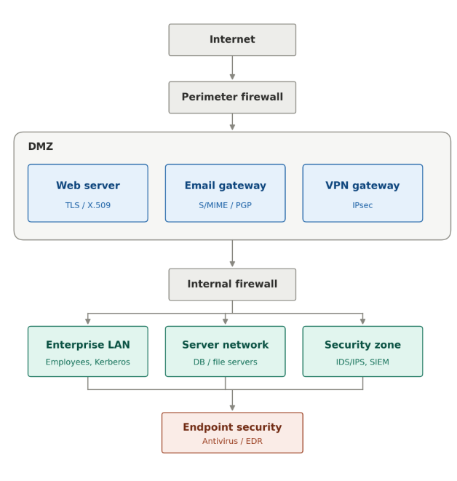

5.2 Security Layers
Layer 1 – Perimeter Security: The perimeter firewall is the first security layer and filters unwanted Internet traffic.
Layer 2 – DMZ Security: Public-facing servers are placed in a DMZ to prevent direct Internet access to internal systems.
Layer 3 – Secure Communication: TLS is used for web applications and IPsec for network-level communication.
Layer 4 – Authentication: Kerberos is used for internal authentication and X.509 certificates for certificate-based authentication.
Layer 5 – Data Security: Hash functions and digital signatures protect data integrity and support non-repudiation.
Layer 6 – Network Monitoring: IDS/IPS monitors network traffic for suspicious behavior.
Layer 7 – Endpoint Protection: Antivirus and EDR protect employee systems from malware.

5.3 Security Mechanism Selection
Security requirement → Recommended mechanism → Main purpose
Data Integrity → SHA-256/SHA-3 → Detect modification
Digital Authentication → Digital Signature → Authentication and integrity
Internal Authentication → Kerberos → Secure user authentication
Certificate Authentication → X.509 → Trusted identity
Branch Communication → IPsec VPN → Secure IP communication
Web Security → TLS/HTTPS → Confidentiality and authentication
Email Security → PGP/S/MIME → Email encryption and signing
Network Filtering → Firewall → Traffic control
Attack Detection → IDS → Detect attacks
Attack Prevention → IPS → Block attacks
Malware → Antivirus/EDR → Endpoint protection

6. Algorithm / Pseudocode / Flowchart

6.1 Secure Communication Algorithm
1. User requests access to an enterprise service.
2. Firewall checks the network traffic.
3. Authentication mechanism verifies the user.
4. Server identity is verified using X.509 certificate where applicable.
5. TLS/IPsec establishes a secure channel.
6. Data is transferred through the protected channel.
7. Hash values are used to check data integrity.
8. IDS/IPS monitors the communication.
9. Suspicious activity is blocked or reported.
10. Security logs are stored for future analysis.

6.2 Pseudocode
START
Receive connection request
IF traffic violates firewall policy
BLOCK connection
ELSE
Allow connection for inspection
Authenticate user
IF authentication fails
DENY ACCESS
Record security event
ELSE
Verify server/user certificate if required
Establish TLS/IPsec secure channel
Transmit data
Generate/verify hash value
IF integrity check fails
Reject data
Generate alert
ELSE
Accept data
Monitor traffic using IDS/IPS
IF malicious activity detected
Block traffic
Generate alert
END IF
Store security logs
END

6.3 Flowchart
START
↓
Connection Request
↓
Firewall Inspection
↓
User Authentication
↓
Certificate Check
↓
TLS/IPsec Establishment
↓
Secure Data Transfer
↓
Hash Verification
↓
IDS/IPS Monitoring
↓
Security Logging
↓
END

7. Implementation / Source Code and Environment / Tools Used

7.1 Experimental Environment
Operating System: Windows/Linux
Virtualization: VMware Workstation or VirtualBox
Web Server: Apache/Nginx
TLS: OpenSSL
Packet Analysis: Wireshark
IDS/IPS: Snort or Suricata
Firewall: pfSense/Linux Firewall
Email Encryption: GnuPG
Programming Language: Python

7.2 Hash Function Implementation
```python
import hashlib
data = input("Enter the message: ")
hash_value = hashlib.sha256(data.encode()).hexdigest()
print("SHA-256 Hash:")
print(hash_value)
```

7.3 File Integrity Verification
```python
import hashlib
def calculate_hash(filename):
sha256 = hashlib.sha256()
with open(filename, "rb") as file:
while True:
data = file.read(4096)
if not data:
break
sha256.update(data)
return sha256.hexdigest()
file_name = "sample.txt"
print("SHA-256:", calculate_hash(file_name))
```

7.4 TLS and Packet Analysis
OpenSSL can be used to inspect certificates and test TLS communication. Wireshark can be used to compare unencrypted HTTP traffic with encrypted HTTPS/TLS traffic. Screenshots of certificates, HTTPS connections and packet captures can be included in the final report.

8. Test Cases and Expected / Actual Results
TC01 – Access HTTPS website → Expected: Secure connection established.
TC02 – Modify input file → Expected: Hash value changes.
TC03 – Invalid user login → Expected: Access denied.
TC04 – Valid user login → Expected: Access granted.
TC05 – Invalid certificate → Expected: Connection warning/rejection.
TC06 – Unauthorized port access → Expected: Firewall blocks traffic.
TC07 – Suspicious traffic → Expected: IDS generates alert.
TC08 – Malicious traffic → Expected: IPS blocks traffic.
TC09 – Encrypted email → Expected: Unauthorized user cannot read content.
TC10 – Signed document modification → Expected: Signature verification fails.
TC11 – VPN communication → Expected: Protected tunnel established.
TC12 – Malware test file → Expected: Endpoint protection detects/quarantines it.
Note: Actual results should be filled based on the experiments actually performed.
1. SHA-256 Hash
import hashlib

message = input("Enter message: ")

hash_value = hashlib.sha256(message.encode()).hexdigest()

print("Original message:", message)
print("SHA-256 hash:", hash_value)
2. File Integrity Verification
This version does not create any file, so it avoids the permission error you got earlier.
import hashlib

original_data = input("Enter original file content: ")

original_hash = hashlib.sha256(
original_data.encode()
).hexdigest()

print("Original hash:", original_hash)

current_data = input("Enter current file content: ")

current_hash = hashlib.sha256(
current_data.encode()
).hexdigest()

print("Current hash:", current_hash)

if original_hash == current_hash:
print("Result: File is intact")
else:
print("Result: File has been modified")
3. Digital Signature
import hashlib

p = 61
q = 53

n = p * q
phi = (p - 1) * (q - 1)

e = 17
d = pow(e, -1, phi)

message = input("Enter message: ")

hash_value = int(
hashlib.sha256(message.encode()).hexdigest(),
16
)

hash_value = hash_value % n

signature = pow(hash_value, d, n)

print("Message:", message)
print("SHA-256 hash:",
hashlib.sha256(message.encode()).hexdigest())
print("Digital signature:", signature)

verification = pow(signature, e, n)

if verification == hash_value:
print("Signature verification: Successful")
print("Integrity: Verified")
print("Status: Valid")
else:
print("Signature verification: Failed")

4. Encryption and Decryption
import base64

message = input("Enter confidential message: ")

key = 23

encrypted = ""

for character in message:
encrypted += chr(ord(character) ^ key)

encrypted_data = base64.b64encode(
encrypted.encode()
).decode()

print("Original message:", message)
print("Encrypted data:", encrypted_data)

decoded_data = base64.b64decode(
encrypted_data
).decode()

decrypted = ""

for character in decoded_data:
decrypted += chr(ord(character) ^ key)

print("Decrypted message:", decrypted)

if message == decrypted:
print("Status: Encryption and decryption successful")
else:
print("Status: Failed")
Note: This is only an educational encryption demonstration, not production-grade encryption.

5. User Authentication
users = {
"admin": "admin123",
"employee": "employee123",
"guest": "guest123"
}

username = input("Enter username: ")
password = input("Enter password: ")

if username in users:
if users[username] == password:
print("Authentication successful")
print("Access granted")
else:
print("Authentication failed")
print("Incorrect password")
print("Access denied")
else:
print("Authentication failed")
print("Username not found")
print("Access denied")

6. Role-Based Access Control
users = {
"admin": "Administrator",
"employee": "Employee",
"guest": "Guest"
}

permissions = {
"Administrator": [
"Database",
"Financial Reports",
"Employee Records"
],
"Employee": [
"Employee Portal",
"Common Files"
],
"Guest": [
"Public Portal"
]
}

username = input("Enter username: ")

if username in users:
role = users[username]

print("Role:", role)

resource = input("Enter resource to access: ")

if resource in permissions[role]:
print("Access granted")
else:
print("Access denied")
else:
print("Username not found")

7. Firewall Simulation
allowed_ports = {
80: "HTTP",
443: "HTTPS",
22: "SSH"
}

source_ip = input("Enter source IP: ")
port = int(input("Enter destination port: "))

print("Source IP:", source_ip)
print("Destination port:", port)

if port in allowed_ports:
print("Protocol:", allowed_ports[port])
print("Firewall action: Allow")
print("Access granted")
else:
print("Firewall action: Block")
print("Access denied")

9. Execution Screenshots / Outputs
Include screenshots of the network architecture, SHA-256 output, TLS certificate, HTTPS connection, Wireshark capture, firewall rule, IDS/IPS alert, VPN connection, PGP/S/MIME encryption or signature, and malware protection output.
Execution Output- 1
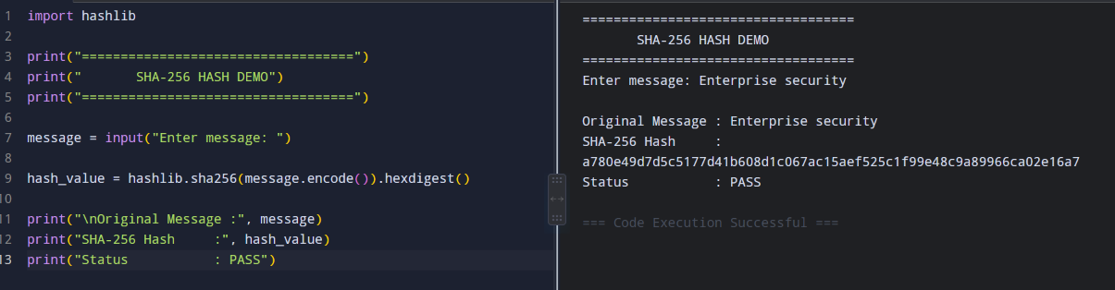
Execution Output- 2
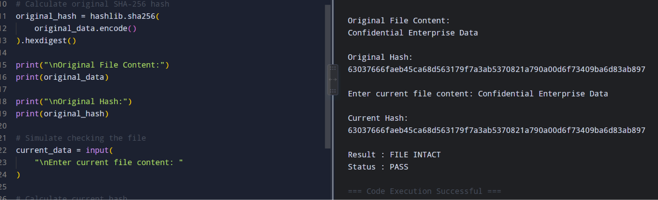
Execution Output- 3
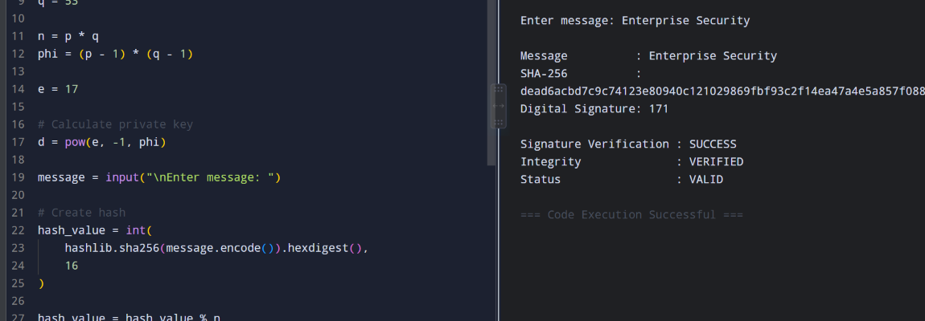
Execution Output- 4

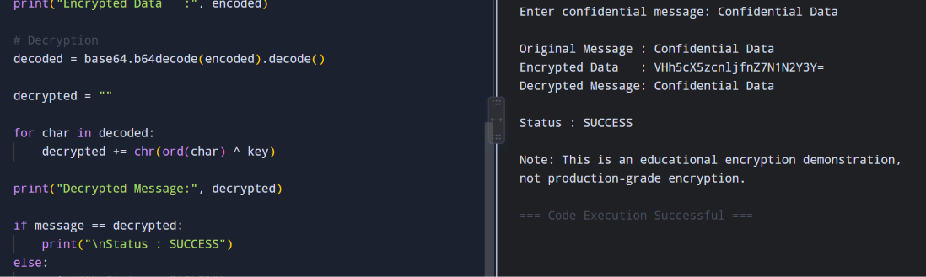
Execution Output- 5
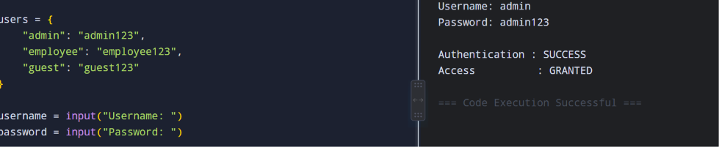

10. Results and Validation
Man-in-the-Middle → TLS + X.509 → Reduced risk through authentication and encryption.
Packet Sniffing → TLS/IPsec → Captured traffic is protected.
IP Spoofing → Firewall + IPS + authentication → Suspicious traffic can be filtered.
Phishing → Email security + filtering + user awareness → Risk reduced.
Unauthorized Access → Kerberos + access control → Unauthorized users denied.
Malware Propagation → Antivirus/EDR + IDS/IPS → Malware activity can be detected.
Data Tampering → Hash + Digital Signature → Modification can be detected.
Email Interception → PGP/S/MIME → Email content protected.
Network Intrusion → IDS/IPS → Suspicious traffic detected/blocked.
DoS → Firewall + IPS + rate limiting → Attack impact can be reduced.
Confidentiality is supported by TLS, IPsec, PGP and S/MIME. Integrity is supported by hashing and digital signatures. Authentication is supported by Kerberos and X.509. Digital signatures support non-repudiation. Firewalls, IDS/IPS and segmentation support availability and resilience.

11. Analysis, Comparison, Trade-offs and Justification

11.1 Comparison
Hash – Integrity: High; Authentication: No; Non-repudiation: No; Performance: High.
Digital Signature – Integrity: High; Authentication: High; Non-repudiation: High; Performance: Medium.
Kerberos – Authentication: High; Performance: High; Scalability: High with proper infrastructure.
X.509 – Authentication: High; Integrity: High; Performance: Medium.
IPsec – Confidentiality: High; Integrity: High; Authentication: High; Performance: Medium.
TLS – Confidentiality: High; Integrity: High; Authentication: High; Performance: High.
PGP – Confidentiality: High; Integrity: High; Authentication: High; Performance: Medium.
S/MIME – Confidentiality: High; Integrity: High; Authentication: High; Performance: Medium.
Firewall – Traffic control: High; Performance: High.
IDS/IPS – Detection/prevention: High; Performance: Medium.
Antivirus/EDR – Malware detection: High; Performance: Medium.

11.2 Trade-offs
Hash functions are fast but do not provide confidentiality. Digital signatures provide strong authentication and non-repudiation but require key management. Kerberos is suitable for enterprise authentication but depends on a reliable authentication infrastructure and time synchronization. TLS provides strong web security but requires certificate management. IPsec protects network traffic but can be more complex to configure. PGP and S/MIME protect email but require key or certificate management. Firewalls provide centralized traffic control but cannot detect every application-level attack. IDS/IPS can detect or block threats but may produce false positives and requires continuous monitoring.

11.3 Justification of Final Solution
No single security mechanism can protect the complete enterprise network. A firewall cannot provide email encryption, and hashing cannot provide confidentiality. Therefore, the recommended combination is Firewall + TLS + IPsec + Kerberos + X.509 + Hashing + Digital Signatures + PGP/S/MIME + IDS/IPS + Endpoint Protection. This layered design provides stronger confidentiality, integrity, authentication, availability and resilience.

12. Broader Considerations / SDG Relevance

SDG 9 – Industry, Innovation and Infrastructure
Secure communication and network defense help organizations build reliable and resilient digital infrastructure.

SDG 11 – Sustainable Cities and Communities
Modern cities depend on connected systems for transportation, healthcare, communication and public services. Protecting these systems helps maintain reliable digital services.

SDG 16 – Peace, Justice and Strong Institutions
Strong authentication, digital signatures and secure communication improve digital trust and protect sensitive institutional information.

SDG 17 – Partnerships for the Goals
Organizations, suppliers and business partners need to exchange information securely. TLS, certificates, VPNs and digital signatures support trusted communication.

13. Conclusion, Limitations and Possible Improvements

13.1 Conclusion
The proposed enterprise-wide security architecture combines cryptographic and network security mechanisms to protect an organization’s digital infrastructure. Hash functions provide data integrity, digital signatures provide authentication, integrity and non-repudiation, Kerberos provides secure internal authentication, and X.509 certificates help establish trusted identities. TLS protects web applications and IPsec provides secure communication between networks. Firewalls control network traffic, IDS/IPS detects and prevents suspicious activities, PGP/S/MIME protects enterprise email, and endpoint security reduces malware risk. A layered security architecture is more effective than isolated security mechanisms.

13.2 Limitations
Initial deployment can be expensive. Security configuration requires skilled administrators. Certificate and key management can become complex. IDS/IPS may generate false alerts. Encryption may introduce performance overhead. Security systems need regular updates. No security system can completely eliminate all cyber threats.

13.3 Possible Improvements
Future improvements can include Zero Trust Network Architecture, multi-factor authentication, AI-based intrusion detection, cloud-based security monitoring, automated certificate management, SIEM, automated incident response, behavioral malware detection, continuous vulnerability assessment and automated threat intelligence integration.

14. Individual Contribution of Group Members
Member 1 – Studied cryptographic hash functions and digital signatures.
Member 2 – Worked on Kerberos, X.509 and authentication mechanisms.
Member 3 – Studied IPsec, TLS, PGP and S/MIME.
Member 4 – Designed firewall, IDS/IPS and malware protection.
Member 5 – Worked on implementation, testing and result analysis.
If the assignment is individual: I studied the enterprise network security requirements, selected suitable cryptographic and network security mechanisms, designed the proposed architecture, prepared the security comparison, performed the testing activities and analyzed the results.

15. References

Asha, V. and Raja, S.K.S., 2026. Performance Analysis of pfSense in Cyber Defense: An Intelligent Firewall Perspective for the Modern Network Landscape. IEEE Access.

- Chandramouli, R. and Chandramouli, R., 2022. Guide to a secure enterprise network landscape. Gaithersburg, MD, USA: US Department of Commerce, National Institute of Standards and Technology.
- Mohammed, S., 2022. Designing secure zero trust architectures for global enterprise environments. International Journal of Science, Research and Technology, 5(6), pp.8953-8956.
- Albashish, D., 2026. Autonomous Cyber Defense Using Reinforcement Learning Across Scalable Multi-Cloud Enterprise Environments. International Research Journal of Innovative Engineering, 10(4), pp.19280-19293.
- Sullivan, E. and Douglas, M.R., 2025. A Hybrid Digital Twin and AI Cyber Defense Architecture for NIST-Based Resilience Assessment of US Critical Infrastructure Networks.

16. One-Page Individual Reflection

Individual Reflection
During this assignment, I learned how different cryptographic and network security mechanisms can be combined to protect an enterprise network. Before working on this topic, I mainly understood encryption and authentication as separate concepts. While designing the architecture, I understood that real enterprise security requires multiple mechanisms working together.
I learned about cryptographic hash functions and how they can be used to identify changes in data. I also understood the importance of digital signatures for authentication, integrity and non-repudiation. The study of Kerberos helped me understand how centralized authentication can be used in an enterprise environment.
Another important part of my learning was understanding the difference between TLS and IPsec. TLS is mainly useful for protecting application communication such as web services, whereas IPsec can protect IP communication between networks. I also learned that PGP and S/MIME can be used to secure email communication.
The network security part of the assignment helped me understand the importance of firewalls and IDS/IPS. A firewall mainly controls network traffic based on security rules, while IDS/IPS can identify suspicious network behavior. I also understood that endpoint protection is necessary because attacks can enter through user devices and email attachments.
One challenge I faced was understanding how all the individual security mechanisms could be combined into one architecture. I solved this by dividing the security design into different layers such as perimeter security, authentication, secure communication, data protection, network monitoring and endpoint protection.
I also learned that there is no single security technology that can completely protect an organization. For example, encryption protects confidentiality, but it does not replace a firewall or an intrusion detection system. Therefore, a layered approach is more practical.
Overall, this assignment improved my understanding of enterprise network security and helped me connect the cryptography concepts learned in class with practical security applications. It also gave me a better understanding of how organizations can protect their communication systems against different types of cyber attacks.

