**PROPOSAL FOR**

**SUPPLY INSTALLATION AND COMMISSIONING OF**

**100 KWp GRID TIED SOLAR ROOF TOP POWER PLANT**

**(Under Solar Energy Corporation of India SECI Scheme, with 30 % Subsidy)**

**Submitted**

**To**

**RAMDEV RAO HOSPITAL,**

**KUKATPALLY, HYDERABAD.**

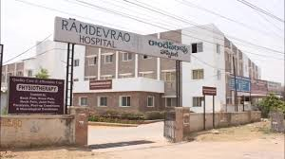

**By**



**(AN ISO 9001-2015 & 14001-2015 CERTIFIED COMPANY)**

# 

# GREENTEK INDIA PRIVATE LIMITED

**Plot # 8, Lepakshi colony, West Marredpally, Secunderabad -500026**

**Tel: 040-27807145 / 040-65198519, Mob: +91-9951951188**

**E-mail: projects@greentekindia.co.in, www.greentekindia.co.in**

**Introduction, Vision & Mission of Greentek India Pvt Ltd**

GIPL is an ISO 9001:2015 & 14001-2015 certified Company based at Hyderabad is one of the leading manufacturers of Solar Photo Voltaic Modules (SPV) in the Country. We are manufacturing modules in the range of 37W to 300W. Thus, our Module production line is geared to produce panels of any custom size or wattage having Certifications/Approvals from MNRE, IEC 61215, IEC 61701, IEC 61730.

GIPL is having strong presence in the field of Renewable Energy and provides complete turnkey solar EPC solutions. We have a team of highly skilled solar engineers to design and construct you solar project. GIPL offers Advisory Services, Engineering, Procurement & Construction (EPC) Services and Operation & Maintenance Services Solar Power Projects ranges KWp to MWp scale to domestic, industrial, commercial and government entities.

Incorporated in the year 2007 and expertise in all renewable energy systems. Joint ventured with many reputed companies throughout the India and having the best technical partners and supplier in their class throughout India.

To become one of the leading renewable energy equipments and turnkey solution provider. We always aim at one step ahead in the development of innovative and competitive solutions for the production and management of electrical power through Solar PV systems. Served & serving many esteemed organizations and individuals in India.

**Solar Photovoltaic:**

 * Grid connected or Utility scale Solar Power Projects.

 * Off-grid SPV Power Packs.

 * Rooftop Solar Power Projects (Standalone & Grid-tied).

 * Other Solar application

GIPL is a registered Solar PV Systems integrator in MNRE, NREDCAP & TNREDC.

GIPL tries not just to meet our customer’s expectations; strive to exceed the customer’s expectations. Every time, measure its success by its customer’s trust and confidence in us. We always work with principle to provide up to date technology, the best quality equipment, error less workmanship and on time service to its clients.

**Services:**

* **Megawatt scale ground mounted solar PV plants.**
* **Megawatt scale solar PV plants for third party sale.**
* **Megawatt scale solar PV plants for captive consumption.**
* **Large scale roof top solar PV plants for Hospitals, Hotels, Educational Institutions and other commercial buildings.**
* **Roof top Solar PV plants under net metering / Gross metering policies.**
* **Solar water heaters and Solar thermal projects.**
* **Solar powered LED street lights & All types of LED lights (Indoor / Outdoor)**

**Benefits of using solar power:**

1. **Energy generation is for 25 years.**
2. **Payback period is 3-4 Years.**
3. **Accelerated depreciation for private / commercial / profit making organizations @ 80% in the first year and 20% in the second year.**
4. **Revenue from generation based renewable energy certificates.**
5. **Low maintenance cost.**
6. **Easy loan process from banks.**
7. **Free from power cuts.**
8. **Free from the DG expenses.**
9. **Quality power.**

**Executed projects by our team:**

* + 1. **4 MW Solar Grid tied plant at Kalwakurthy, Mahaboobnagar (DT)**
    2. **75 KW Solar Grid Tied System for DE-SHAW Jubillee Hills, Hyderabad.**
    3. **20 KW Solar Grid Tied system for CAL Public School, Hyderabad.**
    4. **10 KW Solar Grid Tied System for Dr. Reddys Foundation, Hyd.**
    5. **81.6 KW Solar Power Plant for Omega Hospital, Hyderabad.**
    6. **14 KW for FHD Group Hyderabad.**
    7. **14 KW for Directorate of Sorghum Research, Hyderabad.**
    8. **6 KW for Dr Water Mineral Water Plant, Boduppal, Hyderabad.**
    9. **5 KW Solar System for Commissioner of Industries APIIC, Hyderabad.**
    10. **5 KW for Mahathma Gandhi University, Nalgonda, Hyderabad.**
    11. **5 KW for Vrihat Solar Lucknow.**
    12. **5 X 2 KW(2X5Hp Motors) for Kommuri Prathap Reddy Engg. College.**
    13. **30 KW Solar PV System for Bhashyam Public School, Guntur.**

|  |  |  |
| --- | --- | --- |
| **T Rajagopal** | **Suchitra X Roads, Hyderabad** | **3 KWp On Grid** |
| **Suresh Kumar** | **Hanumakonda** | **3 KWp On Grid** |
| **Gadde Devaki** | **Banjara Hills** | **3 KWp On Grid** |
| **Chamala Shashidhar Reddy** | **Ashok nagar** | **5 Kwp On Grid** |
| **Surender Reddy** | **Champapet** | **10 Kwp On Grid** |
| **Srinivas Reddy** | **Champapet** | **10 Kwp On Grid** |
| **V Chandrashekar** | **Kompally** | **3 KWp On Grid** |
| **Krishnam Raju** | **Moosapet** | **3 KWp On Grid** |
| **4S Systems and Services** | **A S Rao Nagar** | **7.5KWp Hybrid/7.5KWp On Grid** |

**Prestigious Clients:**

* **Commissioner of Industries, TSIIC / APIIC, Abids , Hyderabad.**
* **DE SHAW India Software Pvt. Ltd, Sanali Info Park, Jubilee Hills, Hyderabad.**
* **Dr. Reddys Foundation. Rd. No. 12, Banjara Hills, Hyderabad.**
* **Sreenidhi International school, Hyderabad.**
* **Sreenidhi Institute of Science and Technology, Hyderabad.**
* **Biological E Limited, Hyderabad.**
* **Sree Eneterprises.**
* **Air India.**
* **CAL Public School, Near Radhika Movie Plex, ECIL, Hyderabad.**
* **Kommuri Prathap Reddy Institute of Technology, Ghatkesar, Hyderabad.**
* **Omega Hospitals, Road No. 12, Banjara Hills, Hyderabad.**
* **Fountain Head Group, Srinagar Colony, Hyderabad.**
* **Directorate of Sorghum Research, Rajendra Nagar, Hyderabad.**
* **Dr. Water Mineral Water Plants, Nagaram, Hyderabad.**
* **Bhashyam Public School, Guntur.**

**DETAILS OF THE PROPOSED 100 KWp ROOFTOP SOLAR PV POWER PLANT**

|  |  |
| --- | --- |
| **Client** | **RAMDEV RAO HOSPITAL** |
| **Location** | **KUKATPALLY, HYDERABAD** |
| **Plant Size** | **100 KWp** |
| **Latitude** | **17º29¹** |
| **Longitude** | **78º24¹** |
| **Elevation** | **1888 Ft** |
| **Type of Installation** | **Rooftop** |
| **Solar Radiation** | **5.77 KW/ Hr / Sq. m** |
| **Technology** | **Poly Crystalline** |

## Energy Generation:

|  |  |
| --- | --- |
| **Solar Power Plant Capacity** | **100 KWp** |
| **Average Solar Energy Generated Per Day** | **500 KW / units per Day** |
| **Average Solar Energy Generated Per Year** | **1,60,000 KW /Units/ Year** |
| **Area Required** | **10,000 SFT** |
| **Space required for the control room** | **1 Sq. Mt** |

**System configuration:**

|  |  |  |
| --- | --- | --- |
| **Equipment Description** | **Rating** | **Qty.** |
| **Solar Grid Tied UPS MPPT based** | **25 KVA** | **4** |
| **Polycrystalline PV panels** | **315-334 Wp** | **100 Kw** |
| **Mounting Structures** | **GI/MS Galvanized** | **318 / 308** |
| **AJB’s/SCB’s, Cables, ACDB, Transformers, L/A, Earthling & BOS etc.** | **As per MNRE Spec** |  |

**SATELLITE IMAGE OF RAMDEV RAO HOSPITAL.**

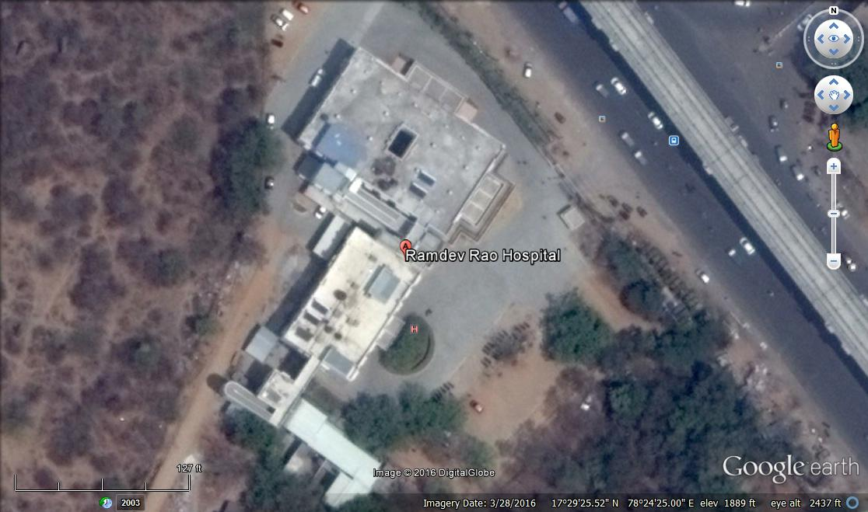

**Physical parameters:**

**Lattitude : 17º29¹**

**Longitude : 78º24¹**

**Elevation : 1888 Ft**

**SOLAR INSOLATION AT PROPOSED SITE**

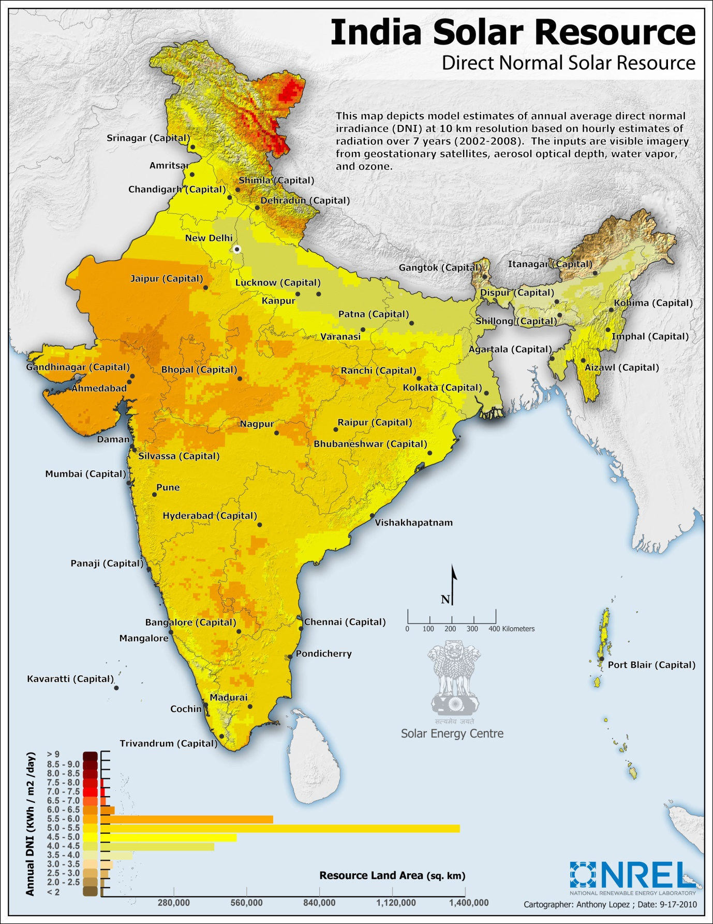

|  |  |
| --- | --- |
| **DNI** | **DIRECT NORMAL IRRADIANCE** |
| **LATTITUDE:** | **17°29¹** |
| **LONGITUDE:** | **78°24¹** |
| **ELEVATION:** | **1888 Ft** |
| **CLIENT** | **RAMDEV RAO HOSPITAL** |
| **MONTH** | **SOLAR INSOLATION KWh/Sq.M/DAY** |
| **JANUARY** | **6.22710009766** |
| **FEBRUARY** | **6.66989990234** |
| **MARCH** | **5.85960009766** |
| **APRIL** | **5.66270019531** |
| **MAY** | **6.10810009766** |
| **JUNE** | **3.94810009766** |
| **JULY** | **2.99310009766** |
| **AUGUST** | **3.11600000000** |
| **SEPTEMBER** | **4.41810009766** |
| **OCTOBER** | **5.40370019531** |
| **NOVEMBER** | **6.37260009766** |
| **DECEMBER** | **6.34739990234** |
| **ANNUAL DNI** | **5.25170019531** |

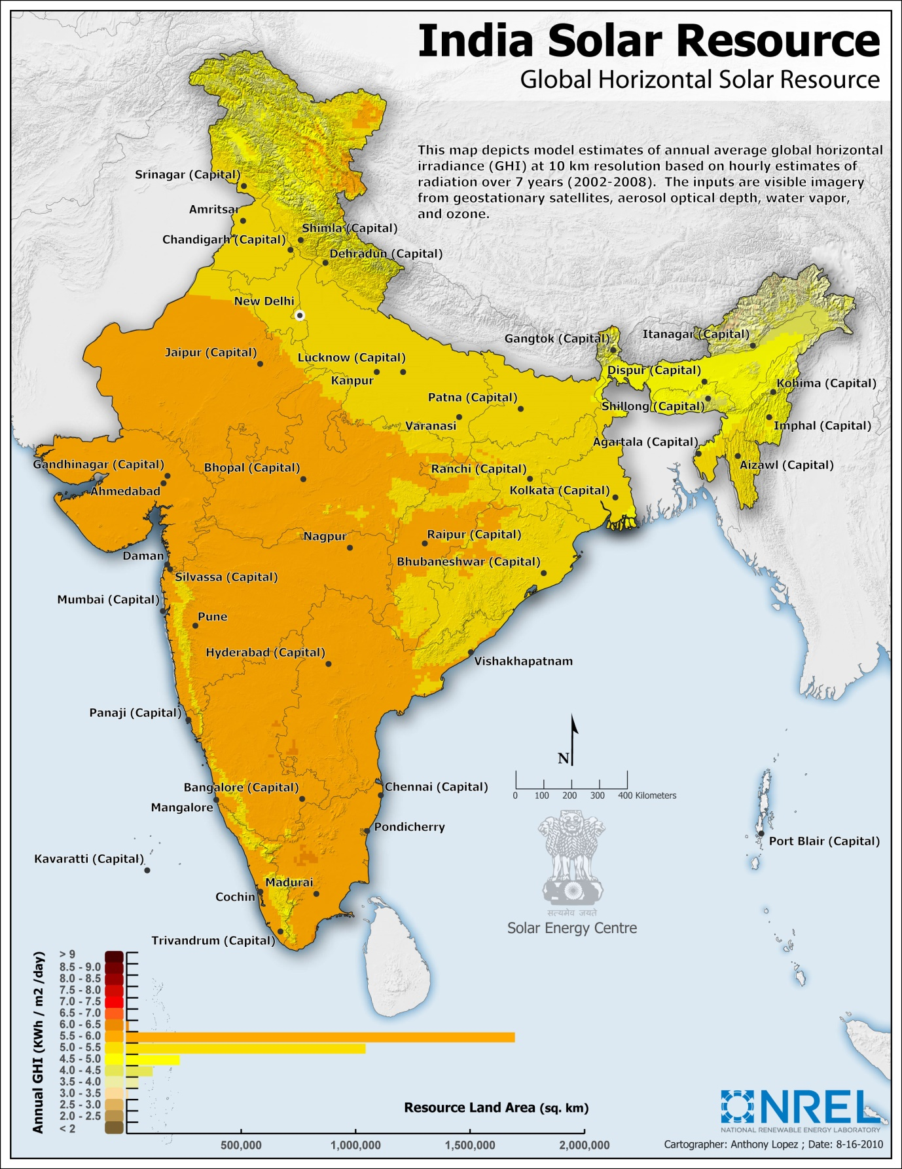

|  |  |
| --- | --- |
| **GHI** | **GLOBAL HORIZONTAL IRRADIANCE** |
| **LATTITUDE:** | **17°29¹** |
| **LONGITUDE:** | **78°24¹** |
| **ELEVATION:** | **1888 Ft** |
| **CLIENT** | **RAMDEV RAO HOSPITAL** |
| **MONTH** | **SOLAR INSOLATION KWh/Sq.M/DAY** |
| JANUARY | **5.30610009766** |
| FEBRUARY | **6.11010009766** |
| MARCH | **6.61100000000** |
| APRIL | **6.84189990234** |
| MAY | **6.86489990234** |
| JUNE | **5.70710009766** |
| JULY | **5.24370019531** |
| AUGUST | **5.15129980469** |
| SEPTEMBER | **5.53360009766** |
| OCTOBER | **5.48139990234** |
| NOVEMBER | **5.32770019531** |
| DECEMBER | **5.10729980469** |
| **ANNUAL GHI** | **5.77050000000** |

# TECHNICAL DETAILS:

**SOLAR PV PANELS:**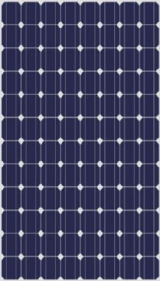

**Make : GREENTEK**

**Model : 315-325 Wp – 72 Cells**

**RFID : Internal**

**Approvals : MNRE, UL, IEC**

**Warranty : 25 Years**

**Wattage : 315 - 334 Wp**

**Voltage : 46.6 V**

**Current : 8.85 A**

**Size : 1961 X 991 X 40 mm**

**Weight : 24 KG**

**CERTIFICATIONS:**

**IEC – 61215, 61730, 62716 & UL**

**Solar Grid – Tied Inverter:**

**Make : Growatt / Delta / Power One**

**Model : 25 KVA**

**MPP Range : 480-850 V**

**Operating Range : 200-950 V**

**Min DC Voltage/Starting Voltage: 200/250V**

**No- Load Voltage :1000V**

**Maximum input Current : 3*36.0A**

**No of MPP Trackers : 1**

**Max Power /Tracker : 25 KW**

**No of strings : 3*4**

**Rated Output : 24900 VA**

**Supply Voltage : According to requirement**

**Rated Current : 50 A**

**Rated Frequency : 50/60Hz**

**Cos Phi : 0.80 inductive, capacitive**

**No of Grid Phases : 3**

**Protection Class : IP-65**

**Weight : 50 Kg**

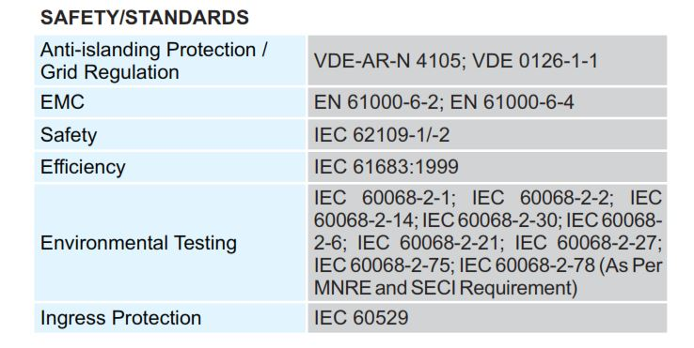

**Mounting Structure:**

**Protection : Galvanized**

**Longevity : Rust proof**

**Material : Mild steel**

**Warranty : 30 years**

[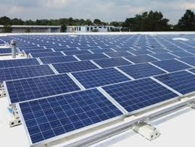](https://www.google.co.in/imgres?imgurl=https://hinrenblog.files.wordpress.com/2015/09/gehrlicher_solar_new_jersey.jpg?w=464&h=348&imgrefurl=http://www.hinren.com/grid-tied-rooftop-solar-pv-system-policies-in-states/&docid=EEEWcgK3aSxsqM&tbnid=2qPKkqEYJs-W5M:&w=464&h=349&hl=en&bih=651&biw=1366&ved=0ahUKEwiE4tiStqLOAhUGo5QKHYCWD2kQxiAIAg&iact=c&ictx=1)

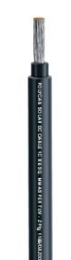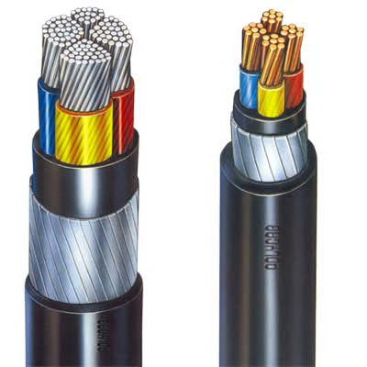**Cables:**

**Polycab**

**UV Resistant**

**Type 1 cable**

**ISO 9001:2008 and 14001:2004 certified**

**Flame Retardant Low Smoke**

**High temperature resistant (Up to 1200C)**

**Tasks and Owners:**

|  |  |  |
| --- | --- | --- |
| **TASK DESCRIPTION** | **OWNERSHIP** | |
| **PRE-CONTRACT STAGE REMARKS** | | |
| **AGREEMENT** | **CLIENT & GREENTEK** |  |
| **GATHER REQUIREMENTS** | **GREENTEK** |  |
| **SITE SURVEY** | **GREENTEK** |  |
| **PROJECT PROPOSAL** | **GREENTEK** |  |
| **FEASIBILITY REPORT** | **DISCOM** |  |
| **EXECUTION STAGE** | | |
| **DESIGN – Civil, Electrical and Mechanical** | **GREENTEK** |  |
| **SOURCE ALL COMPONENTS** | **GREENTEK** |  |
| **CIVIL WORKS** | **GREENTEK** |  |
| **MOUNTING STRUCTURE’S ERECTION** | **GREENTEK** |  |
| **PV MODULE MOUNTING** | **GREENTEK** |  |
| **DC WIRING FROM PV MODULES TO INVERTER & TERMINATION** | **GREENTEK** |  |
| **AC WIRING FROM SOLAR INV. TO LOADS & TERMINATION** | **GREENTEK** |  |
| **EARTHLING & LIGHTINING ARRESTORS** | **GREENTEK** |  |
| **COMMISSIONING** | **GREENTEK** |  |
| **POST-EXECUTION STAGE** | | |
| **TRIAL RUN** | **GREENTEK** |  |
| **INSPECTION** | **DISCOM** |  |
| **GRID SYNCHRONISATION** | **DISCOM** |  |
| **TRAINING CLIENT PERSONNEL** | **GREENTEK** |  |
| **SUBMISSION OF MANUALS & WARRANTIES** | **GREENTEK** |  |
| **HANDING OVER** | **GREENTEK** |  |
| **OPERATIONS & MAINTENANCE** | **GREENTEK** |  |

**Financials:**

|  |  |
| --- | --- |
| **Cost of the project** | **INR. 61,00,000/-** |
| **Taxes (VAT-5%)** | **INCLUDED** |
| **Total** | **INR. 61,00,000/-** |
| **Subsidy @ 30% Through SECI** | **INR. 18,30,000/-** |
| **NET PAYABLE BY CUSTOMER** | **INR. 42,70,000/-** |
| **Transportation** | **At actuals** |
| **Cost of Grid Synchronization** | **At actuals** |
| **Cost of Bi-Directional meter** | **At actuals** |

**Note:**

1. **Cost of Liasoning with DISCOM & SECI will be INR. 2,00,000/- (Include: DISCOM Feasibility Fee, Cost of Bi-Directional meter and SECI processing fees for claiming subsidy).**
2. **Subsidy 30% applicable only to Educational Institutions, Hospitals and nonprofit making organizations.**

**Payment Terms:**

|  |  |
| --- | --- |
| **Advance along with PO** | **20%** |
| **After getting technical feasibility (DISCOM)** | **50%** |
| **Before the dispatch of material** | **20%** |
| **Upon commissioning** | **10%** |

**Warranty:**

|  |  |
| --- | --- |
| **Solar PV module Performance warranty** | **25 years** |
| **Grid tied Inverter** | **5 years** |

**Key Features of the Plant:**

|  |  |
| --- | --- |
| Expected Power Generation from  100 KW solar power plant per day | 500 Units |
| Net Export to the Grid (Month) | 15,000 Units |
| Net Generation Cost@ Rs. 9.5 **(Monthly)** | INR 1,42,500-00 |
| Peak Generation cost per year @ 320 Sunny days | INR 15,20,000-00 |

**CASH FLOW – ANALYSIS FOR 100 KW SOLAR PV PLANT :**

|  |  |  |  |  |
| --- | --- | --- | --- | --- |
| **YEAR** | **GENERATED UNITS** | **TARIFF** | **SAVING'S** | **CUMULATIVE SAVINGS** |
| **1** | **160000** | **9.5** | **1520000** | **1520000** |
| **2** | **159200** | **10.355** | **1648516** | **3168516** |
| **3** | **158404** | **10.855** | **1719475.42** | **4887991.42** |
| **4** | **157611.98** | **11.355** | **1789684.033** | **6677675.453** |
| **5** | **156823.9201** | **11.855** | **1859147.573** | **8536823.026** |
| **6** | **156039.8005** | **12.355** | **1927871.735** | **10464694.76** |
| **7** | **155259.6015** | **12.855** | **1995862.177** | **12460556.94** |
| **8** | **154483.3035** | **13.355** | **2063124.518** | **14523681.46** |
| **9** | **153710.887** | **13.855** | **2129664.339** | **16653345.8** |
| **10** | **152942.3325** | **14.355** | **2195487.184** | **18848832.98** |
| **11** | **152177.6209** | **14.855** | **2260598.558** | **21109431.54** |
| **12** | **151416.7328** | **15.355** | **2325003.932** | **23434435.47** |
| **13** | **150659.6491** | **15.855** | **2388708.737** | **25823144.21** |
| **14** | **149906.3509** | **16.355** | **2451718.368** | **28274862.57** |
| **15** | **149156.8191** | **16.855** | **2514038.186** | **30788900.76** |
| **16** | **148411.035** | **17.355** | **2575673.513** | **33364574.27** |
| **17** | **147668.9798** | **17.855** | **2636629.635** | **36001203.91** |
| **18** | **146930.6349** | **18.355** | **2696911.804** | **38698115.71** |
| **19** | **146195.9818** | **18.855** | **2756525.236** | **41454640.95** |
| **20** | **145465.0019** | **19.355** | **2815475.111** | **44270116.06** |
| **21** | **144737.6768** | **19.855** | **2873766.574** | **47143882.63** |
| **22** | **144013.9885** | **20.355** | **2931404.735** | **50075287.37** |
| **23** | **143293.9185** | **20.855** | **2988394.671** | **53063682.04** |
| **24** | **142577.4489** | **21.355** | **3044741.422** | **56108423.46** |
| **25** | **141864.5617** | **21.855** | **3100449.996** | **59208873.46** |
|  |  |  | **0** | **59208873.46** |
|  |  |  |  |  |
|  |  | **TOTAL CUMULATIVE SAVING IN 25 YEARS** | | |
|  |  | **RETURN ON INVESTMENT (ROI)** | |  |
|  | **TARIFF ESCALATION** | **9% per anum as per electricity act 2003.** | | |
|  | **DETORIATION** | **0.5% Per Year** | |  |

**ANNUAL MAINTENANCE CONTRACT (AMC)**

**FREE FOR FIRST FIVE YEARS**

**SCOPE OF WORK**

***We offer the following services as a part of solar plant annual maintenance contract:***

|  |
| --- |
| **1) Facility Management:**  Maintenance and |
| Implementation of official requirements for technical operation, |
|  |
|  |
| **2) Plant Monitoring:** Monthly analysis and evaluation of operational plant data |
| Remote monitoring |
| Plausibility test of current yield and weather data(If available) |
| Energy meter value management |
| Service Hot line from 8.00 hr-17.00 hr. |
|  |
| **3) Preventive Maintenance:** Preventive inspection and maintenance of system according to |
| Manufacturer’s specifications |
| Documentation of events and measures |
| Provision of small parts and operating material |
| Conduction of regulatory tests according to technical standards |
|  |
| **4) Fault detection and analysis:** Function check after fault message is received |
| Immediate start of fault removal measurers |
| Long term trend analysis |
|  |
| **5) Management of repairs:** Analysis of interruptions and incidents and claims |
| Supply chain management for spare parts i.e. modules, inverters, |
| Cabling and mechanical components |
|  |
| **6) Documentation and Data management:**  Documentation of plant energy output and system availability |
| Electronic plant logbook |
| Detailed information about main events measures |
| Customer reports on a quarterly/yearly basis |
|  |
| **7) Warranty and service management:**  Monitoring and tracking of warranty rights |
| Support with insurance cases |
| Coordination and managing of external (3rd party) service providers |

**AMC – COST AFTER 5TH YEAR**

**AMC – Service with out spares**

|  |  |
| --- | --- |
| **AMC COST FOR 100 KW SOLAR POWER PLANT** | **INR. 1,22,000-00** |
| **SERVICE TAX @ 15%** | **INR. 18,300-00** |
| **NET PAYABLE** | **INR. 1,40,300-00** |
| **ESCALATION** | **5% P.A** |

**AMC – Service with spares**

|  |  |
| --- | --- |
| **AMC COST FOR 100 KW SOLAR POWER PLANT** | **INR. 3,05,000-00** |
| **SERVICE TAX @ 15%** | **INR. 15,250-00** |
| **NET PAYABLE** | **INR. 3,20,250-00** |
| **ESCALATION** | **5% P.A** |

***With all the attributes of a reliable group, we take the opportunity to approach you for giving us the opportunity to serve you with quality and expertise.***

***Looking forward to receive your valuable order on which we will give our prompt attention for smooth execution***.

**Dr. N.V. VIJAYAPRASAD**

**M.Sc., M.Phil., Ph.D.**

**G M (Projects - R&D)**

**GREENTEK INDIA Pvt. Ltd.**

**Plot No. 8, Lepakshi Colony,**

**West Marredpally,**

**SECUNDERABAD – 500 026.**

**Telangana., India.**

**Mob: 9951951188**

**Ph: 040-27807145 / 65198519**

**E-mail: projects@greentekindia.co.in**

**Web Site: www.greentekindia.co.in**