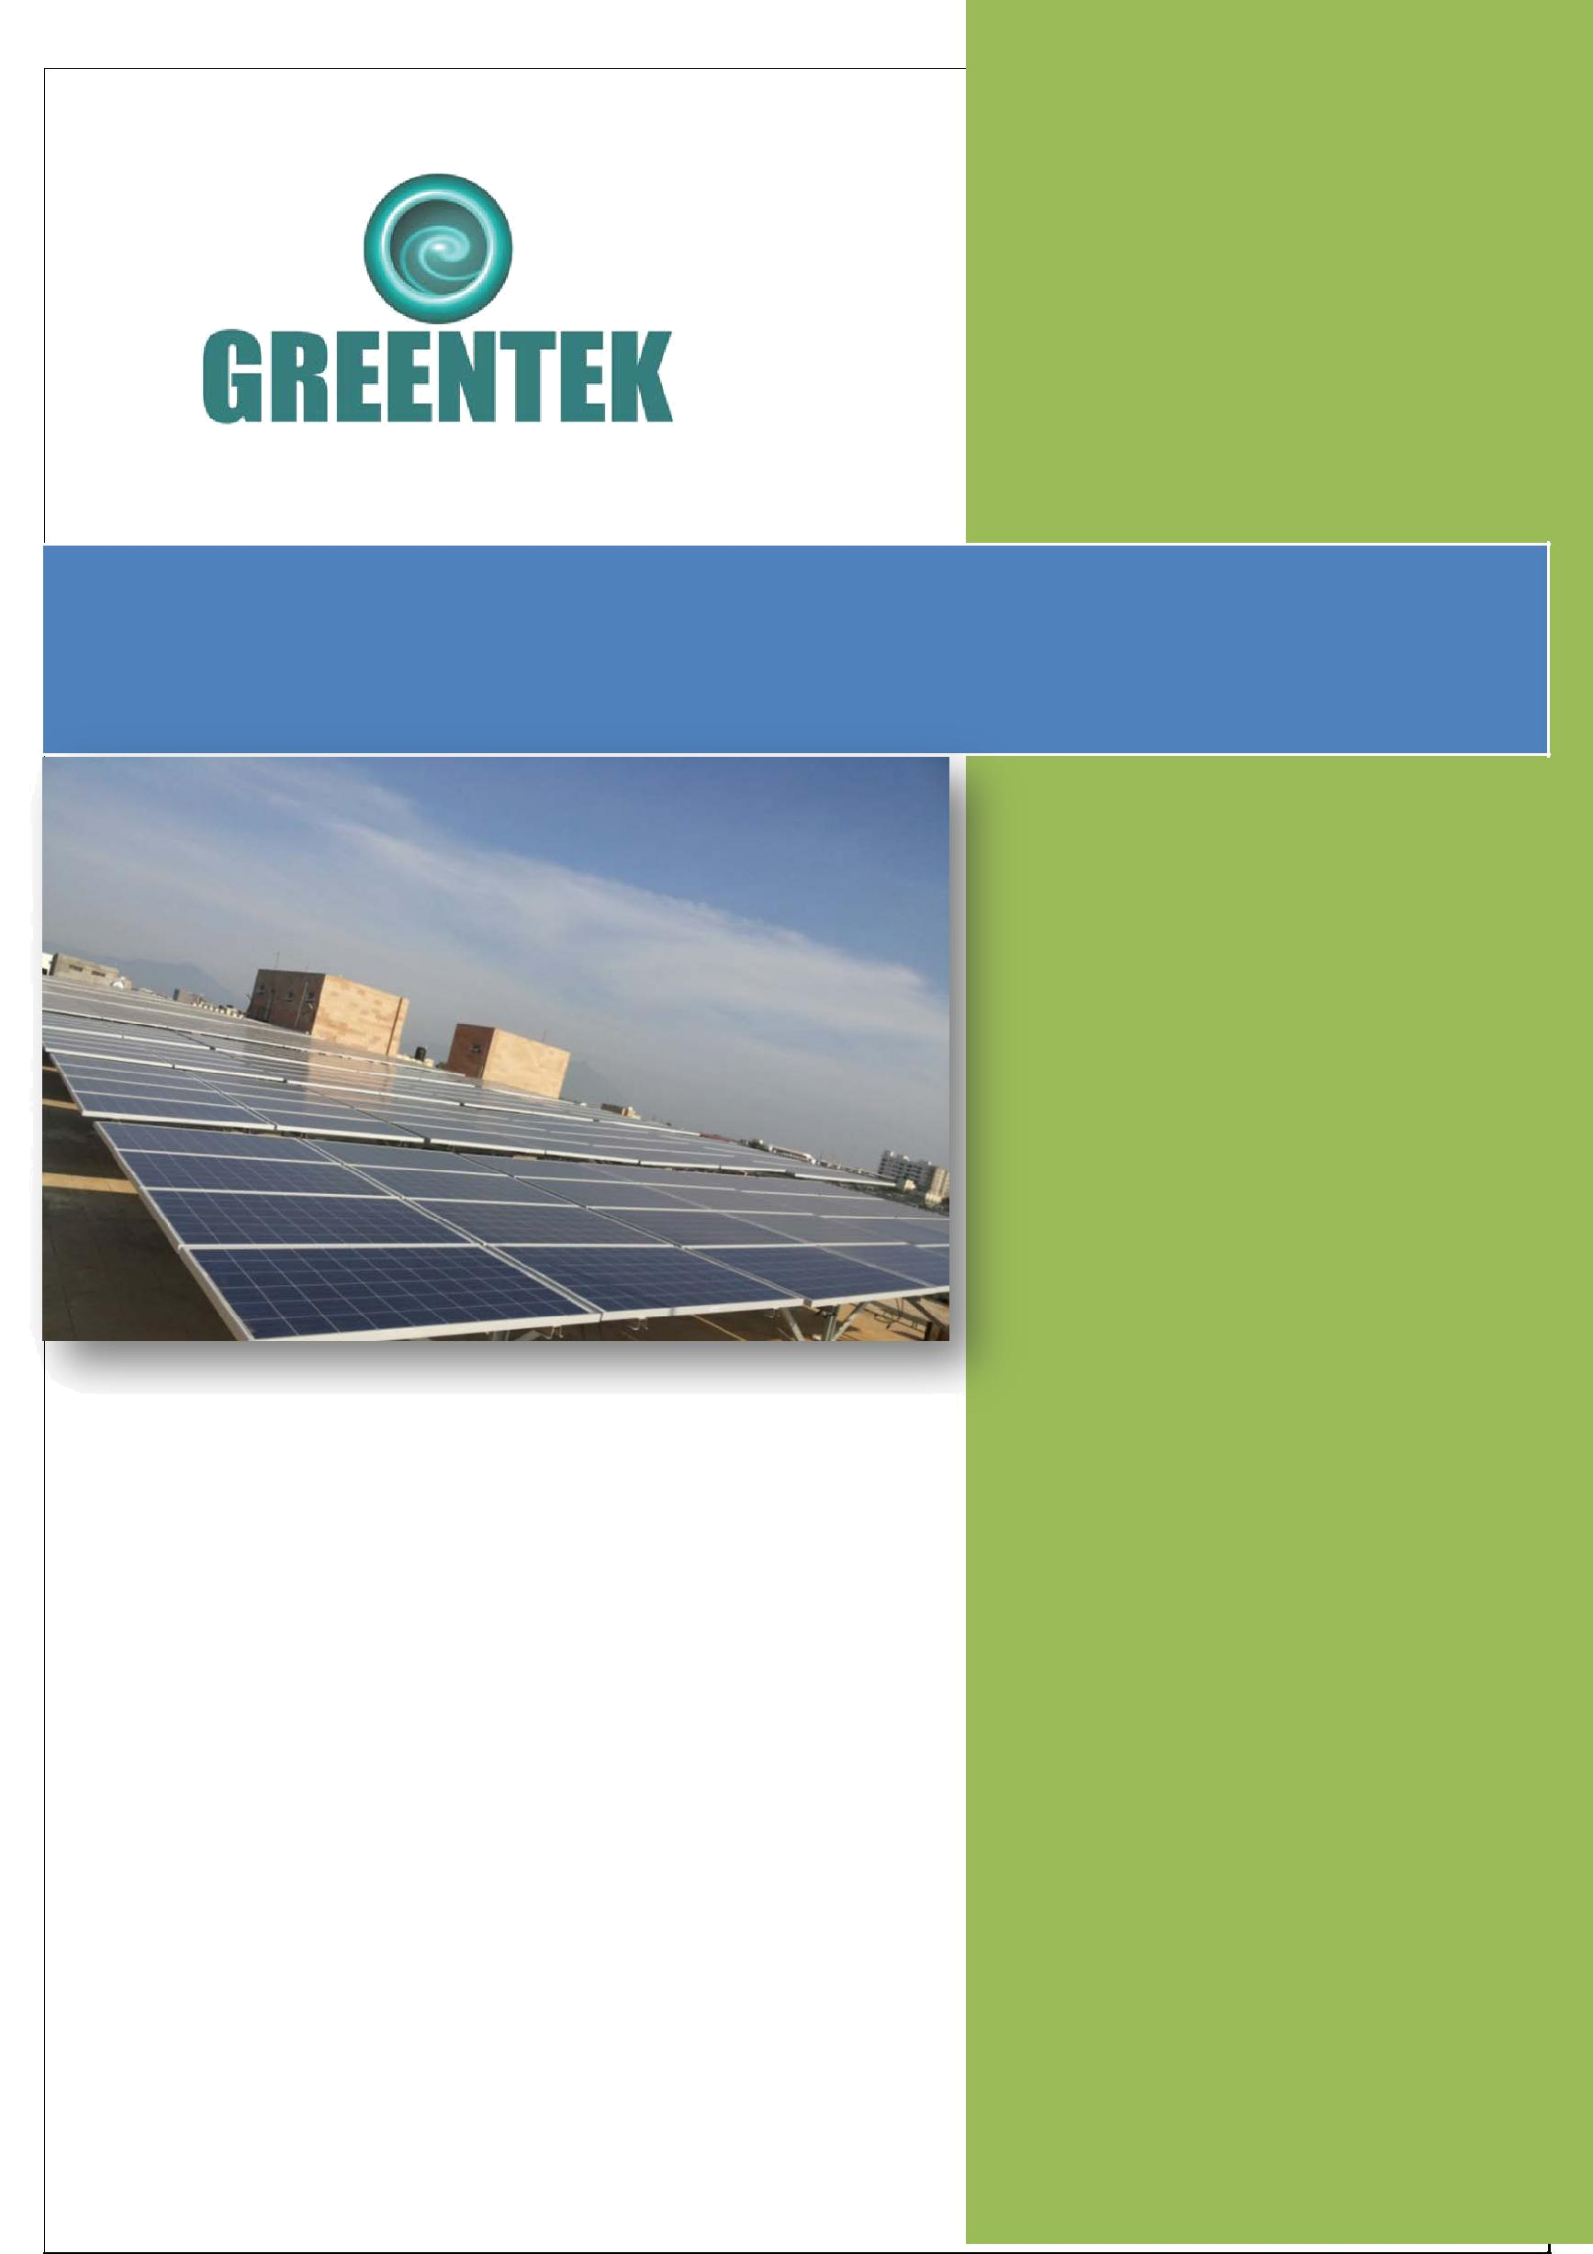
Greentek India Private Limited

Proposal for 8 KWp Solar On-Grid Power Plant System

M/s. GREENTEK INDIA PVT LTD
Plot # 8, Lepakshi colony
West Marredpally, Secunderabad -500026
Tel: 040-27807145 / 040-65198519 |  | To,  Mr. P.Ramanathan  T.T.K Road, Alwarpet,  Chennai-18
Mr. Sandhosh Kumar
Regional Manager
Mob: +91-90031 32081
E-mail: southsales@greentekindia.co.in
Solar Proposal:
GIPL/SPV/SECI/025/2017-18
Dated: 04/10/2017

Greentek India Pvt. Ltd.

Proposal for 8 kWp Grid Tied Captive Solar PV Power Plant

Customer details:

Name: | P. Ramanathan
Address: | 101/51, T.T.K Road, Alwarpet, Chennai, Tamil Nadu 600018
Contact Person: | P. Ramanathan
Mobile: | -
Email:
Site details:

Address: | 101/51, T.T.K Road, Alwarpet, Chennai, Tamil Nadu 600018
Longitude: | 80.244° E
Latitude: | 13.11° N
Rooftop / ground mounted: | Rooftop – mounted on the building’s rooftop
Type of roof / soil: | Flat Terrace
Availability of water: | Yes
Shading: | Area selected is net of shade from building
Load details:

Connected load: | N.A.
Contracted demand: | N.A.
Maximum demand: | N.A.
Type of connection: | Grid
Phases: | 3 Phase
Supply sub-station | NA
Electricity consumed
Existing power backup:

DG / Inverter: | DG
Capacity: | - KVA
Connected load: | - KVA
Proposed system:

Type of system: | Grid tied system of 8 kWp capacity with solar Priority Requires an additional source of power –Grid or DG for functioning (it cannot run in standalone mode)

 | Commercial terms:
 | Price basis: | FOR site
 | Validity: | 30 days from submission of the offer.
 | Taxes & duties: | GST @ 5%, 18%, 28% Service tax @ 18%
 | Placement of order: | Purchase Order will be placed on the Gross value of the System (including subsidy) Purchaser order should be placed upon us along with the advance payment as mentioned in the terms of Payment. Purchase order shall be considered effective from the date of receipt of advance payment along with commercial terms acceptable to us No binding contract shall be deemed to have been effected by the acceptance on the part of the purchaser of a quotation or offer made by us until such contracts have been confirmed in writing through order acceptance by us Orders once placed with us cannot be cancelled by purchaser on any account whatsoever
 | Delivery schedule: | As per project timeline
 | Payment terms: | As a percentage of the Net Value of System  - 100% advance along with PO
 | Warranty: | - 25 years for SPV modules
 |  | - 2 years for balance of system

Annexure – I
System specs

Item | Details | Make | 25KWp
SPV Modules | Mono/Poly crystalline  silicon modules | Greentek India Pvt Ltd | 320Wp x 25  Nos
Module mounting | MS galvanized | Reputed makes | 8 kWp
Structure | MS galvanized | Reputed makes
Inverter | High efficiency 3-Phase Grid Tied Solar String Inverter | Growatt/Polycab / Equivalent | Suitable for 8 kWp
Cables | Cu / Al - BIS standard | Polycab / KEI | As per site
LT Switchgear | BIS standard | ABB / Legrand / L&T/ Schneider | As Required
Other hardware &  electricals (incl. earthing & lightning protection) | BIS standard | Reputed makes | 1 set
Installation | MNRE standard | Greentek India Pvt Ltd | Included
Freight | For Site
System Requirements and Design will be as per MNRE / SECI project installation policies.

Return on Investment

Item | Unit |  | Value
System Size | KWp |  | 8
System cost | Rs |  | 5,76,000.00
Subsidy On the system | Rs |  | 1,49,040.00
Net cost after Subsidy | Rs |  | 4,26,960.00
Avg. solar units generated |  | Units /Years |  | 11520
Variable Cost of Power (Assuming 100 % EBusage @INR 10/ unit) |  | Rs/ unit | 10.00
Avg. savings per year | Rs/ year |  | 115200.00
Assumed increase in EB+DG tariff | % |  | 5%
Payback period | Years |  | 3.22
Project life | Years |  | 25
Savings of project life | Rs |  | 28,80,000.00
Projected Simple IRR | % |  | 35.99%
Rooftop area required | sqft |  | 3,000
Generation Cost Per Unit On System Cost Before Subsidy(On Total Units For 25years) | Rs/Unit |  | 1.84
Generation Cost Per Unit On System Cost After Subsidy(On Total Units For 25years) | Rs/Unit |  | 1.288
Generation Cost Per Unit On System Cost After Subsidy and Tax AD(On Total Units For 25years) | Rs/Unit |  | 1.288

Note: Additional cost will be charged for customized Structure depending up on the requirement of elevation. Technical calibrations considered for this offer are for budgetary purpose. During the execution final quantity may vary as per the actual site situation and final design.

The beneficiary has to make his payment through Cheque/ Demand Draft/ RTGS only no cash payments will be accepted.

Bank Details:

M/s. Greentek India Private Limited

Kotak Mahindra Bank , A/C NO: 05522000005884
IFSC : KKBK0000552, Somajiguda BRANCH, Hyderabad

We hope the above is in line with your requirements. In case of any clarification, kindly feel free to contact us.
Thanking you and assuring you of our best attentions at all times to come.

For Greentek India Pvt Ltd.

Sandhosh Kumar
Regional Manager | South India
90031 32081

