Course Name: System Analysis and Design (INFO 1113)

Section Number: S11

Title of the project: Easy Learning

**Date**:**27 November 2019**

Team Leader

Student Name: Sachreet Dhillon

Student ID: 100383292

Email: [sachreetdhillon2001@gmail.com](mailto:sachreetdhillon2001@gmail.com)

Website URL (Team Leader): <https://sites.google.com/view/sachreetdhillon001/home>

GitHub URL (Team Leader): https://github.com/100383292/Final_Project.git

Trello URL: [**https://trello.com/b/UUETdAQJ/final-project-info-1113**](https://trello.com/b/UUETdAQJ/final-project-info-1113)

Team Member

Student Name: Jobanpreet Kaur

Student Id: 100384723

Email: jobanpreetkaur9785@gmail.com

Website URL (Team members): <https://sites.google.com/view/jobansandhu/home>

GitHub URL (Team Member): <https://github.com/sandhujoban/Final_Project.git>

Trello URL (Team Member):  **https://trello.com/b/gbzKQBOB/finalproject-info-1113**

**Table of Contents:**

EXECUTIVE SUMMARY: 3

INTRODUCTION: 4

PROJECT REQUIREMENTS: 4

USE-CASE DIAGRAM: 5

USE-CASE DISCRIPTION: 6

CLASS DIAGRAM: 8

SEQUENCE DIAGRAM ON SIGN UP: 9

INTERFACE PROTOTYPE: 10

ACCESS DATABASE: 12

PROJECT EXPERIENCE: 13

CONCLUSION: 14

WORK CITED: 14

# **EXECUTIVE SUMMARY**:

Steps for Application Development

Fast Learning Application

**Purpose:**

*The Main Purpose of the project (Developing Fast Learning Application) is to benefit or help the learners in every aspect- Cognitive Improvement, Holistic Approach, Adopting Remote Learning, Utilization of Free Time, Enjoyful and Informal Way of Learning etc.*

To Begin with, The Learning application is the online resource for e-books, Online Lectures, Lecture Summaries, Revision exercises for practice etc. Beside This, Unlike schools, mobile applications are available round the clock. Moreover, In that Fast Learning Application, a lot of new features are added. The main is customisation, User choose the background, text-size, Font style in accordance to his choice(which appears eye-catching ).

The Application Provides a systematic learning Pattern. Initially, Learner get the full Topic detail that he/she chooses. Once the lecture is completed their is a summary which covers all the key points of that topic. Then there is a video which describes that topic with the practical example related to the topic. In the end , there is a review test , User will have to pass that test with more than 70% to score good in his finals or in his actual test.

The main focus of the project is to improve student overall grades. The report is fully based on the online educational resources and their positive consequences. For instance, the student has multiple choice to choose the method of studying like if student do not like to read text, due to which he does not score well, in that case there is an alternative method for that. On the other hand, if there is a language problem a special translator features is added to the application. In addition, auto updates are available. Many of the options are given to make the learning of course easier. The highlighted or underlining text are mentioned in the topic to remember the most significant part of what you’re reading.

Hence, this is the exciting Project which proves very beneficial not only to enhance scores but also for getting deep knowledge and become expertise of that course you completed through learning Application.

# INTRODUCTION:

The Project of developing Fast Learning Application is to perpetuate the learners grades by gaining knowledge through online resources. The Main Goal of the Project is to Extend the new features of technology that how just at a single click of mouse we get different ideas of learning different stuff. In the Application user first have to sign in their accounts with accurate passwords which is the primary key to use the application. Then in the Next Step, user have to choose the course he want to study.

Afterwards, there are choices among the methods of studying. This Application is informal and entertaining way of learning. And, another target is to provide a lot of videos and experimental knowledge, so that student can learn everything under one roof. To make learning easy, all cruxes**.**

Moreover, methods of making learning easy are Underlining, Case Studies, Flashcards, Mind Mapping, etc. The aim of the project is to create a use-case diagram for Developing Easy Learning Application. This requires an expertise Practice of Developing System Life Cycle. Application offers a lot of additional features like User choose everything according to his own choice. In Addition, User also give his feedback while logging out the application.

# **PROJECT REQUIREMENTS**:

Functional requirements: Functional requirements are the features that developer must implement to enable users to do their task.

Non-Functional requirements: Non-Functional requirements is a quality attribute of a software system.

|  |  |  |  |
| --- | --- | --- | --- |
| **Functional** Requirements: |  | **Non-Functional Requirements** |  |
| User Account | Descriptions ofdata is the functional requirement to be entered into the system**.** The user id and its password is the primary key to run the application. If the learner do not have its user id so he will have to sign up with a new username | Customization | This feature helps user to design the background ,colour contrast, fonts and size of user choice. |
| Description of Operations | The operation of each screen in based on the users given command. | Commenting System | By this feature everyone comment their views and ideas  on the topic which  they are reading. |
| Data Classification & Backup: | All Data is classified in an organised manner. | Rating & Review | Everyone Rate the application after using |

# USE-CASE DIAGRAM:

Use-case: A **use case** is a description of how users will perform tasks on the application

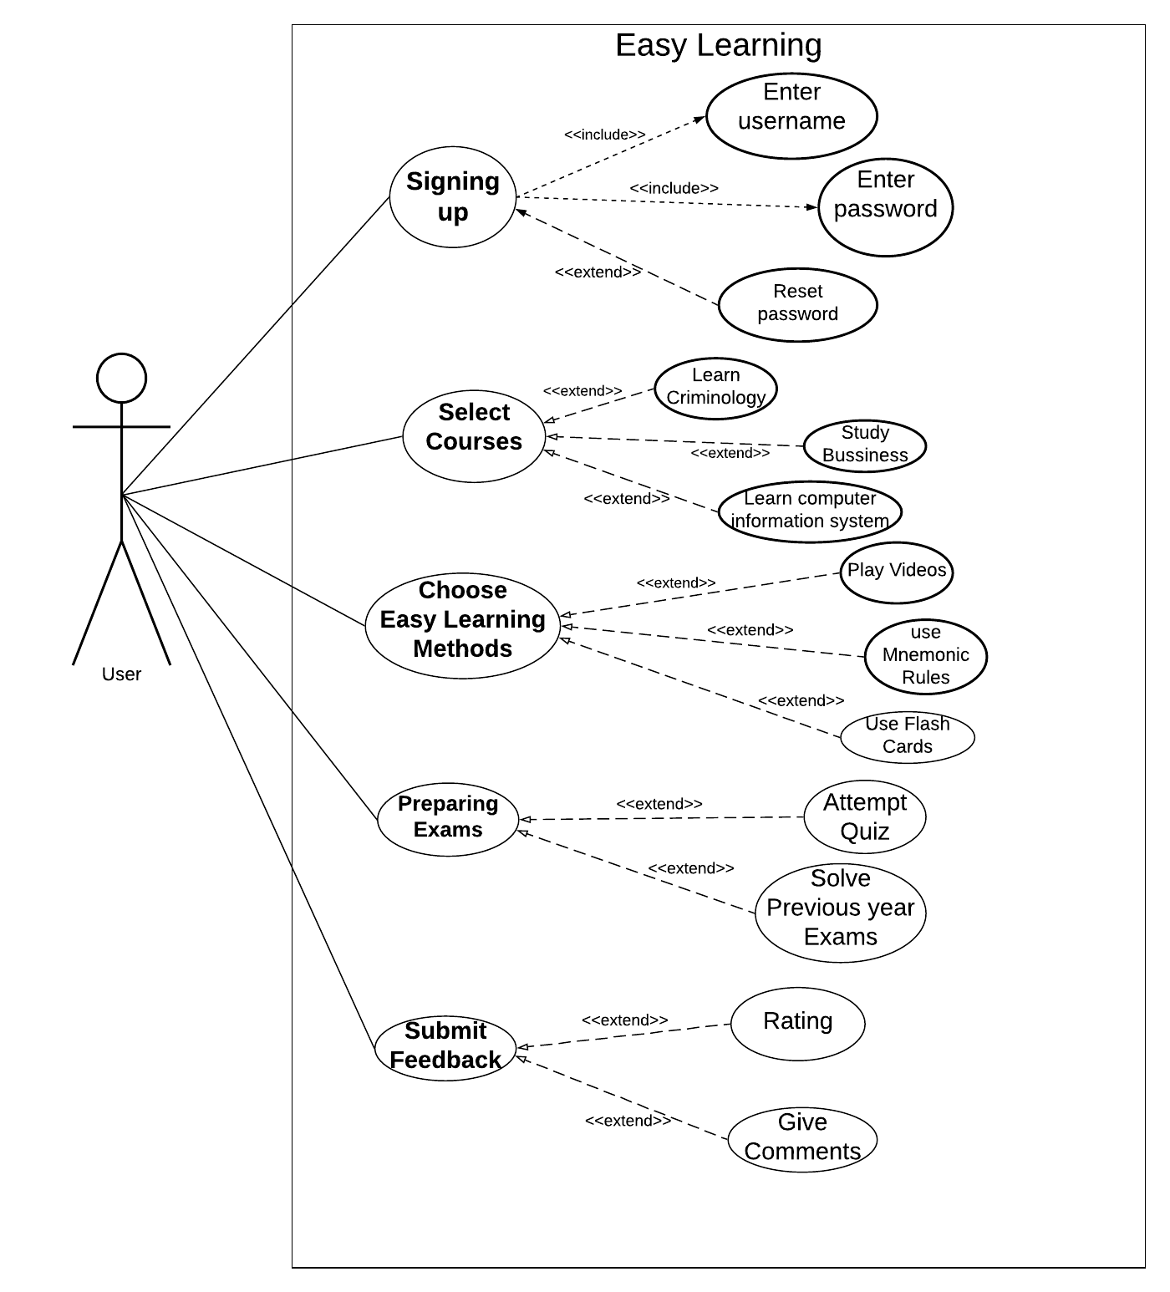

# USE-CASE DISCRIPTION:

Use-case description (Team-Leader): Sachreet Dhillon

|  |
| --- |
| Use case Title: Exam Preparation |
| Primary Actor: User (students) of the app. |
| Goal: Find crux of learning and scoring good in exams. |
| Level: Kite Level |
| Preconditions: User must have their User id and Password. |
| Minimal Guarantee: User definitely gets to know the basics of the topic, he is seeking for. |
| Success Guarantee: Student definitely improve his week points |
| Main Success scenario:  1. User can select the course.  2.Learner can choose learning method.  3.User have to solve the quizzes to get his result.  4.User can submit feedback . |
| Extension  1.Quizzes have three levels i) Easy ii) Moderate iii) Tough.  a. By attempting quizzes user get to know about their mistakes.  b. Review and Reattempting of quiz also available.  2.a. Previous ten year exams are available  b By solving that dummy exams user get to know his mistakes. |

Use-case Reviewer (Jobanpreet Kaur)

The use description is about the fourth step of use case i.e. the describes about the exam Preparation. A Primary Actor are Users of the application. The main aim or goal is to find the shortcuts for learning tough material and to score well. The user id of the user is the main thing or Precondition to use the application. In the application to prepare for the exams there are Previous ten year exam papers to solve in addition quizzes helps to improve the score.

Use case description (Team-Member): Jobanpreet Kaur

|  |
| --- |
| Use case title: Easy Learning method |
| Primary Actor: Learner |
| Goal: To understand tough topics in easy way for good grades. |
| Level: kite |
| Preconditions: User must have web connection. |
| Minimal Guarantee: If user will follow the guidelines he or she may improve grades. |
| Success Guarantee: play videos and get the practical knowledge. |
| Main Success Scenario:  1.User select the learning method.  2.User can view flash cards which have important information.  3.User can submit feedback.  4.user can take audio lessons from videos. |
| Extensions:  1.User can select the any method for learning.  a. Unknown errors appear on screen.  b. The user may experience some fluctuations in web connections.  c. User click on refresh page and page loads successfully.  2.User select video lessons.  a. Video cannot be played on screen.  b. User could be trying to play the video lessons in unsupported web browser.  c. User change the web browser and the video plays successfully. |

Use-case Reviewer Sachreet Dhillon:

The use case description of Jobanpreet Kaur is about the easy Learning Methods Offered by the Application. The Primary Actor is the Learner(user) of the application and the PRIMARY KEY is the user id of the Learner. The Success guarantee is to get Practical knowledge. In extensions, all methods and unfortunately if error occurs what are its solutions. Like, if user play the video and an unknown error occurs then refresh the page and Finally, your video plays successfully.

# CLASS DIAGRAM:

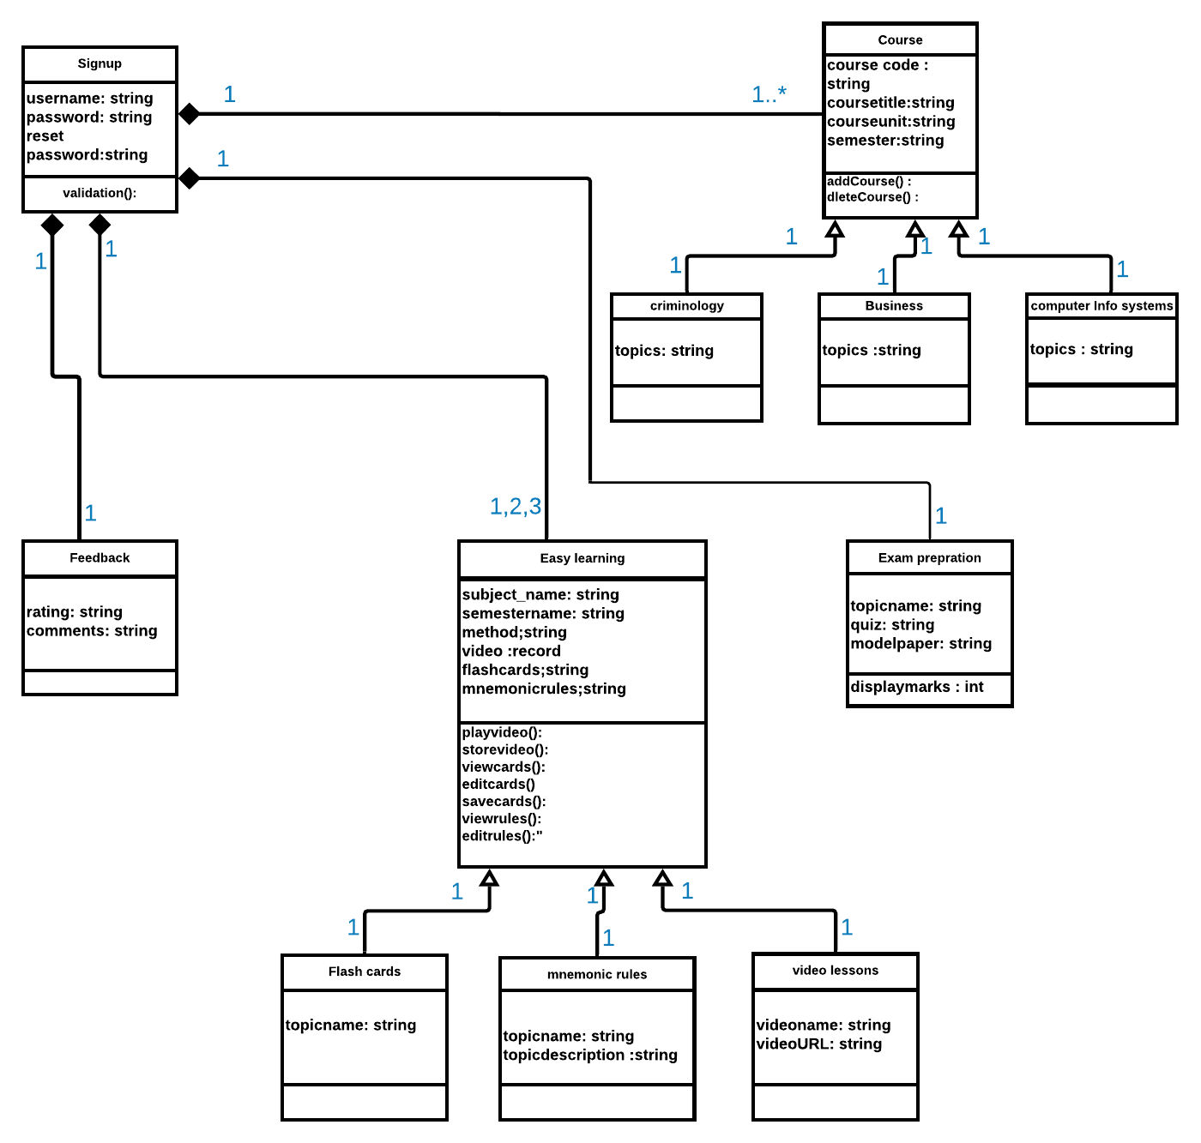

# SEQUENCE DIAGRAM ON SIGN UP:

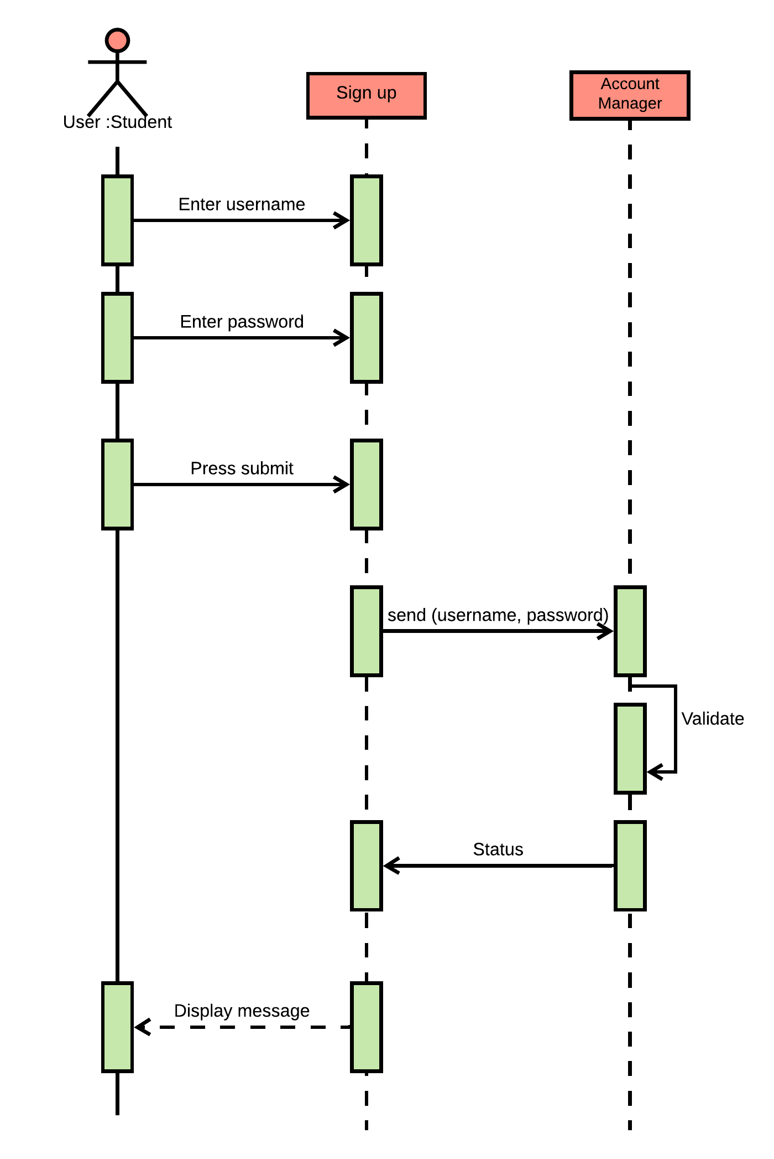

INTERFACE PROTOTYPE:

Fig a: To use the application User need its User id and password.to sign in or to create an account user have to sign up either with phone number or email.

Fig b: Here User have to enter his user id and its Password

Fig a Fig b

**……….**

Abc123@google.com



Back Next

**Login**

Password

**Phone number or email**



or

**Create new account**

Welcome to Easy learning

Sign in successfull



**Accounts**

**Business**

**Computer Information System**

Fig c Fig d

Fig c Fig d

Fig c: shows the screen when your Login goes Successful

Fig d: Depicts that screen when you have to select the course

RATE THE APPLICATION

Jobanpreet Kaur

RATING 

Comment: Make My Study really easy.

Back submit

10 YEAR EXAM

ATTEMPT QUIZ

***Test Your Knowledge***

Fig e

Fig f

Fig e: Here user have to select the type of exam: Quiz or Rating.

Fig f: describes the user rating and comments.

# ACCESS DATABASE:

1. Tables:

Student id is a primary key:

|  | | | | | | | | | |
| --- | --- | --- | --- | --- | --- | --- | --- | --- | --- |
| **student id** | | **student name** | **course selected** | **marks scored** | **semester** | **Preparation method used** | **learning method used** | **feedback** | **day_of_class** |
| 1001 | Joban | | criminology | 70 | January | Quiz | Video | Poor | Monday |
| 1002 | Sachreet | | business | 80 | February | Previous Year Exam | Flashcard | Good | Tuesday |
| 1003 | Gursewak | | computer info system | 40 | March | Quiz | Mnemonic rules | Poor | Wednesday |
| 1004 | Harman | | criminology | 80 | January | Quiz | Video | Good | Monday |
| 1005 | Navjot | | business | 90 | February | Previous Year Exam | Flashcard | Poor | Tuesday |
| 1006 | Harjot | | computer info system | 55 | March | Quiz | Mnemonic rules | Good | Wednesday |

Course is a primary key in the following table:

|  | | |
| --- | --- | --- |
| **course selected** | **semester** | **day_of_class** |
| Business | February | Tuesday |
| computer info system | March | Wednesday |
| Criminology | January | Monday |

1. Queries:

Query for the course (business and computer info system):

|  | | | |
| --- | --- | --- | --- |
| **course selected** | **student id** | **student name** | **semester** |
| Business | 1002 | Sachreet | February |
| computer info system | 1003 | Gursewak | March |
| Business | 1005 | Navjot | February |
| computer info system | 1006 | Harjot | March |

Query for the students marks obtained (70 or 40 or 80):

|  | | | | |
| --- | --- | --- | --- | --- |
| **marks scored** | **course selected** | **semester** | **day_of_class** | **student name** |
| 70 | criminology | January | Monday | Joban |
| 80 | business | February | Tuesday | Sachreet |
| 40 | computer info system | March | Wednesday | Gursewak |
| 80 | criminology | January | Monday | Harman |

Query for the students who has taken the class in January and February:

|  | | | |
| --- | --- | --- | --- |
| **semester** | **student name** | **course selected** | **day_of_class** |
| January | Joban | Criminology | Monday |
| February | Sachreet | Business | Tuesday |
| January | Harman | Criminology | Monday |
| February | Navjot | Business | Tuesday |

# PROJECT EXPERIENCE:

***Experience of that Project was really Amazing. We (Joban-Sachreet) faces some difficulties. The Main difficulty is the Time Management because our schedule is different*.**

**Experience of Team Leader (Sachreet Dhillon)**

My First difficulty I face is to distribute the work between me and my team member because, it’s hard to decide with the team member’s agreement. Beside this, I really enjoy writing execute summary and Introduction. Again My class diagram is not well in first Attempt. Its annoying to reattempt class diagram. However, Rest of the work Including, Conclusion, Introduction. Use-Case (especially –Prototypes is really wonderful)

**Experience of Team Member (Jobanpreet Kaur)**

My Project Experience was incredible. I enjoy working on Access database but I face difficulty while working on Lucid chart But then I watch some you tube videos and learn how to make sequence diagram. After that when I discuss whole Project with my Team member I was in high spirits.

# CONCLUSION:

The Project includes everything for Online Learning in Easy way. To begin with, there are some functional and non-functional requirements. Beside this, there is a use-case which describes the full application scenario in a systematic manner also there are class and sequence diagram related to the application. Afterwards, there are choices among the methods of studying. This Application is informal and entertaining way of learning. And, another target is to provide a lot of videos and experimental knowledge, so that student learn everything under one roof. To make learning easy, all cruxes**.**

# WORK CITED:

I get some information from the mentioned links

(1) http://libgen.is/book/index.php?md5=104FF32032D7780488F1041255116C1D

(2) <https://www.youtube.com/watch?v=YgW0Oiwp9U4>