**USE CASE DIAGRAM AND CASE DESCRIPTION**

NAME- Jobanpreet Kaur

STUDENT ID-100384723

Team member GITHUB URL- https://github.com/100383292/Use-case.git

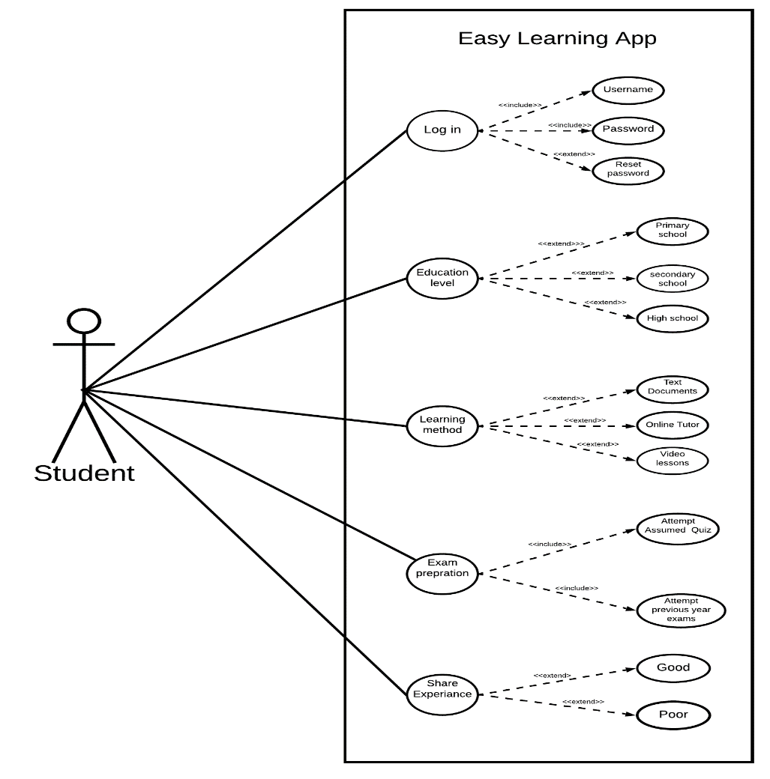

|  |
| --- |
| Use case title: Learning method |
| Primary Actor: Learner |
| Goal: To understand tough topics in easy way for good grades. |
| Level: kite |
| Preconditions: User must have web connection. |
| Minimal Guarantee: If user will follow the guidelines he or she may improve grades. |
| Success Guarantee: If all of the instructions are followed student will experience some changes in grades. |
| Main success scenario:  3. User selects the learning method depending factors like his/her personal choice or type of question he/she want to find results for. |
| Extensions:  3a User select one choice from learning method.  1.Unknown error appears on screen.  3a1. The user may experiencing some fluctuations in web connections.  2. User click on refresh page and page loads successfully.  3b User select video lessons.  1. Video can not be played displayed on screen.  3b1. The user could be trying to play the video lessons in unsupported web browser.  2. User change the web browser and the video plays successfully. |

**Use case diagram** and **use case description of my team member**

Team- member name-SACHREET DHILLON

Student ID-100383292

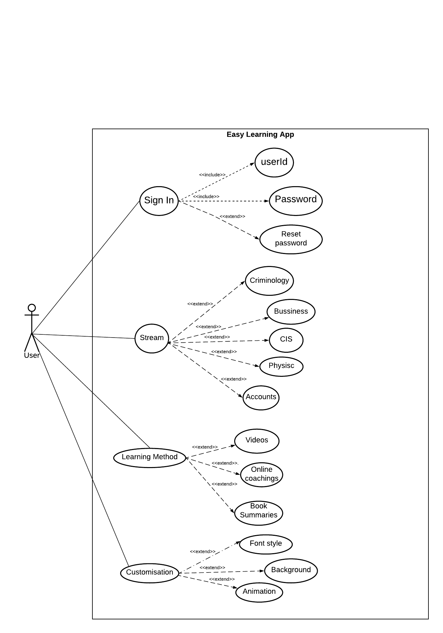

|  |
| --- |
| Use case Title: Easy Learning Techniques |
| Primary Actor: User (students) of the app. |
| Goal: Find crux of learning every tough Topic. |
| Level: Kite Level |
| Preconditions: User must have their userid and Password. |
| Minimal Guarantee: User definitely gets to know the basics of the topic, he is seeking for. |
| Success Guarantee: Perpetuation in Student Knowledge and Horizon. |
| Main Success scenario:  3. User chooses the way by which he is comfortable to learn i.e. Videos, Summaries etc.  As, every question with its solution is available there. Beside this, user makes the look attractive of background. Because it also has a Property of Customisation. |
| Extension  3a. User select one method of learning.  1. Page default error occurs.  3a1.Refresh the page, then page will reload successfully.  3b User selects Multimedia (video) to study.  1. Video do not opened or displayed.  3b1.User try to play video in unsupported browser.  2.User change the browser type and runs successfully. |

**REVIEW**

Review of use-case diagram and description

**DIAGRAM ORIGINATOR: Sachreet Dhillon**

**REVIEWER NAME-JOBANPREET KAUR**



**USE-CASE DIAGRAM REVIEW:**

To run the learning app user have to sign in for which username and Password. First we have to choose the course you want to study. Then out of various methods of learning you have to choose only one which is your favourite .Afterwards, It also include the property of customisation where we choose the background, text style and fonts also size everything of the type which catches your eye.

**REVIEW ON USERCASE DESCRIPTION**

**DESCRIPTION ORIGINATOR=SACHREET DHILLON**

**REVIEWER NAME: JOBANPREET KAUR.**

|  |
| --- |
| Use case Title: Easy Learning Techniques |
| Primary Actor: User (students) of the app. |
| Goal: Find crux of learning every tough Topic. |
| Level: Kite Level |
| Preconditions: User must have their userid and Password. |
| Minimal Guarantee: User definitely gets to know the basics of the topic, he is seeking for. |
| Success Guarantee: Perpetuation in Student Knowledge and Horizon. |
| Main Success scenario:  3. User chooses the way by which he is comfortable to learn i.e. Videos, Summaries etc.  As, every question with its solution is available there. Beside this, user makes the look attractive of background. Because it also has a Property of Customisation. |
| Extension  3a. User select one method of learning.  1. Page default error occurs.  3a1.Refresh the page, then page will reload successfully.  3b User selects Multimedia (video) to study.  1. Video do not opened or displayed.  3b1.User try to play video in unsupported browser.  2.User change the browser type and runs successfully. |

**LEARNING METHOD REVIEW.**

As the Use-case Title reveals this is the use-case description on tips in which the primary Actor is a student or user who wants to learn with a single click of mouse. Moving ahead, the goal is to score well in exams. And also learn everything deeply. To check the preparation there is a quiz in the Tailing of every session. Sometimes if some unknown error occurs just reload .

FINAL USE CASE DIAGRAM AND DESCRIPTION

We (Sachreet and Joban ) have done the review on use-case diagram and description .After discussion this will be our final use case diagram and description.

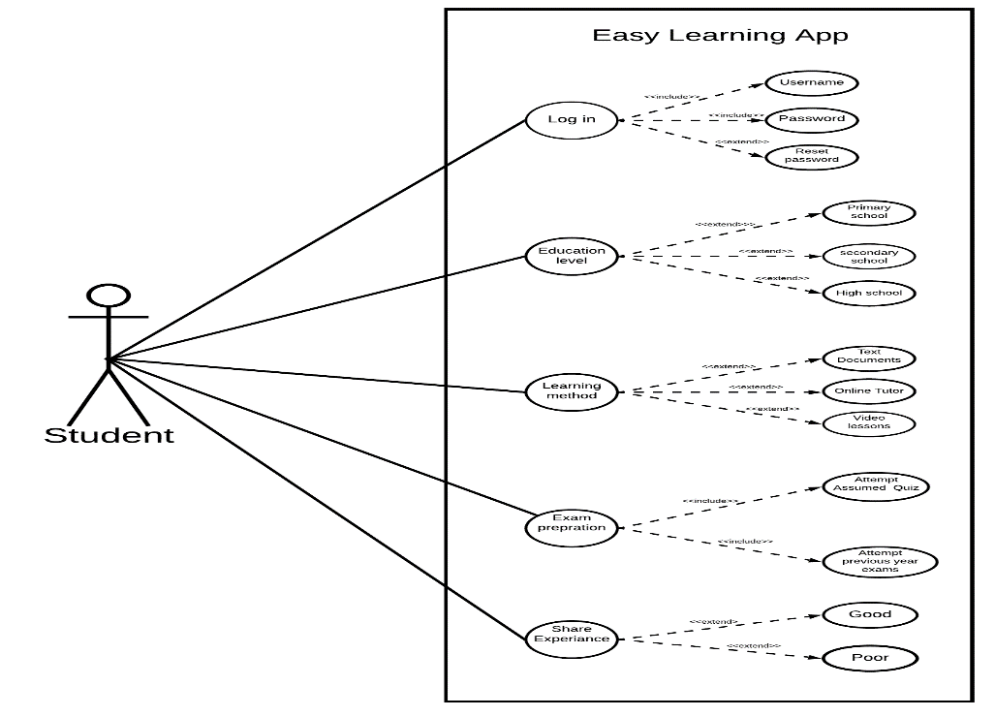

USE CASE DESCRIPTION.

|  |
| --- |
| Use case title: Learning method |
| Primary Actor: Learner |
| Goal: To understand tough topics in easy way for good grades. |
| Level: kite |
| Preconditions: User must have web connection. |
| Minimal Guarantee: If user will follow the guidelines he or she may improve grades. |
| Success Guarantee: If all of the instructions are followed student will experience some changes in grades. |
| Main success scenario:  3. User selects the learning method depending factors like his/her personal choice or type of question he/she want to find results for. |
| Extensions:  3a User select one choice from learning method.  1.Unknown error appear on screen.  3a1. The user may experiencing some fluctuations in web connections.  2. User click on refresh page and page loads successfully.  3b User select video lessons.  1.Video can not be played displayed on screen.  3b1. The user could be trying to play the video lessons in unsupported web browser.  2. User change the web browser and the video plays successfully. |

USE-CASE DESCRIPTION (SACHREET DHILLON)

|  |
| --- |
| Use case Title: Easy Learning Techniques |
| Primary Actor: User (students) of the app. |
| Goal: Find crux of learning every tough Topic. |
| Level: Kite Level |
| Preconditions: User must have their userid and Password. |
| Minimal Guarantee: User definitely gets to know the basics of the topic, he is seeking for. |
| Success Guarantee: Perpetuation in Student Knowledge and Horizon. |
| Main Success scenario:  3. User chooses the way by which he is comfortable to learn i.e. Videos, Summaries etc.  As, every question with its solution is available there. Beside this, user makes the look attractive of background. Because it also has a Property of Customisation. |
| Extension  3a. User select one method of learning.  1. Page default error occurs.  3a1.Refresh the page, then page will reload successfully.  3b User selects Multimedia (video) to study.  1. Video do not opened or displayed.  3b1.User try to play video in unsupported browser.  2.User change the browser type and runs successfully. |