use test;

DELIMITER $$

SHOW CREATE PROCEDURE job_data$$

CALL job_data() $$

DELIMITER $$

CREATE PROCEDURE proc_Variables()

BEGIN

DECLARE a INT DEFAULT 10;

DECLARE b, c INT;

SET a = a + 100;

SET b = 2;

SET c = a + b;

BEGIN

DECLARE c INT;

SET c = 5;

SELECT a, b, c;

END;

SELECT a, b, c;

END$$

CALL proc_Variables() $$

DELIMITER $$

CREATE PROCEDURE proc_User_Variables() BEGIN SET @x = 15; SET @y = 10; SELECT @x, @y, @x-@y; END$$

CALL proc_User_Variables();

CREATE PROCEDURE proc_IN(IN var1 INT)

BEGIN

SELECT * FROM jobs LIMIT var1;

END$$

CALL proc_IN(2)$$

DELIMITER $$

CREATE PROCEDURE my_proc_OUT(OUT highest_salary INT)

BEGIN

SELECT MAX(MAX_SALARY) INTO highest_salary FROM jobs;

END$$

CALL my_proc_OUT(@M)$$

SELECT @M$$

USE test;

DELIMITER $$

CREATE PROCEDURE proc_INOUT (INOUT maxsalary INT, IN desig

CHAR(30))

BEGIN

SELECT MAX_SALARY INTO maxsalary FROM jobs WHERE

JOB_TITLE = desig;

END$$

CALL proc_INOUT(@C,'Stock Clerk')$$

SELECT @C$$

USE test;

DELIMITER $$

CREATE PROCEDURE proc_Compare_Salary(IN desig CHAR(30))

BEGIN

DECLARE progSal INT;

DECLARE presSal INT;

SELECT MIN_SALARY INTO progSal FROM jobs WHERE JOB_TITLE = desig;

SELECT MIN_SALARY INTO presSal FROM jobs WHERE JOB_TITLE = 'president';

SET presSal = presSal /2;

SELECT presSal;

SELECT progSal;

IF (progSal < presSal)

THEN

SELECT 'You need an increment.';

ELSEIF (progSal = presSal)

THEN

SELECT 'Salary is moderate';

ELSE

SELECT 'You are earning good';

END IF;

END$$

CALL proc_Compare_Salary('Programmer')$$

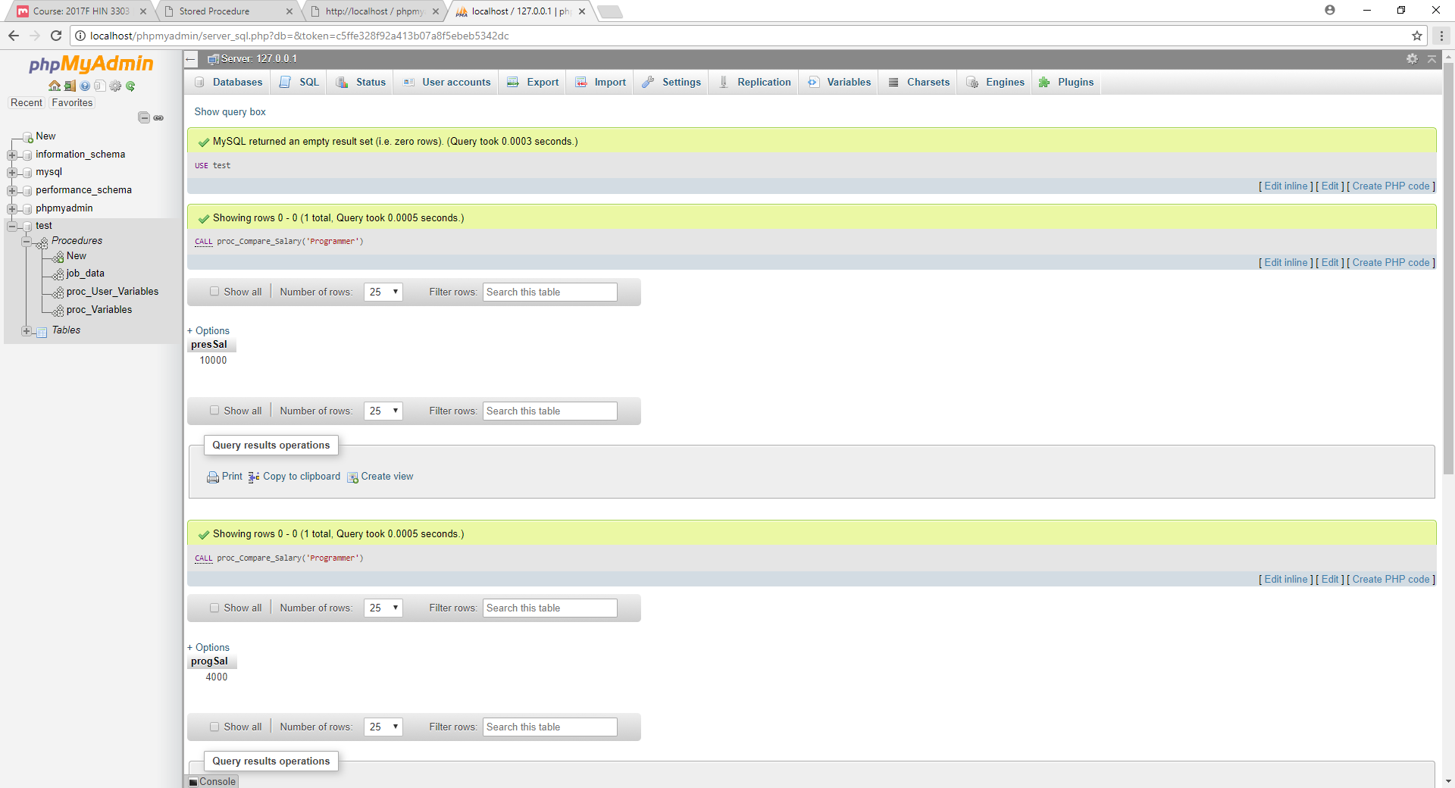

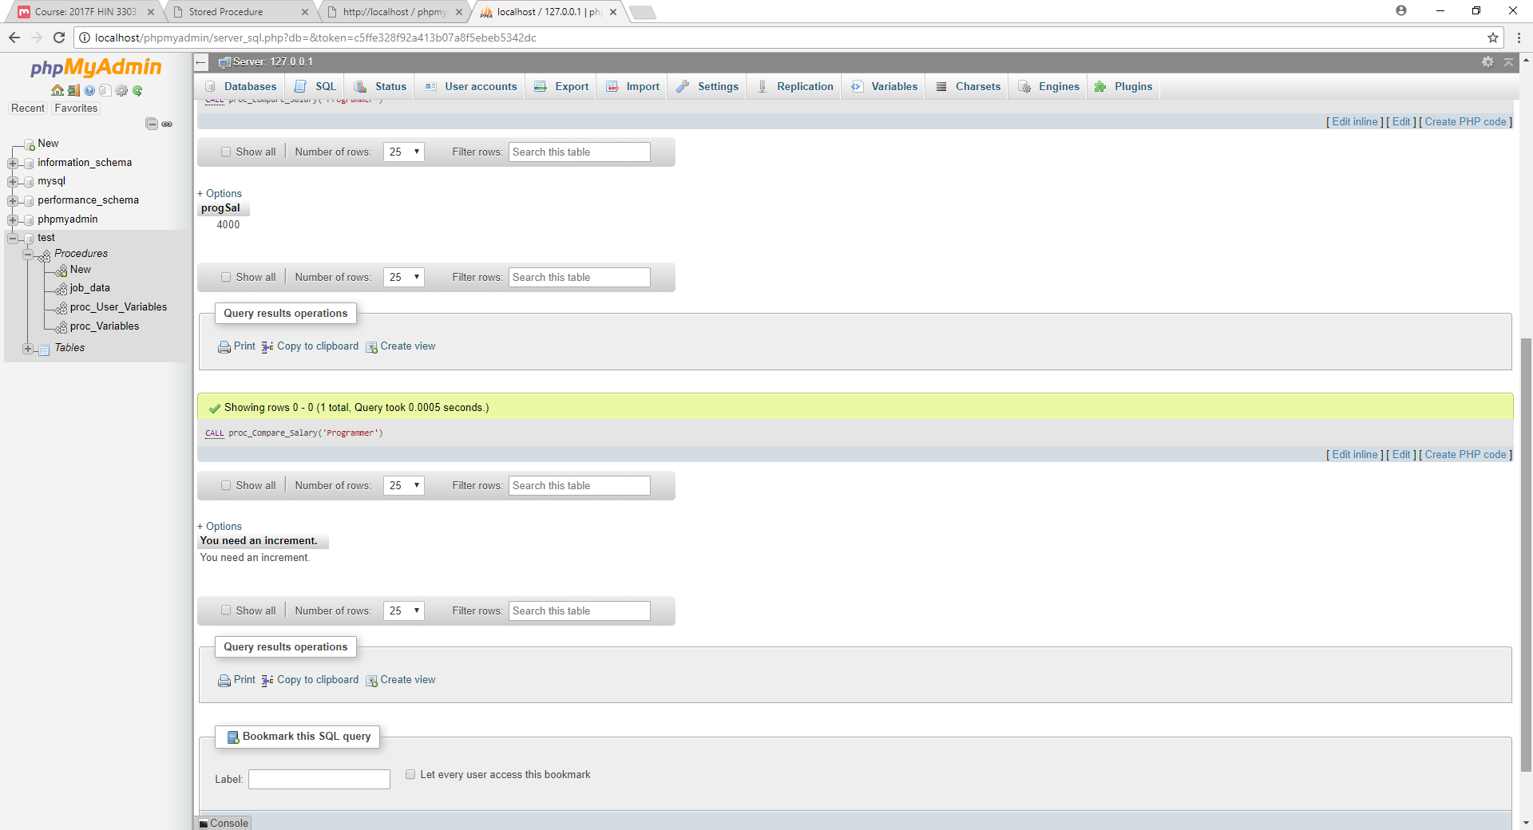

USE test;

DELIMITER $$

CREATE PROCEDURE proc_Case (INOUT no_employees INT, IN

salary INT)

BEGIN

CASE

WHEN (salary>10000)

THEN (SELECT COUNT(job_id) INTO no_employees FROM

jobs WHERE min_salary>10000);

WHEN (salary<10000)

THEN (SELECT COUNT(job_id) INTO no_employees FROM

jobs WHERE min_salary<10000);

ELSE (SELECT COUNT(job_id) INTO no_employees FROM jobs

WHERE min_salary=10000);

END CASE;

END$$

CALL proc_Case(@C,10001)$$

SELECT @C$$

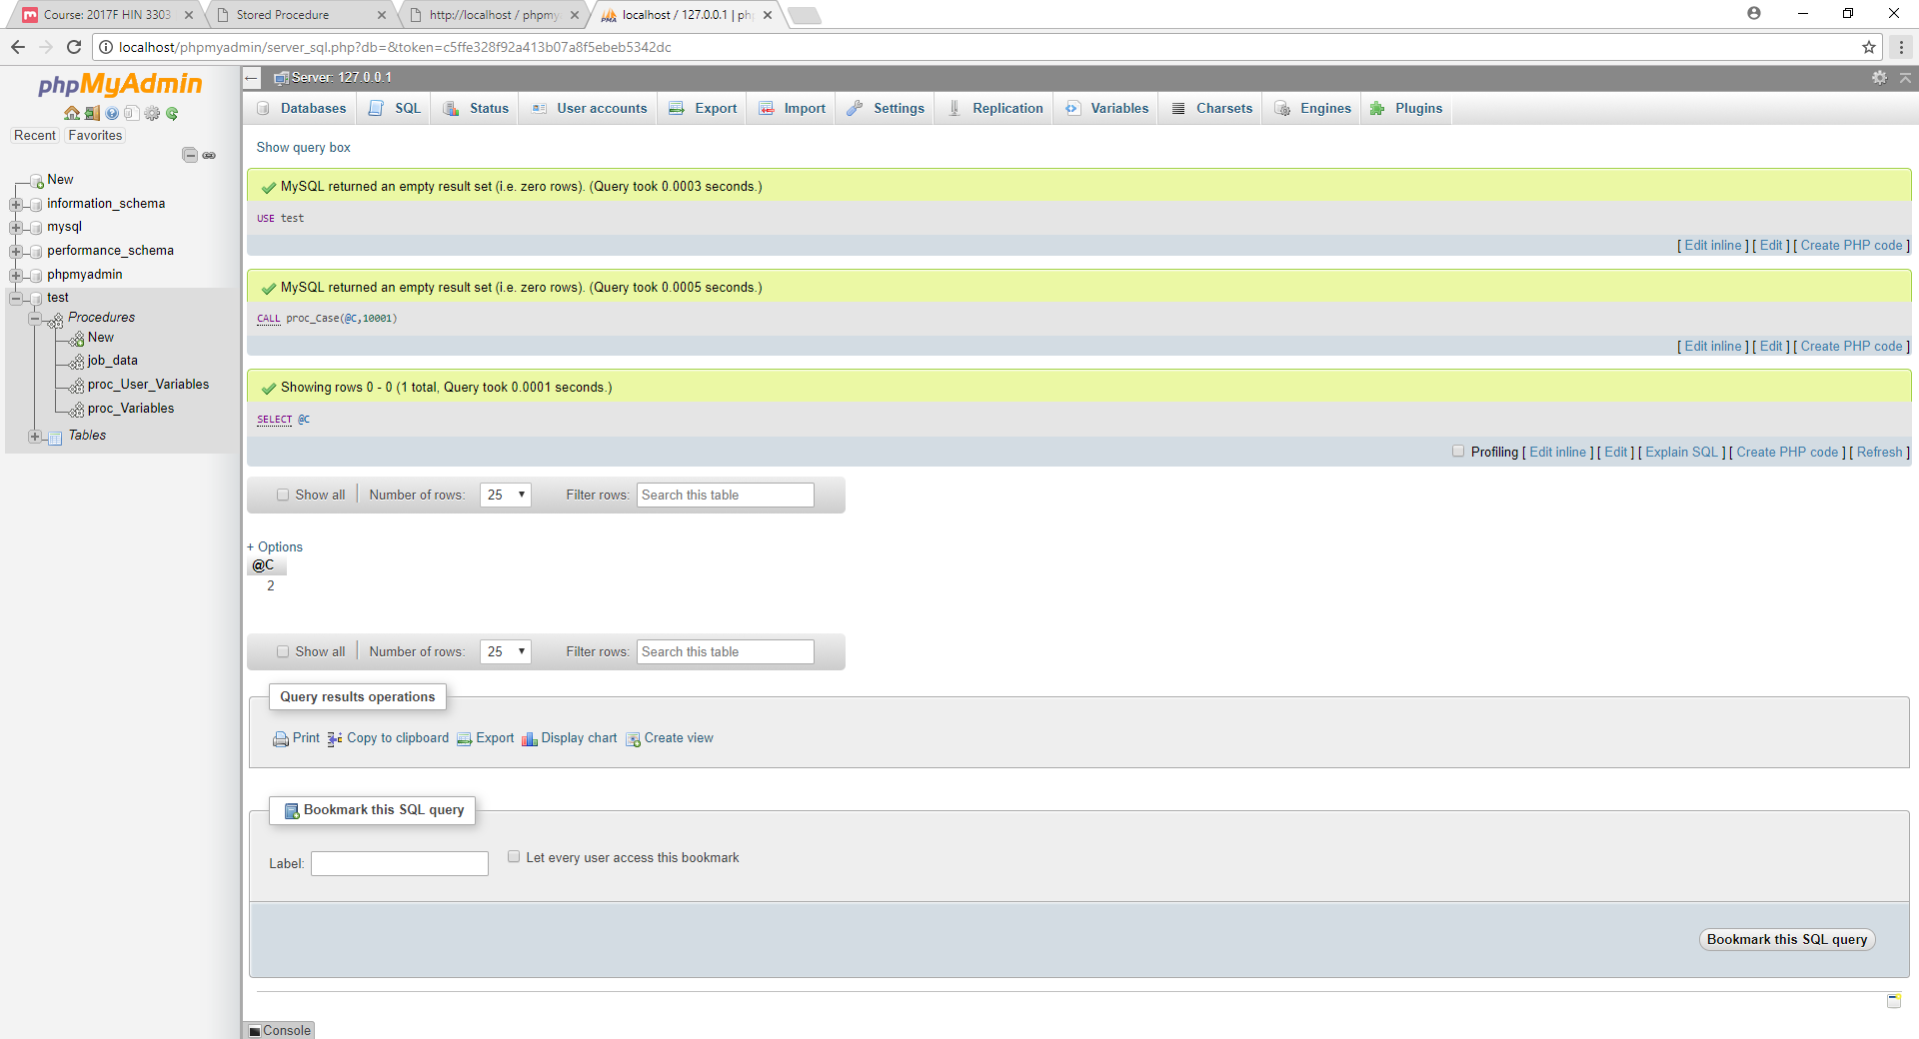

CALL proc_Case(@C,10000)$$

SELECT @C$$

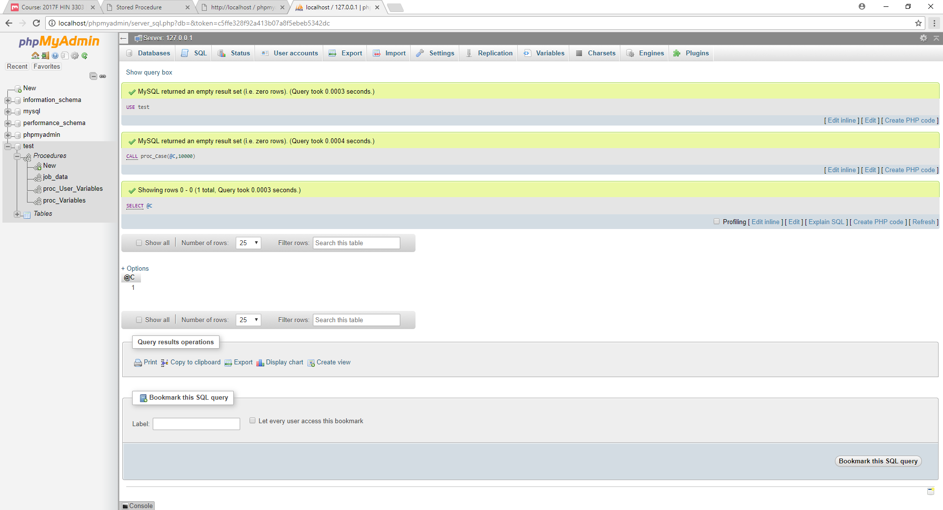

CALL proc_Case(@C,9999)$$

SELECT @C$$

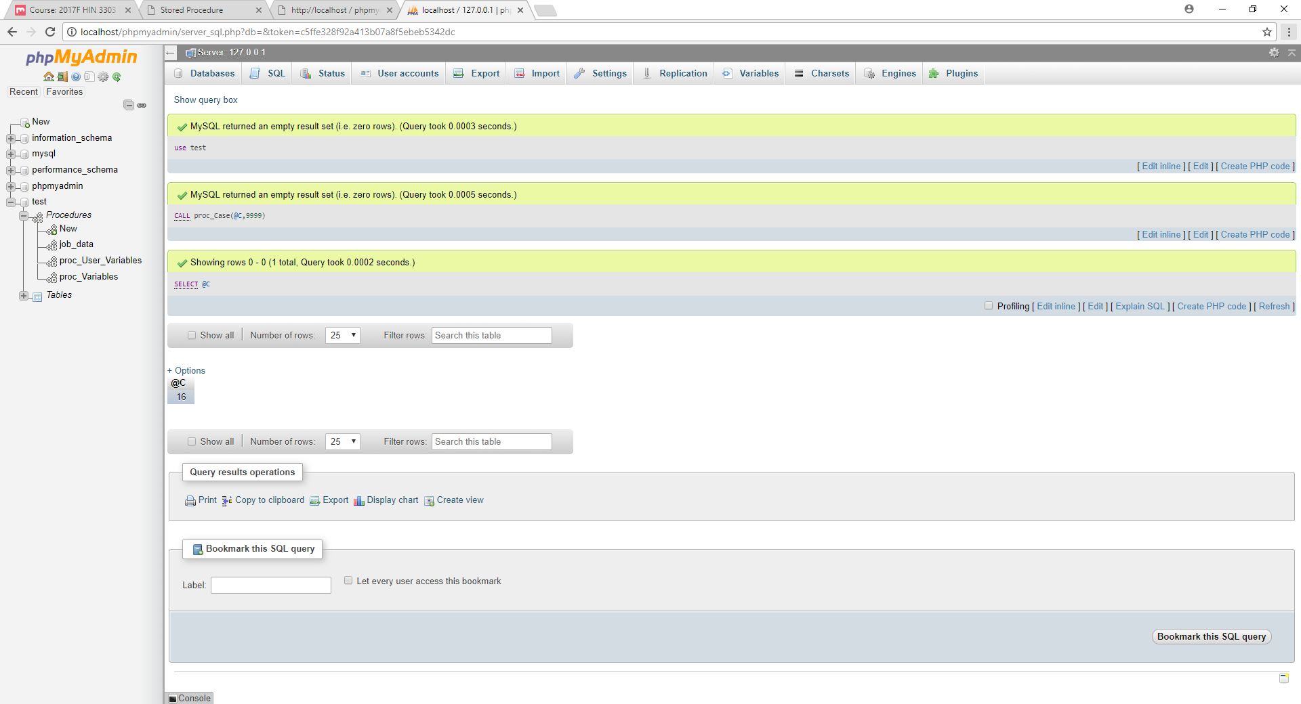

use test;

CREATE TABLE number ( n1 real(3,2) );

DELIMITER $$

CREATE PROCEDURE proc_LOOP (IN num INT)

BEGIN

DECLARE x INT;

SET x = 0;

loop_label: LOOP

INSERT INTO number VALUES (rand());

SET x = x + 1;

IF x >= num

THEN LEAVE loop_label;

END IF;

END LOOP;

END$$

DELIMITER $$

CALL proc_LOOP(3)$$

Select * from number$$

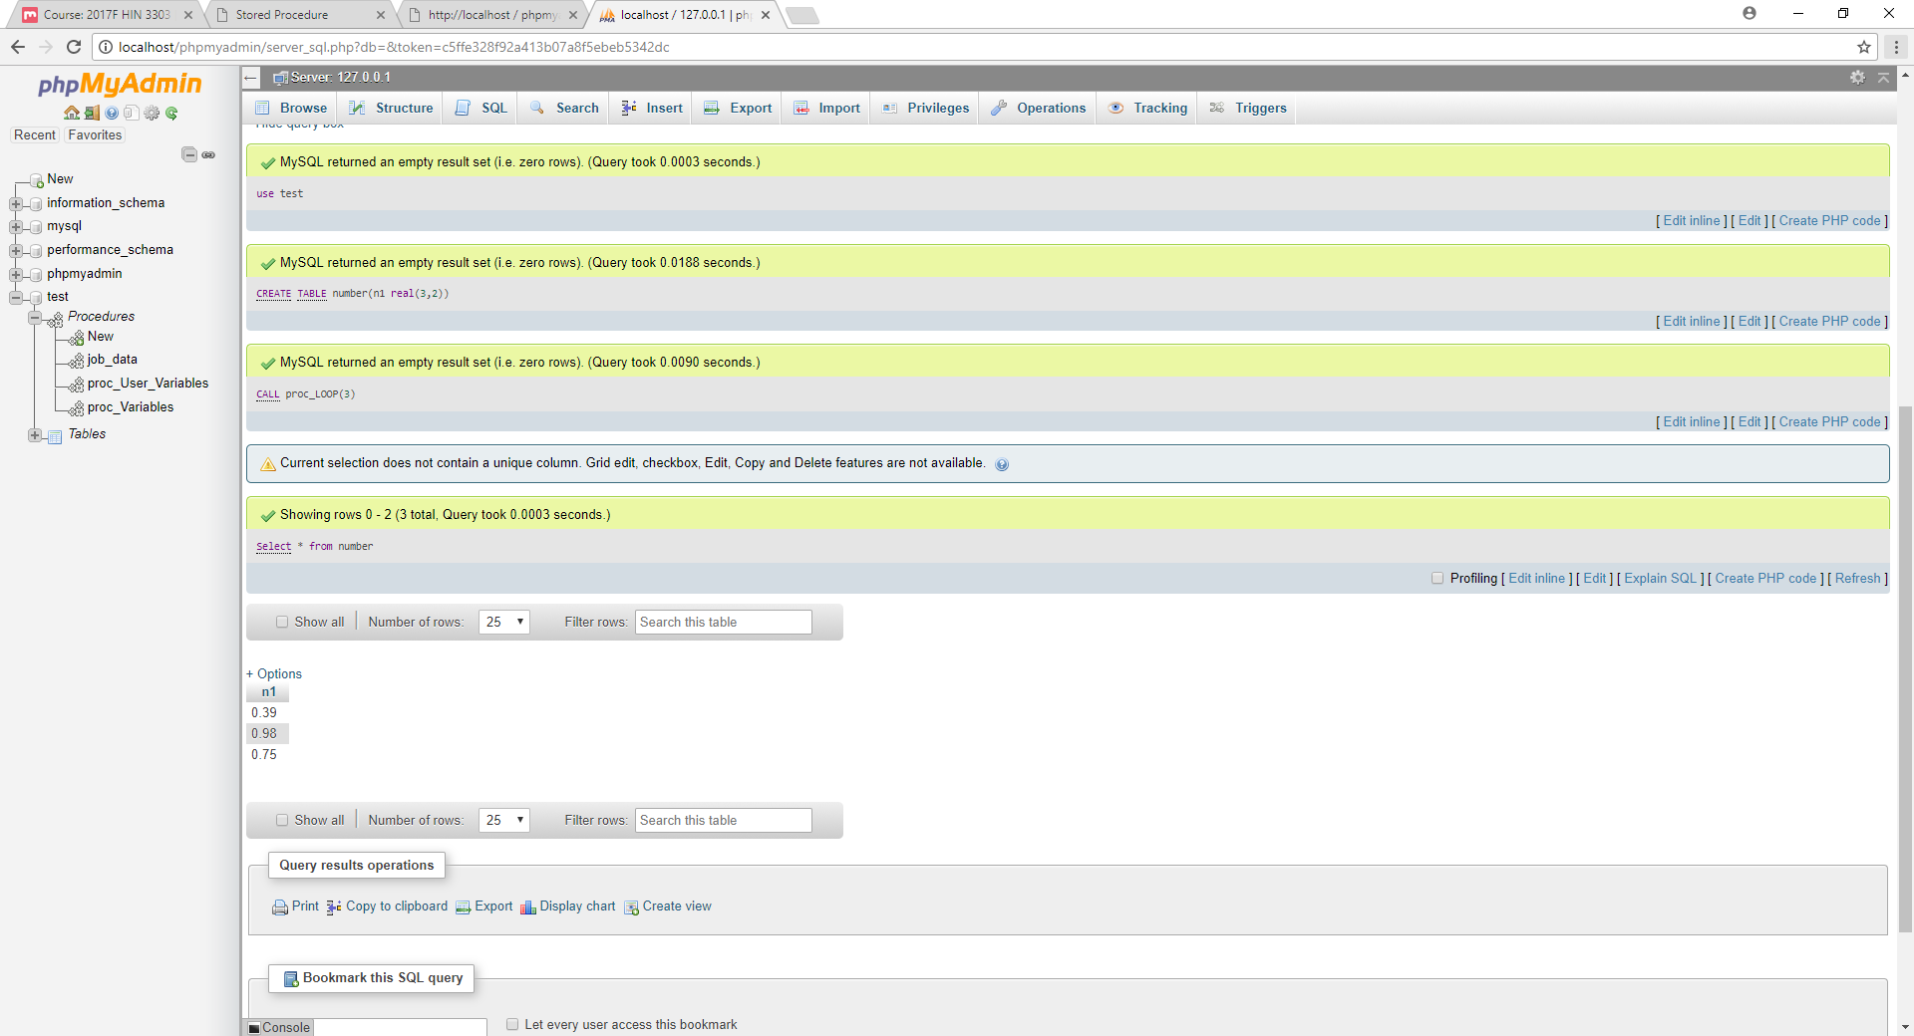

use test;

DELIMITER $$

CREATE PROCEDURE proc_REPEAT (IN n INT)

BEGIN

SET @sum = 0;

SET @x = 1;

REPEAT

IF mod(@x, 2) = 0

THEN SET @sum = @sum + @x;

END IF;

SET @x = @x + 1;

UNTIL @x > n

END REPEAT;

END $$

CALL proc_REPEAT(5)$$

SELECT @sum$$

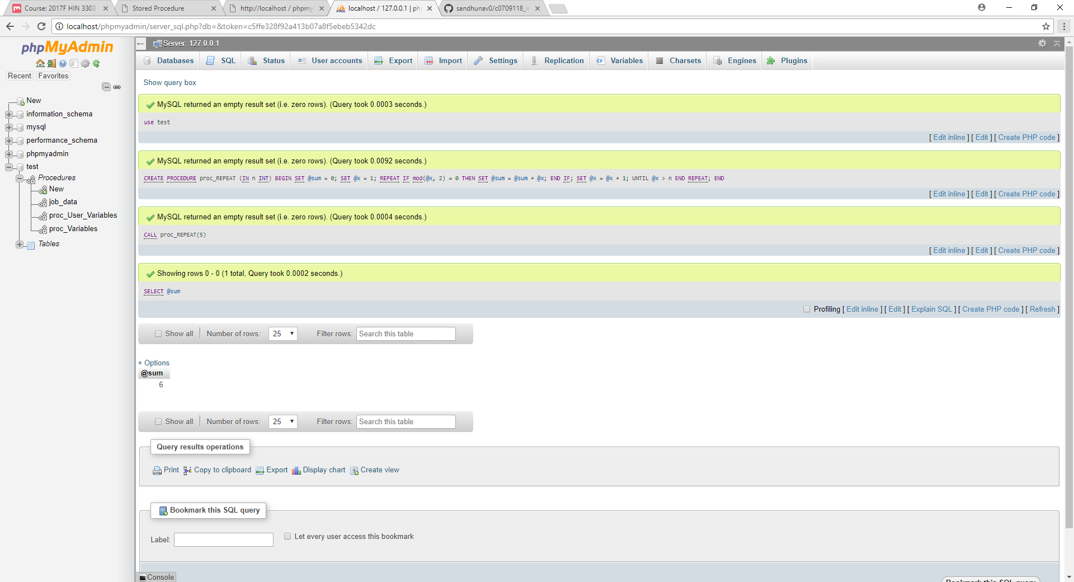

CREATE PROCEDURE proc_WHILE(IN n INT)

BEGIN

SET @sum = 0; SET @x = 1;

WHILE @x<> 0 THEN

SET @sum = @sum + @x; END

IF;

SET @x = @x + 1;

END WHILE;

END$$

CALL proc_WHILE(5)$$

SELECT @sum$$

CALL my_proc_WHILE(10)$$

SELECT @sum$$

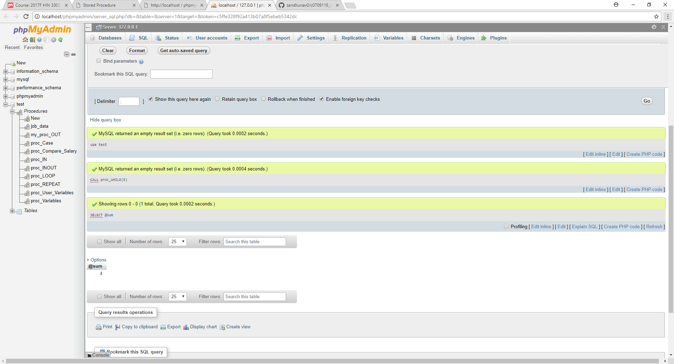

ALTER PROCEDURE proc_WHILE COMMENT 'Modify Comment';

SHOW CREATE PROCEDURE proc_WHILE;

SHOW PROCEDURE STATUS;

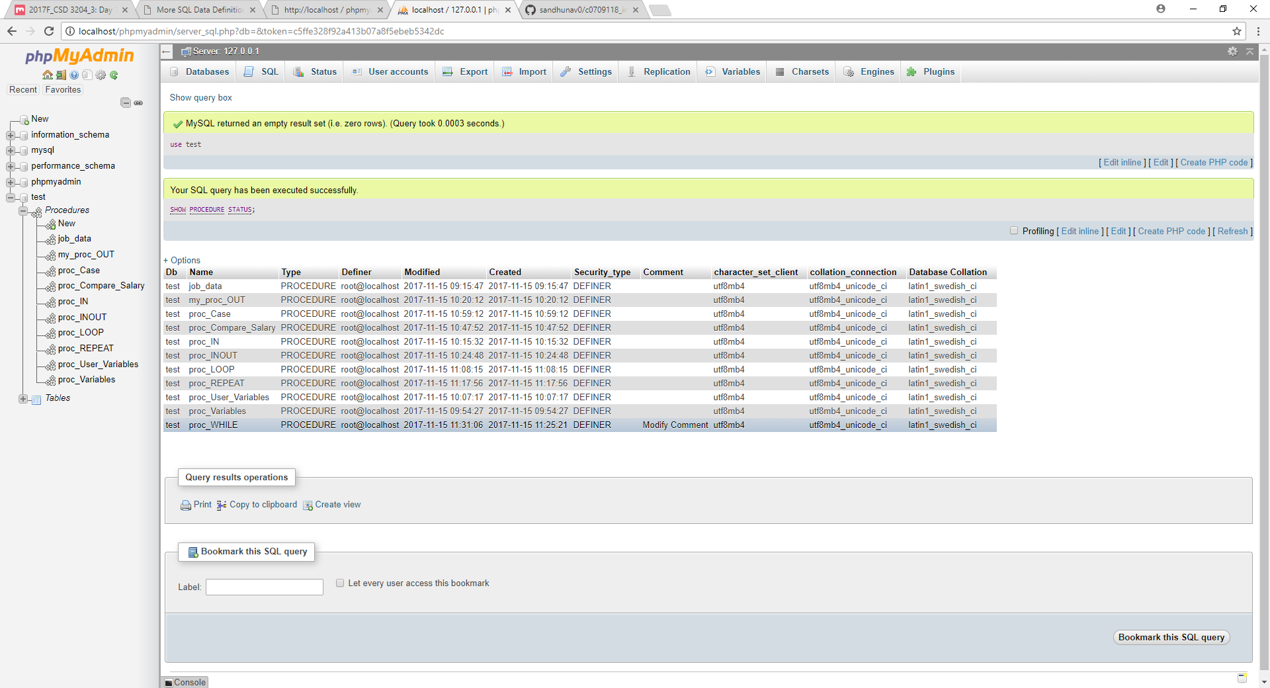

use test;

DELIMITER $$

CREATE PROCEDURE proc_cursors(INOUT return_val INT)

BEGIN

DECLARE a,b INT;

DECLARE cur_1 CURSOR FOR SELECT max_salary FROM jobs;

DECLARE CONTINUE HANDLER FOR NOT FOUND SET b = 1;

OPEN cur_1;

REPEAT

FETCH cur_1 INTO a;

UNTIL b = 1

END REPEAT;

CLOSE cur_1;

SET return_val = a;

END$$

CALL proc_cursors(@R)$$

SELECT @R$$

