Q1. What is Flask Framework? What are the advantages of Flask Framework?
Ans -

Flask Framework
Flask is a lightweight and micro web framework written in Python. It is designed to be simple, flexible, and easy to use, offering the basic tools to build web applications. Flask does not include built-in libraries for database handling, authentication, or form validation, but it is easily extensible with third-party libraries. It's particularly well-suited for small to medium-sized projects but can be scaled for larger applications as well.

Advantages of Flask Framework
- Lightweight and Minimalistic:
  - Flask follows a "micro" framework approach, meaning it provides only the essentials (like routing and request handling) while giving developers the freedom to add additional components as needed.
- Flexibility:
  - Flask is unopinionated, meaning it doesn’t force developers to use specific tools or libraries. You can structure your project as you see fit, making it flexible for a variety of needs.
- Easy to Learn:
  - With a simple and intuitive API, Flask is easy to learn, especially for beginners or developers coming from other languages. Its simplicity makes it a great starting point for learning web development.
- Extensible:
  - While Flask provides a core framework, it also allows you to integrate third-party extensions for various functionalities like form validation, authentication, and database interaction (e.g., SQLAlchemy).
- Scalable:
  - Despite being lightweight, Flask can handle complex applications. You can scale it by adding components as your project grows, making it suitable for both small and large applications.
- Great for Prototyping:
  - Flask is ideal for quickly building and deploying prototypes and MVPs (Minimum Viable Products). Developers can get a web app up and running in a very short time.
- Supports RESTful APIs:
  - Flask is often used to build RESTful APIs because of its simplicity and flexibility, making it a popular choice for developing back-end services for mobile or web applications.
- Built-in Development Server and Debugger:
  - Flask comes with a built-in development server and debugger, which helps developers easily test their applications and catch errors early in the development process.
- Rich Documentation:
  - Flask has comprehensive and well-organized documentation, making it easy for developers to find solutions to their problems or to learn about various Flask features.
- Large Community:
  - Flask has a large and active community. This means there are plenty of tutorials, libraries, extensions, and resources available to help developers.

Q2. Create a simple Flask application to display ‘Hello World!!’. Attach the screenshot of the output in Jupyter Notebook.

Ans -

from flask import Flask

app = Flask(__name__)

@app.route('/')
def hello_world():
return 'Hello World!!'

if __name__ == '__main__':
app.run(debug=True)



Q3. What is App routing in Flask? Why do we use app routes?

App routing in Flask is like giving directions for different pages on your website. When someone visits a certain URL, Flask knows which function to run and what to show them because of these routes.
In Flask, we use @app.route() to create routes. It tells Flask, "When someone visits this URL, show them the result of this function."

Why Do We Use App Routes?
- Directing Traffic: Just like signs on a road, routes help your users find the right page. For example, if someone goes to /about, they’ll see your “About Us” page.
- Clean URLs: App routes help you create easy-to-understand URLs. Instead of something complex, you get clean links like /home, /products, or /contact, making it simple for users to navigate.
- Dynamic Pages: You can make routes that change based on user input. For instance, a URL like /user/john could show a personalized page for the user "John". Here's an example:

@app.route('/user/<name>')
def show_user(name):
return f'Hello, {name}!'
- Handling Different Requests: Routes also handle how your app responds to different types of requests. For example, GET requests are usually for loading pages, and POST requests are for sending data (like submitting a form). You can specify what kind of requests a route should handle:
@app.route('/submit', methods=['POST'])
def submit_form():
return 'Form Submitted!'

Q4. Create a “/welcome” route to display the welcome message “Welcome to ABC Corporation” and a “/”
route to show the following details:
Company Name: ABC Corporation
Location: India
Contact Detail: 999-999-9999
Attach the screenshot of the output in Jupyter Notebook.

Ans

from flask import Flask

app = Flask(__name__)

@app.route('/')
def company_info():
return '''
<h1>Company Name: ABC Corporation</h1>
<h2>Location: India</h2>
<h2>Contact Detail: 999-999-9999</h2>
'''

@app.route('/welcome')
def welcome():
return '<h1>Welcome to ABC Corporation</h1>'

if __name__ == '__main__':
app.run(debug=True)

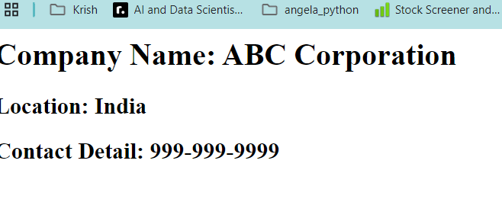

Q5. What function is used in Flask for URL Building? Write a Python code to demonstrate the working of the url_for() function.
Ans -

In Flask, the url_for() function is used to dynamically build URLs for a specific function based on its name. Instead of hardcoding URLs, url_for() ensures that if the route changes, the application will still generate the correct URL. It's especially helpful when you have dynamic URLs or want to include query parameters.
from flask import Flask, url_for

app = Flask(__name__)

@app.route('/')
def home():
return 'This is the home page.'

@app.route('/about')
def about():
return 'This is the about page.'

@app.route('/profile/<username>')
def profile(username):
return f'Profile page of {username}'

@app.route('/generate-urls')
def generate_urls():
# Generating URLs using url_for
home_url = url_for('home')
about_url = url_for('about')
profile_url = url_for('profile', username='JohnDoe')

return f'''
Home URL: {home_url}<br>
About URL: {about_url}<br>
Profile URL: {profile_url}
'''

if __name__ == '__main__':
app.run(debug=True)

