SQL SELECT Query
Last Updated : 13 Jan, 2026

The SQL SELECT statement is used to retrieve data from one or more tables and display it in a structured format of rows and columns.
- Fetches all columns using * or specific columns by name.
- Filters and sorts data using WHERE and ORDER BY.
- Supports grouping, aggregation, and table relationships using GROUP BY, HAVING, and JOIN.
Example: First, we create a demo SQL table, on which we use the SELECT query.
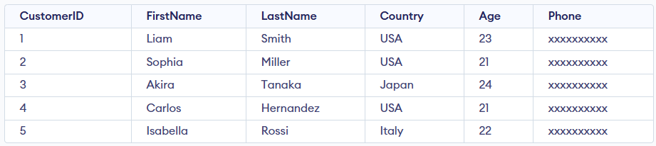Customer Table
Query:
SELECT CustomerID, FirstName FROM Customer;
Output:
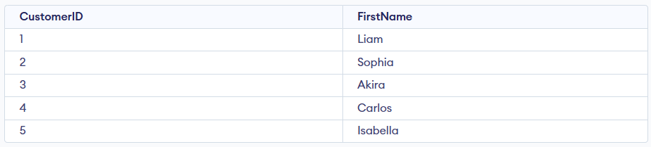
Syntax:
SELECT column1,column2.... FROM table_name;
- column1, column2: columns you want to retrieve.
- table_name: name of the table you're querying.

Working with the SELECT Statement
The SELECT statement is used to retrieve and display data from one or more tables in a structured and readable format.

Example 1: Select Specific Columns
In this example, we will demonstrate how to retrieve specific columns from the Customer table. Here we will fetch only CustomerName and LastName for each record.
Query:
SELECT FirstName, LastName
FROM Customer;
Output:
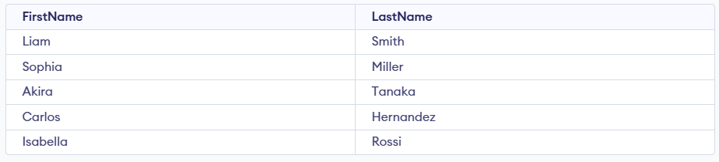

Example 2: Select All Columns
In this example, we will fetch all the fields from table Customer:
Query:
SELECT * FROM Customer;
Output:


Example 3: SELECT Statement with WHERE Clause
Suppose we want to see table values with specific conditions then WHERE Clause is used with select statement. In this example, filter customers who are 21 years old.
Query:
SELECT FirstName
FROM Customer
where Age = 21;
Output:
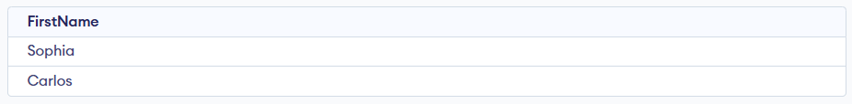

Example 4: SELECT with GROUP BY Clause
In this example, we will use SELECT statement with GROUP BY Clause to group rows and perform aggregation. Here, we will count the number of customers from each country.
Query:
SELECT Country, COUNT(*) AS customer_count
FROM Customer
GROUP BY Country;
Output:
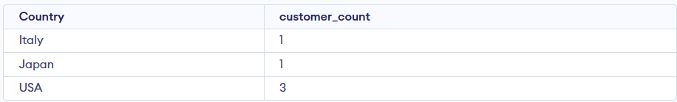

Example 5: SELECT with DISTINCT Clause
In this example, we will use DISTINCT keyword to return only unique values from a column. Here, we will fetch unique countries from the Customer table.
Query:
SELECT DISTINCT Country
FROM Customer;
Output:
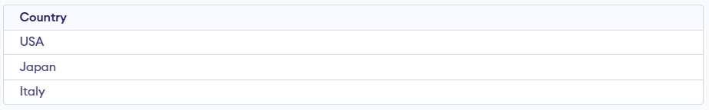

Example 6: SELECT Statement with HAVING Clause
The HAVING clause is used to filter results after applying GROUP BY. In this example, we will find countries that have 2 or more customers in the Customer table.
Query:
SELECT Country, COUNT(*) AS customer_count
FROM Customer
GROUP BY Country
HAVING COUNT(*) >= 2;
Output:

Example 7: SELECT Statement with ORDER BY clause
In this example, we will use SELECT Statement with ORDER BY clause. Here, Sort results by Age in descending order.
Query:
SELECT * FROM Customer ORDER BY Age DESC;
Output:
