SQL - WHERE Clause
Last Updated : 12 Nov, 2025

The SQL WHERE clause filters rows based on one or more conditions, so your query returns (or modifies) only the records that match. It’s used across SELECT, UPDATE, and DELETE statements, and works with data from a single table or from multiple tables after joins
Example: First, we will create a demo SQL database and table, on which we will use the WHERE Clause command.
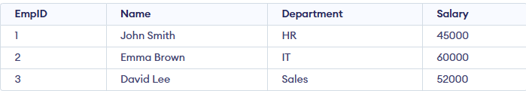
Query:
SELECT Name, Department, Salary
FROM Employees
WHERE Salary > 50000;
Output:
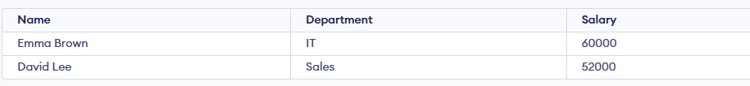
Syntax:
SELECT column1, column2
FROM table_name
WHERE column_name operator value;
- column1, column2: Columns you want to retrieve.
- table_name: Table you are querying from.
- operator: Comparison logic (e.g., =, <, >, LIKE).
- value: The value or pattern to filter against.

Examples of WHERE Clause
We will create a basic employee table structure in SQL for performing all the where clause operation.
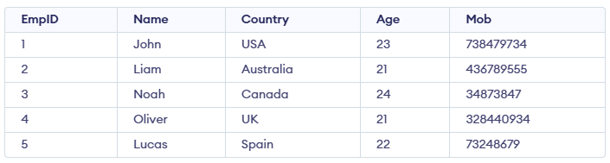

Example 1: Where Clause with Logical Operators
To fetch records of Employee with age equal to 24.
Query:
SELECT * FROM Emp1 WHERE Age=24;
Output:

Example 2: WHERE with Comparison Operators
To fetch the EmpID, Name and Country of Employees with Age greater than 21.
Query:
SELECT EmpID, Name, Country FROM Emp1 WHERE Age > 21;
Output:
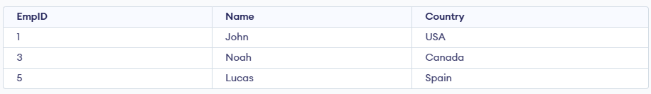

Example 3: Where Clause with BETWEEN Operator
The BETWEEN operator is used to filter records within a specified range, and it includes both the start and end values. In this example, we want to find employees whose age is between 22 and 24, including both 22 and 24.
Query:
SELECT * FROM Emp1
WHERE Age BETWEEN 22 AND 24;
Output:
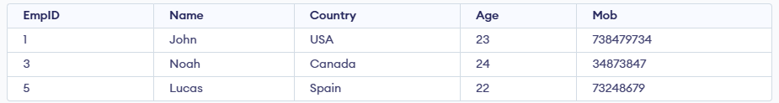

Example 4: Where Clause with LIKE Operator
It is used to fetch filtered data by searching for a particular pattern in the where clause. In this example we want to find records of Employees where Name starts with the letter. The '%'(wildcard) signifies the later characters here which can be of any length and value.
Query:
SELECT *
FROM Employee
WHERE Name LIKE 'L%';
Output:

Example 5: Where Clause with IN Operator
It is used to fetch the filtered data same as fetched by '=' operator just the difference is that here we can specify multiple values for which we can get the result set. Here we want to find the Names of Employees where Age is 21 or 23.
Query:
SELECT Name FROM Emp1 WHERE Age IN (21,23);
Output:
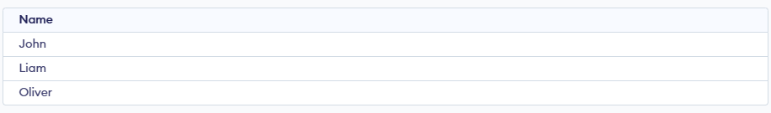

Operators Used in WHERE Clause
Operator | Description
> | Greater Than
>= | Greater than or Equal to
< | Less Than
<= | Less than or Equal to
= | Equal to
<> | Not Equal to
BETWEEN | In an inclusive Range
LIKE | Search for a pattern
IN | To specify multiple possible values for a column

