**Lab 2**

**Submitted by:**

Sandhya Neupane

Student ID: 23002366

**Submitted to:**

Professor: Nawaz Chowdhury

Subject: Programming Paradigms

Course code: CSD215

Due date: 31st of July 2024

​​**Table of Content**

​

Assignment Steps……………………………………………………………………………………………………………….…….3

Assignment- 1 …………………………………………………………………………………………………….…………………….3

Assignment- 2…………………………………………………………………………………………………………………….……..3

Honesty Statement: “I declare that this submission is my own work in compliance with Sault College Academic Policies.”

**Assignment Step 1:**

**Step 1: Records for NBA Basketball Statistics**

In this part I have defined the records, created a list of 5 teams and also filtered the list to find successful teams. Then, I have used the map function to calculate success percentage.

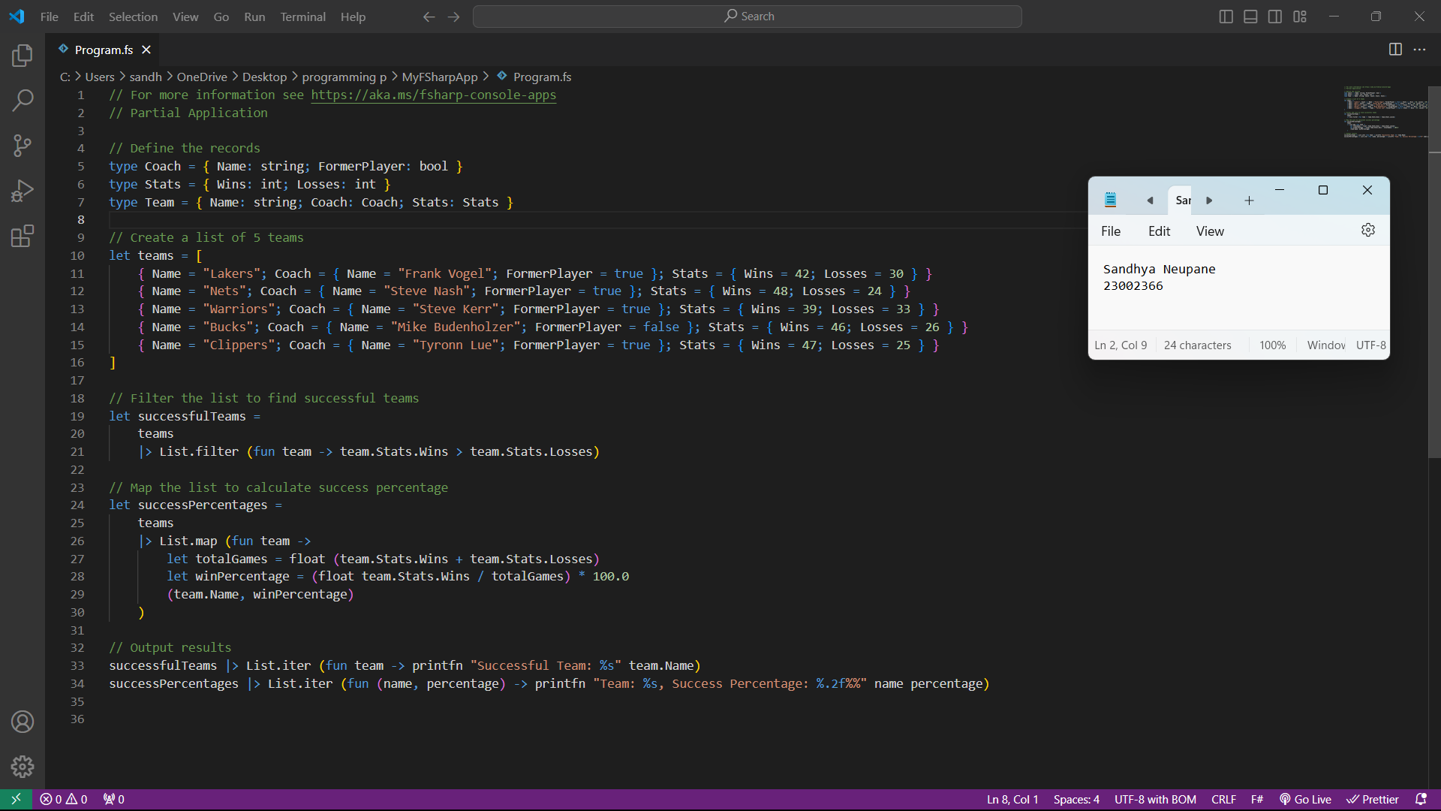

Here is the output of the above code. The output in terminal is shown below:

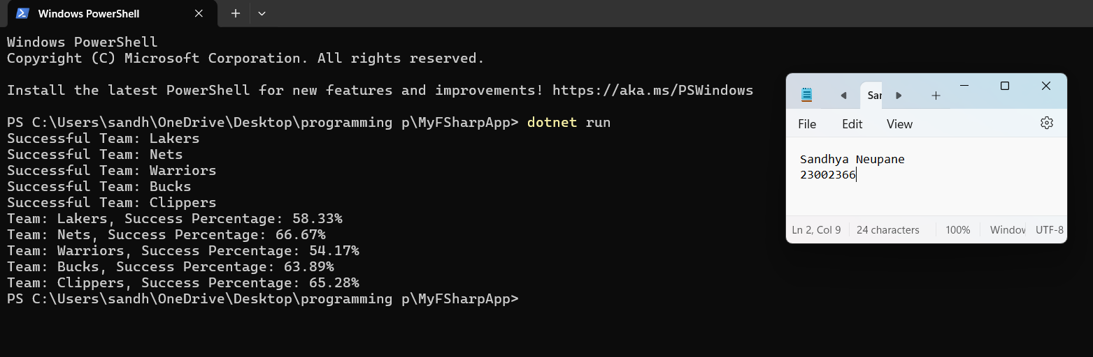

**Assignment Step- 2:**

**Step 2: Discriminated Union for Valentines’s Day Budget**

In this part I have defined the “Discriminated Union” named ‘Cuisine Discriminated Union’, ‘Movietype Discriminated Union’ and ‘Activity Discriminated Union’ respectively. After defining, I have then calculated the total budget of the question mentioned in the question.

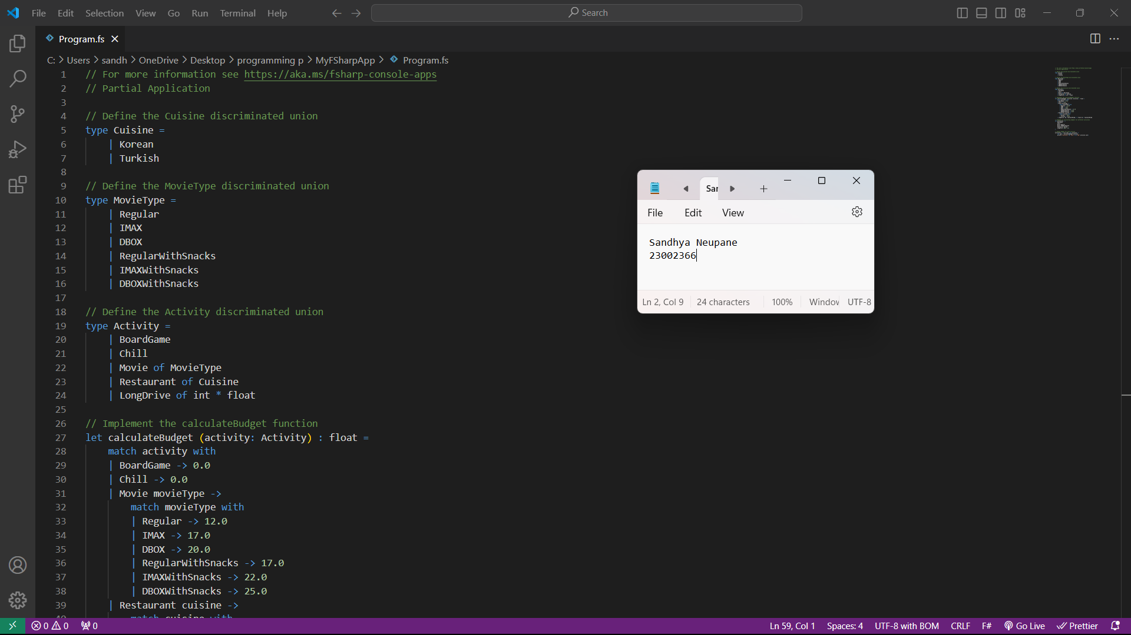

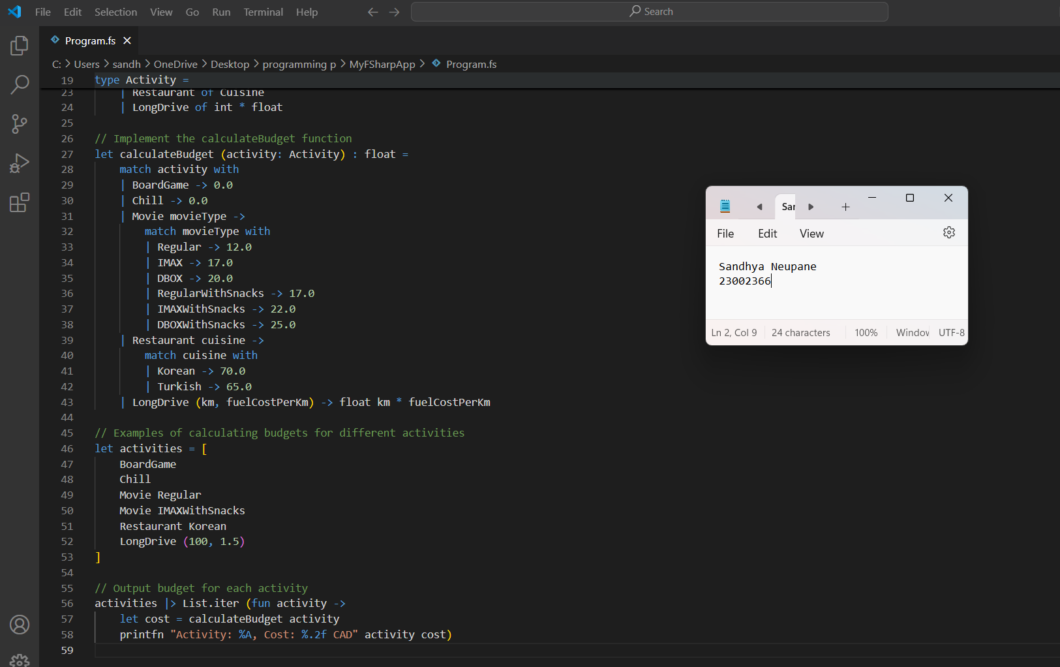

The output of the above program in terminal is as follows:

