Mass-Storage Structure

Mass-Storage Structure
Mass-storage structure is a part of the operating system that is used to store large amounts of data permanently. Unlike main memory (RAM), mass storage keeps data even when the system is turned off. It provides secondary storage for files, programs, operating systems, databases, and user information.
Seek Time is the time taken by the disk head to reach the desired track or cylinder before reading or writing data.
The most common mass-storage devices are hard disk drives (HDDs), solid-state drives (SSDs), optical disks, and USB storage devices. These devices offer high storage capacity at a lower cost compared to primary memory. The operating system manages these storage devices efficiently to improve performance, reliability, and data access speed.

Main Components of Mass-Storage Structure
- Disk Structure – Organization of tracks, sectors, cylinders, and blocks in a disk.
- Disk Attachment – Methods used to connect disks to the computer system such as SATA, SCSI, and USB.
- Disk Scheduling – Techniques used by the operating system to decide the order of disk access requests for better performance.
- Swap-Space Management – Use of disk space as virtual memory when RAM becomes full.

Functions of Mass-Storage Structure
- Stores large volumes of data permanently.
- Supports file systems and database storage.
- Helps in backup and recovery of information.
- Provides virtual memory through swapping.
- Improves system performance using scheduling algorithms.

Advantages
- Large storage capacity.
- Non-volatile storage.
- Cost-effective compared to RAM.
- Reliable long-term data storage.

Disadvantages
- Slower than main memory.
- Mechanical disks may fail due to moving parts.
- Data access time is higher compared to RAM.

Conclusion
Mass-storage structure is an essential component of a computer system that enables permanent storage and management of large amounts of data. It plays an important role in system performance, memory management, and efficient data access. Proper management of storage devices helps improve speed, reliability, and overall system efficiency.

Working of a Disk
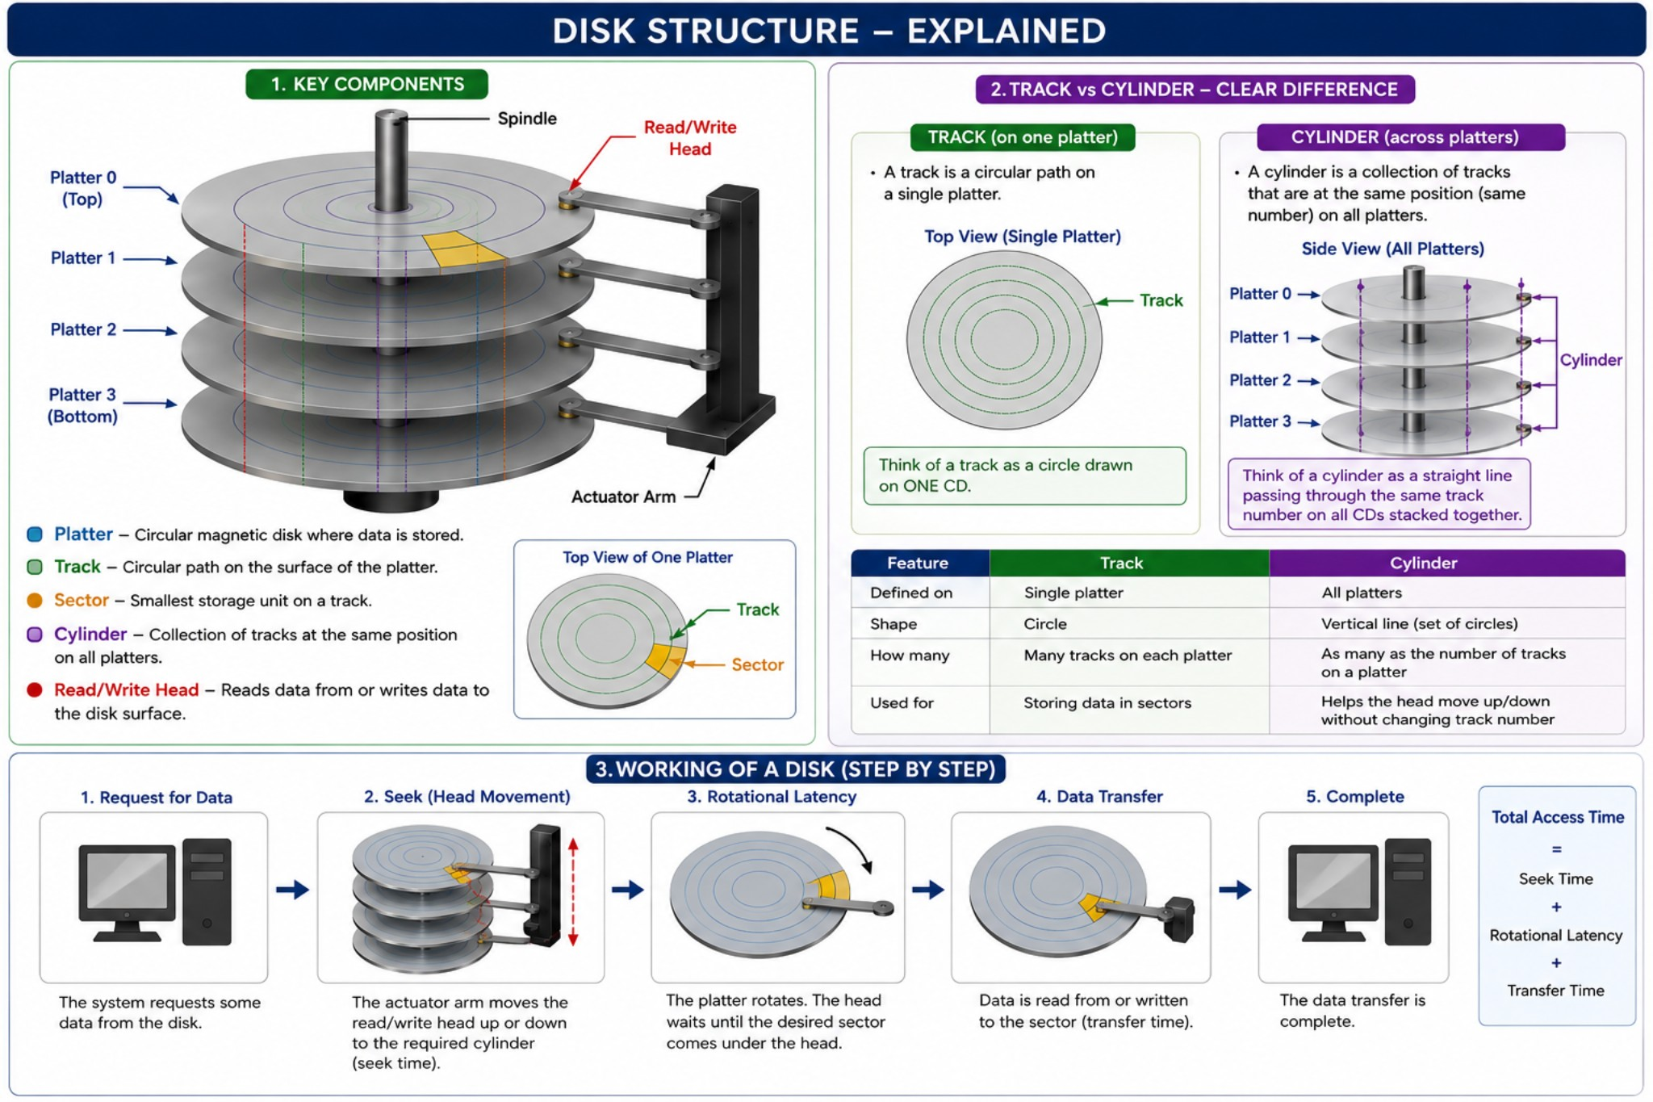
The working of a disk happens in several steps when the computer wants to read or write data.
Step 1: Request for Data
The operating system sends a request to access some data stored on the disk.

Examples: Open a file Play a video Save a document Step 2: Seek Operation (Head Movement)
The actuator arm moves the read/write head to the required track where the data is located. This movement time is called Seek Time.
Example: If data is on Track 50, the head moves to Track 50.

Step 3: Rotational Latency
After reaching the correct track, the disk platter keeps rotating until the required sector comes exactly under the read/write head. The waiting time is called Rotational Latency.
Example: The head is on the correct track, but waits for the correct sector to rotate under it.

Step 4: Data Transfer
Once the required sector comes under the head: Data is read from the disk, or Data is written onto the disk. This time is called Transfer Time.
Step 5: Completion
The requested data is sent to the CPU or memory, and the operation is completed.
Total Disk Access Time
Disk Access Time = Seek Time + Rotational Latency + Transfer Time

Disk Attachments
Disk attachment refers to the method or interface used to connect a storage device such as a hard disk or SSD to a computer system. It enables communication between the storage device and the processor for reading and writing data.
Types of Disk Attachments

1. IDE (Integrated Drive Electronics)
IDE is an older disk attachment technology also called PATA (Parallel ATA). It connects storage devices using parallel communication.
Advantages: Low cost, Simple technology.
Disadvantages: Slow data transfer speed, Supports limited devices.

2. SATA (Serial Advanced Technology Attachment)
SATA is the modern replacement for IDE. It uses serial communication and provides faster data transfer.
Advantages: High speed, Thin cables improve airflow, Easy installation.
Disadvantages: Slower than NVMe SSD technology, Limited performance for high-end systems.

3. SCSI (Small Computer System Interface)
SCSI is mainly used in servers and high-performance systems. It can connect multiple devices together.
Advantages: High reliability, Supports multiple devices, Better performance. Disadvantages: Expensive, Complex configuration.

4. USB (Universal Serial Bus)
USB disk attachment is used for external hard drives and portable storage devices.
Advantages: Portable and easy to use, Plug-and-play support.
Disadvantages: Lower speed compared to internal attachments, Can disconnect accidentally.

5. NVMe (Non-Volatile Memory Express)
NVMe is a high-speed attachment designed for SSDs using PCIe slots.
Advantages: Very high data transfer speed, Low latency, Best performance for SSDs. Disadvantages: Costly, Generates more heat.

Conclusion
Disk attachments are important for connecting storage devices to computers. Different attachment types provide different levels of speed, cost, and performance depending on system requirements.
Swap Space Management
Swap-space management is a memory management technique used by the operating system to handle situations when the main memory (RAM) becomes full. In this method, some inactive processes or data are temporarily moved from RAM to a special area on the disk called swap space. This frees memory for active processes and helps the system run smoothly.
SWAP SPACE
Swap-space management is a memory management technique used by the operating system to handle situations when the main memory (RAM) becomes full. In this method, some inactive processes or data are temporarily moved from RAM to a special area on the disk called swap space. This frees memory for active processes and helps the system run smoothly.
Swap space acts as an extension of RAM but is slower because it uses secondary storage devices such as hard disks or SSDs.
Working of Swap Space Management
Step 1: RAM Gets Full
When many programs run simultaneously, the available RAM may become insufficient.
Step 2: Selecting Inactive Data
The operating system identifies inactive or less-used processes/pages in memory.
Step 3: Swapping Out
These inactive pages are transferred from RAM to swap space on the disk.
Step 4: Free Memory Available
The freed RAM space is then allocated to active programs that need memory.
Step 5: Swapping In
When the swapped-out data is needed again, it is moved back from swap space into RAM.
Types of Swapping
- Swap-In
Moving data or processes from disk back to RAM.
- Swap-Out
Moving inactive data or processes from RAM to disk.

Advantages
- Helps run multiple applications even with limited RAM.
- Prevents system crashes due to insufficient memory.
- Improves multitasking capability.
- Efficient utilization of available memory.

Disadvantages
- Disk access is slower than RAM, reducing performance.
- Excessive swapping causes thrashing.
- Increased disk usage may reduce storage device life.

Applications of Swap Space
- Virtual memory management.
- Running large applications on low-memory systems.
- Supporting multitasking in operating systems.

Conclusion
Swap-space management is an important feature of operating systems that helps extend memory capacity by using disk space as virtual memory. It improves multitasking and system stability, though excessive swapping can reduce performance due to slower disk operations.

