**indexPage**

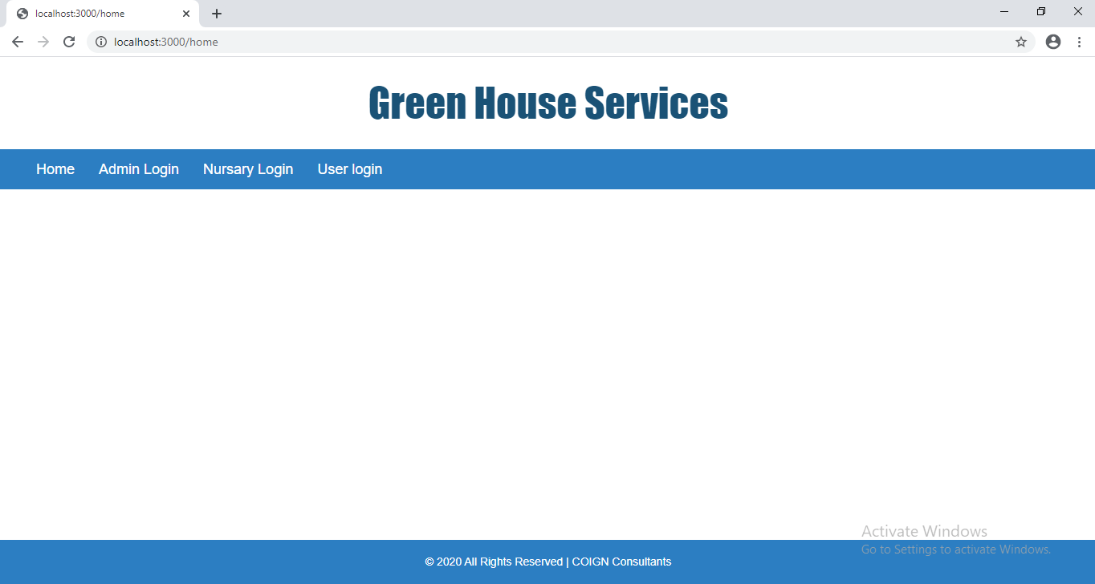

**AdminLoginPage:-**

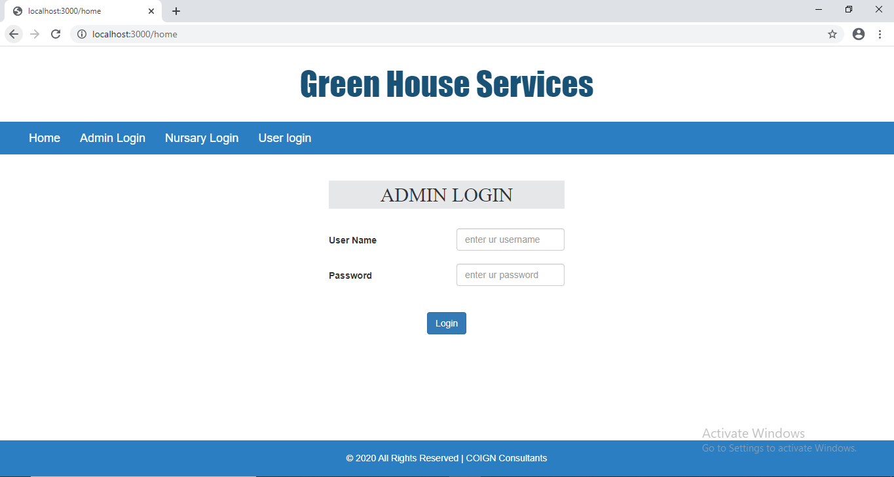

**After admin Login:-**

**indexPage:-**

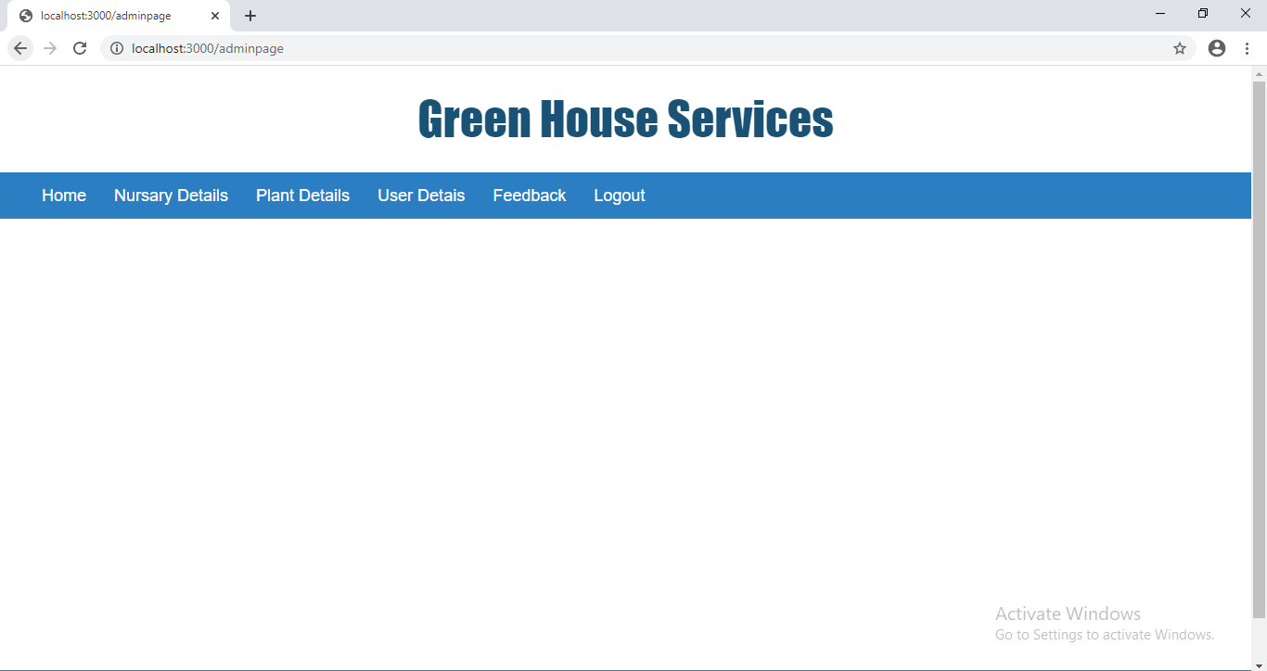

**Admin can view Nursary Details:-**

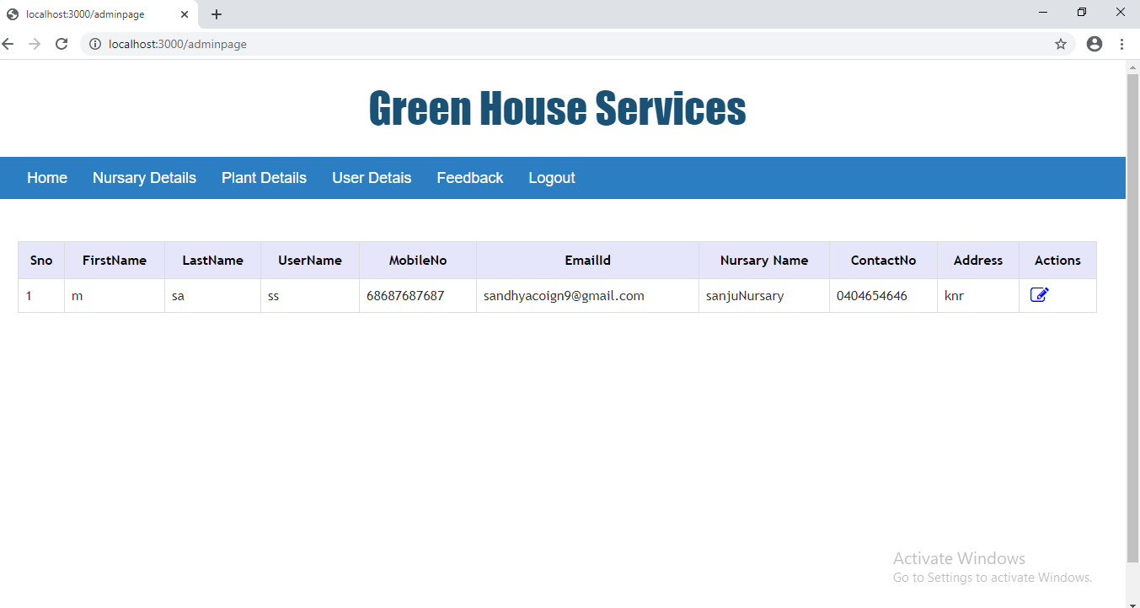

**Admin can edit/update nursery status:-**

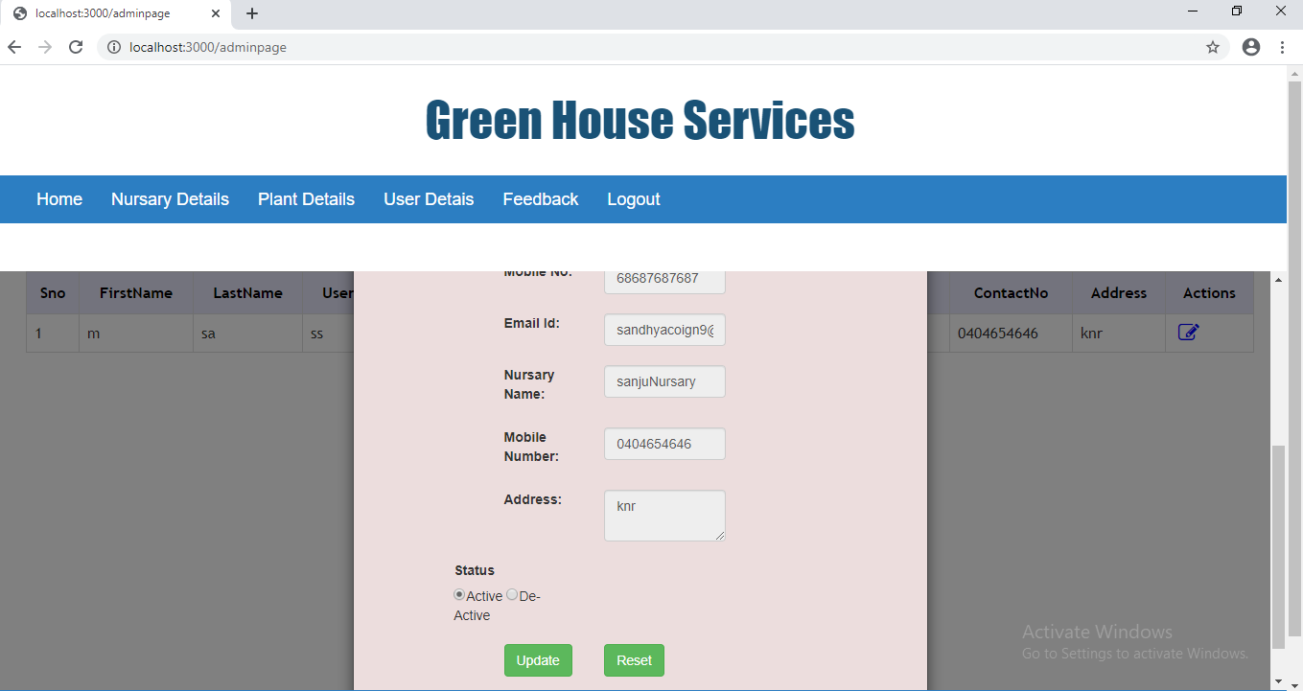

**Admin can view plant details:-**

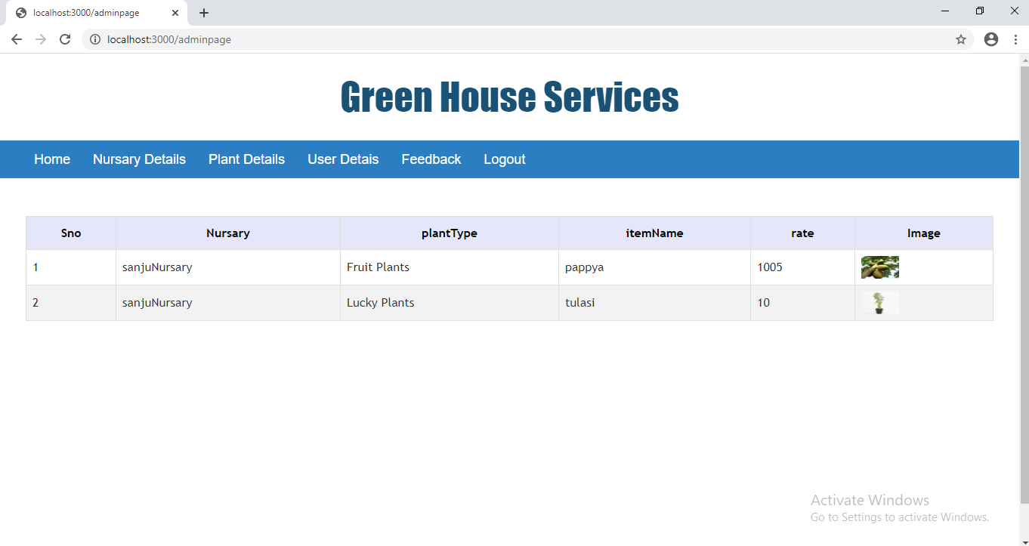

**Admin can view user details:-**

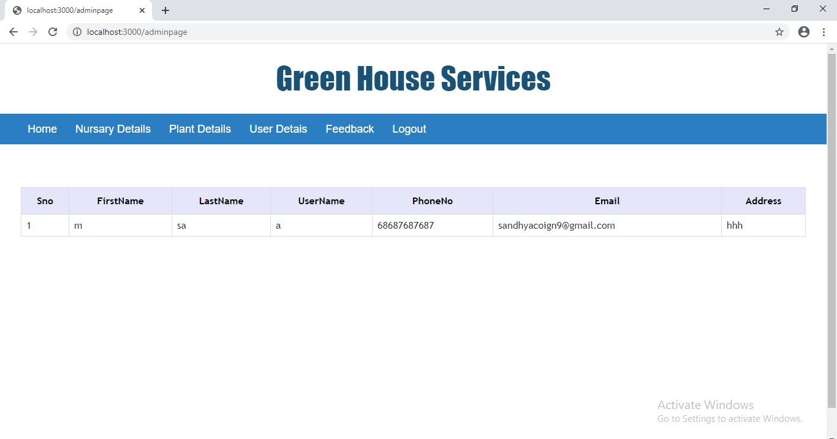

**Admin can view feedback:-**

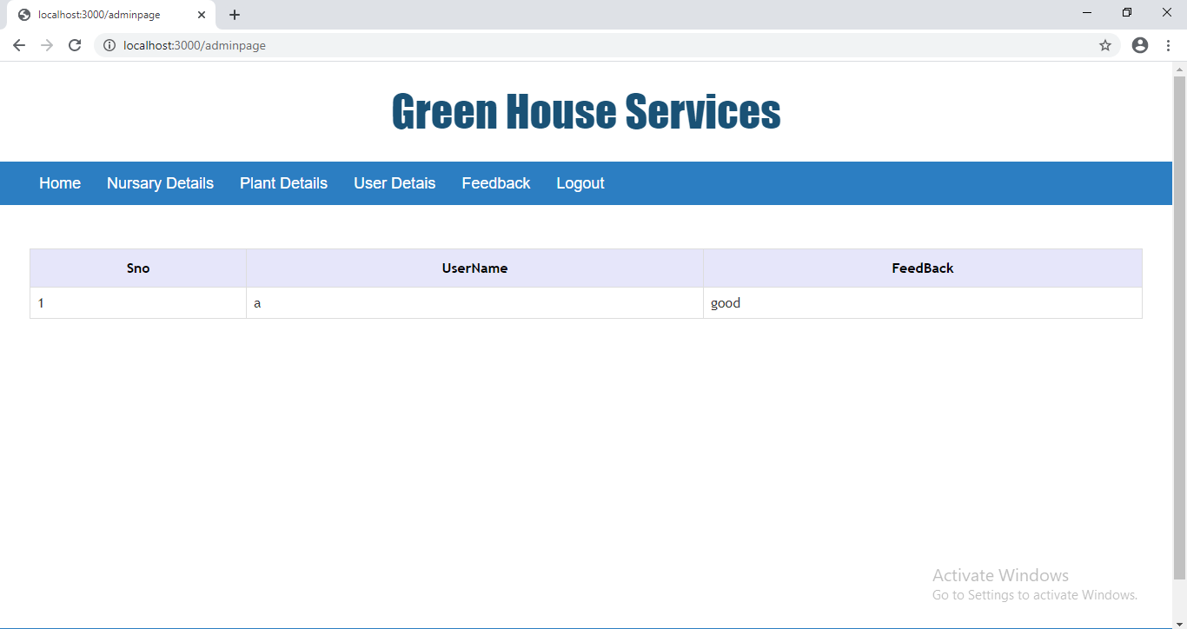

**Nursery Login:-**

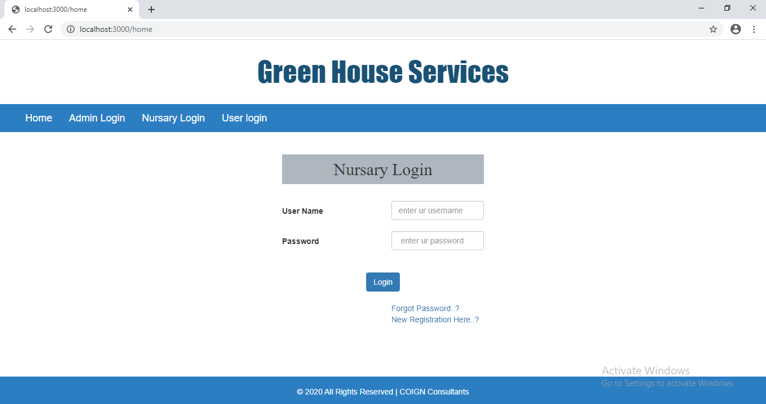

**If new Registration:-**

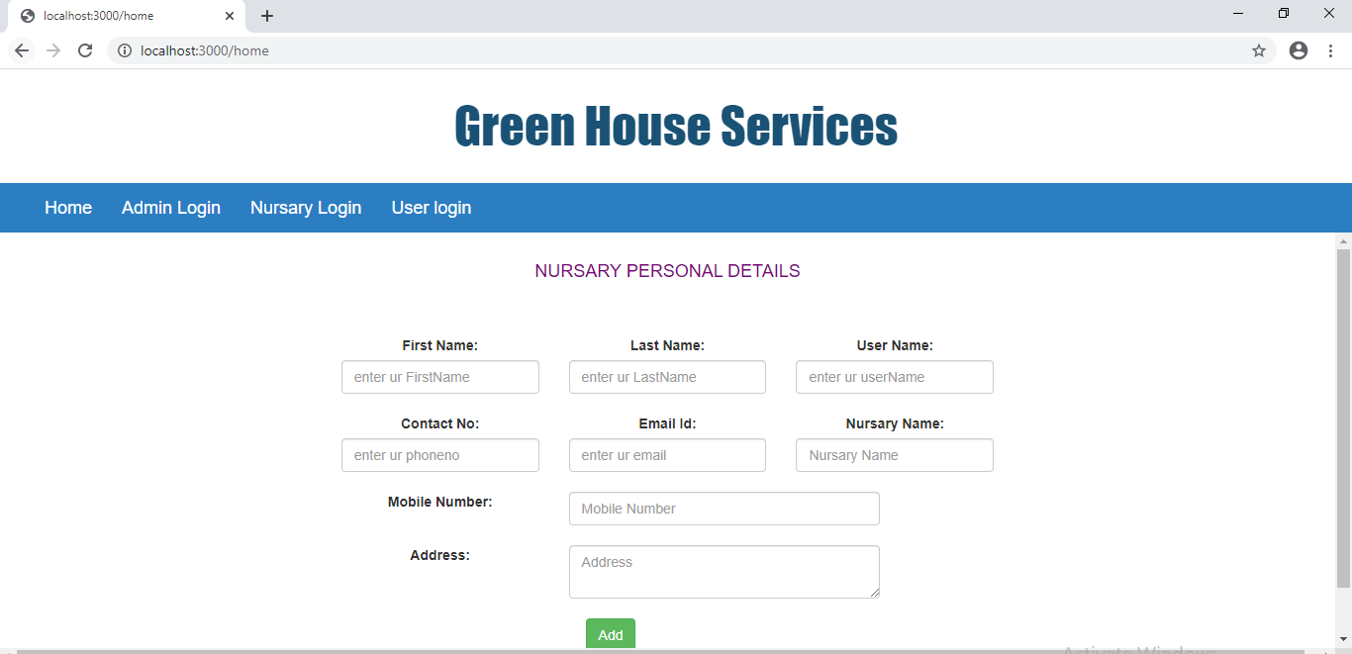

**After nursery Login:-**

**Index Page:-**

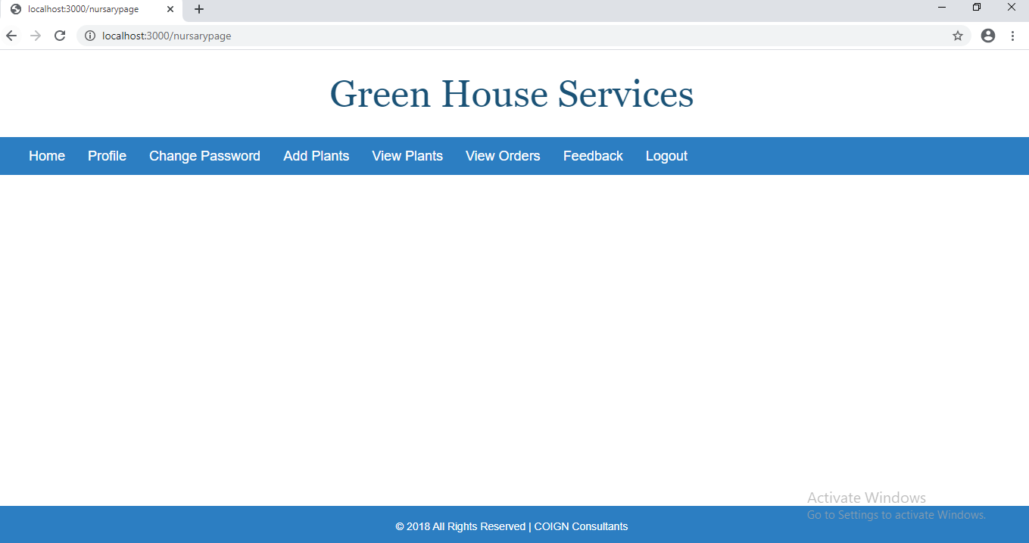

**Nursery Profile:-**

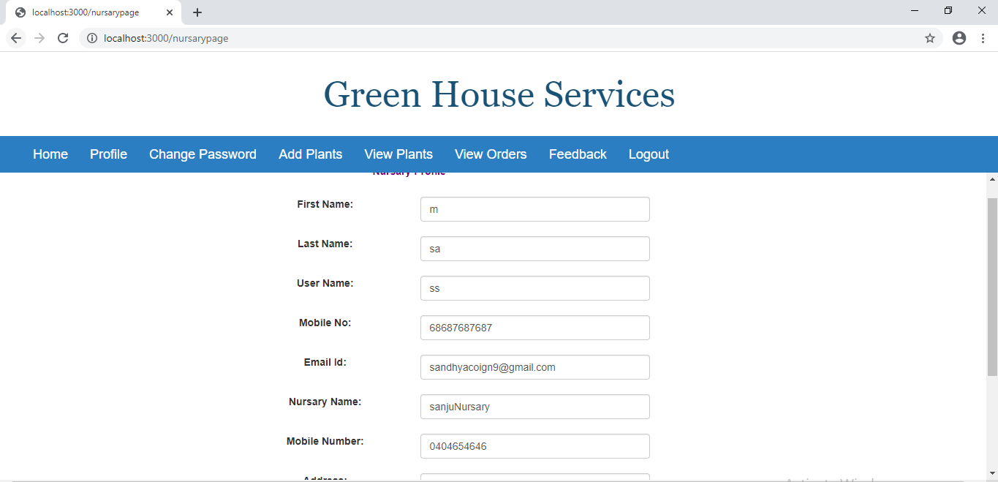

**Change Password:-**

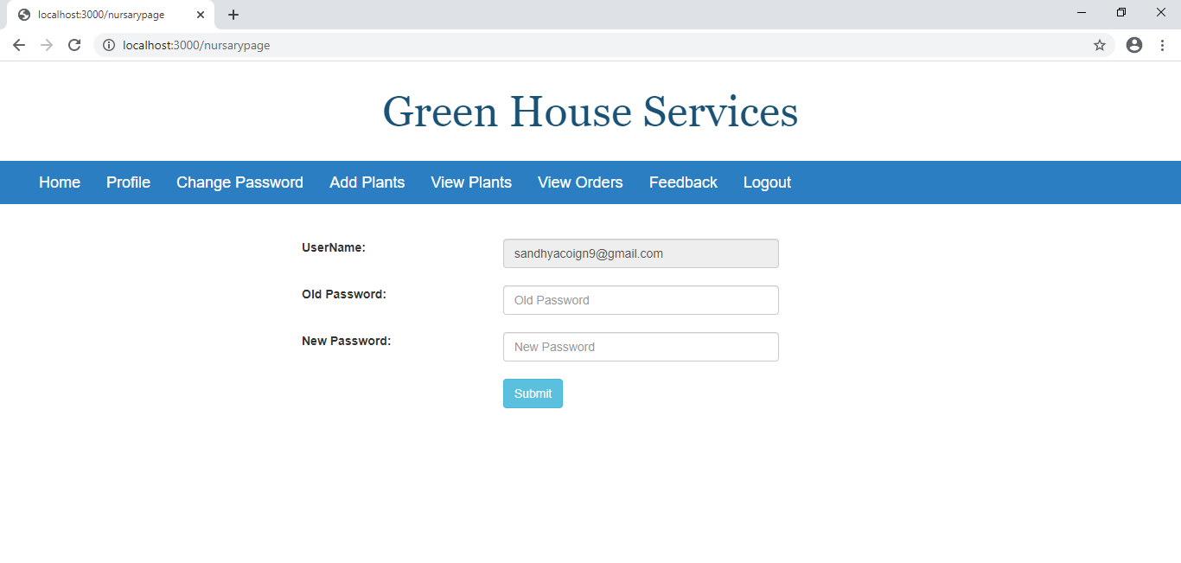

**AddPlants:-**

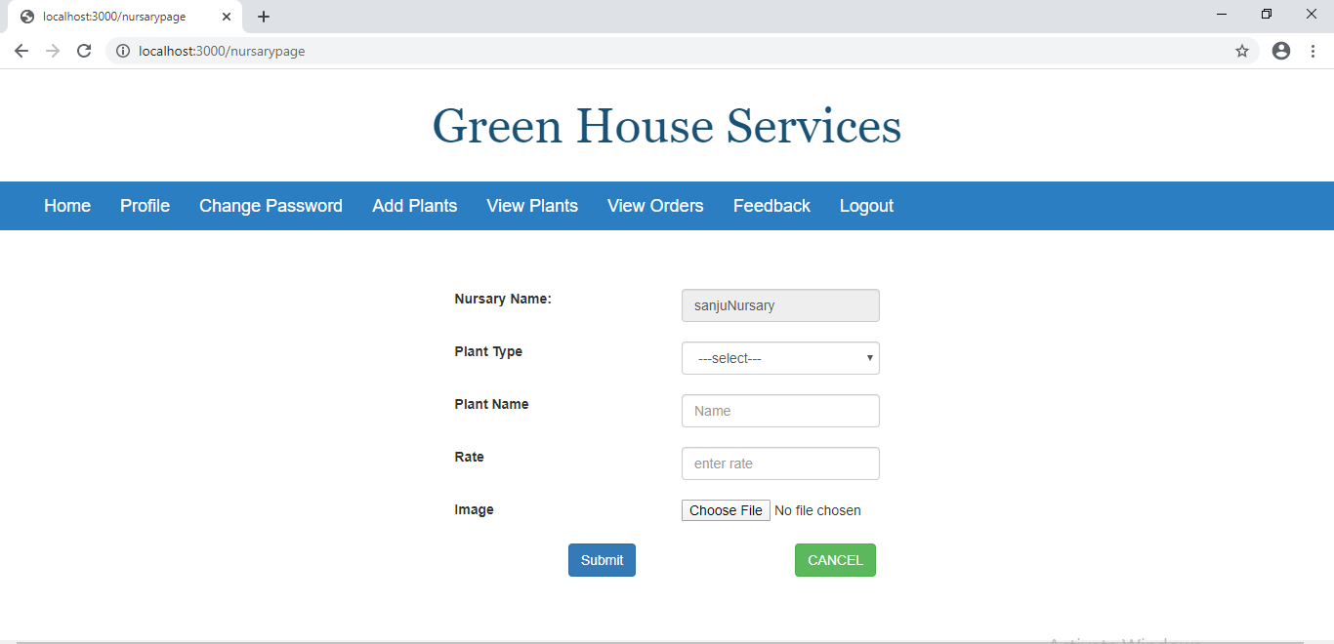

**View Plants:-**

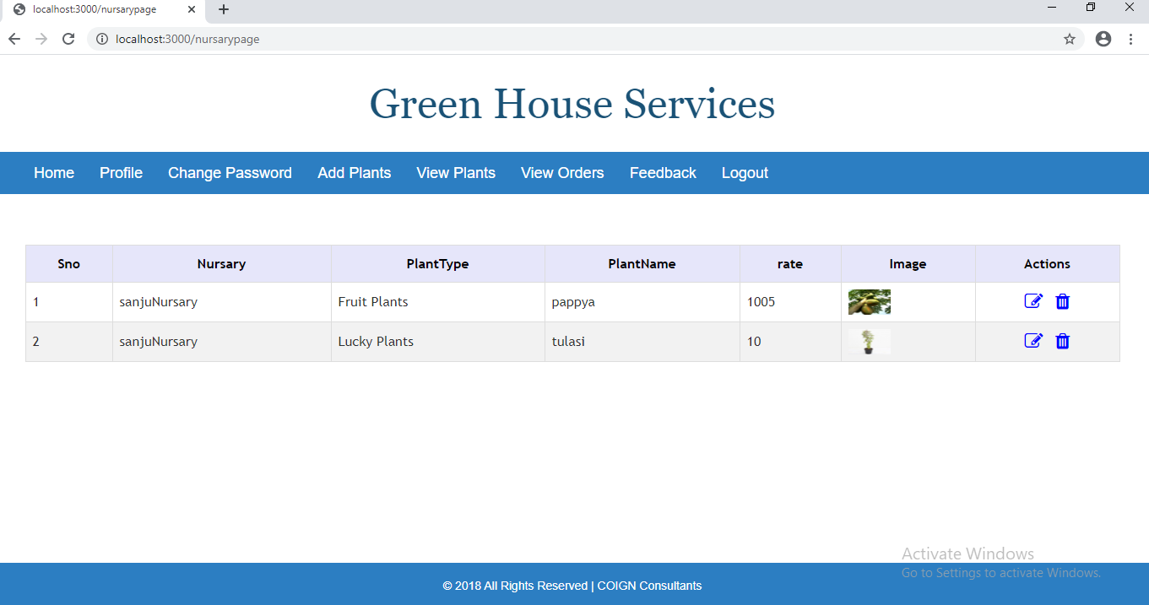

**View orders:-**

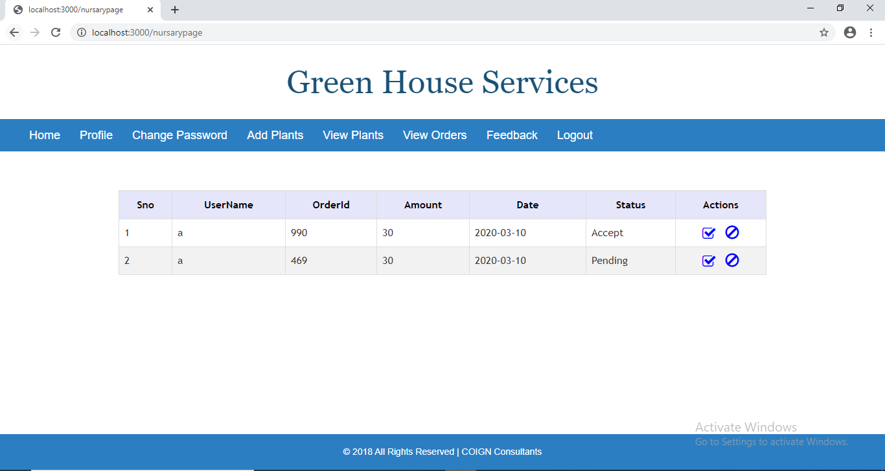

**View feedback:-**

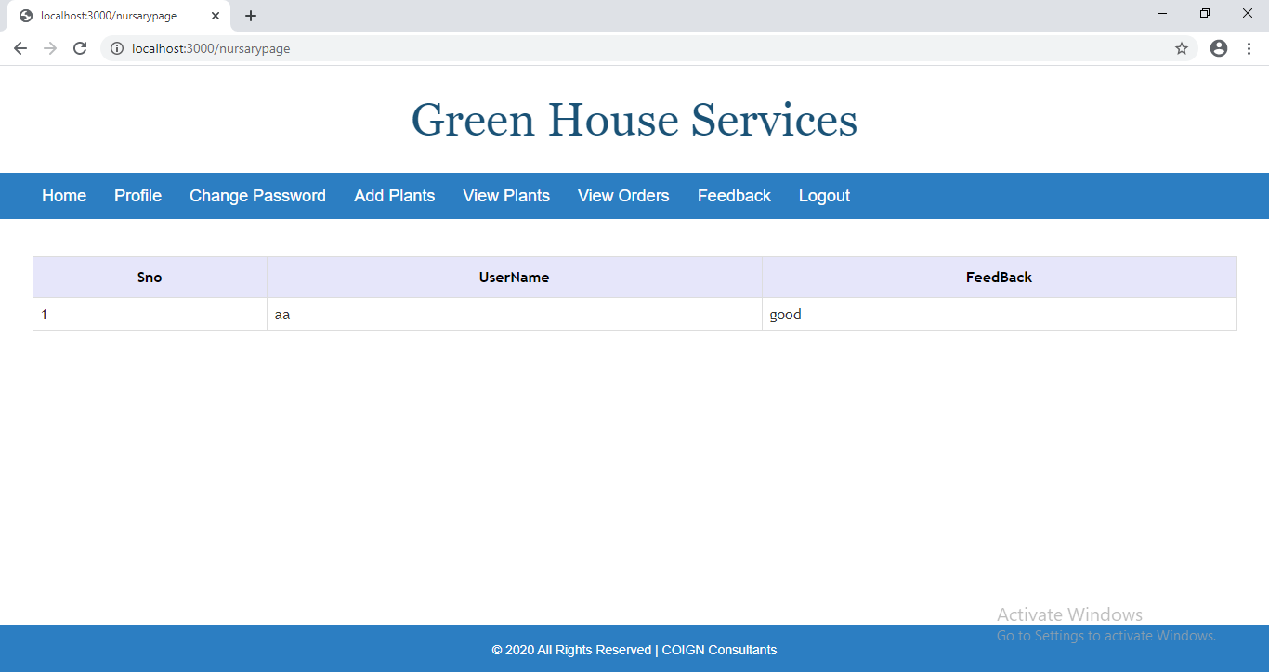

**UserLoginPage:-**

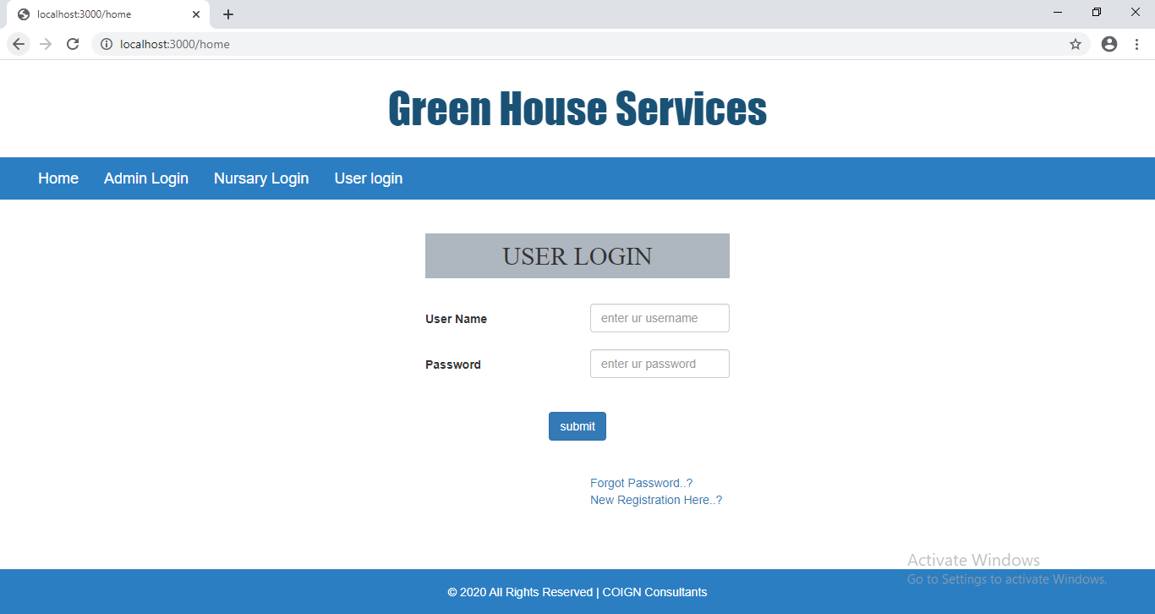

**New Registration:-**

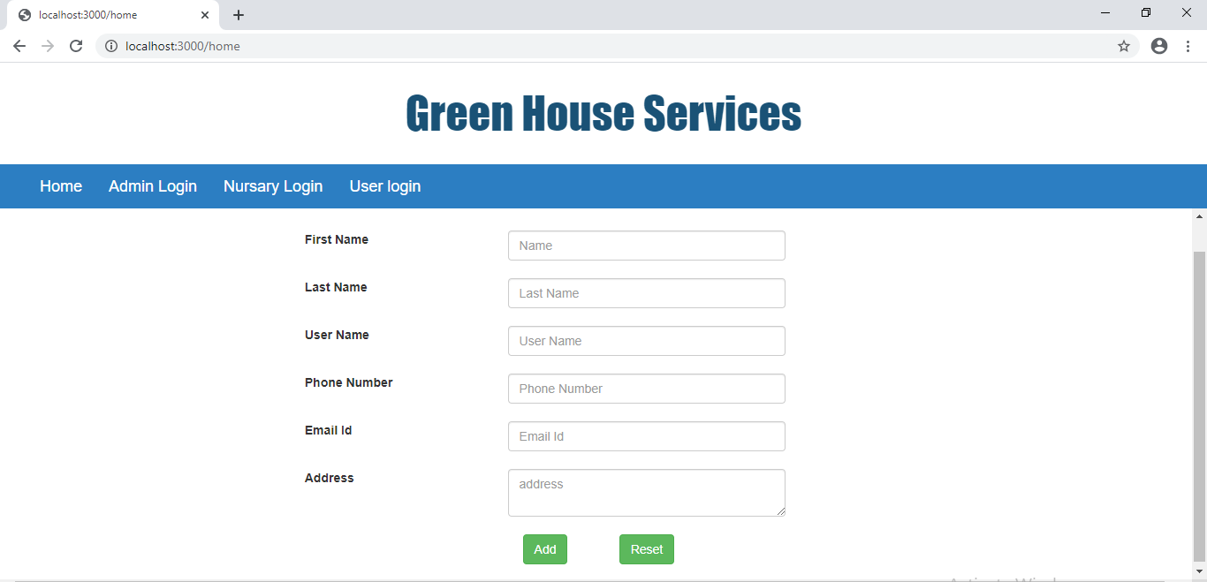

**After user login:-**

**indexPage:-**

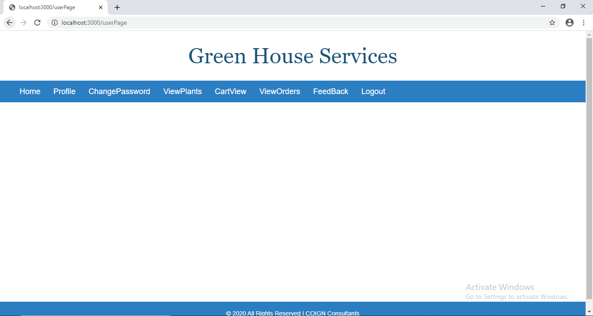

**Profile :-**

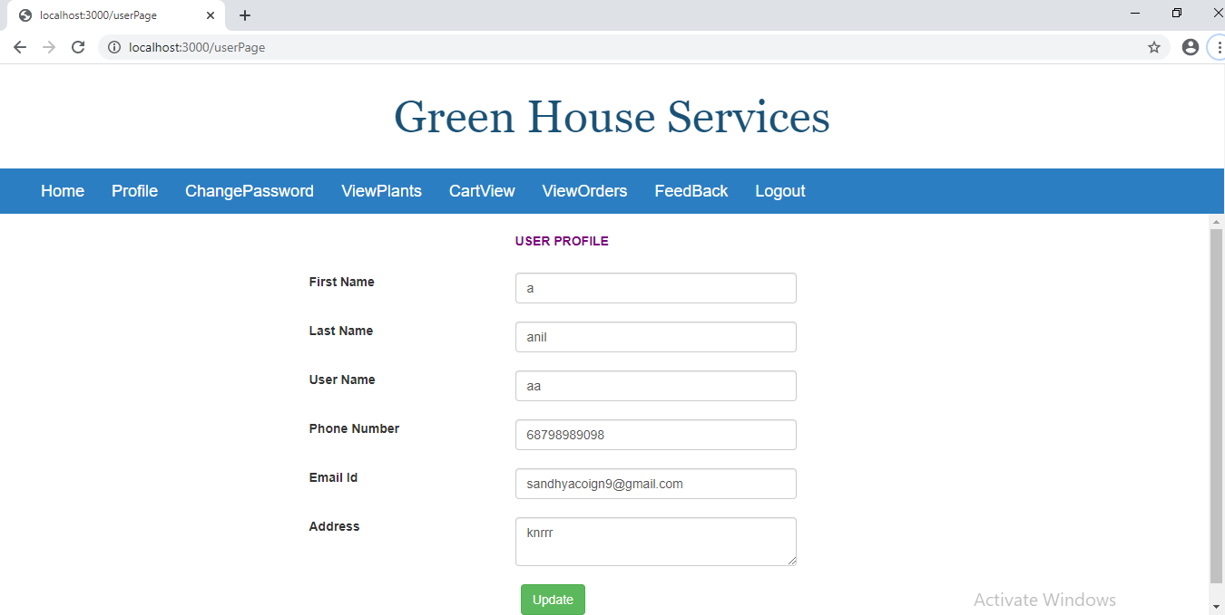

**Change password:-**

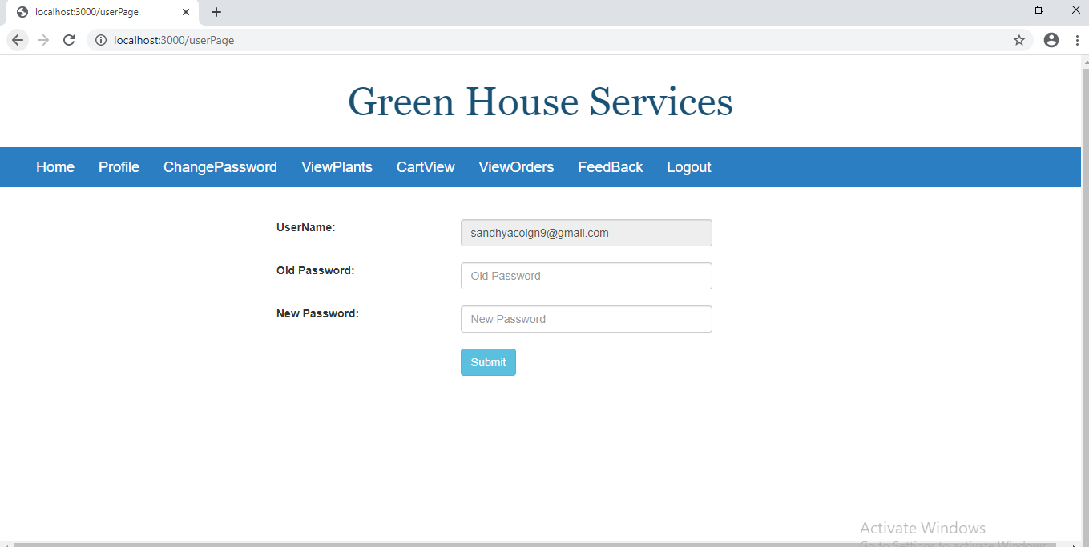

**View Plants:-**

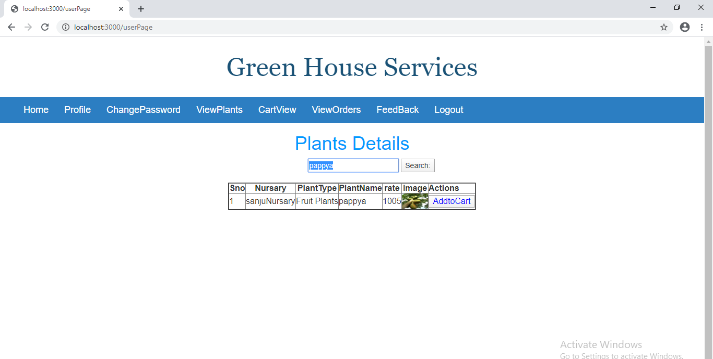

**After search the plant then addtocart table :-**

**Cart View:-**

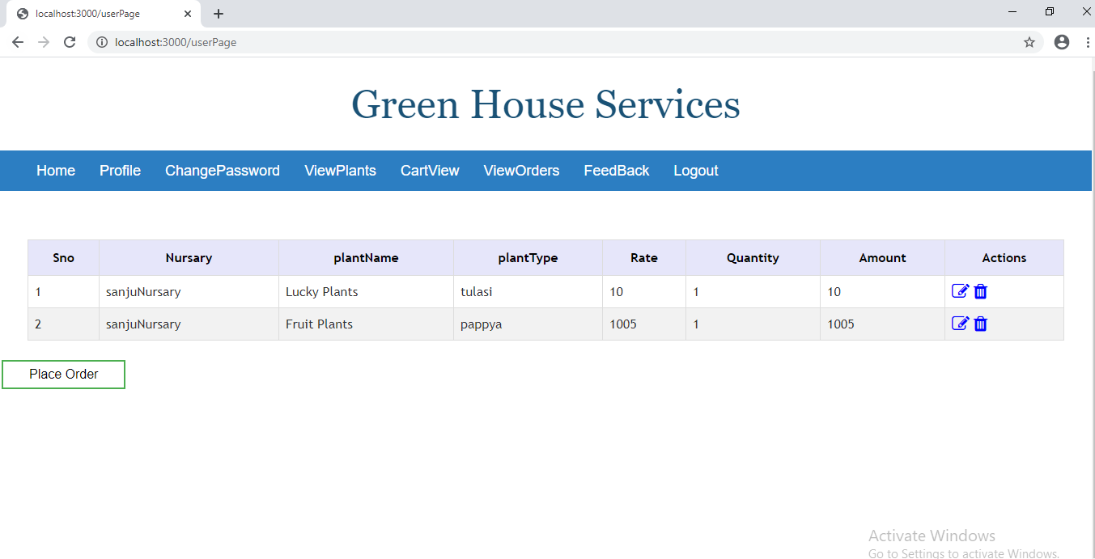

**After Click the Place Order Button You Can View Payment Details Page:-**

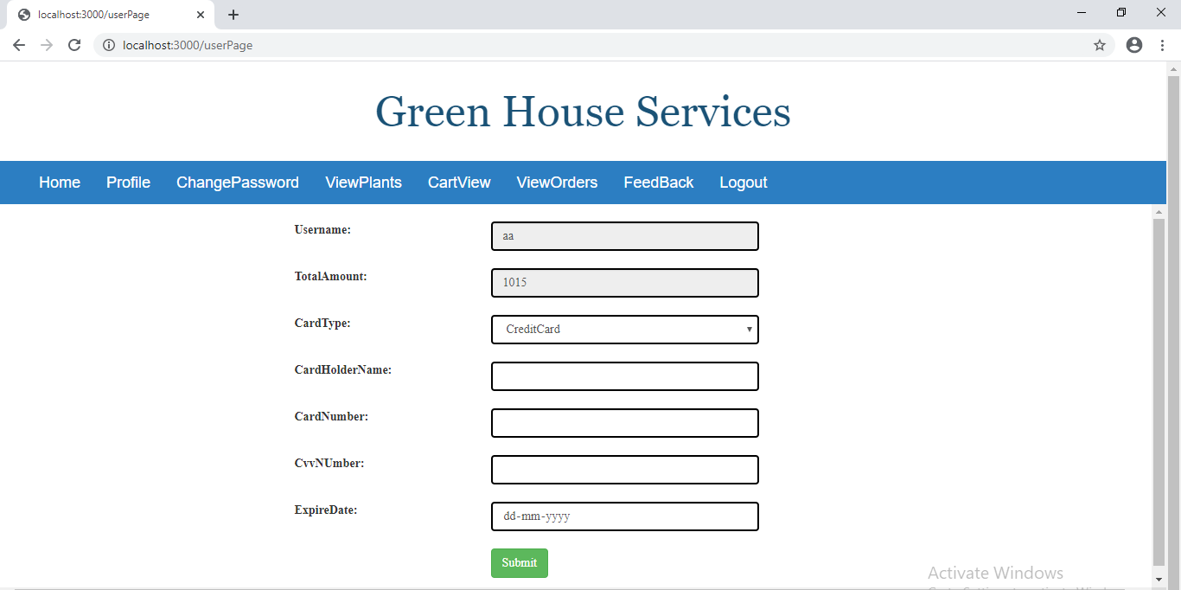

**View orders:-**

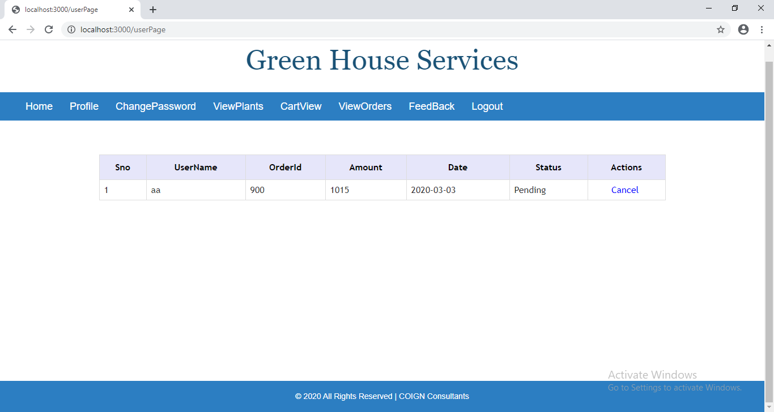

**Thank you…..**