Program 1

class rectangle():

def __init__(self,breadth,length):

self.breadth=breadth

self.length=length

def area(self):

return self.breadth*self.length

def perimeter(self):

return 2*self.breadth+self.length

a1=int(input("Enter length of rectangle: "))

b1=int(input("Enter breadth of rectangle: "))

obj1=rectangle(a1,b1)

print("Area of rectangle:",obj1.area())

print("perimeter of rectangle:",obj1.perimeter())

a2=int(input("Enter length of rectangle: "))

b2=int(input("Enter breadth of rectangle: "))

obj2=rectangle(a2,b2)

print("Area of rectangle:",obj2.area())

print("perimeter of rectangle:",obj2.perimeter())

if (obj1.area()>obj2.area()):

print("obj1 is greater")

else:

print("obj2 is greater")

Output:

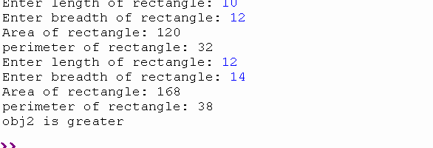

Program 2

class bank:

def __init__(self):

self.balance=0

name=input("enter the name of account holder:")

acno=int(input("enter the account no:"))

print ("The account is created")

print("\n name of account:",name)

print("\n account no:",acno)

def deposit(self):

amount=int(input(" enter the amount:"))

self.balance+=amount

def withdraw(self):

amount = float(input("Enter amount to be Withdrawn:"))

if (self.balance>=amount):

self.balance-=amount

print("\nYou Withdraw:", amount)

else:

print("\ninsufficient balance")

def display(self):

print("\nAvailable Balance =",self.balance)

b=bank()

b.deposit()

b.withdraw()

b.display()

Output:

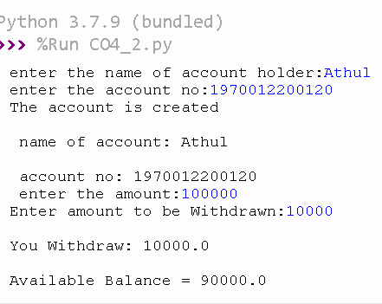

Program 3

class rectangle:

def __init__(self,length,width):

self.__length=length

self.__width=width

def __lt__(self,a1):

area1=self.__length*self.__width

area2=a1.__length*a1.__width

if(area1<area2):

return(True)

else:

return(False)

a1=int(input("Length of 1st rectangle:"))

b1=int(input("width of 1st rectangle:"))

r1=rectangle(a1,b1)

a2=int(input("Length 2nd rectangle:"))

b2=int(input("width 2nd rectangle:"))

r2=rectangle(a2,b2)

if(r1<r2):

print("Rectangle 2 is larger!!")

else:

print("Rectangle 1 is larger!!")

Output:

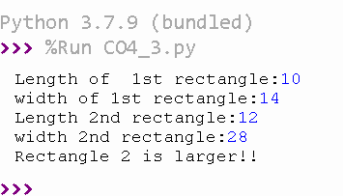

Program 4

class Time:

def __init__(self,hour,minute,second):

self.__hour=hour

self.__minute=minute

self.__second=second

def __add__(self,h):

second=self.__second+h.__second

minute=self.__minute+h.__minute

hour=self.__hour+h.__hour

if(second>60):

second=second-60

minute=minute+1

if(minute>60):

minute=minute-60

hour=hour+1

return hour,minute,second

print("Enter 1 time:")

h1=int(input("enter the hour:"))

m1=int(input("enter the minute:"))

s1=int(input(" enter the second:"))

t1=Time(h1,m1,s1)

print("Enter 2 time:")

h2=int(input("enter the hour:"))

m2=int(input("enter the minute:"))

s2=int(input("enter the second:"))

t2=Time(h2,m2,s2)

hr,min,sec=t1+t2

print(hr,end=":")

print(min,end=":")

print(sec,end=" ")

Output:

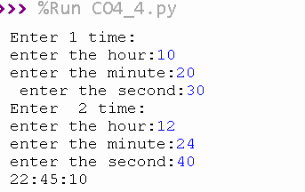

Program 5

class publisher:

def getbook(self):

self.title=input("Title :")

self.author=input("Author :")

class python(publisher):

def getdetails(self):

self.price=int(input("Price :"))

self.nopages=int(input("No.pages :"))

def display(self):

print("Title of the book is :",self.title)

print("Author of the book is :",self.author)

print("Price is: ",self.price)

print("Number of pages :",self.nopages)

a=python()

a.getbook()

a.getdetails()

a.display()

Output:

