**CO5 PROGRAM**

**1. Write a Python program to read a file line by line and store it into a list.**

f1=open("secfile.txt","w")

f1.write("This is my first file in python.\n want to work with files \n This is my third line")

f1=open("secfile.txt","r")

ff=f1.readlines()

print(ff)

**OUTPUT:**



**2. Python program to copy odd lines of one file to other**

f1=open("secfile.txt","r")

ff=f1.readlines()

with open("odd.txt","w") as f2:

for x in range(0,len(ff)):

if(x%2!=0):

f2.write(ff[x])

**OUTPUT:**

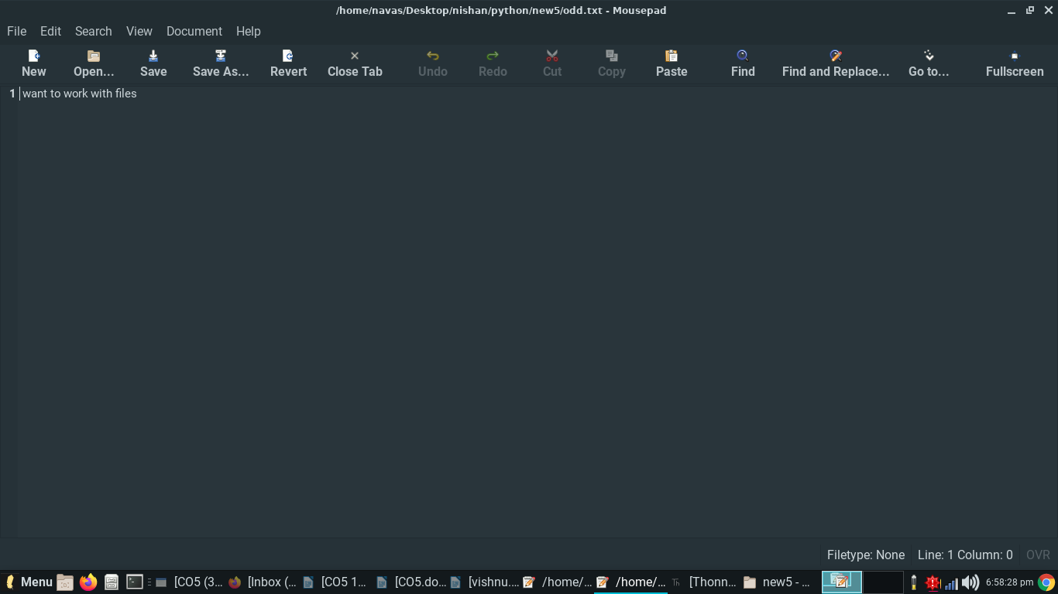

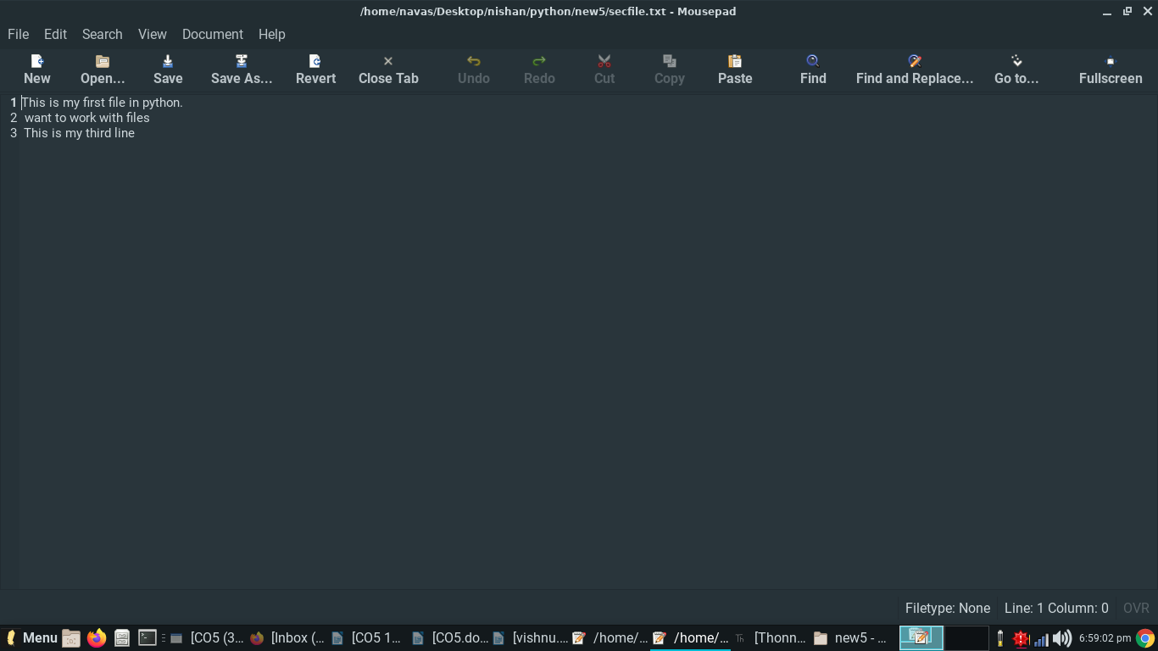

**3. Write a Python program to read each row from a given csv file and print a list of strings.**

import csv

filename = "username.csv"

rows = []

cf=open(filename, 'r')

csvreader = csv.reader(cf)

for r in csvreader:

rows.append(r)

print(rows)

cf.close()

**OUTPUT:**

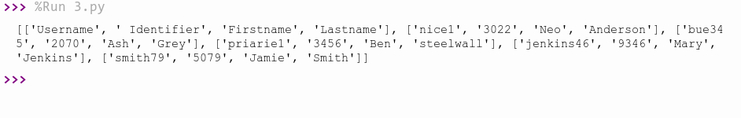

**4. Write a Python program to read specific columns of a given CSV file and print the content of the columns.**

import csv

filename = "emp.csv"

fields = []

rows = []

cf=open(filename, 'r')

csvreader = csv.DictReader(cf)

for r in csvreader:

print(dict(r))

**OUTPUT:**

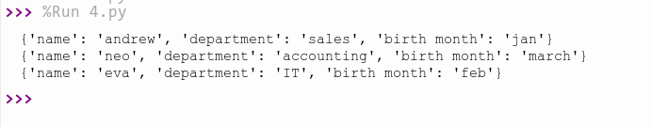

**5. Write a Python program to write a Python dictionary to a csv file. After writing the CSV file  read the CSV file and display the content.**

import csv

field_names = ['No', 'Company', 'Car Model']

cars = [

{'No': 1, 'Company': 'Ferrari', 'Car Model': '488 GTB'},

{'No': 2, 'Company': 'Porsche', 'Car Model': '918 Spyder'},

{'No': 3, 'Company': 'Bugatti', 'Car Model': 'La Voiture Noire'},

{'No': 4, 'Company': 'Rolls Royce', 'Car Model': 'Phantom'},

{'No': 5, 'Company': 'BMW', 'Car Model': 'BMW X7'},

]

with open('names1.csv', 'w') as csvfile:

writer = csv.DictWriter(csvfile, fieldnames = field_names)

writer.writeheader()

writer.writerows(cars)

filename = "names1.csv"

cf=open("names1.csv", 'r')

rows=[]

csvreader = csv.reader(cf)

for r in csvreader:

rows.append(r)

for r in rows:

print(*r)

**OUTPUT:**

