**Co3**

1. Work with built-in packages

a. Math.py

import mathprint("Factorial:",math.factorial(10))

print ("GCD:",math.gcd(6,12))

print ("sqrt:",math.sqrt(45))

output

Factorial: 362880

GCD: 6

sqrt: 6.708203932499369

b.time.py

import time

print("Current time in sec:",time.time())

print("Current time:",time.ctime())

print("Time After 30 sec:",time.ctime(time.time()+30))

t=time.localtime()

print("Time:",t)

print("Time-current year:",t.tm_year)

print("Time:-current month",t.tm_mon)

print("Time:-current day",t.tm_mday)

print("Time:-current hour",t.tm_hour)

print("Time:-current minute",t.tm_min)

print("Time:-current sec",t.tm_sec)

print("Time:-current week day",t.tm_wday)

print("Time:-current year day",t.tm_yday)

output

Current time in sec: 1640103698.0492375

Current time: Tue Dec 21 21:51:38 2021

Time After 30 sec: Tue Dec 21 21:52:08 2021

Time: time.struct_time(tm_year=2021, tm_mon=12, tm_mday=21, tm_hour=21, tm_min=51, tm_sec=38, tm_wday=1, tm_yday=355, tm_isdst=0)

Time-current year: 2021

Time:-current month 12

Time:-current day 21

Time:-current hour 21

Time:-current minute 51

Time:-current sec 38

Time:-current week day 1

Time:-current year day 355

c.Dtime.py

import datetime

t=datetime.time(22,56,20,67)

print(t)

print("Hour",t.hour)

print("Minutes",t.minute)

print("Seconds",t.second)

print("Microsecond:",t.microsecond)

print("\n")

d=datetime.date.today()

print("Today:",d)

print("Year:",d.year)

print("Month:",d.month)

print("Day:",d.day)

d1=datetime.date.today()

print(d1)

td=datetime.timedelta(days=2)

print(td)

d2=d1+td

print(d2)

dt=datetime.datetime.combine(d1,t)

print("date-time comb:",dt)

output

22:56:20.000067

Hour 22

Minutes 56

Seconds 20

Microsecond: 67

Today: 2021-12-21

Year: 2021

Month: 12

Day: 21

2021-12-21

2 days, 0:00:00

2021-12-23

date-time comb: 2021-12-21 22:56:20.000067

d.cal.py

import calendar

mm=int(input("Enter month:"))

yy=int(input("Enter year:"))

print(calendar.month(yy,mm))

print(calendar.calendar(2021))

output

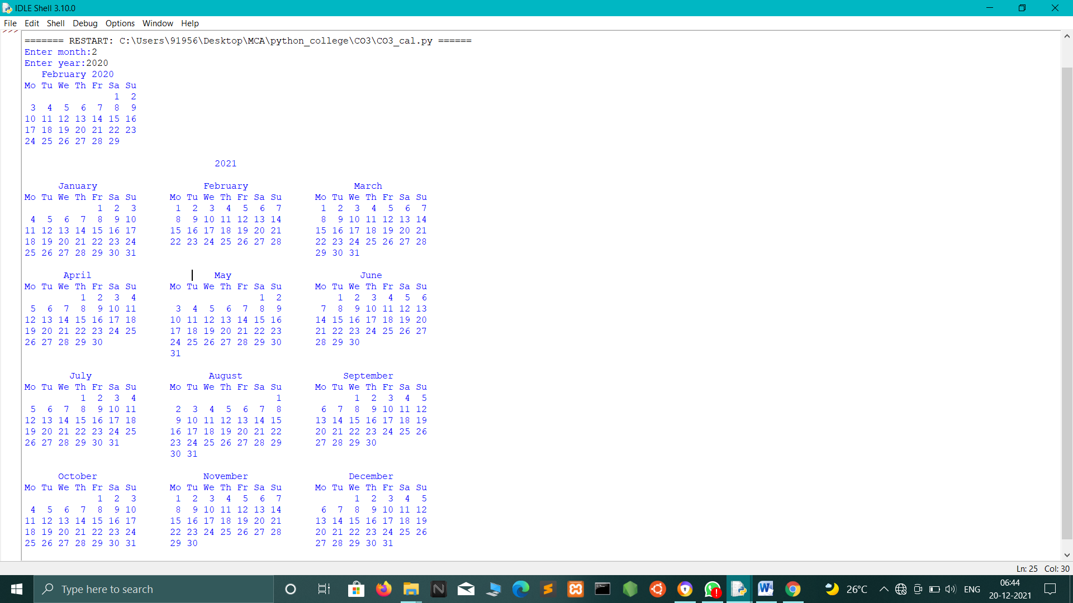

# 2.Programs using statistics module

# a. statistics.variance()

# import statistics

# print(statistics.variance([1, 3, 5, 7, 9, 11]))

# print(statistics.variance([2, 2.5, 1.25, 3.1, 1.75, 2.8]))

# print(statistics.variance([-11, 5.5, -3.4, 7.1]))

# print(statistics.variance([1, 30, 50, 100]))

# output

# 14

# 0.4796666666666667

# 70.80333333333334

# 1736.9166666666667

# b. statistics.pvariance()

# import statistics

# print(statistics.pvariance([1, 3, 5, 7, 9, 11]))

# print(statistics.pvariance([2, 2.5, 1.25, 3.1, 1.75, 2.8]))

# print(statistics.pvariance([-11, 5.5, -3.4, 7.1]))

# print(statistics.pvariance([1, 30, 50, 100]))

# output

# 11.666666666666666

# 0.3997222222222222

# 53.1025

# 1302.6875

# c. statistics.stdev()

# import statistics

# print(statistics.stdev([1, 3, 5, 7, 9, 11]))

# print(statistics.stdev([2, 2.5, 1.25, 3.1, 1.75, 2.8]))

# print(statistics.stdev([-11, 5.5, -3.4, 7.1]))

# print(statistics.stdev([1, 30, 50, 100]))

# output

# 3.7416573867739413

# 0.6925797186365384

# 8.414471660973929

# 41.67633221226008

# d. statistics.pstdev()

# import statistics

# print(statistics.pstdev([1, 3, 5, 7, 9, 11]))

# print(statistics.pstdev([2, 2.5, 1.25, 3.1, 1.75, 2.8]))

# print(statistics.pstdev([-11, 5.5, -3.4, 7.1]))

# print(statistics.pstdev([1, 30, 50, 100]))

# output

# 3.415650255319866

# 0.6322358912796886

# 7.287146217827662

# 36.09276243237694

# e. . statistics.mode()

# import statistics

# print(statistics.mode([1, 3, 3, 3, 5, 7, 7 ,9, 11]))

# print(statistics.mode([1, 1, 3, -5, 7, -9, 11]))

# print(statistics.mode(['red', 'green', 'blue', 'red','blue','blue'])

# output

# 3

# 1

# Blue

# 3.programes of random module

# a.Seed()

# import random

# random.seed(5)

# print(random.random())

# output

# 0.6229016948897019

b.choices()

import random

mylist = ["apple", "banana", "cherry"]

print(random.choices(mylist, weights = [10, 1, 1], k = 14))

output

[apple,cherry,apple,apple,apple,apple,apple,cherry,banana,apple,apple,apple,apple,apple]

c.shuffle()

import random

mylist = ["apple", "banana", "cherry"]

random.shuffle(mylist)

print(mylist)

output

[“cherry”,”apple”,”banana”,”cherry”]

d.uniform()

import random

print(random.uniform(20, 60))

output

44.4561722619496

e.triangular()

import random

print(random.triangular(20, 60, 30))

output

53.36347655740272

4.Create a package graphics with modules rectangle, circle and sub-package 3D-graphics with modules cuboid and sphere. Include methods to find area and perimeter of respective figures in each module. Write programs that finds area and perimeter of figures by different importing statements. (Include selective import of modules and import * statements)

Area.py

from graphics import rectangle

from graphics import circle

from graphics import cuboid

from graphics import sphere

l=int(input("Enter the length of rectangle:"))

b=int(input("Enter the breadth of rectangle:"))

print("Area=",rectangle.area(l,b))

print("Perimeter=",rectangle.perimeter(l,b))

r=int(input("\nEnter the radius of circle:"))

print("Area=",circle.area(r))

print("Perimeter=",circle.perimeter(r))

l=int(input("\nEnter the length of cuboid:"))

w=int(input("Enter the width of cuboid:"))

h=int(input("Enter the height of cuboid:"))

b=int(input("Enter the breadth of cuboid:"))

print("Area=",cuboid.area(l,w,h))

print("perimeter=",cuboid.perimeter(l,b,h))

r=int(input("\nEnter the radius of sphere:"))

print("Area=",sphere.area(r))

print("perimeter=",sphere.perimeter(r))

graphics:

circle.py

def area(r):

return(3.14*r*r)

def perimeter(r):

return(2*3.14*r)

rectangle.py

def area(l,b):

return(l*b)

def perimeter(l,b):

return(2*(l+b))

cuboid.py

def area(l,w,h):

return(2*l*w+2*l*h+2*h*w)

def perimeter(l,b,h):

return(4*(l+b+h))

sphere.py

def area(r):

return(4*3.14*r*r)

def perimeter(r):

return(2*3.14*r)

OUTPUT:

Enter the length of rectangle:4

Enter the breadth of rectangle:3

Area= 12

Perimeter= 14

Enter the radius of circle:2

Area= 12.56

Perimeter= 12.56

Enter the length of cuboid:4

Enter the width of cuboid:3

Enter the height of cuboid:5

Enter the breadth of cuboid:6

Area= 94

perimeter= 60

Enter the radius of sphere:4

Area= 200.96

perimeter= 25.12