Understanding Energy Consumption Behaviour among Students in University Residence
Sandhya Dhanasekar

1. Introduction
The important drivers of daily consumption of energy are the behaviour and choices of an individual. A report by the International Energy Agency stated that 20% of the total energy demand was from the residential sector (Cornago, 2021). Consumers must adopt new behaviours and adjust their current ones to save money on household energy use. Compared to technology advancements, behavioural improvements can result in immediate, cost-free energy savings. As a result, there has been an upsurge of interest in recent years in interventions to raise households' awareness and understanding of energy, in order to accomplish beneficial behavioural change (Aydin, Brounen, & Kok, 2018).
This study observes the energy consumption behaviour of student residents at the University of East Anglia. The analysis examines the facets that correlate with energy consumption, considering student behaviour based on self-identified sustainability, and the effect of a weekly notification of energy usage sent with the aim of raising awareness.

2. Research Questions
Are students in the residencies who profess to practise sustainability doing so in an efficient manner?
Is there a change in energy usage after a notification email was sent, and was notifying the flat an effective measure?
These insights allow us to understand student behaviours towards energy usage, informing the design of effective interventions to address heavy energy consumption.

3. Literature Review

Energy efficiency and behaviour
Energy efficiency is described as “a way of managing and restraining the growth in energy consumption” by the International Energy Agency (IEA). Energy efficiency is based on the idea that using energy more economically and efficiently can produce the same amount of energy as current technology, if not more (Shove, 2018). Energy efficiency “has tremendous potential to boost economic growth and avoid GHG emissions,” according to the IEA (2020). Energy efficiency standards in the building industry have a number of advantages, including a decrease in energy imports and household energy costs (Elsharkawy and Rutherford, 2018). According to the International Energy Agency, space heating accounts for 60% of total consumption in the residential sector. Kelly (2010) notes that the energy performance of older dwellings tends to lag in the UK housing market.
Examining the impact of real-time energy information, households can discover how much energy they consume and whether this awareness stems from more visible energy-use displays. The trial by Lynham, Nitta, Saijo, and Tarui (2016) showed that people who received real-time information on their electricity use decreased it in the morning and evening but not during other times of day, and that this impact weakened over time. They found evidence that learning, rather than saliency, was principally responsible for this effect, suggesting that energy-conservation policies targeting learning (e.g., educational outreach, appliance labelling) might be more cost-effective than installing in-home display devices.
Real-time information appears more successful than a monthly report in promoting learning about energy usage, but this does not appear to promote long-term habit formation. Lynham et al. (2016) note that understanding why learning does not translate into sustained behaviour change is crucial for the effective, widespread implementation of in-home display devices.

4. Methodology
The dataset comprises weekly energy usage observations from student flats at the University of East Anglia across two academic years (2017 and 2018), collected as a balanced panel: 36 flats were each observed over 21 consecutive weeks, yielding 756 observations in total. Fourteen flats were tracked in 2017 (AA17–NN17) and 22 in 2018 (AA18–VV18), including eight flats not present in the 2017 sample.
Three flat-level characteristics are fixed for the duration of a flat's observation period: whether the flat is en-suite (Ensuite), whether its occupants self-identified as “sustainable” (Green), and whether the flat received weekly usage-notification emails (Notified). Critically, the notification intervention was only implemented as a controlled comparison in 2018: every 2017 flat is coded as notified, with no corresponding control group that year. The genuine treatment/control structure — notified flats versus a control group receiving no notifications — exists only within the 2018 cohort, which comprises 462 observations (22 flats × 21 weeks), split between 210 control-condition observations and 252 notified-condition observations.
A fourth variable, Emailsent, is not a flat-level treatment indicator but a week-level marker denoting whether notification emails were sent to any flat that week (coded 0 during university holiday weeks, when no emails were sent). This variable is therefore identical across all flats within a given week and should be interpreted as a proxy for term-time versus vacation periods, rather than as evidence of a per-flat intervention.
The original analysis pooled all 756 observations into a single OLS regression of Usage on Notified, Ensuite, Emailsent, and Green, without a year or cohort control. This specification has two notable limitations given the structure just described. First, because the 2017 subsample contains no variation in Notified, pooling it with 2018 confounds the estimated notification effect with unmodelled differences between the two cohorts. Second, because Ensuite, Green, and Notified are time-invariant within each flat, and each flat contributes 21 repeated observations, residuals are likely correlated within flats — a violation of the independence assumption underlying standard OLS standard errors, which were not adjusted for clustering in the original analysis.
To address these issues, four specifications are estimated and compared: (1) the original pooled OLS across both years, replicated for reference; (2) an OLS restricted to the 2018 subsample only, where Notified genuinely varies; (3) the same 2018-only OLS with standard errors clustered by Flat, to correct for repeated-measures correlation; and (4) a random-effects panel model (Swamy–Arora transformation), which explicitly separates within-flat (idiosyncratic) variation from between-flat (individual) variation. A fixed-effects (within) specification was also estimated as a diagnostic check; because Green, Ensuite, and Notified do not vary within a flat over time, this model necessarily absorbs them entirely, leaving Emailsent as the only estimable predictor — a structural feature of the data rather than an error, and itself informative about which variables operate at the between-flat versus within-flat level.

5. Results

5.1 Descriptive Statistics
Before turning to the regression analysis, it is useful to examine the raw descriptive patterns in the data, summarised in Table 1 and Figures 1–3 below.
Figure 1 represents the average energy usage in green flats — those occupied by students who identify themselves as sustainable — broken down by academic year. Comparing the mean values of energy usage in 2017 and 2018, there is a difference of 6.1%, with usage falling from 16.002 kWh in 2017 to 15.043 kWh in 2018. Furthermore, flats that claimed to be sustainable do show lower energy consumption on average: 14.471 kWh, compared to 15.686 kWh for non-green flats, a reduction of 8.3%. This descriptive pattern is consistent with student sustainability self-identification corresponding to somewhat lower usage, though it should be noted that occupancy also depends on the university semester pattern, and — as the regression analysis below shows — the strength of this association is more uncertain once properly modelled. Student energy-efficient behaviour is often understood as combining two components: understanding of the environmental problem, and the willingness to act on that understanding (Shutaleva et al., 2022). An environmentally conscious lifestyle of this kind typically includes recycling, conserving water and electricity, purchasing eco-friendly products, and using eco-friendly transport such as bike-sharing (Maranzano et al., 2021).
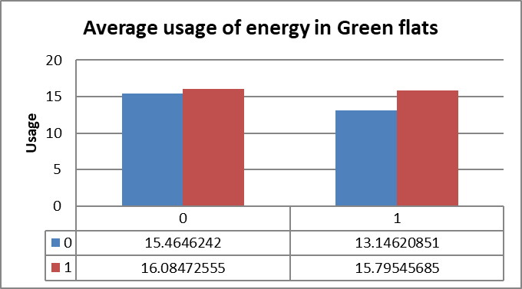
Figure 1. Average energy usage in green flats, by year.
Table 1 summarises the underlying mean values referenced above.
Variable | Mean | Standard deviation
Usage (overall) | 15.416 | 5.895
Usage 2017 | 16.002 | 6.587
Usage 2018 | 15.043 | 5.383
Green flats | 14.471 | 6.685
Non-green flats | 15.686 | 5.626

Figure 2 represents the average energy usage in notified and non-notified flats. These results depict the weekly energy consumption of flats made aware of their consumption. Flats that received weekly usage feedback averaged 15.71 kWh, compared to 14.64 kWh for non-notified flats — a difference of 7.2% in the opposite direction to what the intervention intended. Taken at face value, this descriptive contrast would suggest that notification was not an effective measure, and may even be associated with higher usage. However, this raw comparison pools flats across both years and does not account for the fact that each flat is observed repeatedly over 21 weeks; Section 5.2 revisits this comparison using a corrected specification, and shows that the apparent effect does not hold up once these issues are addressed.
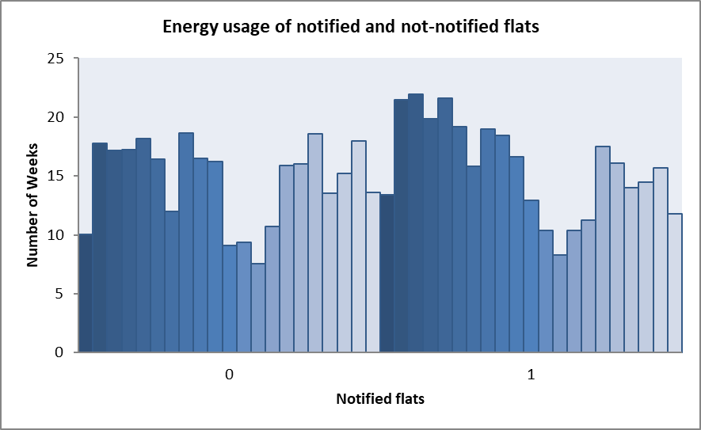
Figure 2. Weekly energy usage of notified and non-notified flats, by individual flat.
Figure 3 shows flats ranked by their average usage in the league table used to communicate relative standing to students; this ranking underlies the weekly notification emails but was not itself used as a regression predictor in either the original or the corrected analysis below.
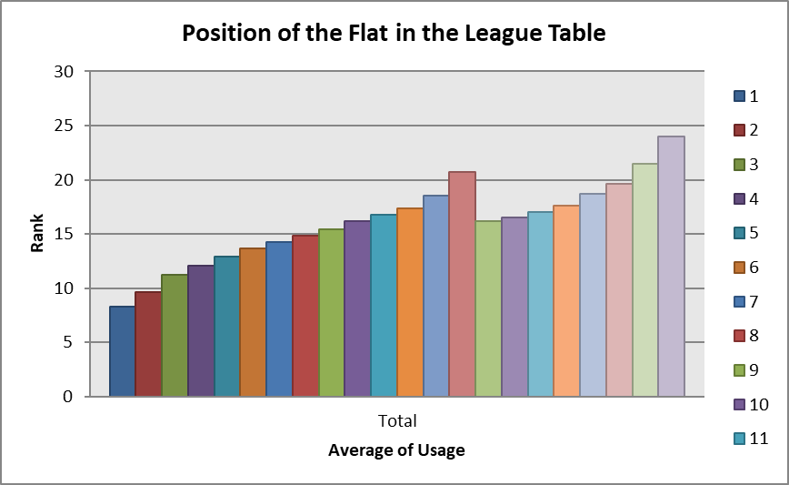
Figure 3. Flat position in the usage league table, ranked by average usage.

5.2 Regression Analysis
The original regression specification — pooling both years without a cohort control, and without adjusting standard errors for the repeated-measures structure of the data — is reproduced in Figure 4 for reference. Its coefficients correspond to the “Original pooled OLS” column of Table 2 below.
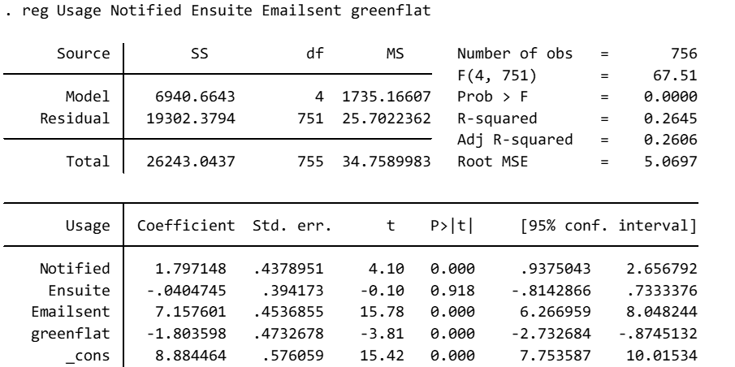
Figure 4. Original regression specification (Stata output).
Table 2 reports coefficient estimates and significance across the four corrected specifications described in the Methodology.
Predictor | Original pooled OLS (n=756) | 2018-only OLS, uncorrected (n=462) | 2018-only OLS, clustered by Flat | 2018-only Random Effects
Notified | 1.798 *** (p<0.001) | 1.790 *** (p<0.001) | 1.790 (p=0.202) | 1.790 (p=0.211)
Ensuite | -0.040 (p=0.919) | 0.860 . (p=0.069) | 0.860 (p=0.562) | 0.860 (p=0.551)
Emailsent | 7.157 *** (p<0.001) | 6.818 *** (p<0.001) | 6.818 *** (p<0.001) | 6.818 *** (p<0.001)
Green | -1.804 *** (p<0.001) | -3.337 *** (p<0.001) | -3.337 * (p=0.028) | -3.337 . (p=0.070)
R² | 0.265 | 0.304 | — | 0.355

Signif. codes: *** p<0.001, * p<0.05, . p<0.10

Emailsent
The Emailsent coefficient (approximately 6.8–7.2 kWh) is large and highly significant (p<0.001) across every specification, including the fixed-effects model, in which all time-invariant covariates drop out entirely and only genuine within-flat, over-time variation remains. Because this variable identifies term-time weeks versus university holidays rather than a flat-specific treatment, its robustness across specifications — including one that removes all between-flat confounding — indicates that energy usage is substantially higher while flats are occupied during term time than during vacation periods, a highly credible finding.

Notified
The Notified coefficient is unchanged in magnitude (1.79–1.80) across all specifications, and highly significant in the naive OLS models (p<0.001). However, once standard errors are corrected for flat-level clustering, or a random-effects model is used to properly account for the panel structure, its standard error roughly triples and its significance disappears entirely (p=0.202 clustered; p=0.211 random effects). This indicates that the original finding — that notified flats used significantly more energy — does not survive correction for the fact that 21 repeated observations per flat are not independent.

Green
The Green coefficient strengthens once the analysis is restricted to 2018 (from -1.80 to -3.34) and remains statistically significant when standard errors are clustered (p=0.028), though it weakens to only marginal significance under the random-effects specification (p=0.070), which more conservatively partitions within- and between-flat variance. This suggests a real, but less certain than originally presented, association between self-identified “green” status and lower energy usage.

Ensuite
Ensuite shows no robust association with usage in any properly specified model (p=0.56 once corrected for clustering or panel structure), consistent with the original pooled result.

Model fit
The random-effects specification explains a substantially larger share of variance (R²=0.355) than either OLS specification (0.304 for the 2018-only model; 0.265 for the original pooled model). This reflects a substantial individual (flat-level) variance component, accounting for 38.6% of total variance in the random-effects decomposition, confirming that stable, flat-specific characteristics not captured by Green or Ensuite play a meaningful role in shaping usage.

6. Discussion and Limitations
The analysis substantially changes the study's central conclusion. The original pooled specification suggested that flats receiving usage notifications used significantly more energy than non-notified flats — an apparently robust, if counter-intuitive, finding. Once the sample is properly restricted to 2018, the only year in which a genuine notified/control comparison exists, and once standard errors are corrected for repeated observations within each flat, this effect is no longer statistically significant. This suggests the original finding was likely inflated by treating 756 serially correlated observations from 36 flats as though they were independent, understating the true standard errors and overstating the precision of the Notified estimate. This is a valuable methodological lesson in its own right: apparent statistical significance in panel or repeated-measures data can be highly sensitive to whether the clustering structure is properly modelled, and the corrected, non-significant result is likely the more trustworthy conclusion.
The Green coefficient tells a related but distinct story. Its estimated effect strengthens once the 2017 cohort — where no meaningful Notified variation existed and cohort-level differences were unmodelled — is excluded, and remains significant once standard errors are clustered, but weakens to marginal significance under the random-effects specification. Taken together, this suggests a real association between self-identified “green” status and lower energy usage, but one that should be described with appropriate caution, particularly given that Green status is self-reported and not randomly assigned: flats identifying as sustainable may differ from others in unmeasured ways (environmental attitudes generally, occupancy patterns, or appliance ownership) that independently affect usage.
Emailsent was the only predictor that remained robust across every specification, including the within (fixed-effects) model, which isolates purely within-flat, over-time change. Because this variable in fact indicates term-time versus university-holiday weeks (identical across all flats in a given week, per the dataset's own variable definitions) rather than a flat-specific treatment, its consistent, large, and highly significant coefficient most plausibly reflects that occupants use substantially more energy while resident during term time than during vacation periods, when flats are largely empty. This is a credible and interesting finding, but the original write-up's framing of it as evidence that “the number of emails sent was a major predictor of energy use” mischaracterises what the variable measures, and should instead be described as a term-time/occupancy proxy.
A further limitation concerns how the notification treatment was assigned. The dataset does not record whether flats were randomly assigned to the notified or control condition, or assigned at a coarser level such as building or floor; the pattern of consecutive flat codes sharing the same Notified status is suggestive of block-level assignment, though this cannot be confirmed without further information from the original data collection. If assignment was not randomised at the level of the individual flat, unmeasured building- or floor-level differences (e.g., insulation, meter type, or resident composition) would confound the estimated notification effect independently of the panel-structure correction described above.
Finally, even under the best-specified model here, the majority of variance in weekly energy usage remains unexplained (R²=0.355), indicating that the flat-level characteristics recorded in this dataset capture only part of what drives consumption. Richer data on household composition, individual appliance ownership, and weather conditions would likely improve future analyses of this kind.

7. Conclusion
This study set out to examine whether students identifying as environmentally sustainable used less energy than their peers, and whether providing flats with weekly usage notifications was an effective intervention for reducing consumption. Correcting weaknesses in the original analysis — specifically, isolating the year in which a genuine treatment/control comparison existed, and accounting for the repeated-measures structure of the data — leads to a substantially revised set of conclusions.
Self-identified “green” flats showed a real, though more modest than originally estimated, association with lower energy usage, robust to clustering but weakening under a more conservative random-effects specification; this association should be interpreted as suggestive rather than firmly established, given the non-random, self-reported nature of “green” status.
By contrast, the headline finding of the original analysis — that notified flats used significantly more energy than the control group — did not survive correction for the panel structure of the data. Once standard errors are properly clustered by flat, or a random-effects model is used, the Notified coefficient, while unchanged in magnitude, is no longer statistically distinguishable from zero. This indicates that weekly usage notifications, as implemented in this study, did not have a demonstrable effect on energy consumption, in either direction, once methodological weaknesses in the original analysis are addressed.
The most robust finding across every specification was the association between term-time weeks (as proxied by the Emailsent variable) and substantially higher energy usage — a plausible reflection of occupancy patterns rather than any behavioural intervention.
These results illustrate a broader methodological point: analyses of repeated-measures or panel data that do not account for within-unit correlation risk overstating both the size and the certainty of estimated effects. The large share of unexplained variance, even in the best-specified model here, further suggests that flat-level factors beyond those recorded in this dataset play a substantial role in shaping energy consumption, and would be a natural focus for future data collection.

8. References
Aydin, E., Brounen, D., & Kok, N. (2018). Information provision and energy consumption: Evidence from a field experiment. Energy Economics, 71, 403-410.
Cornago, E. (2021). The potential of behavioural interventions for optimal energy use at home. International Energy Agency.
Elsharkawy, H., & Rutherford, P. (2018). Energy-efficient retrofit of social housing in the UK: Lessons learned from a Community Energy Saving Programme (CESP) in Nottingham. Energy and Buildings, 172, 295-306.
Kelly, M. J. (2010). Energy efficiency, resilience to future climates and long-term sustainability: the role of the built environment. Philosophical Transactions of the Royal Society A, 368, 1083-1089.
Lynham, J., Nitta, K., Saijo, T., & Tarui, N. (2016). Why does real-time information reduce energy consumption? Energy Economics, 54, 173-181.
Maranzano, P., Ascari, R., Chiodini, P. M., & Manzi, G. (2021). Analysis of Sustainability Propensity of BikeSharing Customers Using Partially Ordered Sets Methodology. Social Indicators Research, 157, 123-138.
Shove, E. (2018). What is wrong with energy efficiency? Building Research & Information, 46(7), 779-789.
Shutaleva, A., Martyushev, N., Nikonova, Z., Savchenko, I., Abramova, S., Lubimova, V., & Novgorodtseva, A. (2022). Environmental Behavior of Youth and Sustainable Development. Sustainability, 14, 250.

