A Project Report on

DISSECTING THE DIGITAL LANDSCAPE:

A comprehensive Analysis of social media.

**by**

**Team Leader: SANDHYA KARUNAKAR (20AT1A0564)**

**Student 1 POTHULA INDHU (20AT1A0552)**

**Student 2 EDIGA HARSHITH GOUD (20AT1A0546)**

**Student 3 EDIGA KASI VISWANATH (20AT1A0501)**

**Under the Guidance of**

**MRS.M. JAYA SUNITHA, MTech**

**Associate Professor**



**DEPARTMENT OF COMPUTER SCIENCE ENGINEERING**

**G. PULLAIAH COLLEGE OF ENGINEERING AND TECHNOLOGY**

**(Autonomous)**

(Approved by AICTE | NAAC Accreditation with ‘A’ Grade | Accredited by NBA (ECE, CSE, EEE, CE) |

Permanently Affiliated to JNTUA)

ABSTRACT

Social media platforms offer valuable information about customer behavior and interests. Without social media analysis, businesses may miss opportunities to understand their target audience and improve marketing effectiveness. This project provides a detailed analysis of various platforms, including Facebook, Instagram, Google, Twitter, YouTube, and LinkedIn, covering topics like history, demographics, challenges, and opportunities. Additionally, the paper reviews research on social media's impact on higher education, with a focus on computing, and offers recommendations for future studies.

By harnessing social media data, businesses can gain insights that lead to better customer understanding and informed decision-making. The analysis of various platforms allows for a deeper understanding of their impact on communication and society. Moreover, the literature review highlights the need for further research on social media's effects on student learning and faculty perspectives in higher education.

**Contents**

**Abstract** 2

**Contents** 3

**List of Figures and Tables** 4

**CHAPTER 1 INTRODUCTION 4**

**CHAPTER 2 LITERATURE REVIEW 5**

**CHAPTER 3 PROPOSED METHOD 6**

**CHAPTER 4 LINKEDIN DATASET ATTRIBUTES 7-8**

**CHAPTER 5 EXPERIMENTAL RESULTS OF THE 9-12**

**LINKEDIN DATASET**

* Data Visualization
* DashBoard

**CHAPTER 6 DATASET IMPLEMENTATION BY USING 13**

**MACHINE LEARNING ALGORITHM**

**CHAPTER 7 APPLICATIONS/ADVANTAGES 14**

**CHAPTER 8 CONCLUSIONS 15**

**LIST OF FIGURES AND** **TABLES**

The database collected from IBM cogon’s about the DISSECTING THE DIGITAL LANDSCAPE: A Comprehensive Analysis of social media.

**CHAPTER 1**

**INTRODUCTION**

Social media platform provides a wealth of information about customer behavior, preferences, and interests. Without social media analysis, businesses may miss out on opportunities to better understand their target audience and make data-driven decisions. Social media data provides valuable insights for a better understanding of Customers, Improved Marketing Effectiveness, and Competitive Analysis. Product and Services Development. This project provides a detailed and in-depth analysis of various social media platforms, including Facebook, Instagram, Google, Twitter, Youtube, and LinkedIn.

**What is social media?**

Social media is an internet-based form of communication. Social media platforms allow users to have conversations, share information, and create web content. There are many forms of social media, including blogs, micro-blogs, wikis, social networking sites, photo-sharing sites, instant messaging, video-sharing sites, podcasts, widgets, virtual worlds, and more.

**What are the benefits of using social media?**

Billions of people around the world use social media to share information and make connections. On a personal level, social media allows you to communicate with friends and family, learn new things, develop your interests, and be entertained. On a professional level, you can use social media to broaden your knowledge in a particular field and build your professional network by connecting with other professionals in your industry. At the company level, social media allows you to have a conversation with your audience, gain customer feedback, and elevate your brand.

**CHAPTER 2**

**LITERATURE REVIEW**

In the digital age, businesses grapple with effectively utilizing social media for marketing. To excel, they must conduct a comprehensive analysis of the digital landscape, optimizing their social media strategies to engage the target audience successfully.

Various Business Problems are.

* Insufficient measurement and analytics.
* Inefficient Resource allocation
* Poor Audience Targeting
* Platform Selection
* Unclear Objectives

**Limited Awareness**

- Over 70% of online adults are using social networking sites.

- Computing faculty members have been slower in adopting social media for teaching compared to faculty in other fields.

- Web 2.0, with its social networking and user-generated content, is considered beneficial for teaching and learning.

- Despite the potential suitability of Web 2.0 applications for learner-centered environments, their adoption in higher education is lagging behind the adoption of such technologies in general.

- The shift in learning paradigms has moved towards more learner-centered environments, emphasizing knowledge creation over transmission.

- Some faculty members see limitations and potential issues with using online and interactive technologies in education.

**CHAPTER 3**

**PROPOSED METHOD**

1. How do businesses leverage social media for marketing and customer engagement?
2. What are the advertising models and monetization strategies employed by social media platforms?
3. How can businesses effectively reach and engage with their target audience through social media?

* Businesses use social media for marketing and engaging customers by creating valuable content, listening to feedback, offering customer support, and using influencers.
* Social media platforms monetize through pay-per-click, sponsored content, native advertising, and providing data and analytics to businesses.
* To reach the target audience, define personas, choose the right platforms, maintain a consistent brand voice, and analyze metrics for optimization.
* For scalability, track audience growth, gather customer feedback, analyze competitors, adapt to market trends, increase content production, and invest in marketing efforts.

.

**CHAPTER 4**

**LINKEDIN DATASET ATTRIBUTES**

* User ID
* Username, Profile Picture
* Bio, Followers, Following
* Posts, Likes
* Comments
* Job Search and Recruitment
* Company Pages
* Groups and Communities
* Recommendations,
* Endorsements,
* Networking Opportunities
* Learning and Development
* Analytics and Insights
* Time Spent (Hours)
* Skill Assessments
* Alumni Networking
* Status

**DATASET**

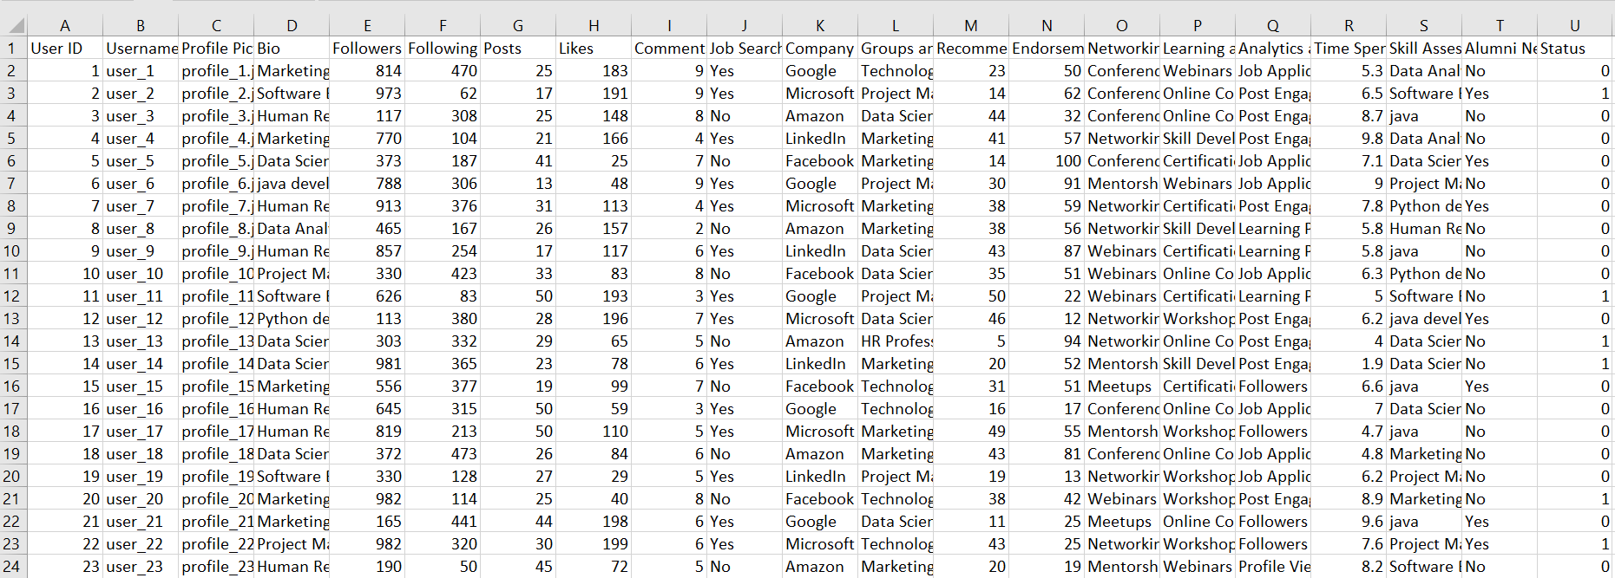

**CHAPTER 5**

**EXPERIMENTAL RESULTS OF THE LINKEDIN DATASET**

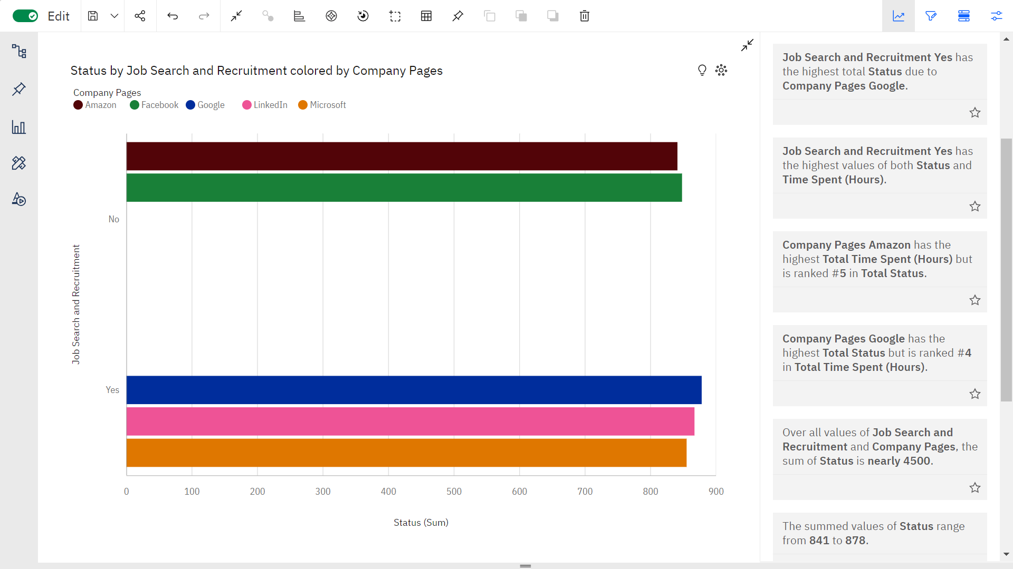

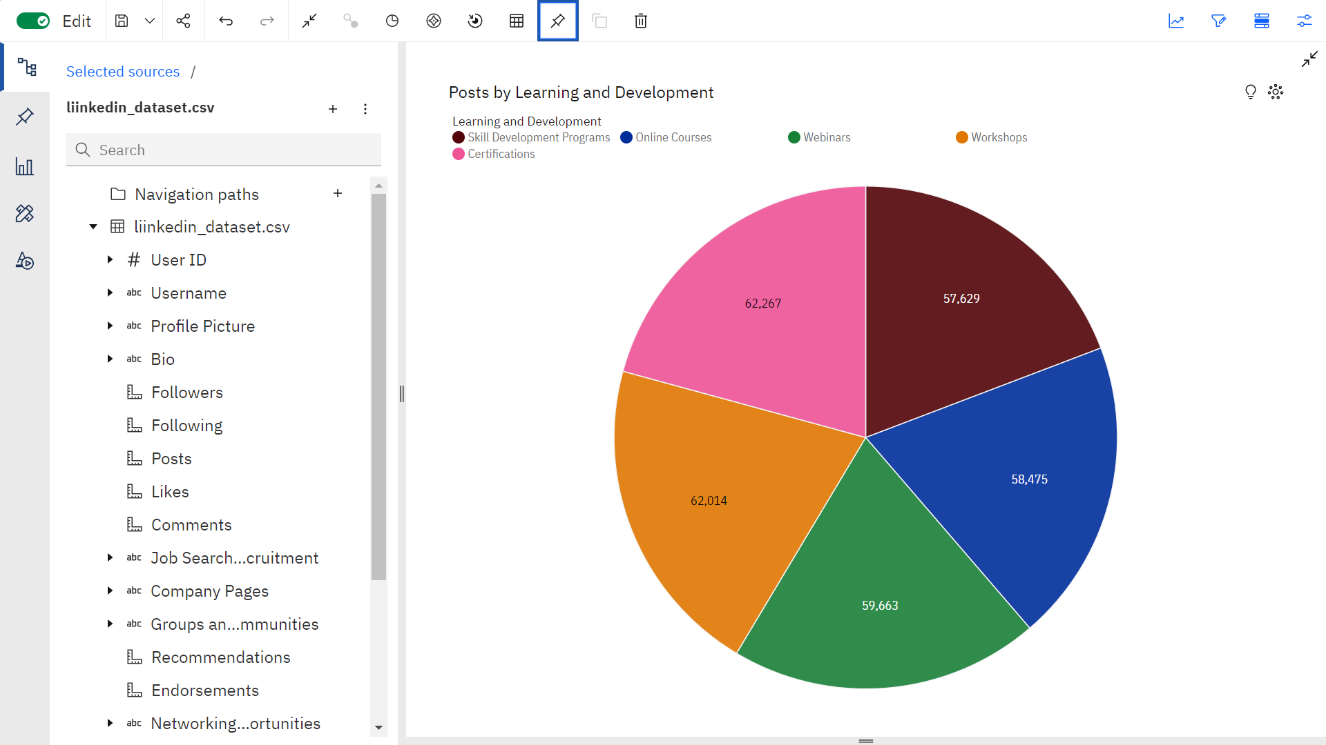

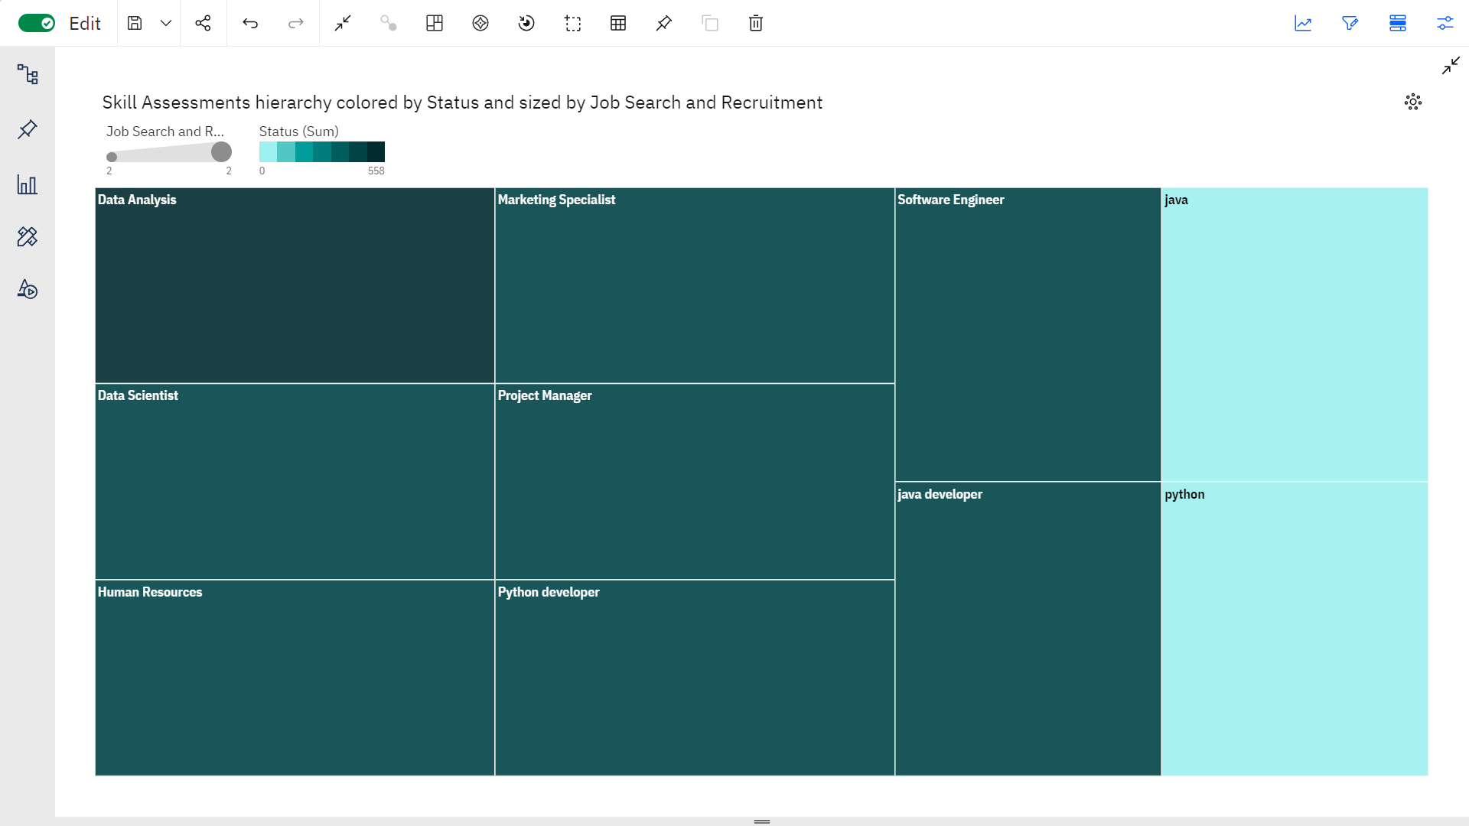

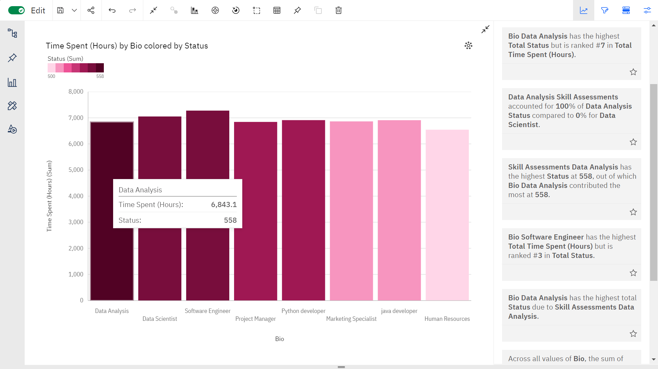

**DASHBOARD…**

* **Linkedin dataset visualization**

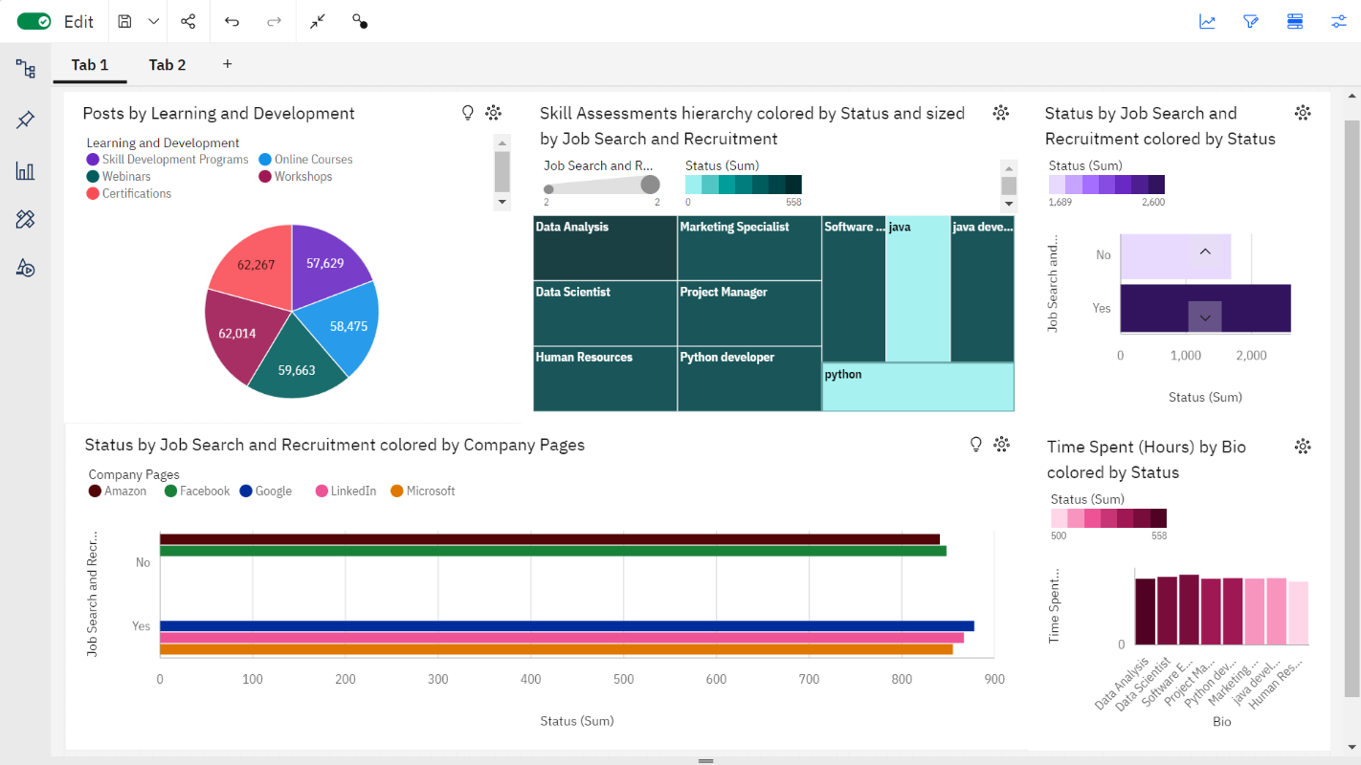

**CHAPTER 6**

**DATASET IMPLEMENTATION BY USING**

**MACHINE LEARNING ALGORITHM…**

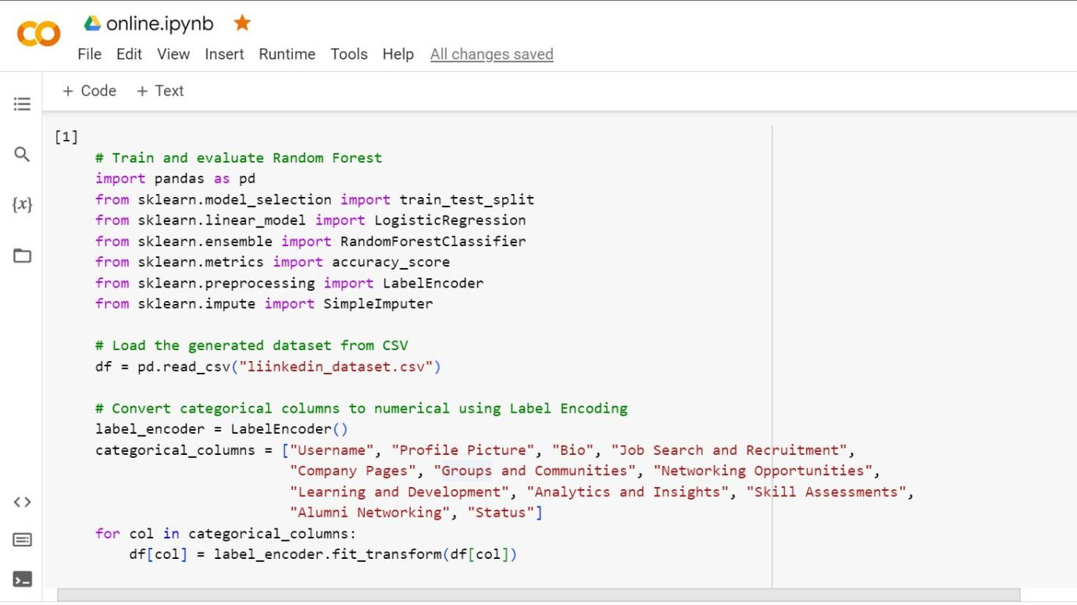

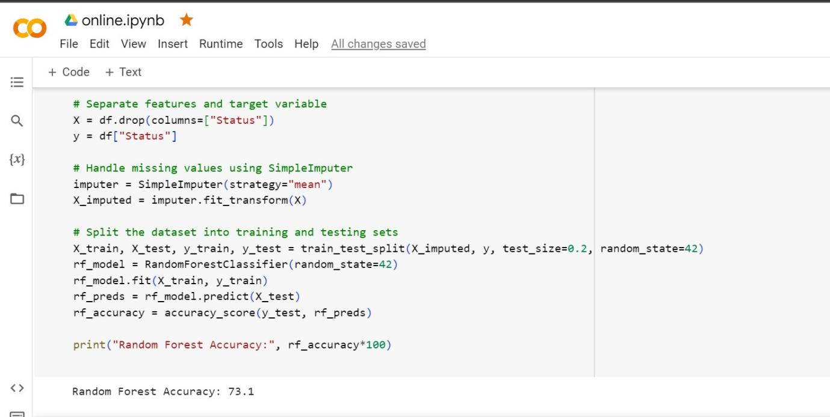

**CHAPTER 7**

**APPLICATIONS/ADVANTAGES AND DISADVANTAGES**

**ADVANTAGES**

1. Professional Networking

2. Job Opportunities

3. Skill Showcase

4. Learning and Development

5. Industry Insights

**DIS ADVANTAGES**

1. Privacy Concerns
2. Profile Management
3. Limited Engagement
4. Competition

5. Skill Validation

**APPLICATIONS**

* Linkedin
* Youtube
* Instagram
* FaceBook etc…

**CHAPTER 8**

**CONCLUSION**

The analysis of the status attribute provides valuable insights into the usage patterns and behavior of engineering students on LinkedIn. It highlights the importance of having an active and engaging presence on the platform, with relevant and consistent information in bios and skill assessments. Engineering students can leverage LinkedIn to enhance their professional networks, access job opportunities, and showcase their skills to potential employers and industry stakeholders.

To make the most of LinkedIn, engineering students should focus on creating compelling and up-to-date profiles, engaging with relevant content, and actively participating in networking activities. By doing so, they can maximize the benefits of LinkedIn and advance their careers in the competitive engineering industry.