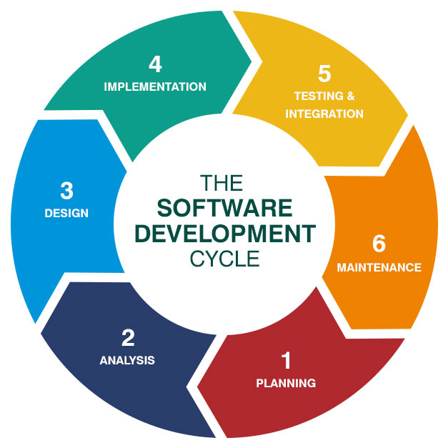

- Planning
Task Time Tracker is designed with pastel colors and it shall persuade a user to be a part of the web application in subtle ways. As per the market research there is a need for such websites that can track time and help users complete their tasks on time.

- Analysis
The project is designed for people who find it difficult to manage their time and struggle to focus on their work. Task Time Tracker is developed to track time and can be a helping hand for people who sit for hours on screen and ends up distracting themselves. The web application will help users to start time and calculate the time needed to complete a task.

- Design
Task Time Tracker is designed with the help of web development tools like HTML, CSS, and JavaScript. This is a comprehensive website that shall guide the user to track time and be punctual. With the pastel colours it shall attract more users. There are features like tabs, and a search bar to enhance the quality of the user experience.

- Implementation
Task Time Tracker has been successfully implemented with the web development tools. This web application includes front-end tools like HTML and CSS. Bootstrap is preferable for the foundation of the website. All the tools are faultlessly implemented and it is a working website for people who are willing to track their time.

- Testing
After the website is developed, a set of rigorous tests are conducted to eliminate any bugs in the system. Tests like Unit testing, Stress testing, Integration Testing, and Load testing meticulously, checking the functionality, usability, compatibility, and performance of the web app.

- Maintenance
With continuous feedback and regular maintenance, the web application will be implemented with further updates as per the requirement of the user.

