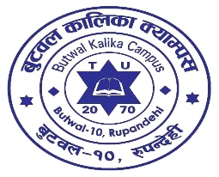 BUTWAL KALIKA CAMPUS

Affiliated to Tribhuvan University

Impacts of Photoshop Training

TERMS OF REFERENCE: The report aims to investigate the impacts of photoshop training on students and teachers of Butwal Kalika Campus. It points out what kind of influence is shadowed on students especially, after the training. The report insights the positive and negative aspects of training and majorly tends to add the photoshop course our academic books. The training involve 35 students and 5 teachers.

FINDINGS:

PROCEDURE: To gather the data for the report. We have used mixed methods of data. We have done surveys, interviews and analysis of impacts on students in practical life too. The surveys and interviewers involve the thought and messages of students who had participated in the training. Teachers were also interviewed by our team to get broader sense of prospective and thoughts on the same topic. Furthermore, we have

RECOMMENDATIONS:

CONCLUSION: The impact of photoshop training on students and teachers has been both remarkable and multifaceted. The training has significantly enhanced digital skills, fueled creativity and improved educational effectiveness. The newfound abilities in photoshop have led to visually engaging content creation, improved communication and a richer learning experience.