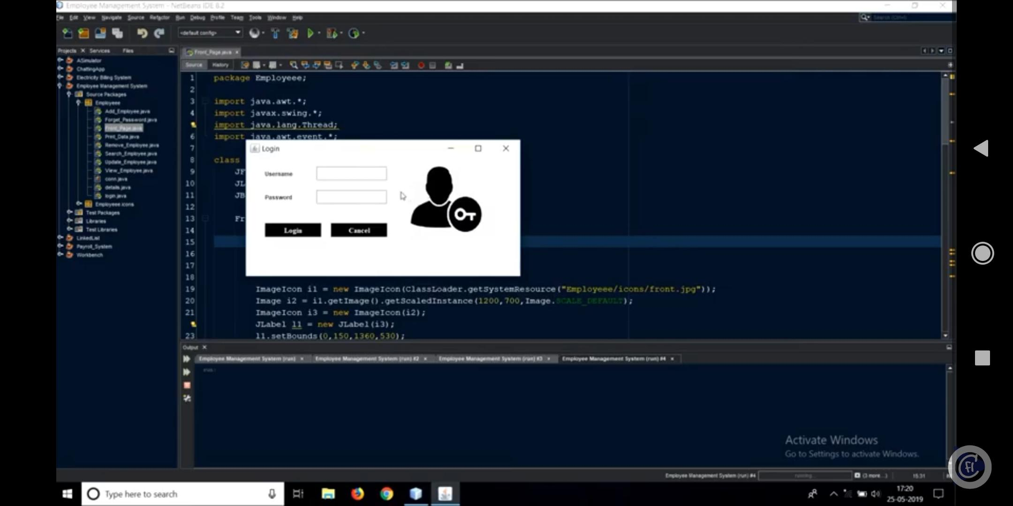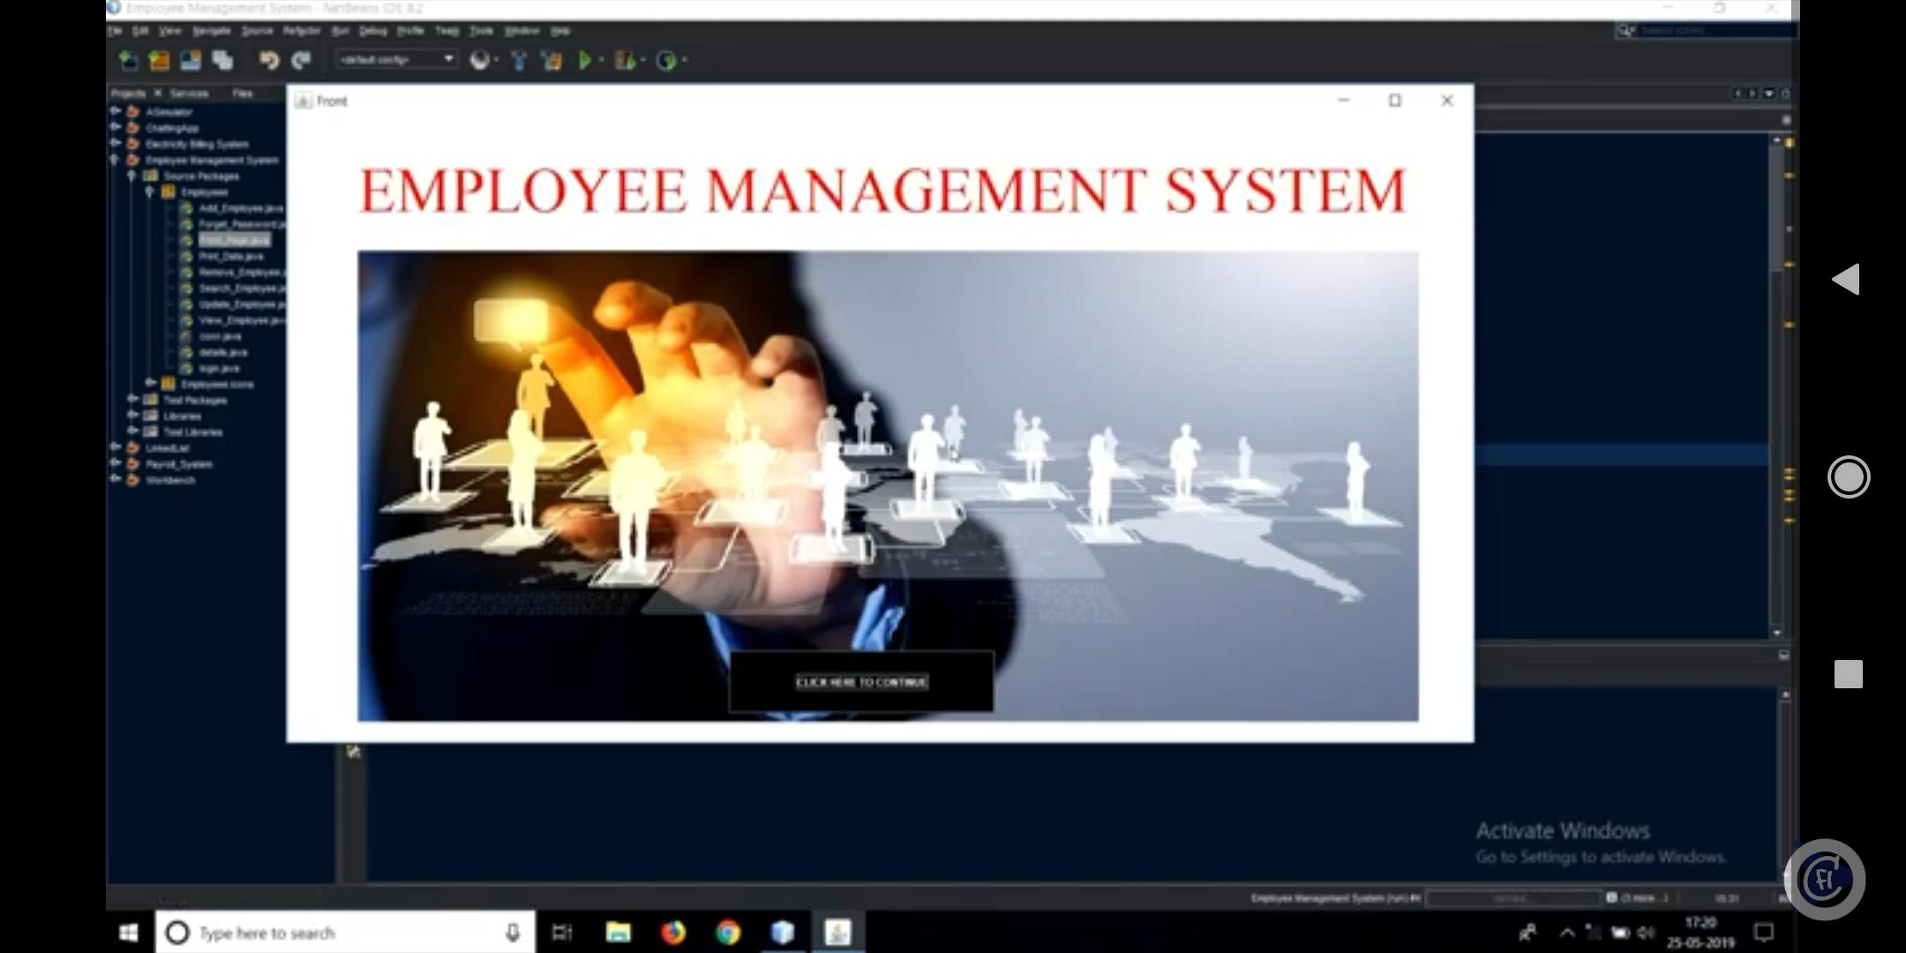Output : Employee Management System.

This is the front page of output.

After clicking continue open a LOGON FORM.

Here two requred parameters USERNAME and PASSWORD.

After cliking login it will go to next form.

Or after clicking cancel it will go to previews front page.