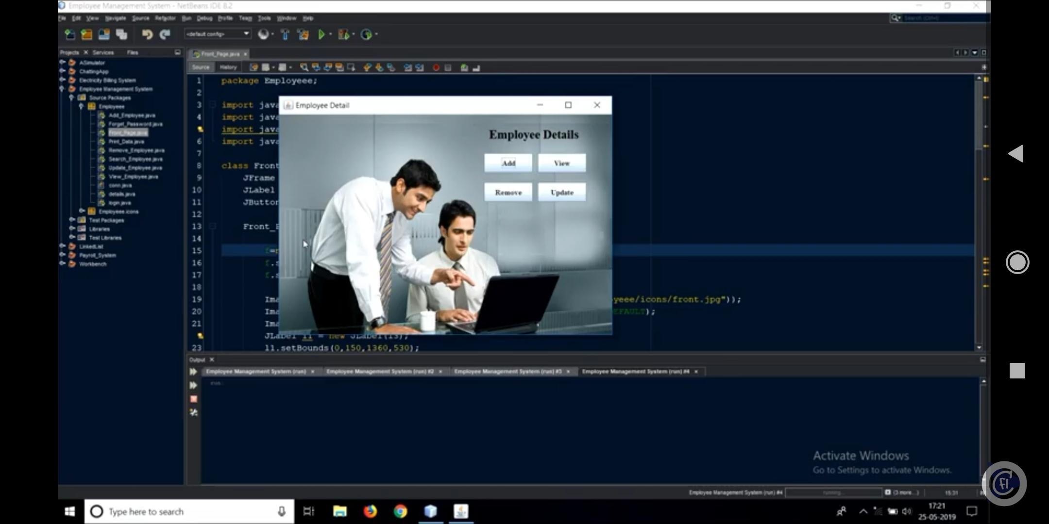After click on login button here displayed new Employee Details Form.

Here we can Add Employee details, View employee details, Remove employee details and

Update employee details.

By click on the Add Button, here new form will be displayed.

Here after filling the details click submit button.The message displayed Details Successfully Submitted.

