Task 1: Setup WordPress on XAMPP
Step 1: Open XAMPP Control Panel. Start Apache and MySQL. Both should turn green.
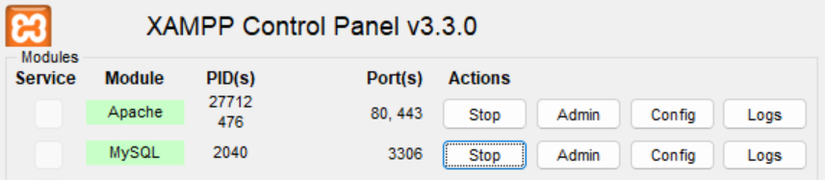
Step 2: Go to: localhost/phpmyadmin

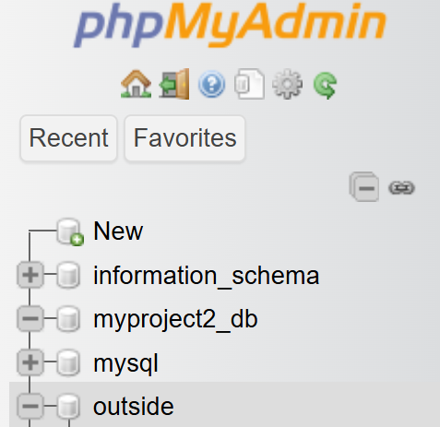
Step 3: Create a new database named “outside”.

Step 4: Go to wordpress.org, download WordPress, and extract the folder inside C:/xampp/htdocs/.
Step 5: Go to localhost/wordpress. Fill in the database name, username (root), leave password blank, and click Submit.

Step 6: Log in and we will see the WordPress Dashboard.
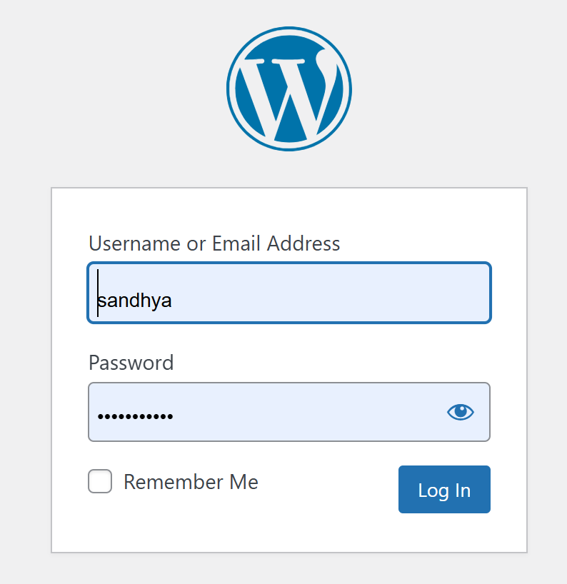
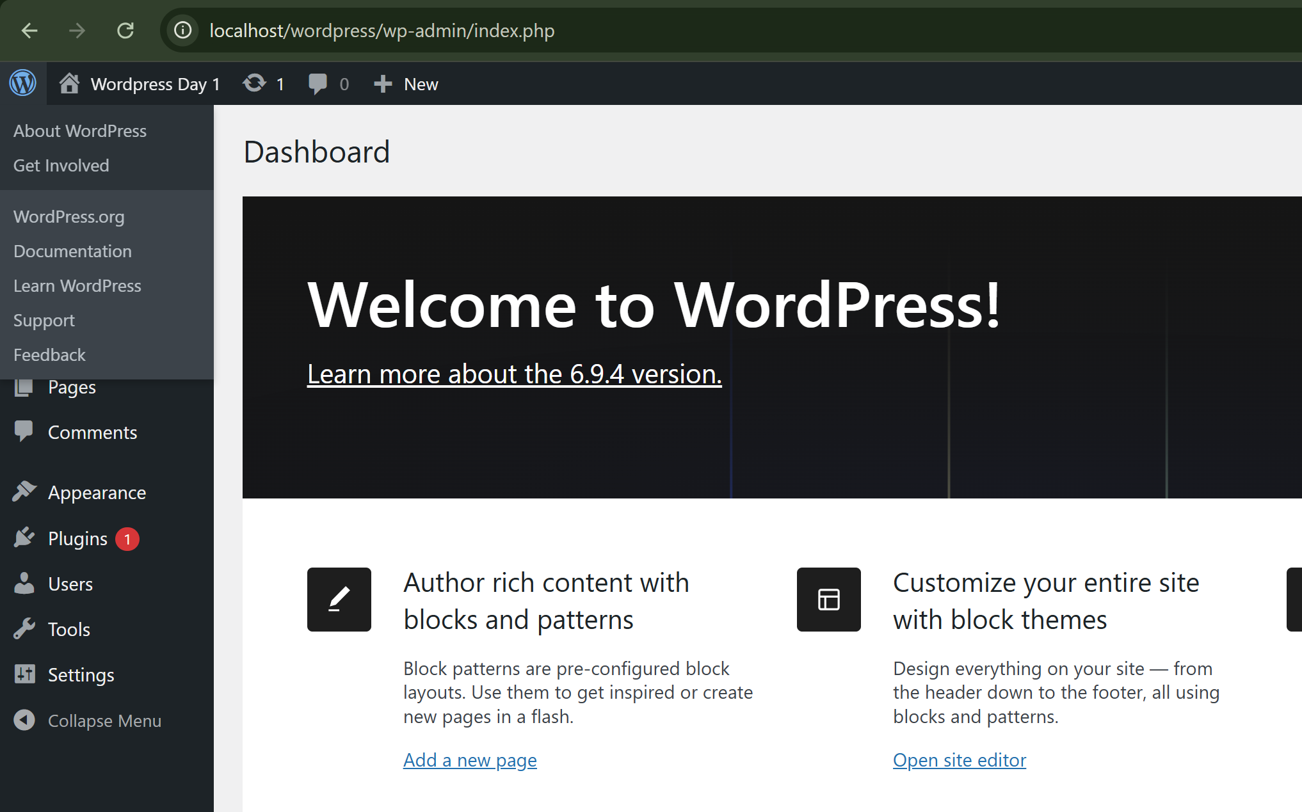

Task 2: What is LocalWP and How to Set It Up
LocalWP is a free app that sets up WordPress on our computer automatically. There is no need of manual database or server setup.
Step 1: Download and install the app through localwp.com.
Step 2: Open LocalWP. Click the + button to create a new site.
Step 3: Type a site name (eg. Outside-Day1-Sandhya). Click Continue.
Step 4: Enter an admin username and password. Click Add Site.
Step 6: LocalWP will create the site. Once done, we will see it listed. Click Open Site to view it in browser. Click Open Admin to go to the dashboard.
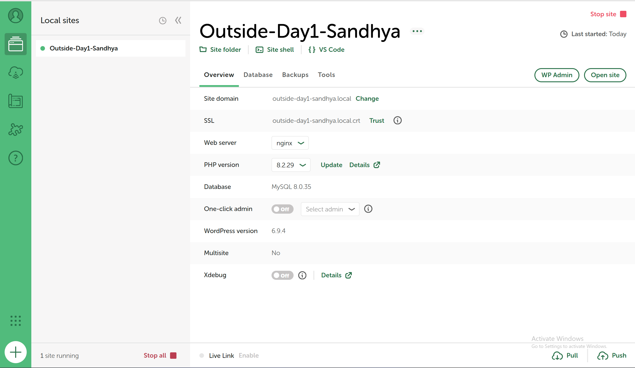
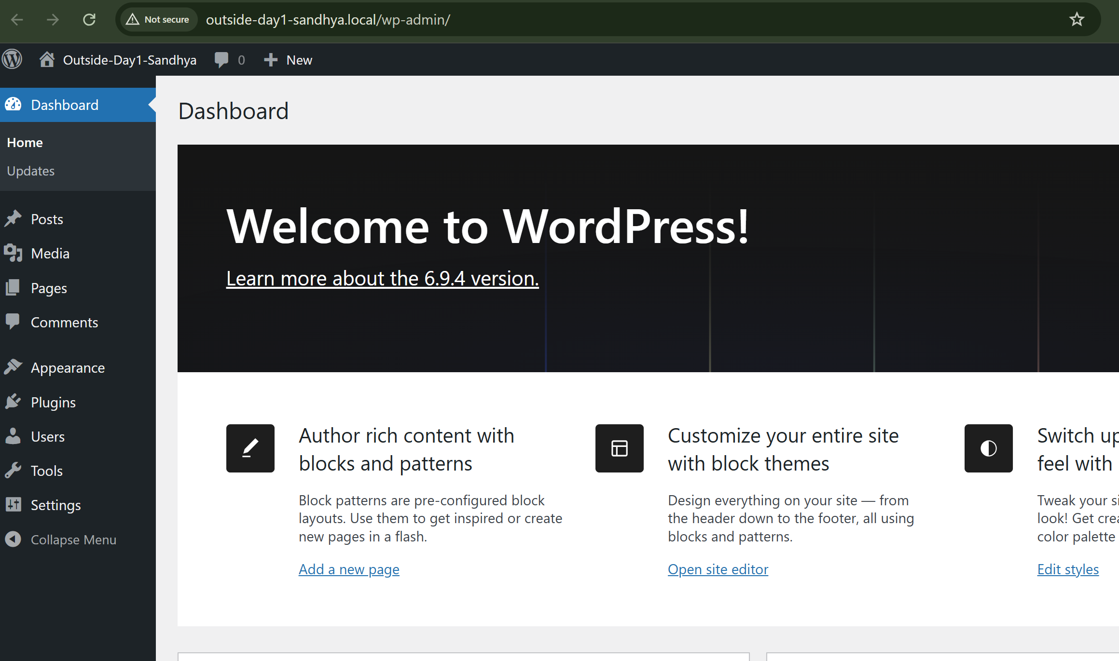
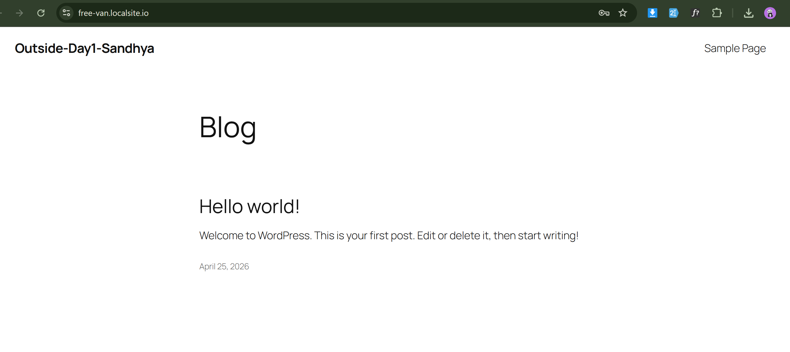
Task 3: Exploring the WordPress Dashboard
Step 1: Go to dashboard. This is the first screen we see after logging in.
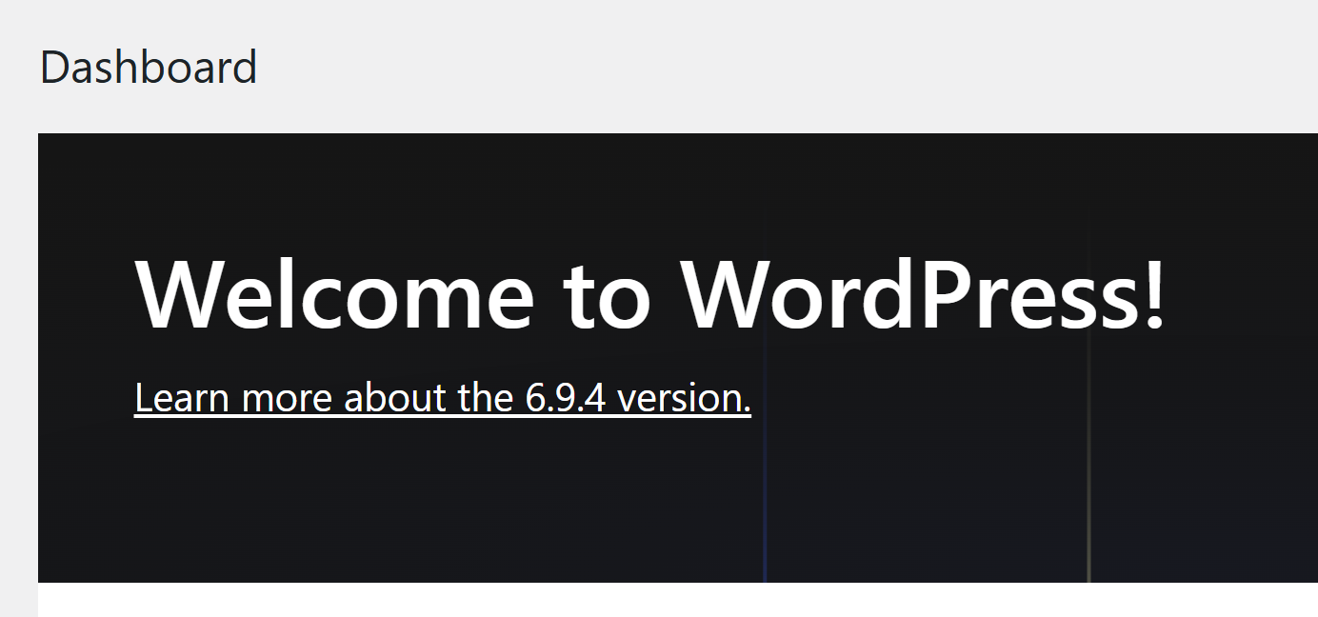
Step 2: Click Posts on the left menu. We will see all our posts here.
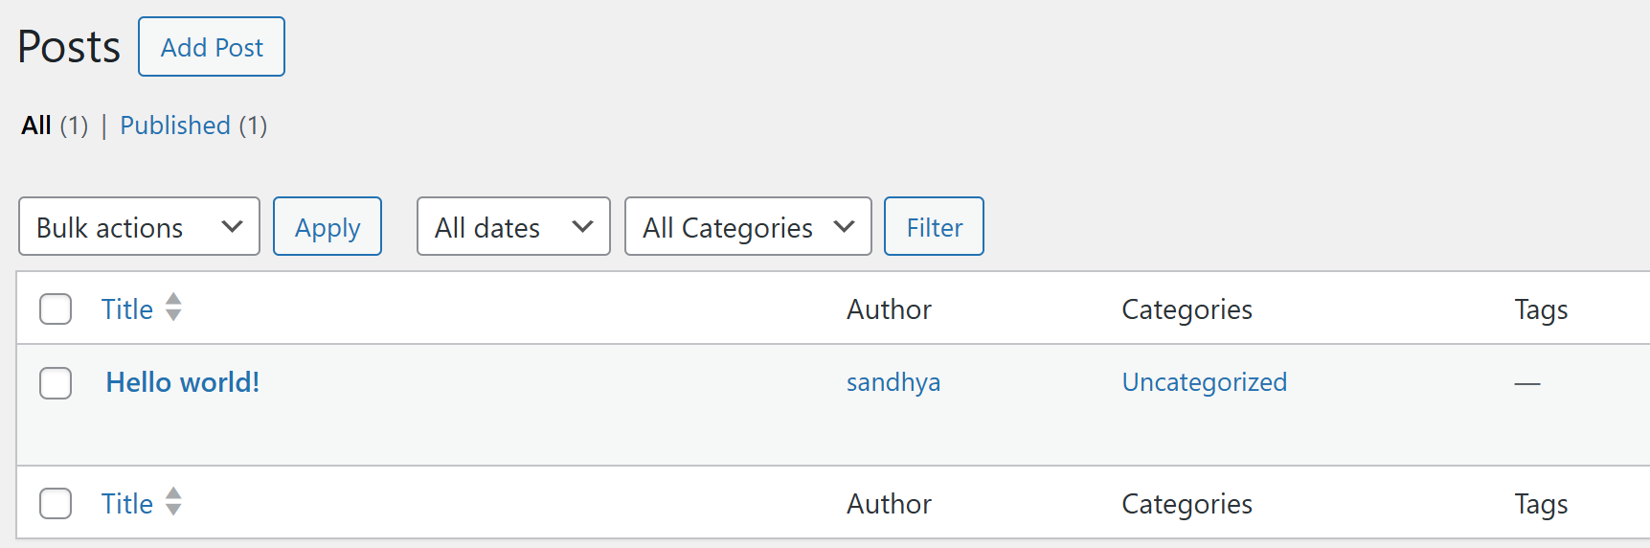
Step 3: Click Add New Post. Write a title, add some text, choose a category, and click Publish.
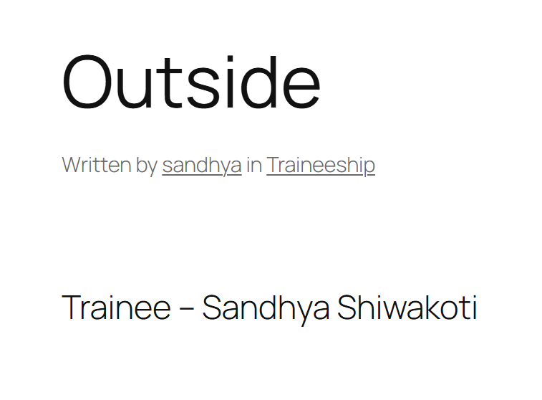
Step 4: Click Pages on the left menu.
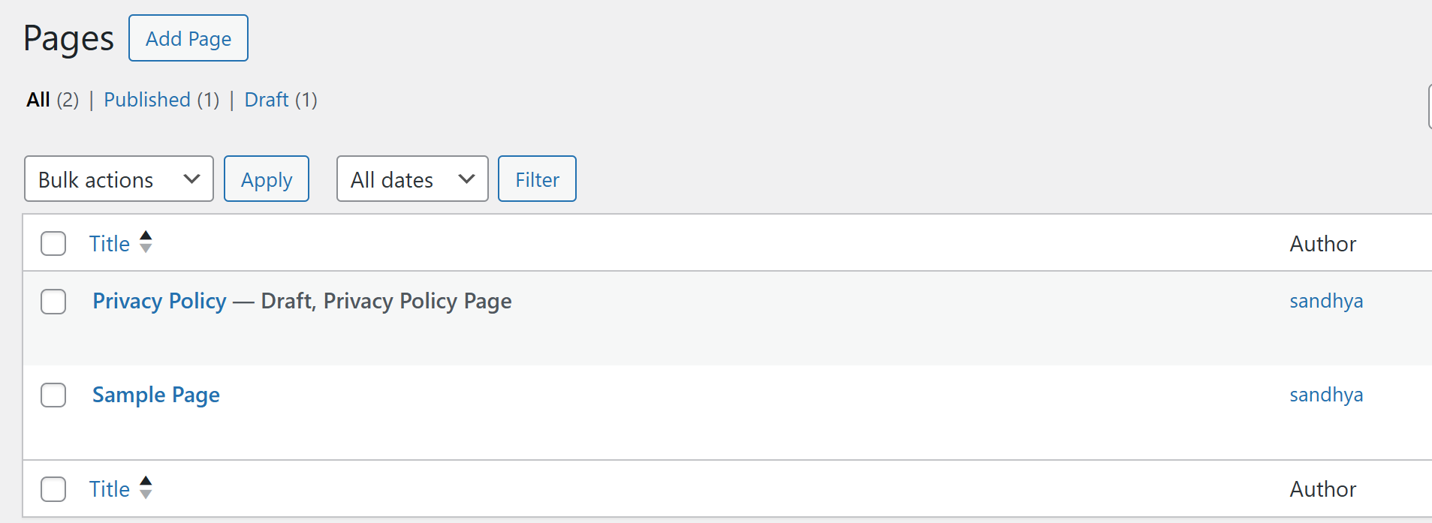
Step 5: Click Plugins on the left menu. We will see all installed plugins.
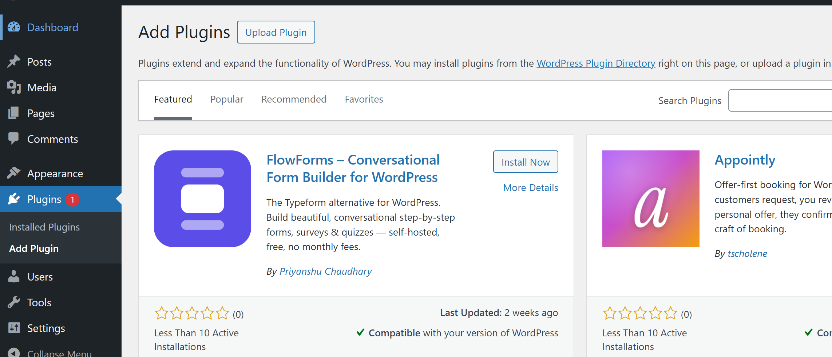

Step 6: Click Settings → General. We can see the site title, timezone, and other settings here.
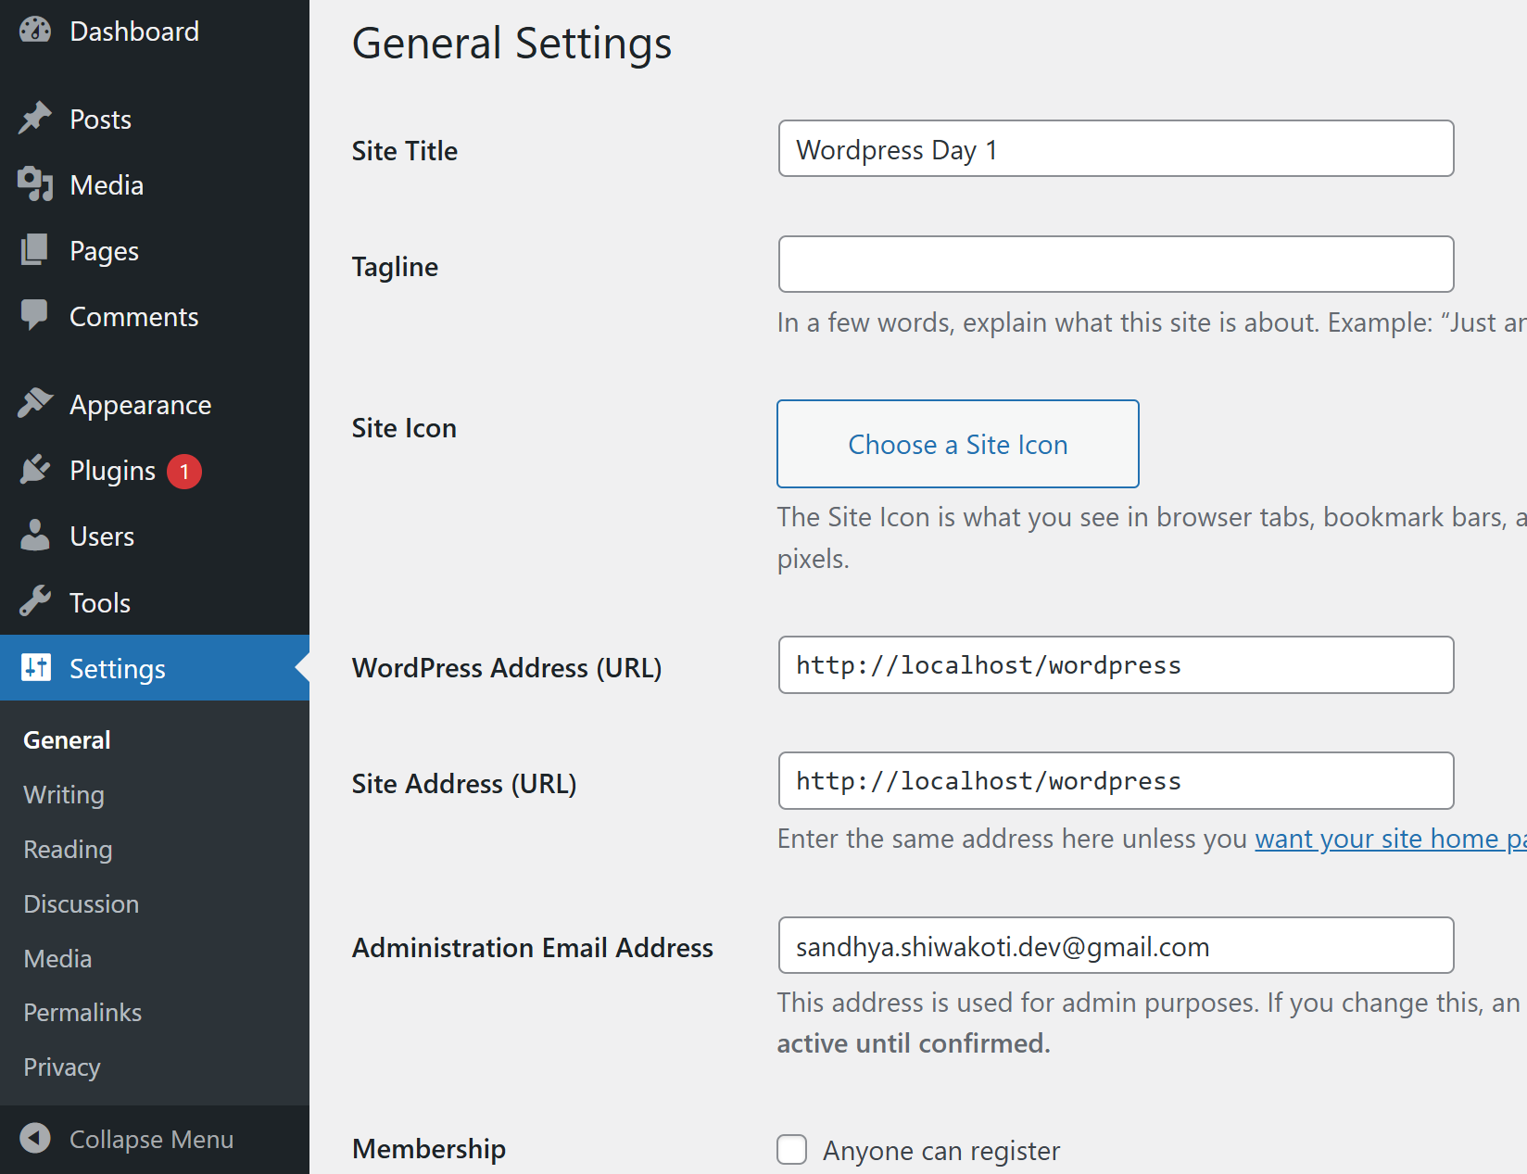
Task 4: Exploring Nav Menus
Nav menus are the navigation links at the top of our website that help visitors go from page to page.
Step 1: In dashboard, go to Appearance → Theme/Editor → Navigation Menu.
Step 2: Click the three dots ⋮ next to Navigation and create page (eg. About).
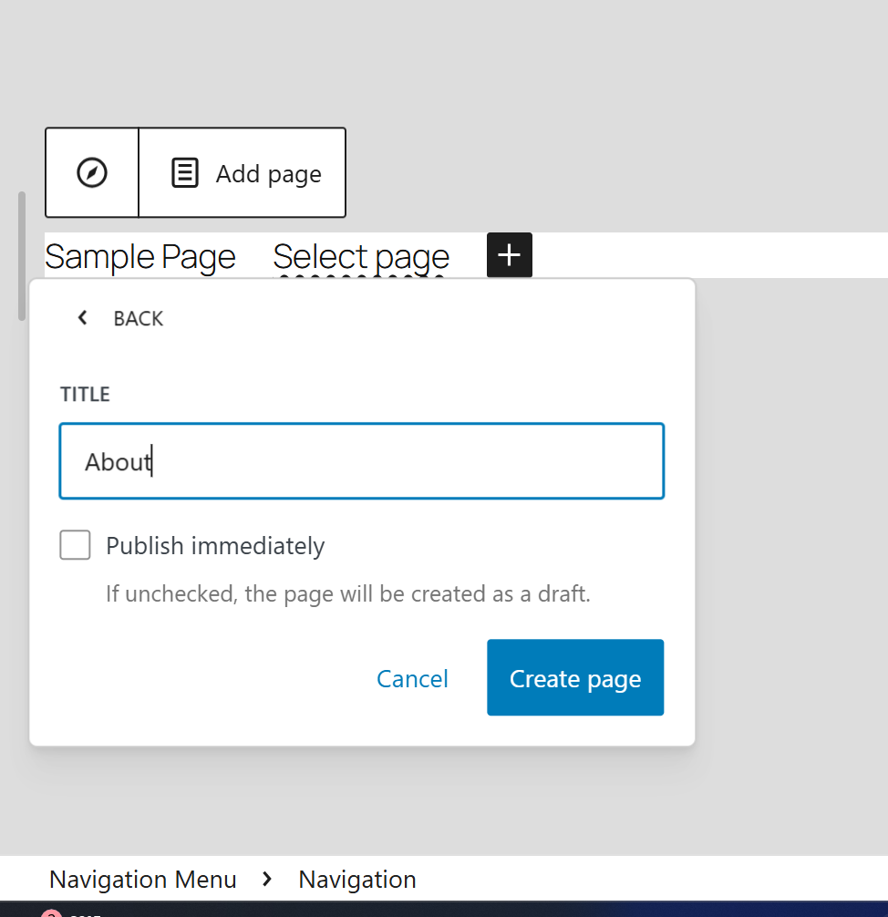
Step 3: The page gets added to the menu
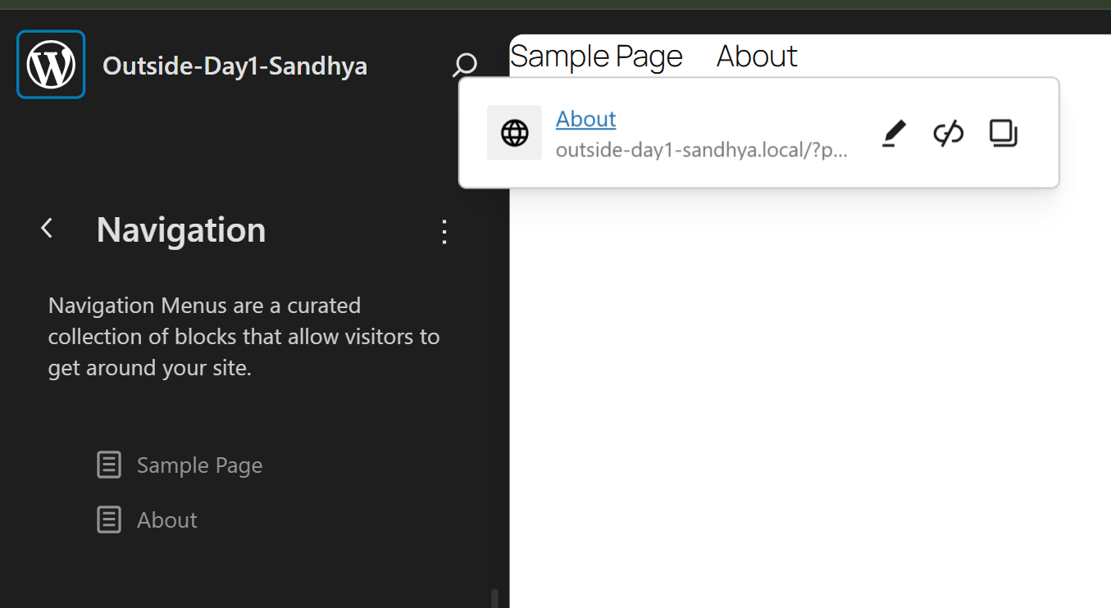
Task 5: Theme Development – File Structure and Template Hierarchy
Themes control how our WordPress site looks. Each theme has a specific set of files.
Step 1: Open VS Code. Navigate to WordPress folder → wp-content → themes. We will see the theme folders inside.

Step 2: Open one of the theme folders. We will see files like style.css, index.php, functions.php etc.
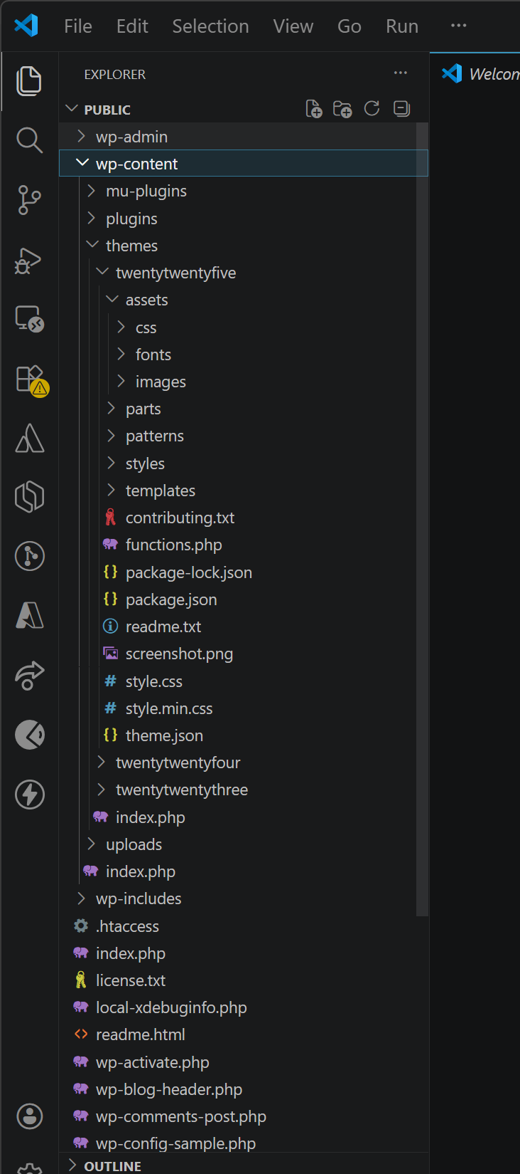
Step 3: Open style.css. At the top we will see the theme name, author, and version written as comments.
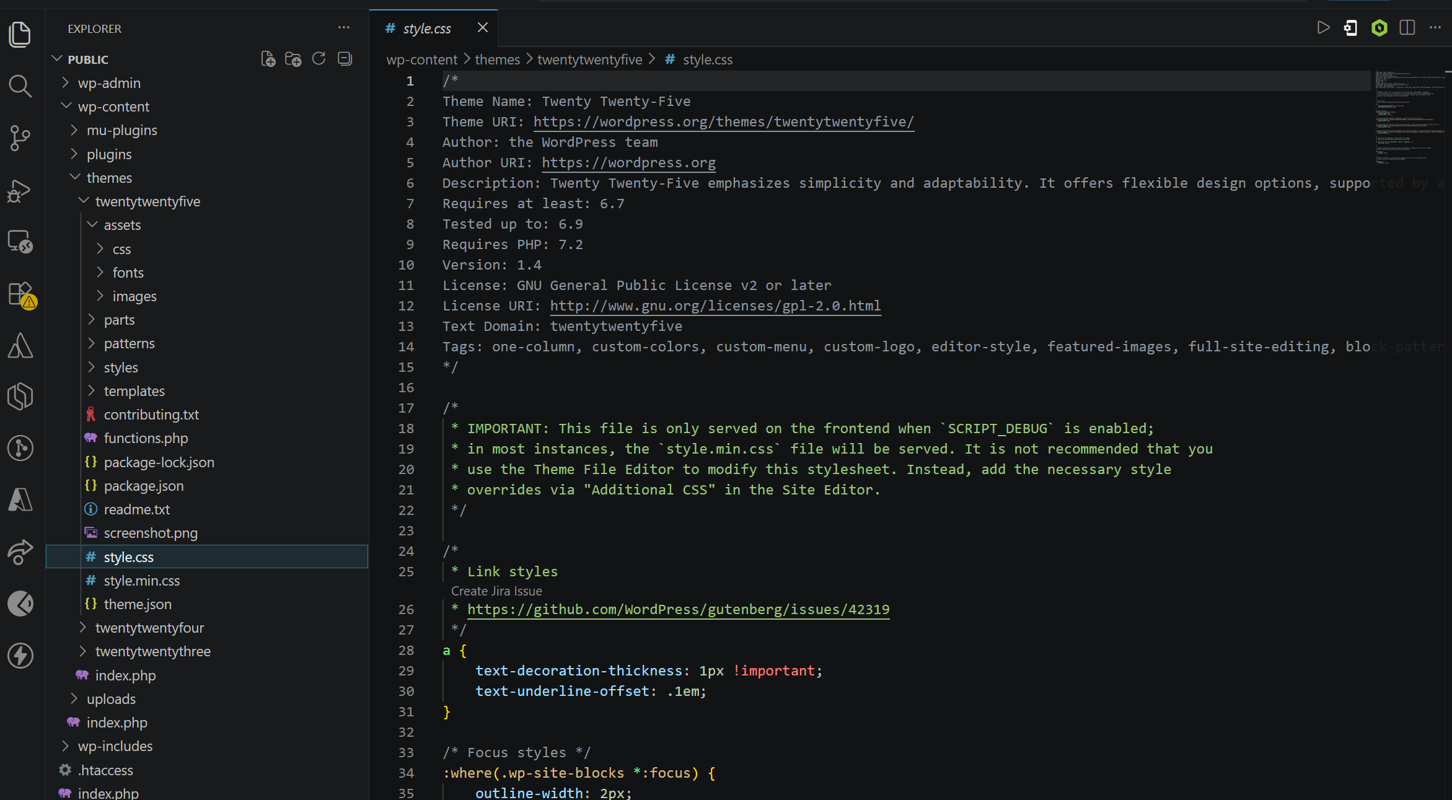

Theme File Structure - What I Understood
A WordPress theme controls how a website looks, not the content. So even if we change the theme, all posts and pages stay the same. All theme files are stored inside wp-content/themes/ folder. Each theme has its own folder inside there.
The main files and what they do:
style.css - The main stylesheet of the theme. At the very top it contains the theme name, author, and version as a comment. WordPress reads this to identify the theme. All CSS styling is written below that.
functions.php - Works like a plugin for the theme. Used to add features like registering menus, loading scripts, and enabling theme support.
index.php - The main fallback template. If WordPress can’t find any other matching file, it always uses this one.
templates folder - Contains different template files for different pages like home, single post, archive etc.
parts folder - Contains smaller reusable pieces like header and footer that are used inside the bigger templates.
theme.json - Controls global settings like colors, fonts, and spacing. Used in modern Full Site Editing themes like Twenty Twenty Five.
Template Hierarchy - What I Understood
Template hierarchy is the system WordPress uses to decide which template file to load. It always looks for the most specific file first. If that file doesn’t exist, it moves to the next one. This continues until it finds a match. If nothing matches, it always falls back to index.php.
i. For example for a single post it checks:
single-{post-type}.php → single.php → index.php
ii. For a page it checks:
page-{slug}.php → page-{id}.php → page.php → index.php
iii. For a category it checks:
category-{slug}.php → category.php → archive.php → index.php
This system gives developers control to create specific templates for specific pages while still having a general fallback for everything else.
We can see the full visual diagram of this at wphierarchy.com.
